**Why Docker-**

1. An application works in developer’s laptop but not in testing or production.this is due to difference in computing environments Dev,Test and prod.

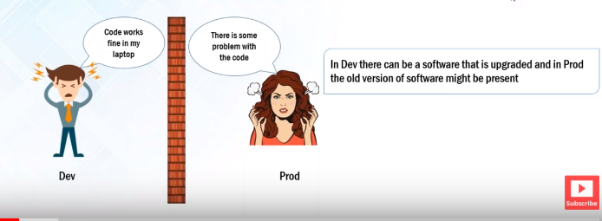

What are microservices-

Consider a very large application which is broken into smaller services,each of those services are microservices. Or microservices is a small processes which communicate with each other over a network to fulfill a particular goal.

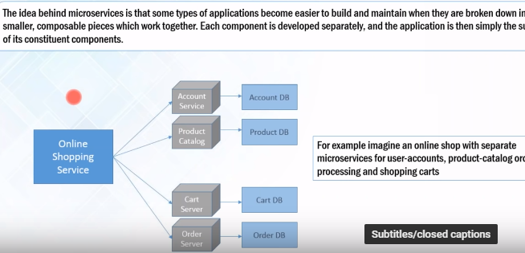

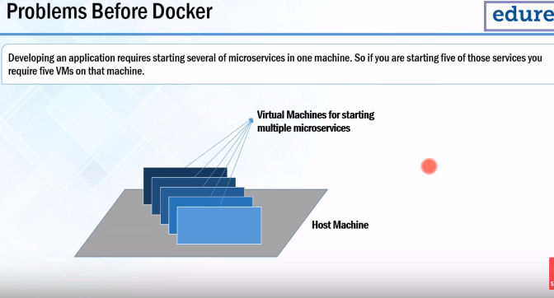

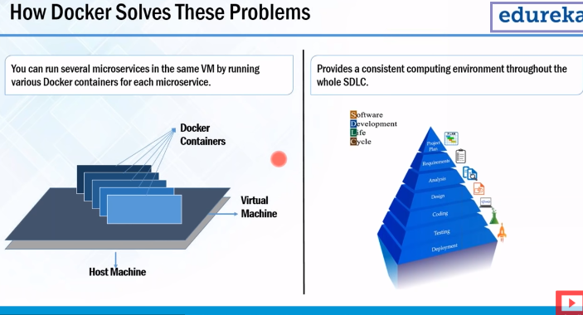

Why we need virtual machines-

Docker containers are lightweight alternatives of virtual machines.in docker container we do not need topealocate any RAM.the host machine needs UNIX or linus based to run docker container.docker container do not work on windows.so if we have window system then we need linus or unix virtual machine.a

**What is DOCKER**

Docker is not using **guest** operating system,it uses Host operating system.

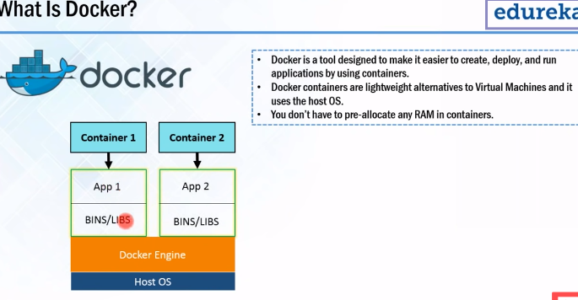

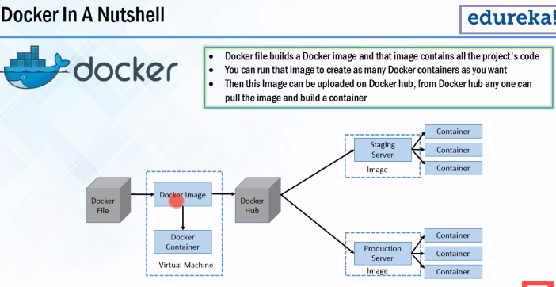

Developer writes code that defines application requirement and depoendancies in docker file.and docker file generate docker image.whatever dependancies requrre for particular application are present inside this image.and docker containers are runtime instance of docker image.

Docker hub is nothing but Git repository for docker images.it contains public as well as private repo.form docker hub qa and production can pull images as shown in diagram.hub is clud hosted service provided by docker. over here u can upload your own image or pull images.

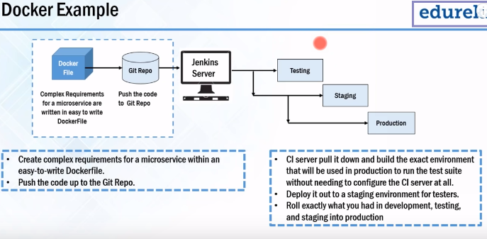

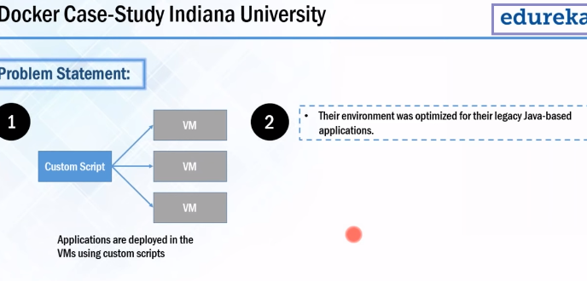

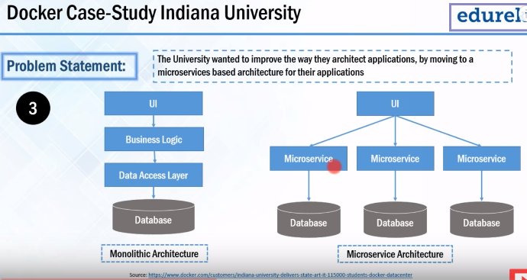

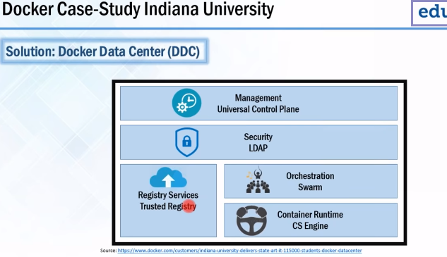

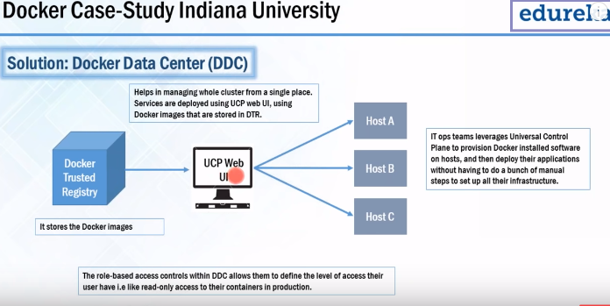

**Docker component:**

