Cancellation of Software Request Automation

Purpose:

We are trying to automate the resolution of **Cancellation of Software** tickets, by using Robotic Process Automation with the help of **UIPath**.

High Level Overview:

We are using two portals for ticket resolution namely:-

* Service Now
* Aspera (Smart Track)

1. We will get the ticket details from **Service Now .** Then analyze the ticket for Cancellation of Software request and get the RITM no for the respective ticket.
2. In **Aspera** we will search for active requests according to the RITM no if request is found we will check for request status and accordingly resolve the ticket.

If request is not found we will inform the SGL team and move to the next tickets.

Cancellation of Software Pseudocode

1. Open Service Now.
2. On the left hand side search bar type “Run” and open the “View/Run” report.
3. Click on the saved incident report.
4. Download the report.
5. Open the report and get the request number from “Short description” column.
6. Open SmartTrack application.
7. Go to Processes🡪Requests🡪Active Requests screen.
8. In the “Batch-ID” put the request number and click enter.
9. If request found, then proceed with step 9.
10. If request not found, then notify SGL and update comment in the incident saying “Request not found in SmartTrack”.
11. If request found then check “Request status” column.
12. If “Request status” is “Pending purchase” or “Pending purchase confirmation” then
13. Close the incident by clicking on “Resolve Incident” button
14. Fill all Mandatory columns.
15. In the close notes field mention “Purchase has been initiated. Cannot cancel request at this point” and click on “Save” button.
16. If “Request status” is “Closed” then
17. Close the incident by clicking on “Resolve Incident” button
18. Fill all Mandatory columns.
19. In the close notes field mention “The request is already fulfilled” and click on “Save” button.
20. If “Request status” having key word “Rejected” then
21. Close the incident by clicking on “Resolve Incident” button
22. Fill all Mandatory columns.
23. In the close notes field mention “The request is already rejected” and click on “Save” button.
24. If “Request status” is “Pending approval”, “Pending business review” or ”Pending sourcing requisition” then
25. Click on the 3 dots which is corresponding to the request in “Active request” screen

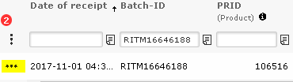

1. Click on “Edit”
2. Change the “Request status” to “Rejected(Cancelled)”

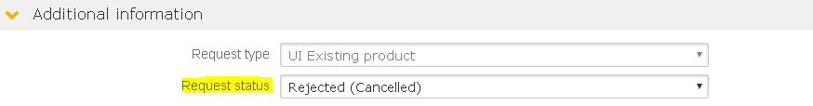

1. Click on “Save”
2. Close the incident by clicking on “Resolve Incident” button
3. Fill all Mandatory columns.
4. In the close notes field mention “We have cancelled the request” and click on “Save” button.

Please use the following values to resolve the incident:

