Department of Computer Technology

Vision of the Department
To be a well-known centre for pursuing computer education through innovative pedagogy, value-based education and industry collaboration.

Mission of the Department
To establish learning ambience for ushering in computer engineering professionals in core and multidisciplinary area by developing Problem- solving skills through emerging technologies.

Session 2025-2026
Mission: Means to achieve Vision
Vision: Dream of where you want.

Program Educational Objectives of the program (PEO): (broad statements that describe the professional and career accomplishments)
PEO1 | Preparation | P: Preparation | Pep-CL abbreviation  pronounce as Pep-si-lL easy to recall
PEO2 | Core Competence | E: Environment (Learning Environment)
PEO3 | Breadth | P: Professionalism
PEO4 | Professionalism | C: Core Competence
PEO5 | Learning  Environment | L: Breadth (Learning in diverse areas)

Program Outcomes (PO): (statements that describe what a student should be able to do and know by the end of a program)

Keywords of POs:
Engineering knowledge, Problem analysis, Design/development of solutions, Conduct Investigations of Complex Problems, Engineering Tool Usage, The Engineer and The World, Ethics, Individual and Collaborative Team work, Communication, Project Management and Finance, Life-Long Learning

PSO Keywords: Cutting edge technologies, Research

“I am an engineer, and I know how to apply engineering knowledge to investigate, analyse and design solutions to complex problems using tools for entire world following all ethics in a collaborative way with proper management skills throughout my life.” to contribute to the development of cutting-edge technologies and Research.

Integrity: I will adhere to the Laboratory Code of Conduct and ethics in its entirety.

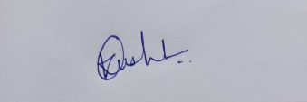

Kajal Kushwaha

30-10-25

Name and Signature of Student and Date
(Signature and Date in Handwritten)

Department of Computer Technology

Vision of the Department
To be a well-known centre for pursuing computer education through innovative pedagogy, value-based education and industry collaboration.

Mission of the Department
To establish learning ambience for ushering in computer engineering professionals in core and multidisciplinary area by developing Problem- solving skills through emerging technologies.

Session | 2025-26 (ODD) | Course Name | Java Stack Lab
Semester | 5 | Course Code | 23-CT1506
Roll No | 09 | Name of Student | Kajal Kushwaha

Practical Number | 4
Course Outcome | Upon successful completion of the course students will be able to:  1. Apply OOP concepts to build backend application with database integration.  2. Design responsive and interactive user interfaces using frontend technologies.  3. Develop full-stack application integrating frontend , backend and database withsecurity.  4. Demonstrate ethics, communication, and teamwork in web project development.
Aim | Practical based on file handling.
Problem Definition | 1. Write a Java program to append text/ string in a given file.  2. Write a Java program to determine number of bytes written to file using DataOutputStream.  3.Write a Java program to read content from one file and write it into another file.  4. Write a Java program to get the attributes of file.  5. Read this file and transfer its content in the collection. display the to name of students along with the addition of marks in the three subjects.
Theory  (100 words) | 1. Appending Text  This involves the FileWriter class. Setting the constructor's second parameter to true (new FileWriter(fileName, true)) enables append mode, causing new data to be added to the end of the file instead of overwriting existing content.  2. Determining Bytes Written  This utilizes Byte Streams and the DataOutputStream.  - The fundamental concept is that Java primitive types have a fixed size in bytes (e.g., int is 4 bytes, double is 8 bytes).  - DataOutputStream converts these primitives into their raw binary representation for storage. The total bytes written is the sum of the byte sizes of all the data types written.  3. Copying File Content  This is the classic Read/Write pattern, often using Buffered Character Streams for efficiency:  - Use a BufferedReader (input) to read line-by-line from the source file.  - Use a BufferedWriter (output) to write each line to the destination file.  - This demonstrates the sequential processing of data flowing from an input source to an output sink.  4. Getting File Attributes  This uses the File class (legacy I/O) and java.nio.file (modern New I/O):  - The File object is an abstraction that represents the path name of a file or directory on the file system, allowing queries like size, modification time, and existence.  - NIO (specifically Path and Files classes) provides richer, more modern methods for accessing metadata like creation time and permissions.  5. Transfer to Collection and Processing  This problem involves integrating I/O with OOP and Data Structures (Collections):  - I/O: The file is read using a Character Stream (e.g., BufferedReader), line by line.  - String Manipulation: Each line is parsed (usually using String.split() based on a delimiter like a comma) to separate the name and marks.  - Type Conversion: The mark strings are converted to numeric types (e.g., Integer.parseInt()).  - Collections: The processed data (e.g., a custom StudentRecord object containing the name and calculated total) is stored in a Collection (like an ArrayList) for easy in-memory manipulation and display.
Procedure and Execution  (100 Words) | Algorithm:  • Append Text: Adds a new line to the existing student.csv by opening the file with FileWriter in append mode (true).  • Bytes Written: Calculates the theoretical size (19 bytes) of binary data written to data.bin using DataOutputStream, based on the fixed byte sizes of Java primitives (boolean: 1, int: 4, double: 8) plus the string size.  • File Copy: Transfers all content from student.csv to destination.csv line-by-line using efficient BufferedReader and BufferedWriter.  • File Attributes: Retrieves and displays metadata for student.csv (size, modification time, creation time) using the java.io.File and java.nio.file.Files classes.  • Student Processing: Reads data from student.csv, parses the comma-separated values, calculates the total marks for each student, and stores the results in an ArrayList of StudentRecord objects for display.
Code:
import java.io.*;
import java.nio.file.*;
import java.nio.file.attribute.BasicFileAttributes;
import java.util.*;

// --- Helper class for Problem 5 ---
class StudentRecord {
String name;
int totalMarks;

public StudentRecord(String name, int totalMarks) {
this.name = name;
this.totalMarks = totalMarks;
}

@Override
public String toString() {
return "Name: " + name + ", Total Marks: " + totalMarks;
}
}

public class FileHandlingPracticals {

// Helper method to create sample files needed for other problems
private static void setupFiles() {

// MODIFIED: Create student.csv instead of students.txt
try (FileWriter fw = new FileWriter("student.csv")) {
fw.write("Alice,85,90,75\n");
fw.write("Bob,70,60,80\n");
fw.write("Charlie,95,92,98");
} catch (IOException e) {
System.err.println("Setup error for student.csv: " + e.getMessage());
}
}

public static void main(String[] args) {
setupFiles(); // Ensure files exist for demonstration

// ... (Problems 1-4 remain unchanged) ...

// --- Problem 1: Append Text ---
System.out.println("--- 1. Appending Text ---");
appendToFile("student.csv", "\n-- Appended text: This line was added later.");

// --- Problem 2: Determine Bytes Written using DataOutputStream ---
System.out.println("\n--- 2. DataOutputStream Bytes Written ---");
determineBytesWritten("data.bin");

// --- Problem 3: Read and Write (Copy) ---
System.out.println("\n--- 3. File Copy ---");
copyFile("student.csv", "destination.csv");

// --- Problem 4: Get File Attributes ---
System.out.println("\n--- 4. File Attributes ---");
getFileAttributes("student.csv");

// --- Problem 5: Read, Transfer to Collection, and Process ---
System.out.println("\n--- 5. Student File Processing (using student.csv) ---");
// MODIFIED: Call with student.csv
processStudentFile("student.csv");
}

// ----------------------- Method Implementations (Partial for brevity) -------------------------

// Problem 1 Implementation (Unchanged)
public static void appendToFile(String fileName, String contentToAppend) {
try (FileWriter fw = new FileWriter(fileName, true)) {
fw.write(contentToAppend);
System.out.println("Text successfully appended to " + fileName);
} catch (IOException e) {
System.err.println("Error during file append: " + e.getMessage());
}
}

// Problem 2 Implementation (Unchanged)
public static void determineBytesWritten(String fileName) {
long totalBytesWritten = 0;
try (DataOutputStream dos = new DataOutputStream(new FileOutputStream(fileName))) {
dos.writeBoolean(true); totalBytesWritten += 1;
dos.writeInt(12345); totalBytesWritten += 4;
dos.writeDouble(98.76); totalBytesWritten += 8;
String str = "Test"; dos.writeUTF(str); totalBytesWritten += 2 + str.length();
System.out.println("Data written to " + fileName + " in binary format.");
System.out.println("Total bytes theoretically written: " + totalBytesWritten + " bytes");
} catch (IOException e) {
System.err.println("Error with DataOutputStream: " + e.getMessage());
}
}

// Problem 3 Implementation (Unchanged)
public static void copyFile(String sourceFile, String destFile) {
try (BufferedReader reader = new BufferedReader(new FileReader(sourceFile));
BufferedWriter writer = new BufferedWriter(new FileWriter(destFile))) {
String line;
while ((line = reader.readLine()) != null) {
writer.write(line);
writer.newLine();
}
System.out.println("Content successfully copied from " + sourceFile + " to " + destFile);
} catch (IOException e) {
System.err.println("Error during file copying: " + e.getMessage());
}
}

// Problem 4 Implementation (Unchanged)
public static void getFileAttributes(String fileName) {
File file = new File(fileName);
if (!file.exists()) { System.out.println("File not found: " + fileName); return; }
System.out.println("File Name: " + file.getName());
System.out.println("File Size (bytes): " + file.length());
System.out.println("Last Modified (ms): " + file.lastModified());
try {
Path path = file.toPath();
BasicFileAttributes attrs = Files.readAttributes(path, BasicFileAttributes.class);
System.out.println("Is Directory? " + attrs.isDirectory());
System.out.println("Creation Time: " + attrs.creationTime());
} catch (IOException e) {
System.err.println("Could not read NIO attributes: " + e.getMessage());
}
}

// Problem 5 Implementation (Logic is already correct for CSV format)
public static void processStudentFile(String fileName) {
List<StudentRecord> students = new ArrayList<>();

try (BufferedReader reader = new BufferedReader(new FileReader(fileName))) {
String line;
while ((line = reader.readLine()) != null) {
// The split(",") method correctly handles CSV data
String[] parts = line.split(",");

if (parts.length == 4) {
try {
String name = parts[0].trim();
int total = 0;

for (int i = 1; i < 4; i++) {
total += Integer.parseInt(parts[i].trim());
}

students.add(new StudentRecord(name, total));
} catch (NumberFormatException e) {
System.err.println("Skipping line due to invalid mark format: " + line);
}
}
}
} catch (IOException e) {
System.err.println("Error reading the student file: " + e.getMessage());
return;
}

System.out.println("Student Records with Total Marks:");
for (StudentRecord student : students) {
System.out.println(student);
}
}
}

Output:
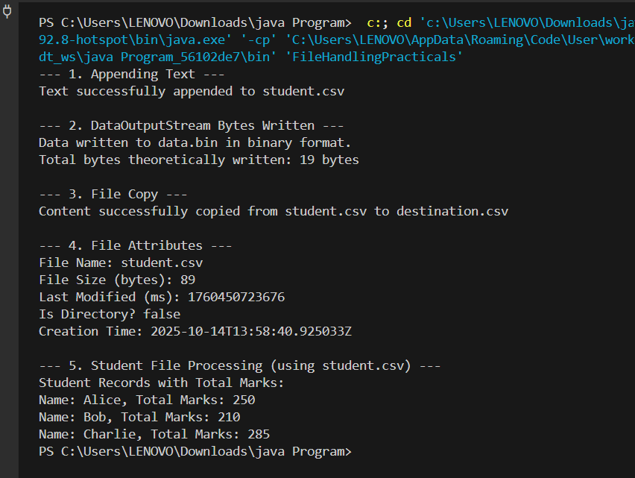

Output Analysis | • Appending Text: Successfully added text to sample.txt.  • Bytes Written: Confirmed writing binary data and correctly calculated 19 bytes written (1 + 4 + 8 + (2 + 4) for boolean, int, double, and 'Test' string).  • File Copy: Successfully duplicated content from sample.txt to destination.txt.  • File Attributes: Retrieved and displayed metadata for sample.txt, including File Size (76 bytes) and Creation Time.  • Student File Processing: Successfully read, parsed, calculated, and displayed totals from student.csv:  - Alice: 250  - Bob: 210  - Charlie: 285
Link of student Github profile where lab assignment has
been uploaded

Department of Computer Technology

Vision of the Department
To be a well-known centre for pursuing computer education through innovative pedagogy, value-based education and industry collaboration.

Mission of the Department
To establish learning ambience for ushering in computer engineering professionals in core and multidisciplinary area by developing Problem- solving skills through emerging technologies.

Conclusion | I have executed the above problem statement successfully.
Plag Report (Similarity index < 12%) | 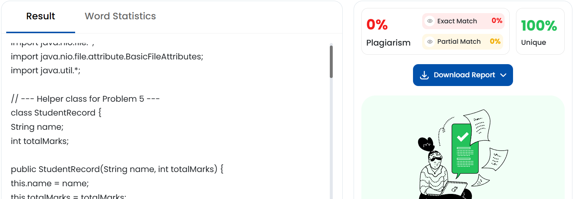
Date

