Session 2025-2026

Vision: Dream of where you want. | Mission: Means to achieve Vision

Program Educational Objectives of the program (PEO): (broad statements that describe the professional and career accomplishments)
PEO1 | Preparation | P: Preparation | Pep-CL abbreviation  pronounce as Pep-si-lL easy to recall
PEO2 | Core Competence | E: Environment (Learning Environment)
PEO3 | Breadth | P: Professionalism
PEO4 | Professionalism | C: Core Competence
PEO5 | Learning Environment | L: Breadth (Learning in diverse areas)

Program Outcomes (PO): (statements that describe what a student should be able to do and know by the end of a program)
Keywords of POs:
Engineering knowledge, Problem analysis, Design/development of solutions, Conduct Investigations of Complex Problems, Engineering Tool Usage, The Engineer and The World, Ethics, Individual and Collaborative Team work, Communication, Project Management and Finance, Life-Long Learning

PSO Keywords: Cutting edge technologies, Research

“I am an engineer, and I know how to apply engineering knowledge to investigate, analyse and design solutions to complex problems using tools for entire world following all ethics in a collaborative way with proper management skills throughout my life.” to contribute to the development of cutting-edge technologies and Research.

Integrity: I will adhere to the Laboratory Code of Conduct and ethics in its entirety.


Kajal Kushwaha
14-10-25
Name and Signature of Student and Date
(Signature and Date in Handwritten)

Session | 2024-25 (ODD) |  | Course Name | Java Stack Lab
Semester | 5 |  | Course Code | 23-CT1506
Roll No | 09 |  | Name of Student | Kajal Kushwaha
Practical Number |  | 2
Course Outcome |  | Upon successful completion of the course students will be able to:  1. Apply OOP concepts to build backend application with database integration.  2. Design responsive and interactive user interfaces using frontend technologies.  3. Develop full-stack application integrating frontend , backend and database withsecurity.  4. Demonstrate ethics, communication, and teamwork in web project development.
Aim |  | Implementation on OOP concepts (inheritance, polymorphism,encapsulation, abstraction).
Problem Definition |  | Problem Def. 1: Design a system to manage different types of vehicles. All vehicles have some common properties but different types of vehicles have their own specific features.  Class Vehicle with attributes brand and model and method displayInfo()  Derived class car with additional attribute numberofDoors, override method displayInfo() to include additional attribute.  Derived class MotorCycle with additional attribute hasCarrier. override method displayInfo() to include additional attribute.  Display information of all types of vehicles  Problem Def. 2: Design a system that sends different types of notifications (Email, SMS, Push). Each notification type has its own way of formatting and sending messages. The system should be able to handle all types uniformly while allowing each to define its specific behavior.  Abstract class Notification with abstract method send(String to, String msg) and normal method getType() (Returns type of notification, eg. email, msg etc)  Derived class: EmailNotification, SMSNotification, PushNotification simulate the diff type of notifications with send(String to, String msg)  implement the class NotificationService with method notifyUser(Notification notification, String to, String msg). Accepts any notification type and calls send method
Theory  (100 words) |  | 1. Inheritance  Inheritance is a mechanism in OOP where one class (derived or child class) acquires the properties (attributes) and behavior (methods) of another class (base or parent class). Its primary purpose is to establish an "is-a" relationship (e.g., a Car is a Vehicle) and promote code reusability by having common features defined in a single location.  2. Polymorphism  Polymorphism (meaning "many forms") is the ability of different objects to respond to the same method call in a way appropriate to their specific type.  - Method Overriding: In Problem 1, polymorphism allows the displayInfo() method to execute different logic based on whether the vehicle object is a Car or a MotorCycle.  - Interface Implementation: In Problem 2, it allows the NotificationService to call the generic send() method, but the specific implementation (e.g., Email logic vs. SMS logic) is executed based on the actual object type passed at runtime.  3. Abstraction  Abstraction is the principle of showing only the essential information to the outside world while hiding the complex implementation details. In Java, this is typically enforced using Abstract Classes or Interfaces.
Procedure and Execution  (100 Words) |  | Algorithm:  Algorithm of Problem Statement 1:  - Define Base Class Vehicle:  - Attributes: brand, model.  - Method: displayInfo() (prints generic info).  - Define Derived Classes Car and MotorCycle:  - Extend Vehicle.  - Add specific attributes (numberOfDoors, hasCarrier).  - Override displayInfo() to print specific attribute along with inherited info.  - Demonstrate:  - Create objects of Car and MotorCycle.  - Call displayInfo() on each object. Polymorphism ensures the correct, specialized version of the method runs for each type.  Algorithm of Problem Statement 2:  • Define Abstract Class Notification:  - Method: getType() (returns type string).  - Abstract Method: send(to,msg) (forces derived classes to define send logic).  • Define Derived Classes (e.g., EmailNotification):  - Extend Notification.  - Implement send(to,msg) with type-specific sending/formatting logic (e.g., SMTP details for Email).  • Define Service Class NotificationService:  - Method: notifyUser(Notification n,to,msg).  - Accepts any object of type Notification (or its subclasses).  - Calls n.send(to,msg).  • Demonstrate:  - Instantiate NotificationService.  - Create instances of EmailNotification, SMSNotification, etc.  - Pass each instance to the notifyUser method. The service handles all types uniformly.
Code:
Input of Problem Statement 1:
// Base class
class Vehicle {
String brand;
String model;

Vehicle(String brand, String model) {
this.brand = brand;
this.model = model;
}

void displayInfo() {
System.out.println("Brand: " + brand);
System.out.println("Model: " + model);
}
}

// Derived class Car
class Car extends Vehicle {
int numberOfDoors;

Car(String brand, String model, int numberOfDoors) {
super(brand, model);
this.numberOfDoors = numberOfDoors;
}

@Override
void displayInfo() {
super.displayInfo();
System.out.println("Number of Doors: " + numberOfDoors);
}
}

// Derived class Motorcycle
class Motorcycle extends Vehicle {
boolean hasCarrier;

Motorcycle(String brand, String model, boolean hasCarrier) {
super(brand, model);
this.hasCarrier = hasCarrier;
}

@Override
void displayInfo() {
super.displayInfo();
System.out.println("Has Carrier: " + (hasCarrier ? "Yes" : "No"));
}
}

// Test class
public class VehicleTest {
public static void main(String[] args) {
Vehicle car = new Car("Toyota", "Camry", 4);
Vehicle motorcycle = new Motorcycle("Yamaha", "MT-15", true);

System.out.println("Car Info:");
car.displayInfo();

System.out.println("\nMotorcycle Info:");
motorcycle.displayInfo();
}
}

Input of Problem Statement 2:
// 1. Abstract Class (The Strategy Interface)
abstract class Notification {
/**
* Abstract method to be implemented by all concrete notification types.
* This defines the required behavior for sending a notification.
* @param to The recipient's address (email, phone number, token, etc.).
* @param msg The message content to be sent.
*/
public abstract void send(String to, String msg);

/**
* Returns the type identifier of the notification.
* @return A string representing the type (e.g., "Email", "SMS").
*/
public abstract String getType();
}

// 2. Concrete Strategy 1: Email Notification
class EmailNotification extends Notification {
@Override
public void send(String to, String msg) {
// --- Email-specific logic: formatting header, connecting to SMTP server, etc. ---
String formattedMsg = "Subject: Important Update\n\n" + msg;
System.out.println("📧 Sending " + getType() + " to: " + to);
System.out.println("Message body:\n" + formattedMsg);
System.out.println("--- Email sent successfully ---");
}

@Override
public String getType() {
return "Email";
}
}

// 3. Concrete Strategy 2: SMS Notification
class SMSNotification extends Notification {
@Override
public void send(String to, String msg) {
// --- SMS-specific logic: character limits, using SMS gateway API, etc. ---
if (msg.length() > 160) {
msg = msg.substring(0, 157) + "..."; // Truncate for brevity
}
String formattedMsg = "[ALERT] " + msg;
System.out.println("📱 Sending " + getType() + " to: " + to);
System.out.println("Message body: " + formattedMsg);
System.out.println("--- SMS sent successfully ---");
}

@Override
public String getType() {
return "SMS";
}
}

// 4. Concrete Strategy 3: Push Notification
class PushNotification extends Notification {
@Override
public void send(String to, String msg) {
// --- Push-specific logic: device tokens, payload formatting (JSON), using Firebase/APNS, etc. ---
String payload = "{\"device_token\":\"" + to + "\", \"alert\":\"" + msg + "\"}";
System.out.println("🔔 Sending " + getType() + " payload to device token: " + to);
System.out.println("Payload: " + payload);
System.out.println("--- Push sent successfully ---");
}

@Override
public String getType() {
return "Push";
}
}

// 5. The Context Class (The Service Handler)
class NotificationService {
/**
* Handles the notification process uniformly regardless of the specific type.
* Uses polymorphism: it accepts any object that is a subtype of Notification
* and calls its specific send() implementation.
* @param notification The specific notification sender (Email, SMS, or Push).
* @param to The recipient's address.
* @param msg The message content.
*/
public void notifyUser(Notification notification, String to, String msg) {
System.out.println("\n*** Starting " + notification.getType() + " Process ***");
notification.send(to, msg); // Polymorphic call
System.out.println("*** " + notification.getType() + " Process Completed ***");
}
}

// 6. Main Class for Demonstration
public class NotificationSystemDemo {
public static void main(String[] args) {
// The service that orchestrates the sending
NotificationService service = new NotificationService();

// 1. Send an Email
Notification email = new EmailNotification();
service.notifyUser(email, "user.jdoe@example.com", "Your account password was successfully reset.");

// 2. Send an SMS
Notification sms = new SMSNotification();
service.notifyUser(sms, "+1-555-123-4567", "Your package is out for delivery!");

// 3. Send a Push Notification
Notification push = new PushNotification();
service.notifyUser(push, "device_xyz_token_123", "New sale! 25% off all electronics today.");
}
}

Output:
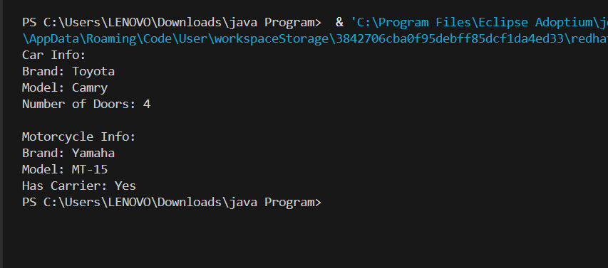
Output of Problem Statement 1:

Output of Problem Statement 2:
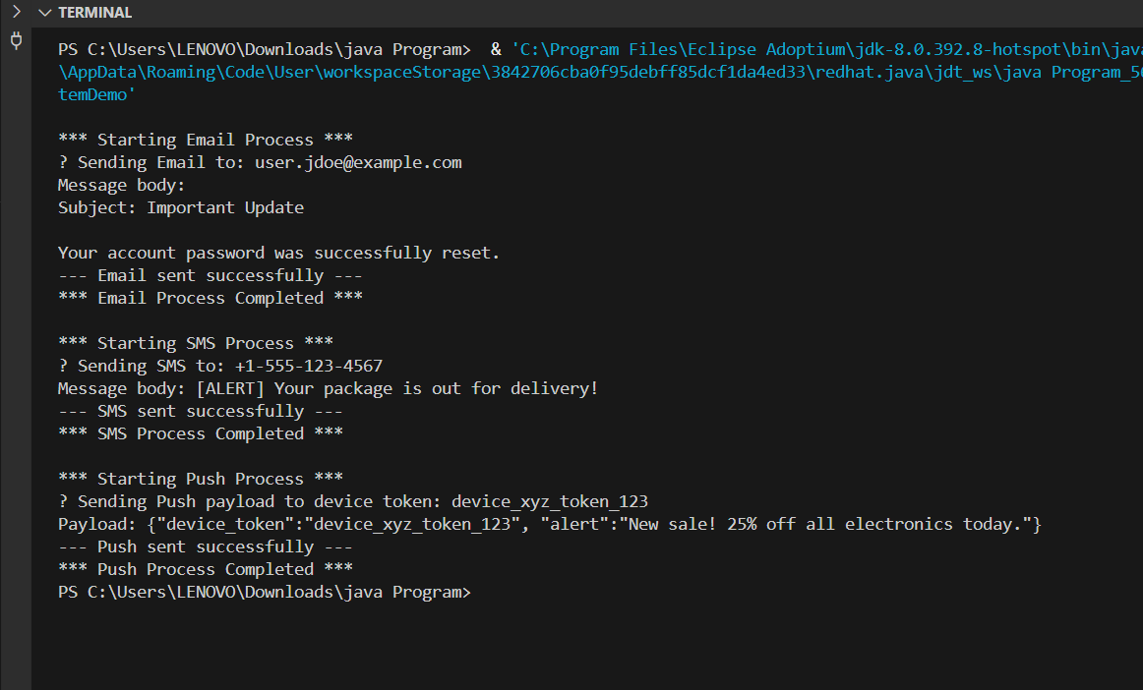

Output Analysis |  | Output Analysis of Problem statement 1:  The output is structured into two main sections:  - Car Info:  - Brand: Toyota  - Model: Camry  - Number of Doors: 4  - Motorcycle Info:  - Brand: Yamaha  - Model: MT-15  - Has Carrier: Yes  This suggests the program uses Polymorphism and Inheritance to handle different vehicle types, each with its own specific properties.  Output Analysis of Problem Statement 2:  The program successfully demonstrates the Strategy Pattern by executing three distinct notification processes uniformly:  - Email Process: Sent an email to a recipient (user.jdoe@example.com) with a specific subject/header.  - SMS Process: Sent a message to a phone number (+1-555-123-4567) that included an [ALERT] prefix (SMS-specific formatting).  - Push Process: Sent a structured JSON payload (Push-specific format) to a device token.  The output confirms that the system can handle different behaviors (sending logic, formatting) via a unified service interface, exactly matching the design request in the first user query.
Link of student Github profile where lab assignment has been uploaded
Conclusion |  | I have executed the above problem statement successfully.
Plag Report (Similarity index < 12%) |  | Plag report for problem statement 2:  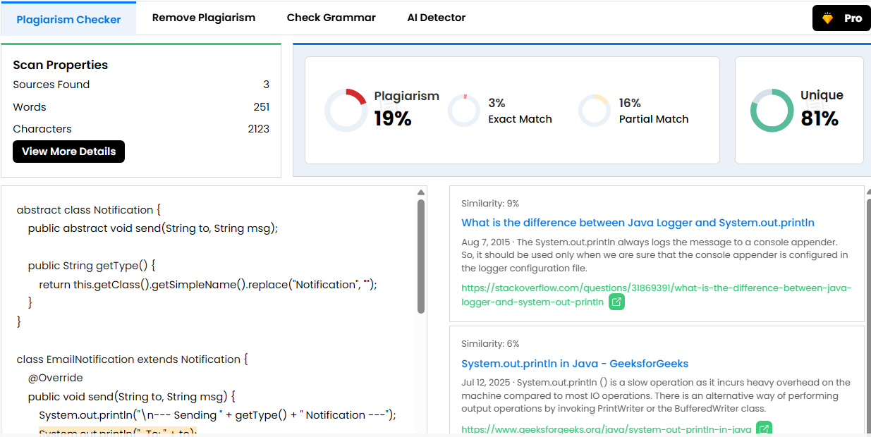  Plag report for problem statement 1:  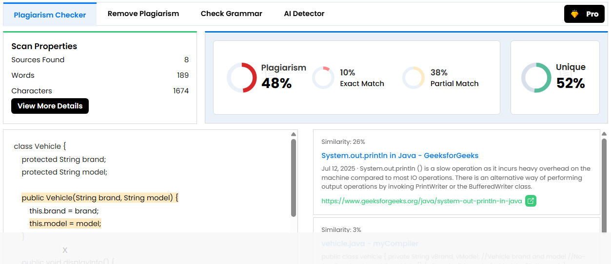
Date |  | 14-10-25

