Department of Computer Technology

Vision of the Department
To be a well-known centre for pursuing computer education through innovative pedagogy, value-based education and industry collaboration.

Mission of the Department
To establish learning ambience for ushering in computer engineering professionals in core and multidisciplinary area by developing Problem- solving skills through emerging technologies.

Session 2025-2026
Mission: Means to achieve Vision
Vision: Dream of where you want.

Program Educational Objectives of the program (PEO): (broad statements that describe the professional and career accomplishments)
PEO1 | Preparation | P: Preparation | Pep-CL abbreviation  pronounce as Pep-si-lL easy to recall
PEO2 | Core Competence | E: Environment (Learning Environment)
PEO3 | Breadth | P: Professionalism
PEO4 | Professionalism | C: Core Competence
PEO5 | Learning  Environment | L: Breadth (Learning in diverse areas)

Program Outcomes (PO): (statements that describe what a student should be able to do and know by the end of a program)

Keywords of POs:
Engineering knowledge, Problem analysis, Design/development of solutions, Conduct Investigations of Complex Problems, Engineering Tool Usage, The Engineer and The World, Ethics, Individual and Collaborative Team work, Communication, Project Management and Finance, Life-Long Learning

PSO Keywords: Cutting edge technologies, Research

“I am an engineer, and I know how to apply engineering knowledge to investigate, analyse and design solutions to complex problems using tools for entire world following all ethics in a collaborative way with proper management skills throughout my life.” to contribute to the development of cutting-edge technologies and Research.

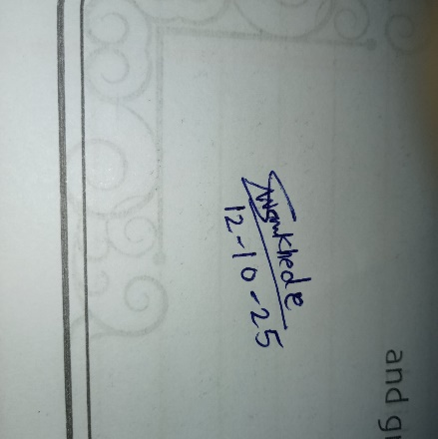
Integrity: I will adhere to the Laboratory Code of Conduct and ethics in its entirety.

Kajal Kushwaha

Name and Signature of Student and Date

Department of Computer Technology

Vision of the Department
To be a well-known centre for pursuing computer education through innovative pedagogy, value-based education and industry collaboration.

Mission of the Department
To establish learning ambience for ushering in computer engineering professionals in core and multidisciplinary area by developing Problem- solving skills through emerging technologies.

Session | 2024-25 (ODD) | Course Name | Lab:Full Stack
Semester | 5 | Course Code | 23-CT1506
Roll No | 09 | Name of Student | Kajal Kushwaha

Practical Number | 3
Course Outcome | Upon successful completion of the course students will be able to:  - Apply OOP concepts to build backend application with database integration.  - Design responsive and interactive user interfaces using frontend technologies.  - Develop full-stack application integrating frontend , backend and database with security.  - Demonstrate ethics, communication, and teamwork in web project development.
Aim | Implemention on use collections and exception handling in Java.
Problem Definition | Problem Statement 1: Creating a simple banking application.  Requirements are  1. Use a HashMap&lt;Integer, Double&gt; to store account details (key = account number,  value = balance).  2. Allow deposit and withdrawal operations.  3. If the withdrawal amount is greater than the available balance, throw an  InsufficientBalanceException.  4. If the account number doesn’t exist, throw an AccountNotFoundException.  5. Display all account details at the end.  Problem Statement 2: Employee Directory System.  Requirements are  1.Use an ArrayList&lt;Employee&gt; where Employee is a class with fields: id, name,  designation.  2.Add new employees to the list.  3. If someone tries to add an employee with a duplicate ID, throw a  DuplicateEmployeeException.  4. Provide a search feature by employee ID; if the ID is not found, throw an  EmployeeNotFoundException.  5.Print all employees at the end.
Theory  (100 words) | Java Collections Framework  The Java Collections Framework provides a standardized architecture for managing groups of objects. Key interfaces are:  - Map: Stores data as key-value pairs (e.g., HashMap for fast lookup).  - List: Stores ordered sequences of elements (e.g., ArrayList for dynamic arrays). Collections simplify common data operations like storage, retrieval, and searching.  Exception Handling  Exception handling is Java's mechanism for managing errors (exceptions) that occur during program execution.  - The try-catch blocks are used to safely execute code that might fail and handle the resulting error.  - Programmers create custom exceptions (by extending Exception or RuntimeException) to define specific, meaningful error conditions tailored to the application logic. This improves code clarity and robustness.
Procedure and Execution  (100 Words) | Algorithm:  BankingApp Algorithm  - Initialization: Create a BankingApp object containing an empty HashMap (accounts) to store <Account Number, Balance>.  - createAccount(number, balance):  - If number exists in accounts, print error.  - Else, add (number, balance) to accounts.  - deposit(number, amount):  - Check: If number not found, throw AccountNotFoundException.  - Else, add amount to the current balance of number.  - withdraw(number, amount):  - Check: If number not found, throw AccountNotFoundException.  - Else:  - If current balance < amount, throw InsufficientBalanceException.  - Else, subtract amount from the current balance of number.  - main Logic:  - Create two accounts (101, 102).  - Execute transactions (deposit, withdraw) inside a try-catch block.  - Catch and print errors for InsufficientBalanceException and AccountNotFoundException.  - Finally, call displayAllAccounts() to list all accounts and their final balances.  Employee Directory Algorithm  - Initialization: Create a static ArrayList (employees) to store Employee objects.  - addEmployee(newEmployee):  - Check: Iterate through employees. If newEmployee.id matches any existing ID, throw DuplicateEmployeeException.  - Else, add newEmployee to the list.  - findEmployeeById(id):  - Search: Iterate through employees. If an employee's ID matches the search id, return that employee.  - If loop completes without a match, throw EmployeeNotFoundException.  - main Logic:  - Try-Catch 1: Call addEmployee for three employees. Catch and report DuplicateEmployeeException when the third employee (ID 101) is added.  - Try-Catch 2: Call findEmployeeById twice (one successful, one unsuccessful). Catch and report EmployeeNotFoundException.  - Call printAllEmployees() to display the final list.
Code:
Code for BankingApp
import java.util.HashMap;
import java.util.Map;
class InsufficientBalanceException extends Exception {
public InsufficientBalanceException(String message) {
super(message);
}
}
class AccountNotFoundException extends Exception {
public AccountNotFoundException(String message) {
super(message);
}
}
public class BankingApp {
private Map<Integer, Double> accounts;
public BankingApp() {
this.accounts = new HashMap<>();
}
public void createAccount(int accountNumber, double initialBalance) {
if (accounts.containsKey(accountNumber)) {
System.out.println("Account with number " + accountNumber + " already exists.");
} else {
accounts.put(accountNumber, initialBalance);
System.out.println("Account " + accountNumber + " created with an initial balance of $" + initialBalance);
}
}
public void deposit(int accountNumber, double amount) throws AccountNotFoundException {
if (!accounts.containsKey(accountNumber)) {
throw new AccountNotFoundException("Account " + accountNumber + " not found.");
}
double currentBalance = accounts.get(accountNumber);
accounts.put(accountNumber, currentBalance + amount);
System.out.println("Deposited $" + amount + " into account " + accountNumber + ". New balance: $" + accounts.get(accountNumber));
}
public void withdraw(int accountNumber, double amount) throws AccountNotFoundException, InsufficientBalanceException {
if (!accounts.containsKey(accountNumber)) {
throw new AccountNotFoundException("Account " + accountNumber + " not found.");
}
double currentBalance = accounts.get(accountNumber);
if (currentBalance < amount) {
throw new InsufficientBalanceException("Insufficient balance in account " + accountNumber + ". Available: $" + currentBalance);
}
accounts.put(accountNumber, currentBalance - amount);
System.out.println("Withdrew $" + amount + " from account " + accountNumber + ". New balance: $" + accounts.get(accountNumber));
}
public void displayAllAccounts() {
System.out.println("\n--- All Account Details ---");
if (accounts.isEmpty()) {
System.out.println("No accounts to display.");
} else {
for (Map.Entry<Integer, Double> entry : accounts.entrySet()) {
System.out.println("Account Number: " + entry.getKey() + ", Balance: $" + entry.getValue());
}
}
}
public static void main(String[] args) {
BankingApp app = new BankingApp();
app.createAccount(101, 500.0);
app.createAccount(102, 1000.0);
try {
app.deposit(101, 200.0);
app.withdraw(102, 300.0);
app.withdraw(101, 800.0); // This will throw an InsufficientBalanceException
} catch (InsufficientBalanceException e) {
System.err.println("Error: " + e.getMessage());
} catch (AccountNotFoundException e) {
System.err.println("Error: " + e.getMessage());
}
app.displayAllAccounts();
}
}

Code for Employee Directory
import java.util.ArrayList;
import java.util.List;
class Employee {
int id;
String name;
String designation;
public Employee(int id, String name, String designation) {
this.id = id;
this.name = name;
this.designation = designation;
}
@Override
public String toString() {
return "ID: " + id + ", Name: " + name + ", Designation: " + designation;
}
}
class DuplicateEmployeeException extends Exception {
public DuplicateEmployeeException(String message) {
super(message);
}
}
class EmployeeNotFoundException extends Exception {
public EmployeeNotFoundException(String message) {
super(message);
}
}
public class EmployeeDirectory {
private static List<Employee> employees = new ArrayList<>();
public static void main(String[] args) {
try {
addEmployee(new Employee(101, "Alice", "Developer"));
addEmployee(new Employee(102, "Bob", "Manager"));
addEmployee(new Employee(101, "Charlie", "Analyst")); // This will cause an exception
} catch (DuplicateEmployeeException e) {
System.err.println("Error: " + e.getMessage());
}
try {
System.out.println("\nFound: " + findEmployeeById(102));
findEmployeeById(103); // This will cause an exception
} catch (EmployeeNotFoundException e) {
System.err.println("Error: " + e.getMessage());
}
printAllEmployees();
}
public static void addEmployee(Employee newEmployee) throws DuplicateEmployeeException {
for (Employee emp : employees) {
if (emp.id == newEmployee.id) {
throw new DuplicateEmployeeException("Employee with ID " + newEmployee.id + " already exists.");
}
}
employees.add(newEmployee);
System.out.println("Added: " + newEmployee.name);
}
public static Employee findEmployeeById(int id) throws EmployeeNotFoundException {
for (Employee emp : employees) {
if (emp.id == id) {
return emp;
}
}
throw new EmployeeNotFoundException("Employee with ID " + id + " not found.");
}
public static void printAllEmployees() {
System.out.println("\n--- All Employees ---");
employees.forEach(System.out::println);
}
}

Output:
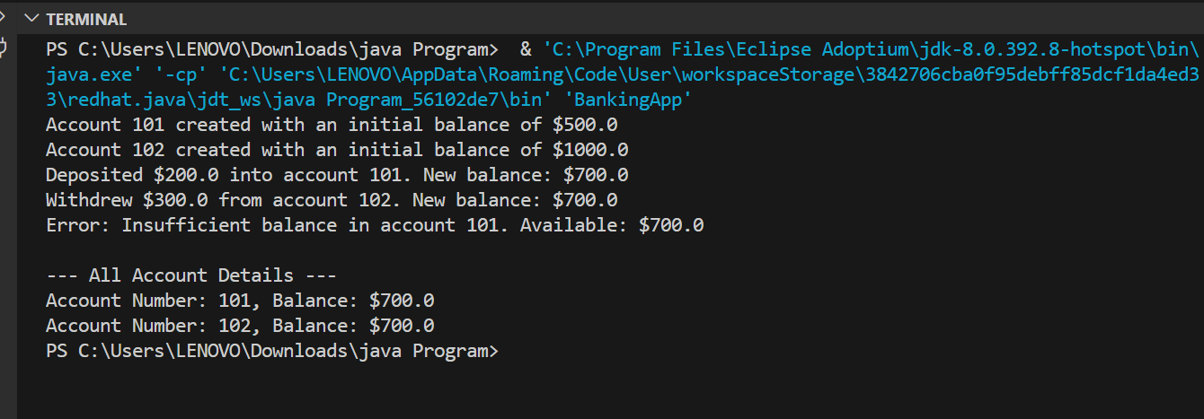
Output for BankingApp

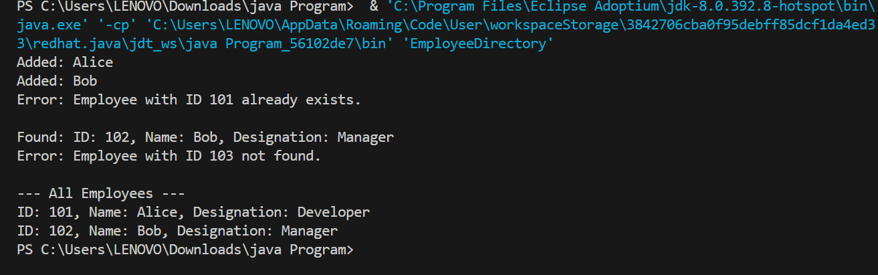
Output for Employee Directory

Output Analysis | Output Analysis of Banking App  The program successfully executes the bank operations and demonstrates exception handling as required:  - Initial Setup: Accounts 101 ($500.0) and 102 ($1000.0) are created.  - Successful Transactions: A deposit ($200.0) is made to 101 (new balance: $700.0), and a withdrawal ($300.0) is made from 102 (new balance: $700.0).  - Exception Triggered: The attempted withdrawal of $800.0 from account 101 fails because the balance is only $700.0. The program successfully catches and prints the InsufficientBalanceException error message.  - Final State: The final account balances are $700.0 for both Account 101 and Account 102. The failed transaction did not affect Account 101's balance.  Output Analysis of Employee Directory  The program successfully demonstrates directory management and custom exception handling:  - Employee Addition: Alice (101) and Bob (102) are added to the directory.  - Duplicate Exception: The attempt to add Charlie (101) fails. The program correctly catches and prints the DuplicateEmployeeException error, ensuring data integrity.  - Search Success: The search for ID 102 is successful, returning Bob's details.  - Search Failure: The search for ID 103 fails. The program correctly catches and prints the EmployeeNotFoundException.  - Final State: The directory accurately contains only the two validly added employees: Alice (101) and Bob (102).
Link of student Github profile where lab assignment has been uploaded | https://github.com/KajalKushwaha01/CT-09_Java_Practical

Department of Computer Technology

Vision of the Department
To be a well-known centre for pursuing computer education through innovative pedagogy, value-based education and industry collaboration.

Mission of the Department
To establish learning ambience for ushering in computer engineering professionals in core and multidisciplinary area by developing Problem- solving skills through emerging technologies.

Conclusion | I have executed the above practical successfully.
Plag Report (Similarity index < 12%) | Plag report for Banking App  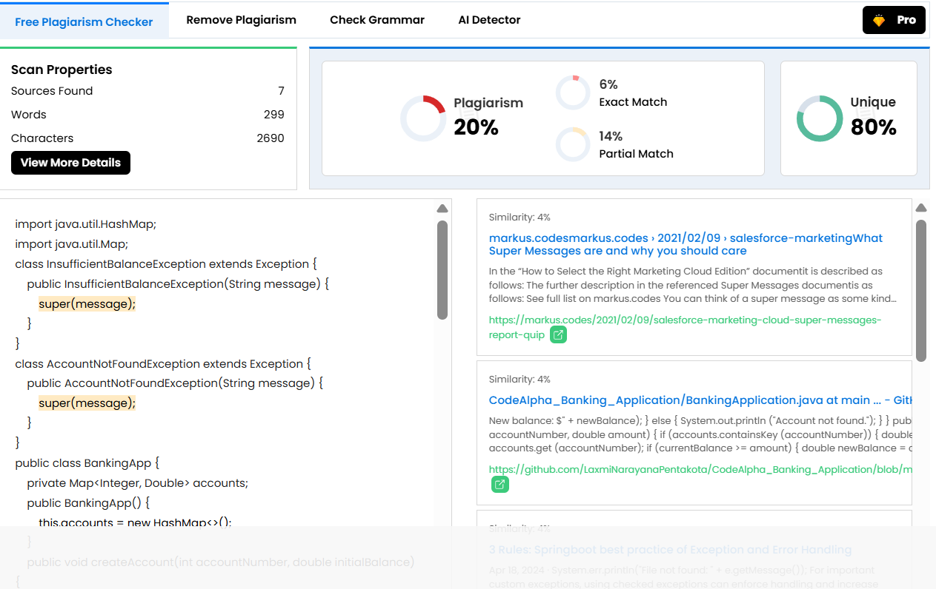  Plag Report for Employee directory  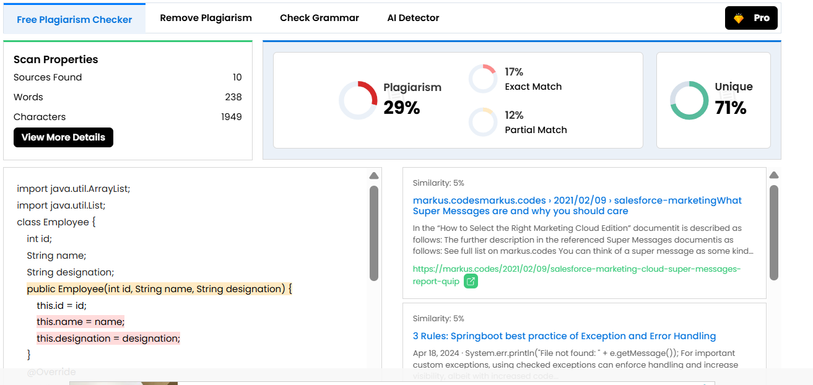
Date | 12-10-2025

