Department of Computer Technology

Vision of the Department
To be a well-known centre for pursuing computer education through innovative pedagogy, value-based education and industry collaboration.

Mission of the Department
To establish learning ambience for ushering in computer engineering professionals in core and multidisciplinary area by developing Problem- solving skills through emerging technologies.

Session 2025-2026
Mission: Means to achieve Vision
Vision: Dream of where you want.

Program Educational Objectives of the program (PEO): (broad statements that describe the professional and career accomplishments)
PEO1 | Preparation | P: Preparation | Pep-CL abbreviation  pronounce as Pep-si-lL easy to recall
PEO2 | Core Competence | E: Environment (Learning Environment)
PEO3 | Breadth | P: Professionalism
PEO4 | Professionalism | C: Core Competence
PEO5 | Learning  Environment | L: Breadth (Learning in diverse areas)

Program Outcomes (PO): (statements that describe what a student should be able to do and know by the end of a program)

Keywords of POs:
Engineering knowledge, Problem analysis, Design/development of solutions, Conduct Investigations of Complex Problems, Engineering Tool Usage, The Engineer and The World, Ethics, Individual and Collaborative Team work, Communication, Project Management and Finance, Life-Long Learning

PSO Keywords: Cutting edge technologies, Research

“I am an engineer, and I know how to apply engineering knowledge to investigate, analyse and design solutions to complex problems using tools for entire world following all ethics in a collaborative way with proper management skills throughout my life.” to contribute to the development of cutting-edge technologies and Research.
Integrity: I will adhere to the Laboratory Code of Conduct and ethics in its entirety.


Kajal Kushwaha
12-10-25

Name and Signature of Student and Date

Department of Computer Technology

Vision of the Department
To be a well-known centre for pursuing computer education through innovative pedagogy, value-based education and industry collaboration.

Mission of the Department
To establish learning ambience for ushering in computer engineering professionals in core and multidisciplinary area by developing Problem- solving skills through emerging technologies.

Session | 2025-26 (ODD) | Course Name | FSD Lab
Semester | 5 | Course Code | 23-CT1506
Roll No | 21 | Name of Student | Shivani Wankhede

Practical Number | 1
Course Outcome | Upon successful completion of the course students will be able to:  - Apply OOP concepts to build backend application with database integration.  - Design responsive and interactive user interfaces using frontend technologies.  - Develop full-stack application integrating frontend , backend and database with security.  - Demonstrate ethics, communication, and teamwork in web project development.
Aim | Introduction to java and implement basic java programs(loops, conditionals, array)
Problem Definition | .Problem Statement 1: Lottery  Develop a program to play lottery.the program randomly generates a lottery of a two-digit number ,prompts the user to enter a two-digit number, and determines whether the user wins according to the following rules:  1.If the user input matches the lottery number in the exact order, the award is $10,000.  2.If all digits in the user input match all digits in the lottery number, the award is $3,000.  3.If one digit in the user input matches a digit in the lottery number ,the award is $1,000.  Problem Statement 2: Computing Body Mass Index  Write a program that prompts the user to enter a weight in pounds and height in inches and displays the BMI.  * One pound is 0.45359237 kilograms, one inch is 0.0254 meters.  1.It can be calculated by taking your weight in kilograms and dividing it by the square of your height  in meters.  2.The interpretation of BMI for people 20 years or older is as follows:  BMI Interpretation  BMI<18.5 Underweight  18.5<=BMI<25.0 Normal  25.0<=BMI<30.0 Overweight  30.0<=BMI Obese
Theory  (100 words) | Java is a high-level, class-based, object-oriented programming language designed to have as few implementation dependencies as possible. It's a general-purpose language known for its "write once, run anywhere" (WORA) principle, meaning compiled Java code can run on any platform that supports Java without the need for recompilation. Developed by James Gosling at Sun Microsystems, Java is used for building a vast range of applications, including web apps, mobile apps (Android), and enterprise software. Its key features include automatic memory management (garbage collection), strong typing, and a rich standard library.  Conditionals  Conditionals are used to execute a block of code only if a specific condition is met. The most common conditional statements in Java are if, else if, and else.  Example: This program checks if a number is positive, negative, or zero.  Java is a high-level, class-based, object-oriented programming language designed to have as few implementation dependencies as possible. It's a general-purpose language known for its "write once, run anywhere" (WORA) principle, meaning compiled Java code can run on any platform that supports Java without the need for recompilation. Developed by James Gosling at Sun Microsystems, Java is used for building a vast range of applications, including web apps, mobile apps (Android), and enterprise software. Its key features include automatic memory management (garbage collection), strong typing, and a rich standard library.  Conditionals  Conditionals are used to execute a block of code only if a specific condition is met. The most common conditional statements in Java are if, else if, and else.  Example: This program checks if a number is positive, negative, or zer  Loops  Loops are used to execute a block of code repeatedly as long as a certain condition is true. The most common types of loops in Java are for, while, and do-while.  Example: This program uses a for loop to print numbers from 1 to 5.  Arrays  An array is a data structure that stores a collection of elements of the same data type in a contiguous memory location. Elements are accessed using an index, which starts from 0.  Example: This program declares an array, initializes its elements, and then iterates through the array to print each element.
Procedure and Execution  (100 Words) | Algorithm:  Algorithm for the Lottery Game  - Generate a Random Number: Create a random two-digit number between 10 and 99, and store it as the lottery number. 🎲  - Get User Input: Prompt the user to enter a two-digit number and store it as their guess.  - Extract Digits:  - Separate the first and second digits of the lottery number.  - Separate the first and second digits of the user's guess.  - Check for Matches and Award Prizes:  - If the guess is an exact match for the lottery number, award $10,000.  - Else if the guess digits are the reverse of the lottery digits (e.g., lottery is 25, guess is 52), award $3,000.  - Else if any single digit of the guess matches a single digit in the lottery number, award $1,000.  - Otherwise, no prize is awarded.  - End Program: Close the scanner and terminate the program.  Algorithm for computing Body Mass Index  - Start: Initialize a Scanner object to receive user input.  - Input: Prompt the user to enter their weight in pounds and height in inches. Store these values.  - Convert: Convert the weight from pounds to kilograms and the height from inches to meters.  - Calculate BMI: Use the formula BMI=height(m)2weight(kg)​ to compute the BMI.  - Display: Print the calculated BMI, formatted to two decimal places.  - Interpret: Use a series of if-else if-else statements to categorize the BMI:  - Underweight: BMI < 18.5  - Normal: 18.5 <= BMI < 25.0  - Overweight: 25.0 <= BMI < 30.0  - Obese: BMI >= 30.0  - End: Close the Scanner object and terminate the program.
Code:
Code for Lottery Game
import java.util.Scanner;

public class LotteryGame {
public static void main(String[] args) {
int lottery = (int)(Math.random() * 90) + 10;

Scanner input = new Scanner(System.in);
System.out.print("Enter a two-digit number: ");
int guess = input.nextInt();

int lot_digit1 = lottery / 10;
int lot_digit2 = lottery % 10;

int guessDigit1 = guess / 10;
int guessDigit2 = guess % 10;

System.out.println("Lottery number: " + lottery);

if (guess == lottery) {
System.out.println("Exact match: you win $10,000");
} else if ((guessDigit1 == lot_digit2 && guessDigit2 == lot_digit1)) {
System.out.println("Match all digits: you win $3,000");
} else if (guessDigit1 == lot_digit1 || guessDigit1 == lot_digit2 ||
guessDigit2 == lot_digit1 || guessDigit2 == lot_digit2) {
System.out.println("Match one digit: you win $1,000");
} else {
System.out.println("Sorry, your entered number doesn't match with lottery number.");
}

input.close();
}
}
Code for computing Body Mass Index

import java.util.Scanner;

public class BMICalculator {
public static void main(String[] args) {
Scanner input = new Scanner(System.in);

System.out.print("Enter your weight in pounds: ");
double weightPounds = input.nextDouble();

System.out.print("Enter your height in inches: ");
double heightInches = input.nextDouble();

double weightKg = weightPounds * 0.45359237;
double heightMeters = heightInches * 0.0254;

double bmi = weightKg / (heightMeters * heightMeters);

System.out.printf("Your BMI is: %.2f\n", bmi);

if (bmi < 18.5) {
System.out.println("Interpretation: Underweight");
} else if (bmi < 25.0) {
System.out.println("Interpretation: Normal");
} else if (bmi < 30.0) {
System.out.println("Interpretation: Overweight");
} else {
System.out.println("Interpretation: Obese");
}

input.close();
}
}

Output:
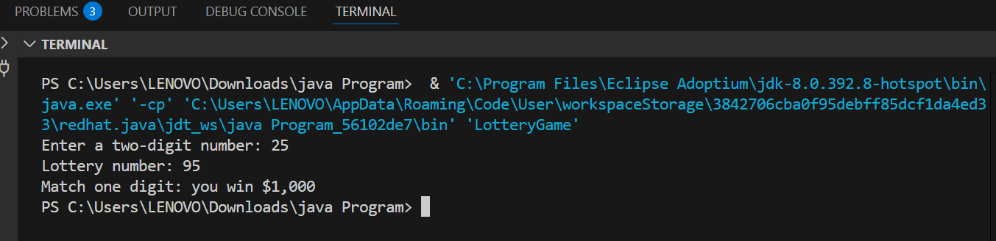
Output for Lottery Game

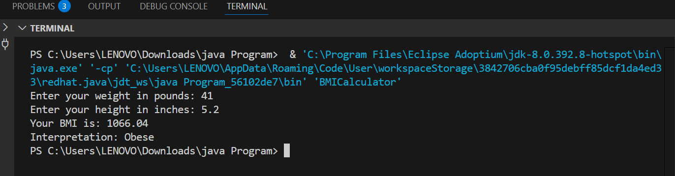
Output for Computing Body Mass Index

Output Analysis | Output Analysis of Lottery Game  • The program generated a random lottery number: 95.  • The user entered a guess: 25.  • The program compared the user's guess to the lottery number.  • The guess 25 has a digit, 5, that matches a digit in the lottery number 95.  • Based on the if-else if logic in the code, this single-digit match resulted in a prize of $1,000.  • The output Match one digit: you win $1,000 confirms this outcome.  Output Analysis of Computing Body Mass Index  • The user entered a weight of 41 pounds.  • The user entered a height of 5.2 inches.  • The program calculated the BMI using these values. The calculated BMI is 1066.04.  • This BMI value is exceptionally high, which is likely due to an error in the user input for height. A height of 5.2 inches is extremely short. It seems the user might have intended to enter a height of 5 feet 2 inches, which is 62 inches.  • Based on the program's logic, a BMI of 1066.04 falls into the Obese category, as it's well above the threshold of 30.0. The program correctly applies its interpretation logic to the provided, albeit illogical, input.
Link of student Github profile where lab assignment has been uploaded

Department of Computer Technology

Vision of the Department
To be a well-known centre for pursuing computer education through innovative pedagogy, value-based education and industry collaboration.

Mission of the Department
To establish learning ambience for ushering in computer engineering professionals in core and multidisciplinary area by developing Problem- solving skills through emerging technologies.

Conclusion | I have executed the above practical successfully.
Plag Report (Similarity index < 12%) | 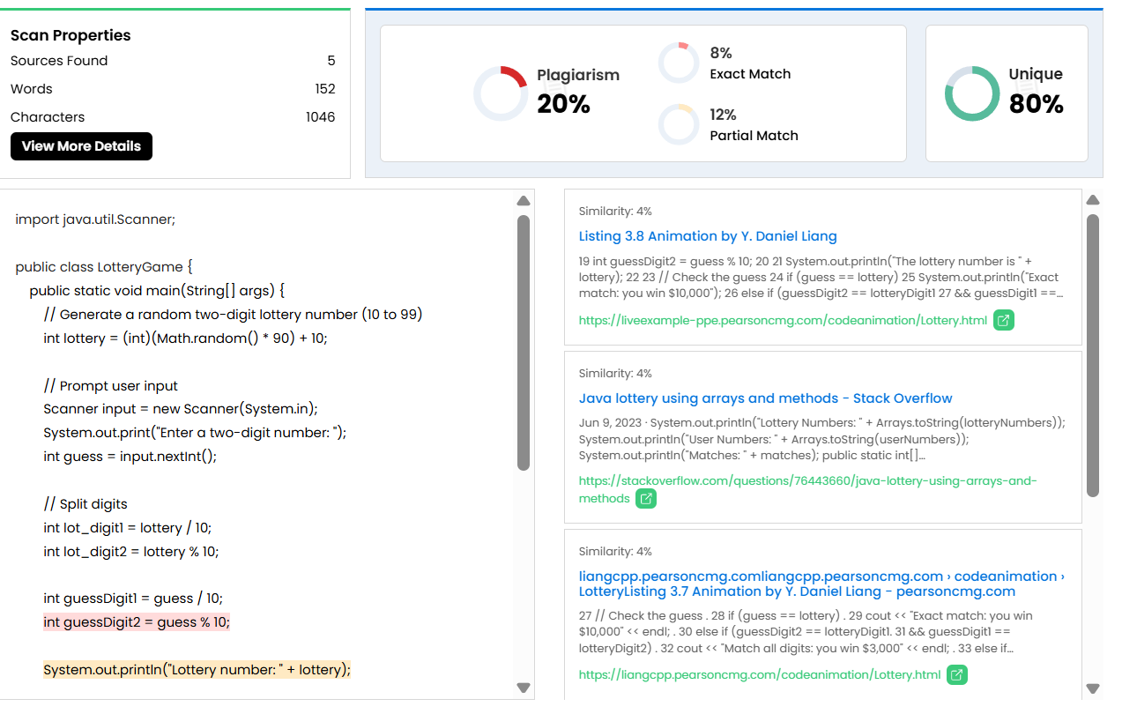  Plag Report for Lottery Game  Plag Report for  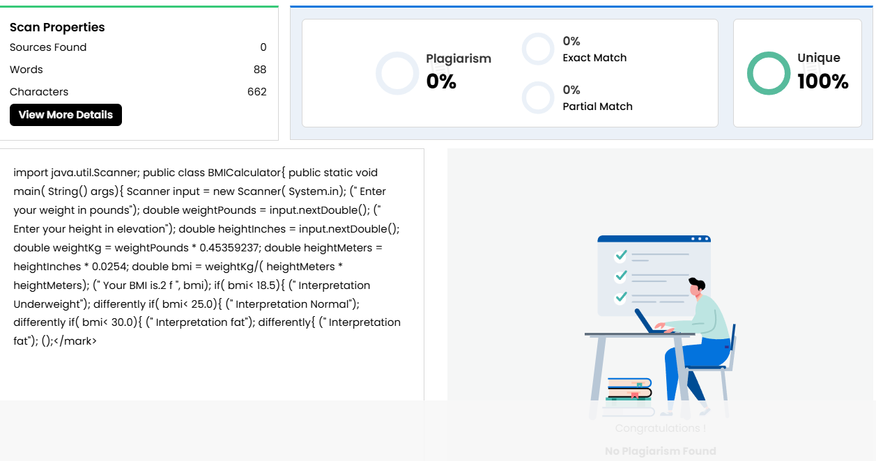
Date | 12-10-2025

