**Assignment 3 – Summary Report**

**GitHub Repo link:** <https://github.com/KajalMittal01/Titanic_A3>

**Determine if the survival rate is associated to the class of passenger:**

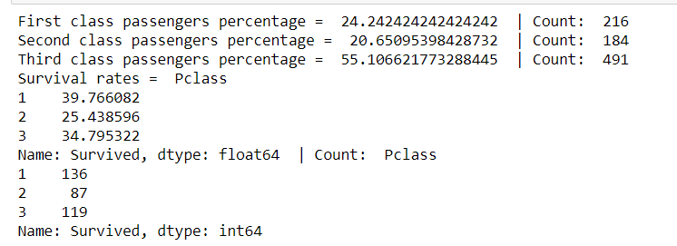

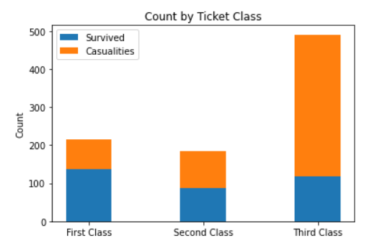

First Class represents approximate 24% passengers and approx. 40% of survivors.

Second Class represents approx. 20% passengers and ~25% of survivors.

Third Class represents ~ 55% passengers and ~ 34% of survivors.

We can see that there is a clear correlation between death and ticket class: the higher the ticket class, the higher the chances of survival.

**Chi-Square Analysis Result:**



P-value is less than 0.05, hence we have to reject the null hypothesis, which means there is a positive relationship between Survival and Pclass variables.

**Determine if the survival rate is associated to the gender:**

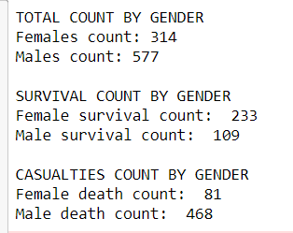

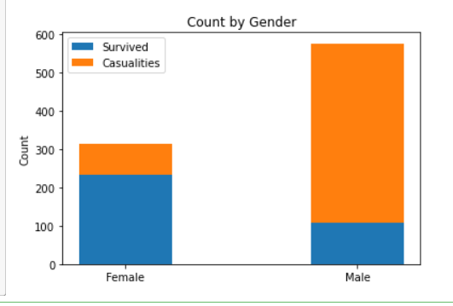

According to above analysis it is clear that women had a higher chance of survival than men. Let’s verify this by using Spearman’s correlation between Survival and Gender.

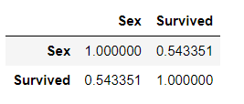

Co-relation value is coming as “0.54” which is also suggesting that there is a positive and moderate correlation between Sec and Survival.

**Chi-Square Analysis Result:**

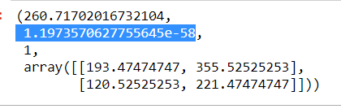

P-value is less than 0.05, hence we have to reject the null hypothesis, which means there is a positive relationship between Survival and Gender variables.

**Determine the survival rate is associated to the age:**

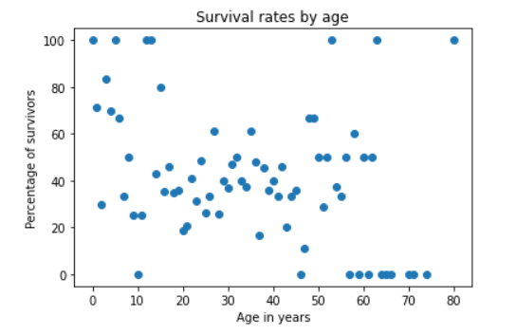

We can interpret from the scatterplot above that younger people have more chances to survive than older because higher Y values have lower X values.