Assignment-01

1. To list all records with sal > 2000 and comm>200

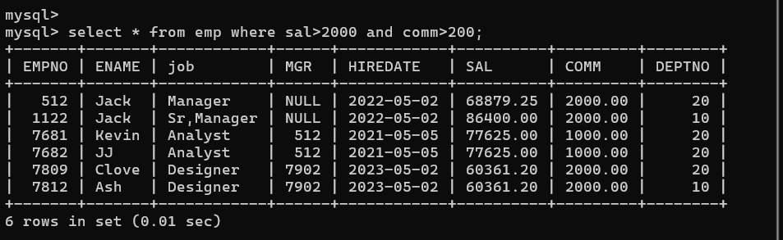

1. To list all record with job=’Clerk’ or sal>2000

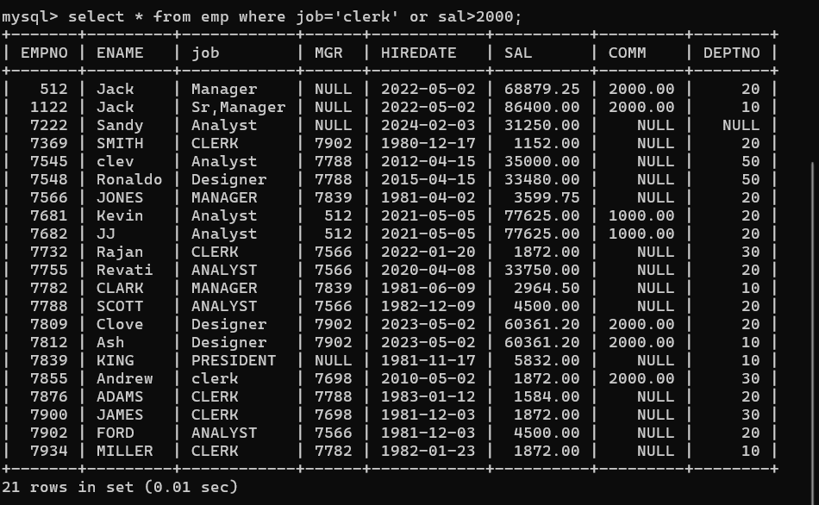

1. To list all the record with sal=1250 or 1100 or 2850

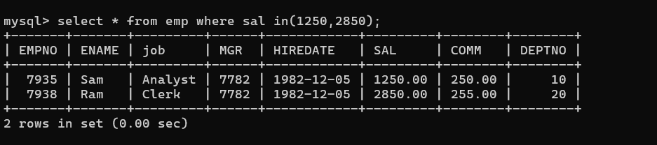

1. To list all employees with sal>1250 and <2850

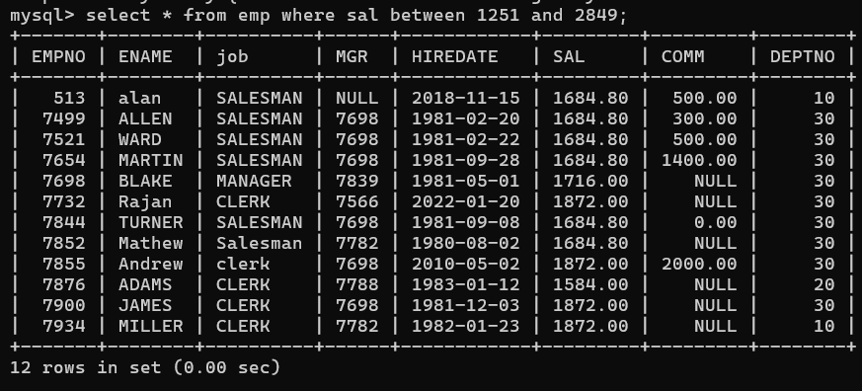

5. To list all employees with name ends with AS

Answer:: **select * from emp where ename like ‘%AS’;**

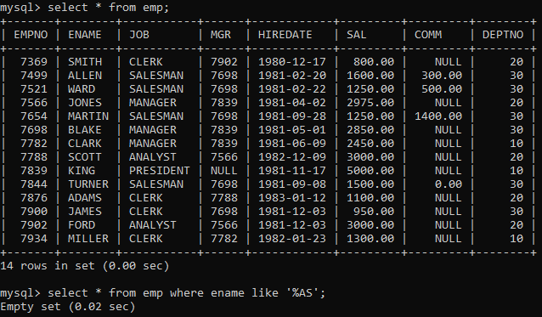

6. To list all employees with job starts with C and ends with K

Answer :: **select *from emp where job like ‘C%K’;**

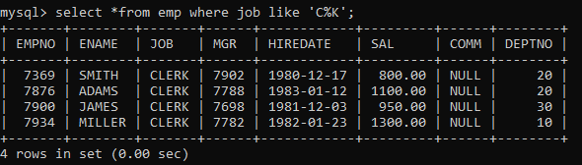

7. To list all employees with job contains L at third position and M at third last position

Answer :: **select *from emp where job like ‘__L%M__’;**

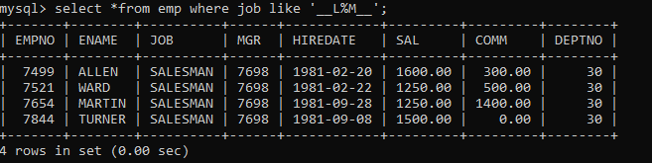

10. To list all employees with job starts with C , E at 3rd position and ends with K

Answer :: **select * from emp where job like ‘C_E%K’;**

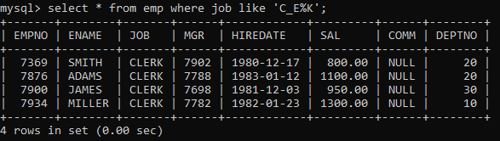

12. To list all employees with sal is null and name starts with ‘S’

Answer :: **select *from emp where sal is null and ename like ‘S%’;**



13. To list all employees with job contains 5 characters

Answer :: **select *from emp where job REGEXP ‘^.{5}$’;**

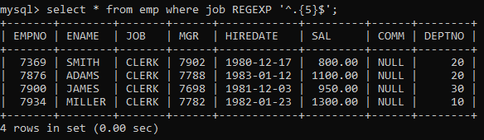

**Select *from emp where job like ‘_____’;**

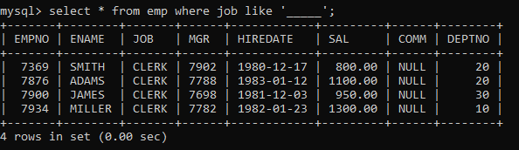

14. To list all employees with name contain ‘A’ at 1 position and job Contains 5 characters

Answer :: **select *from emp where ename like ‘A%’ and job like ‘_____’;**

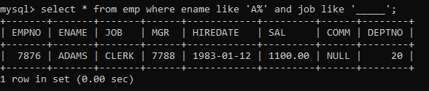

Q2. Solve the following

1. Retrieve the details (Name, Salary and dept no) of the emp who are working in department code 20, 30 and 40.

Answer :: **select ename,sal,deptno from emp where deptno in(20,30,40);**

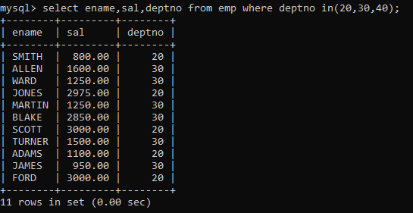

1. Display the total salary of all employees . Total salary will be calculated as sal+comm+sal*0.10

Answer :: **select sal,empno,comm,sal+comm+sal*0.10 netsalary from emp;**

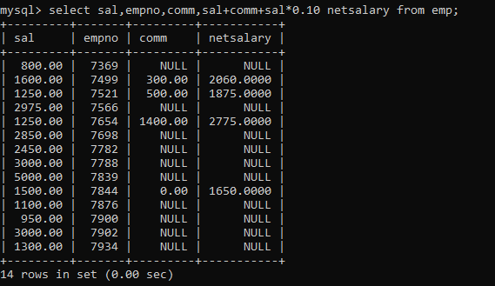

**Select sal,empno,comm,sal+ifnull(comm,0)+sal*0.10 netsalary from emp;**

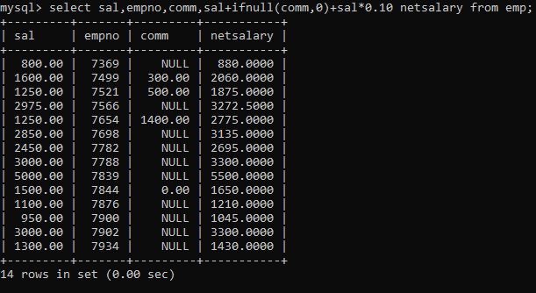

1. List the Name and job of the emp who have joined before 1 jan 1986 and whose salary range is between 1200and 2500. Display the columns with user defined Column headers

Answer :: **select ename,job,hiredate date,sal salary from emp where hiredare<’1986-01-01’ and sal between 1200 and 2500;**

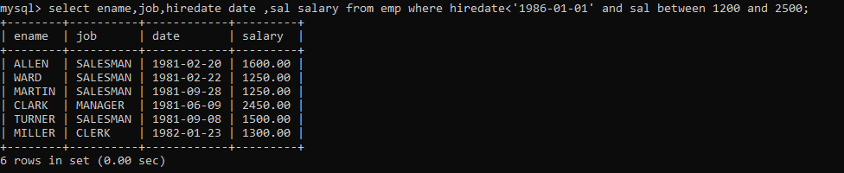

1. List the empno, name, and department number of the emp works under manager with id 7698

Answer :: **select empno,enmae,mgr,deptno from emp where mgr = 7698;**

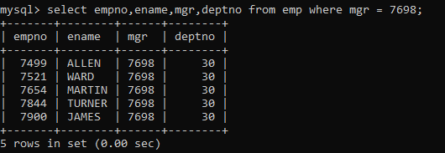

1. List the name, job, and salary of the emp who are working in departments 10 and 30.

Answer :: **select ename,job,sal,deptno from emp where dept in(10,30);**

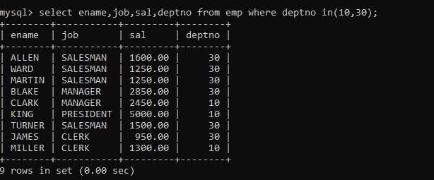

1. Display name concatenated with dept code separated by comma and space. Name the column as ‘Emp info

Answer:: **select ename, deptno,concat_ws(“, ”,ename,deptno) EmpInfo from emp;**

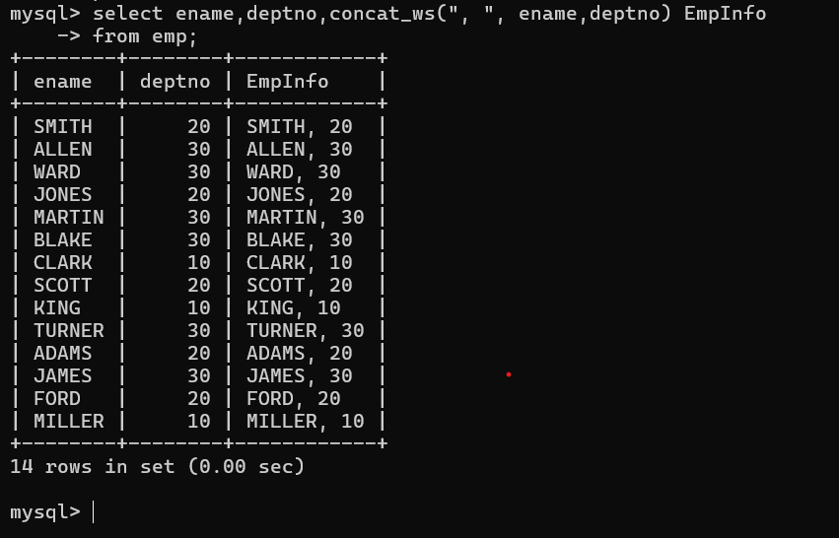

1. Display the emp details who do not have manager.

Answer :: **select *from emp where mgr is null;**

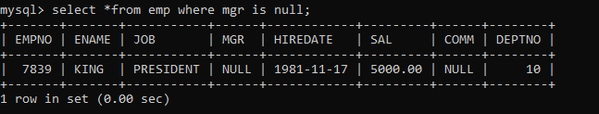

1. Write a query which will display name, department no and date of joining of all employee who were joined January 1, 1981 and March 31, 1983. Sort it based on date of joining (ascending).

Answer :: **select ename,deptno,hiredate from emp where hiredate between ‘1981-01-01’ and ‘1983-03-31’ order by hiredate;**

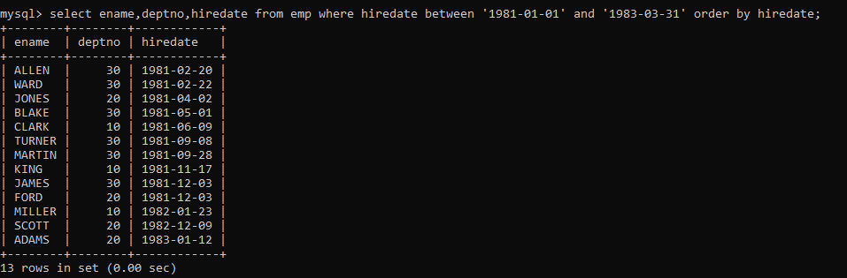

1. Display the employee details where the job contains word ‘AGE’ anywhere in the Job

Answer :: **select * from emp where job REGEXP ‘^.*[AGE].*$;’**

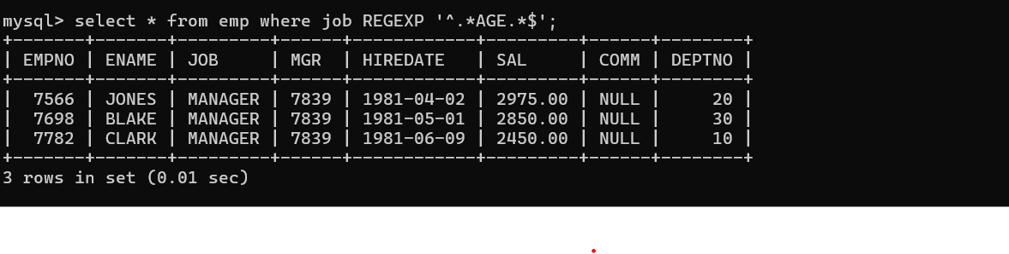

11.List the details of the employee , whose names start with ‘A’ and end with ‘S’ or whose names contains N as the second or third character, and ending with either ‘N’ or ‘S’.

select * from emp where ename like ‘A%S’ or ename like ‘_N%N’ or ename like ‘_N%S’ or ename like ‘__N%N’ or ename like ‘__N%S’

or select * from emp where ename REGEXP ‘^A.*S$| ^..?N.*[NS]$‘

Answer:: **select * from emp where ename like ‘A%S’ or ename like ‘_N%N’ or ename like ‘_N%S’;**

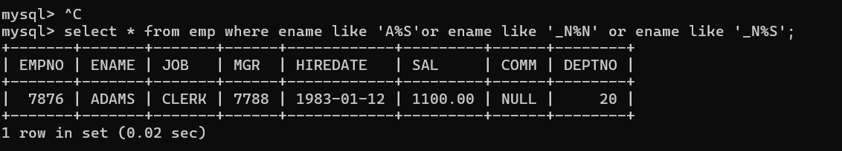

Answer::**select * from where ename REGEXP ‘^A.*S$| ^..?N.*[NS]$‘;** 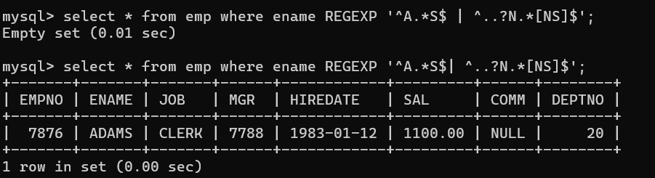

12. List the names of the emp having ‘_’ character in their name

Answer:: **select * frm emp where ename like ‘%\_%’;**

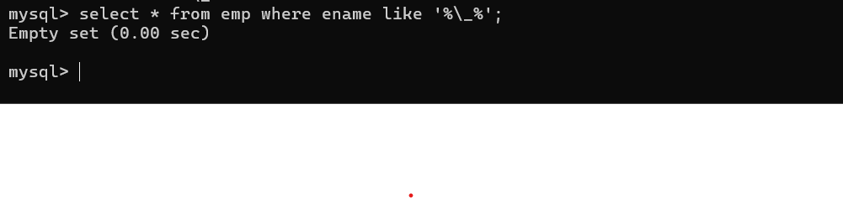

Group functions

6. Display the Highest, Lowest, Total & Average salary of all employee. Label the columns Maximum, Minimum, Total and Average respectively for each Department. Also round the result to the nearest whole number.

Answer:: select deptno,round(sum(sal)) total, round(avg(sal)) Average, round(max(sal)) Maximum, round(min(sal)) Minimum

From emp

group by deptno;

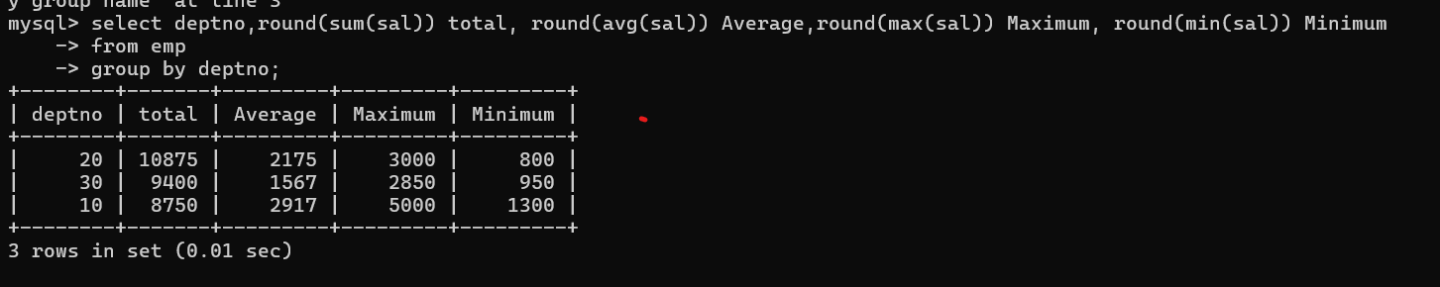

7.Display Department no and number of managers working in that department. Label the column as ‘Total Number of Managers’ for each department.

Answer:: **select deptno,count(mgr) from emp**

**Group by deptno;**

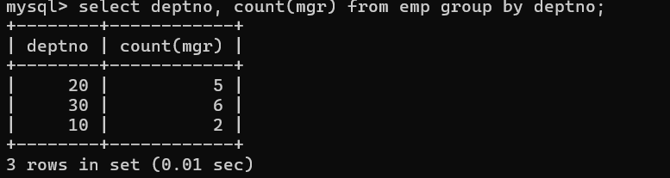

8. Get the Department number, and sum of Salary of all non managers where the sum is greater than 2000.

Answer:: select deptno, sum(sal) from emp where job!= ‘manager’

group by deptno

having sum(sal)>2000;

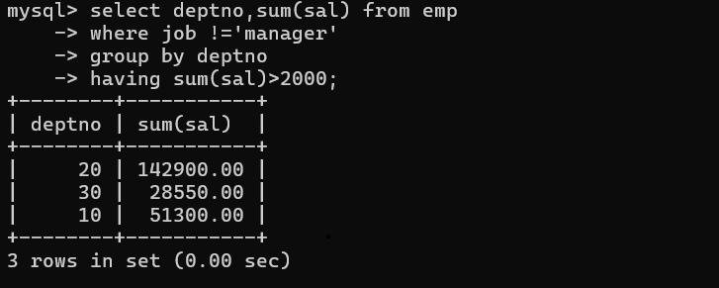

Single Row functions

1.To list all employees and their email, to generate email use 2 to 5 characters from ename Concat it with 2 to 4 characters in job and then concat it with ‘@mycompany.com

Answer:: **select empno,ename,job,concat(substr(ename,2,5),’.’,substr(job,2,4),’@mycompany.com’**

**from emp;**

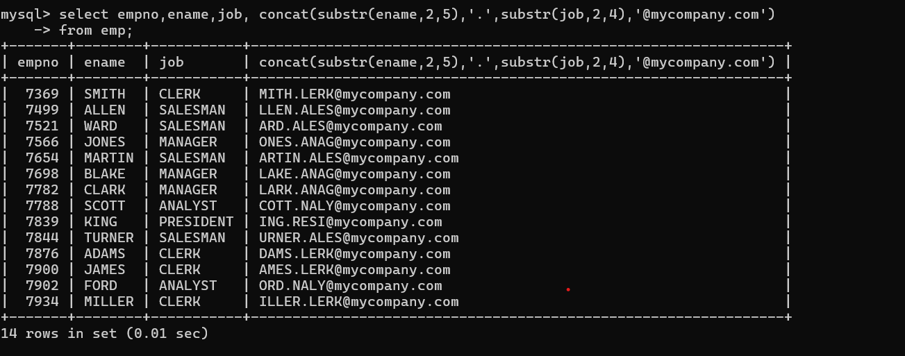

2. List all employees who joined in September.

Answer:: **select empno,ename,hiredate,extract(month from hiredate)**

**from emp -> where extract(month from hiredate)=9 ;**

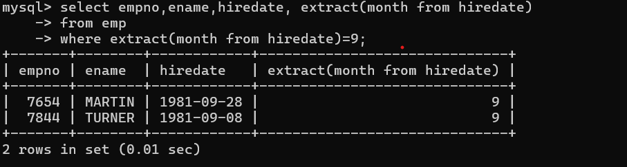

3.List the empno, name, and department number of the emp who have experience of 18 or more years and sort them based on their experience.

Answer:: select empno,ename,deptno,hiredate,floor(datediff(curdate(),hiredate)/365) Expereince

From emp

having >18

order by Expereince desc;

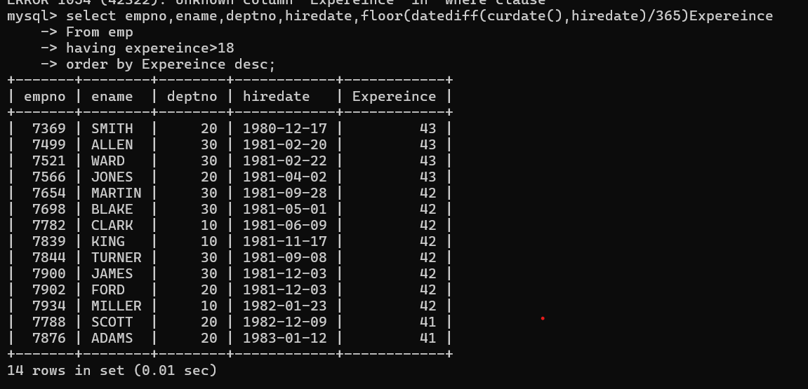

4. Display the employee details who joined on 3rd of any month or any year

Answer:: select empno,ename,deptno,hiredate, extract(day from hiredate)

-> from emp

-> where extract(day from hiredate)=3;

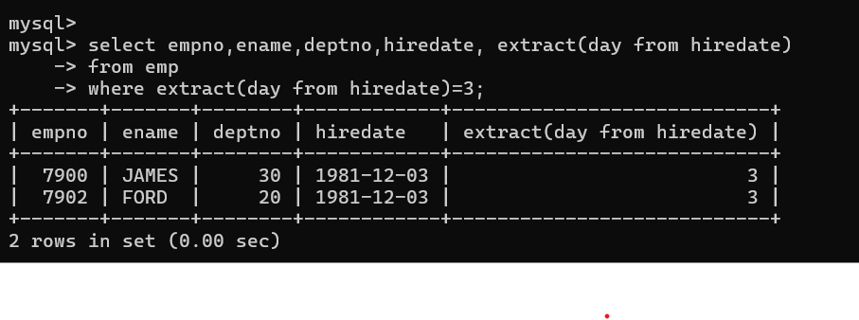

5. display all employees who joined between years 1981 to 1983.

Answer:: **select empno,ename,hiredate,extract(year from hiredate)**

**from emp**

**where extract(year from hiredate) between 1981 and 1983;**

