**ONLINE RAILWAY RESERVATION SYSTEM**

Low level Design (LLD)

**Project Members**

|  |
| --- |
| Kajal Bhausaheb Shinde |

# Table of Content

|  |  |  |
| --- | --- | --- |
| **SR No.** | **Title** | **Page No.** |
| Chapter 1 | **INTRODUCTION** | 4 |
| 1.1 | Document Purpose | 4 |
| 1.2 | Overview | 4 |
| 1.3 | Intended Audience | 4 |
| 1.4 | Problem Statement | 5 |
| Chapter 2 | **REQUIREMENTS** | 6 |
| 2.1 | Hardware Requirements | 6 |
| 2.2 | Software Requirements | 6 |
| 2.3 | Technology Used | 7 |
| Chapter 3 | **UML DIAGRAM** | 9 |
| 3.1 | Use Case Diagram | 9 |
| 3.2 | Database Diagram | 10 |
| 3.3 | Sequence Diagram | 11-12 |
| 3.4 | Activity Diagram | 13-14 |

## INTRODUCTION

### Document Purpose

Railway Reservation System has various kinds of information that helps regarding booking of railway tickets.

This system contains the information about the passenger.

Users will be able to search the train, train fare, arrival and departure time of the train and they can also book the ticket by using online payment and after booking the ticket if the user wants to cancel the ticket, they can cancel that ticket.

### Overview

This system is designed for the online reservation of railway tickets for travel between any destinations.

This system enables the Advance booking in general and lady’s quota, on payment of fare in full for adults and children, a maximum of six seats at a time, for journey between any two stations served by a train.

### Intended Audience

This document is intended as a reference for the following roles and stakeholders who are interested in the Railway Reservation System technical architecture.

|  |  |
| --- | --- |
| **ROLE** | **NATURE OF ARCHITECTURE** |
| PASSENGER | The person to whom our services would be directly provided to. |
| ADMIN | The person who would be responsible for smooth functioning of the system. |

### Problem Statement

The need of this system arises because as is the known fact that India has the largest railway network and to handle it manually is quite a tough job.

By computerizing it, we will be able to overcome many of its limitations such as we can manage passenger record in database instead of hardcopy and will be able to make it more efficient. As we all know, if we want to book a railway ticket. We heaved to go the station stand in that queue, which leads to wastage of time.

With the help of online railway reservation system, we can book ticket online and can save our time.

## Requirements

### Hardware Requirements

* Operating Systems- Windows, macOS, Linux, Chrome OS
* Windows 8.0, 8.1 and 10, 11 (32-bit and 64-bit)
* Random Access Memory (RAM) - 1 GB RAM minimum; 8 GB RAM recommended.
* 1.6 GHz or faster processor.
* Internet Connection (20MBps or above)

### Software Requirements

* Microsoft Windows XP or later versions ▪ A standard web browser.
* .Net framework.
* Visual Studio Code above 2014

### Technology Used

Technologies which are going to use in this Application are as follows:

* **HTML** - HyperText Markup Language is a markup language with the help of that we can give the structure to our application.

* **CSS** - CSS is a style sheet language responsible for the presentation of documents written in a markup language, CSS is use for designing purpose in our application.

* **Bootstrap -** Bootstrap is a free, open-source front-end development framework for the creation of websites and web apps.

* **C#** - It is an object-oriented programming language provided by Microsoft that runs on .Net Framework. For logical purpose we use C# in our application.

* **ASP .NET** **MVC** - The MVC (Model-View-Controller) is an application development pattern or design pattern which separates an application into three main components. Model, View, Controller.

* **Asp .Net Web API -** ASP.NET Web API is a framework that helps you to build services by making it easy to reach a wide range of clients including browsers, mobiles, tablets, etc. It is a framework for building HTTP services.

* **Entity Framework -** Entity Framework is an open-source ORM (Object

Relational Mapping) Framework for the .NET applications supported by Microsoft. It enables the developers to work with the data using the objects of domain-specific classes. Entity Framework can generate the necessary database commands for reading or writing the data in the database and execute them for us.

* **SQL -** SQL (Structured Query Language) is used to perform operations on the records stored in the database, such as updating records, inserting records, deleting records, creating, and modifying database tables, views, etc.
* **Asp.Net Core –** Is   a cross-platform, high-performance, open-source framework for building modern, cloud- enabled, internet-connected apps. With Asp.net Core, we can build web apps and services, internet of things (IOT) apps, and mobile backends. Just like Asp. Net , Asp.Net Core is based on the Model-View-Controller Framework.it supports modular architecture better than Asp.Net does. Asp.Net core is the latest version of Asp.Net, and it includes many improvements over ASP.NET MVC.
* **Angular -**Angular is a client-side JavaScript-based framework that follows the Mvc (model view controller) architectural pattern which is originally founded and maintained by Google but now it’s open-source so anyone can contribute to it. The updated Angular project template provides a convenient starting point for Asp.Net Core apps using Angular and the Angular CLI to implement a rich, client-side user interface (UI).
* **Node JS –** Nodejs is a run time environment that allows us to load JavaScript application into the server directly. NodeJS takes part in loading the AngularJS application with all the dependencies, such as CSS files and JS files in the browser. For loading all the assets of Angular and accepting all the API calls from the Angular JS applications, NodeJS is generally used as Web server.

## UML Diagram

### Use Case Diagram

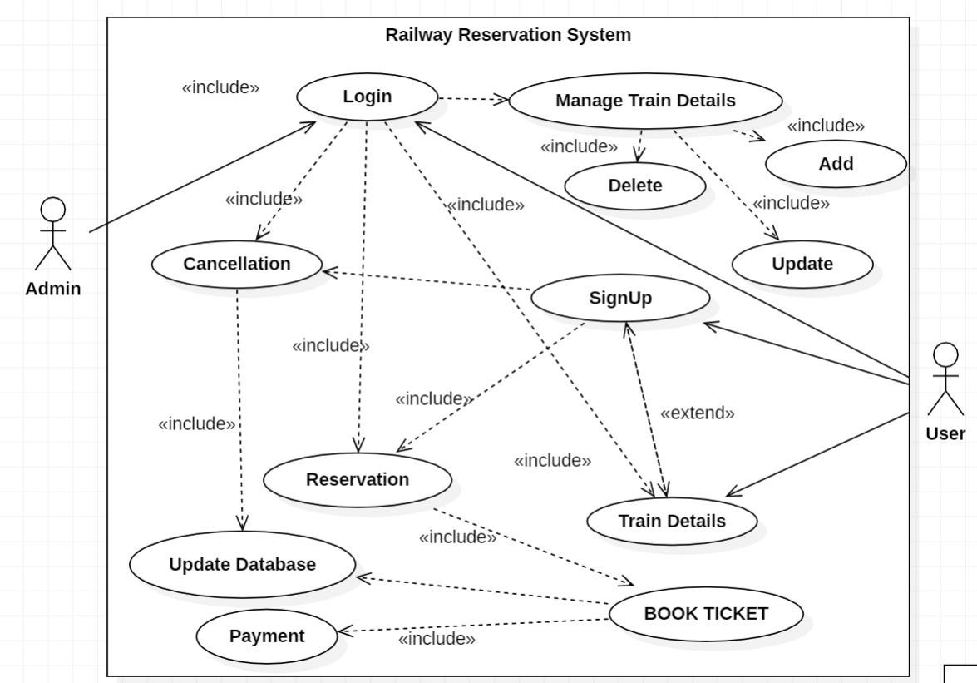

### Database Schema

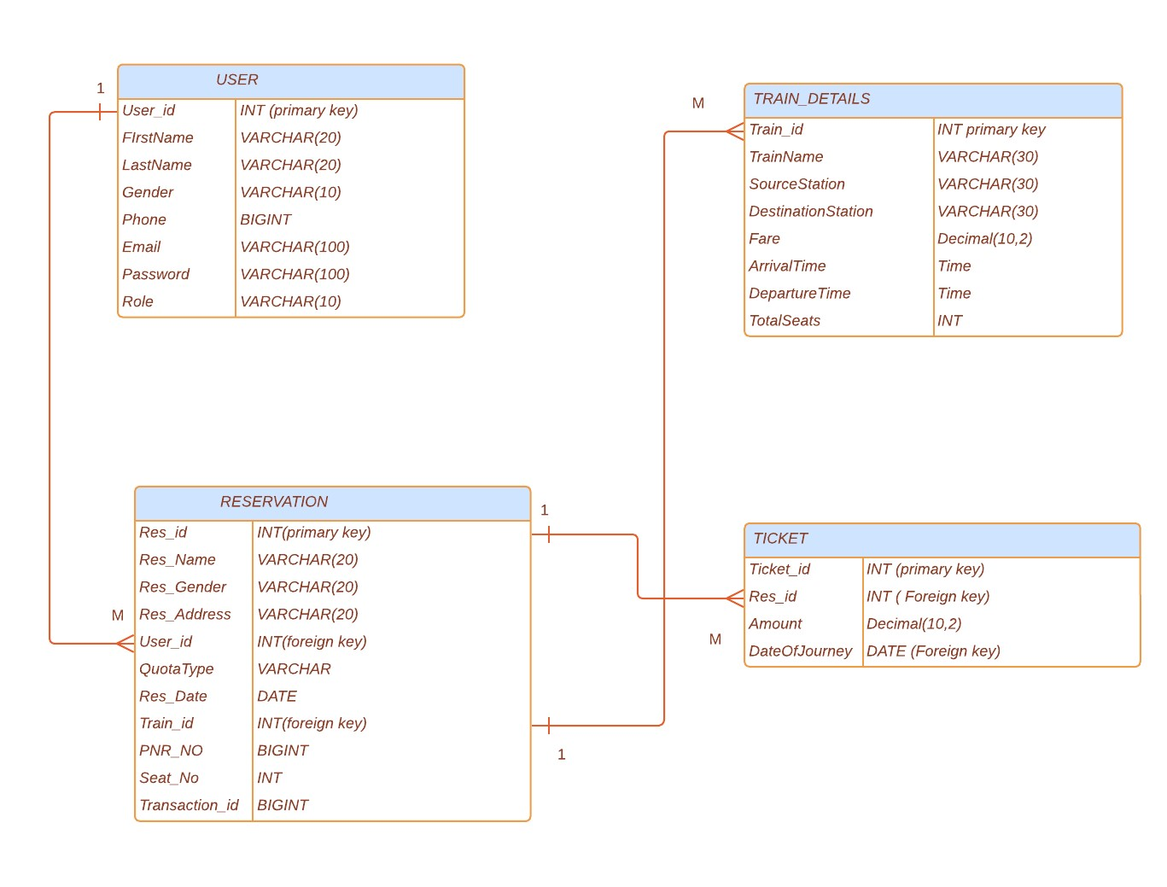

### Sequence Diagram

#### User Sequence Diagram

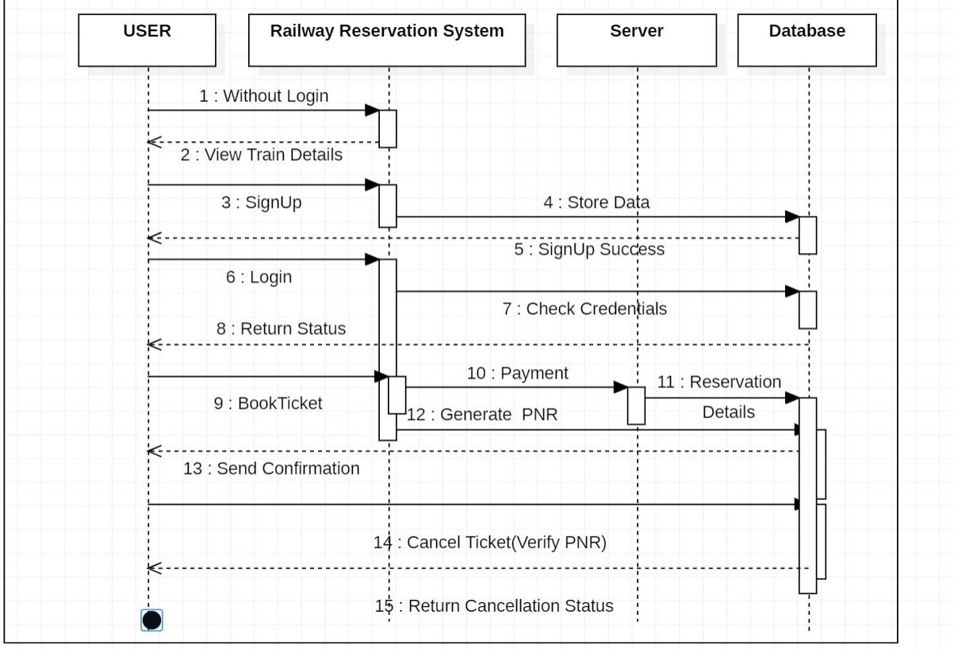

#### Admin Sequence Diagram

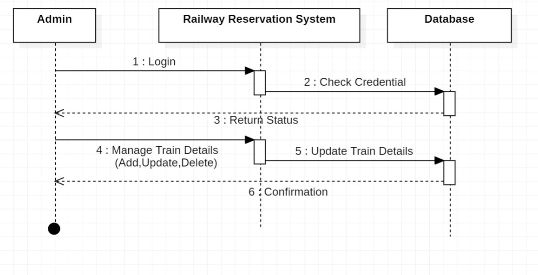

#### Activity Diagram

**User Activity Diagram**

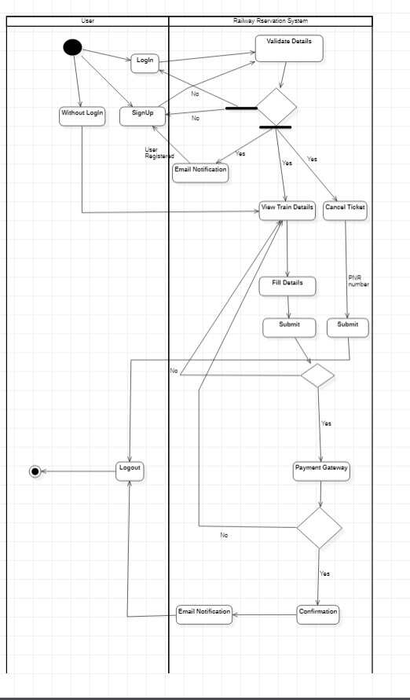

### Admin Activity Diagram

