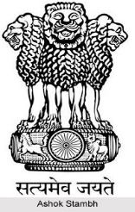

[This Photo](http://www.indianetzone.com/5/national_symbols_india.htm) by Unknown Author is licensed under [CC BY-NC-ND](https://creativecommons.org/licenses/by-nc-nd/3.0/)