* Login as ZHRA-LNMGR19/Welcome1. Navigate to My Manager Evaluations tab. Here make sure that PD ZHRA-RRF-Analytics2013 is transferred to Ethel Green and is Completed. Thus Ethel Green is a surrogate Worker for this particular PD. Also, this PD is InProgress (Manager Evaluation Completed) for Stuart Bernett who is the direct report of ZHRA-LNMGR19. The PD is Completed for Pat Miller who is the direct report of Stuart Bernett.

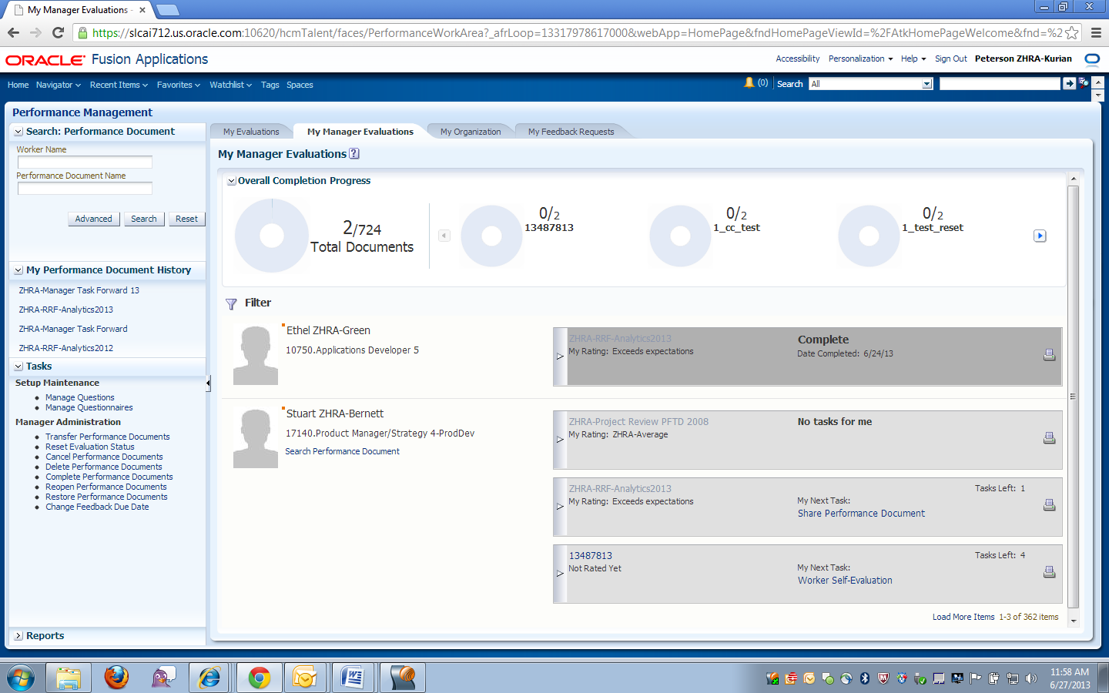

* Navigate to My Organization tab and select the PD as ZHRA-RRF-Analytics2013 and All Reports. View the Task Completion Status Analytic. Here data is only shown for Stuart Bernett and Pat Miller who are the direct and indirect report of ZHRA-LNMGR19. The analytic is not considering Ethel Green who is the surrogate Worker and PD is completed for him.

