https://javaconceptoftheday.com/java-8-interview-sample-coding-questions/

[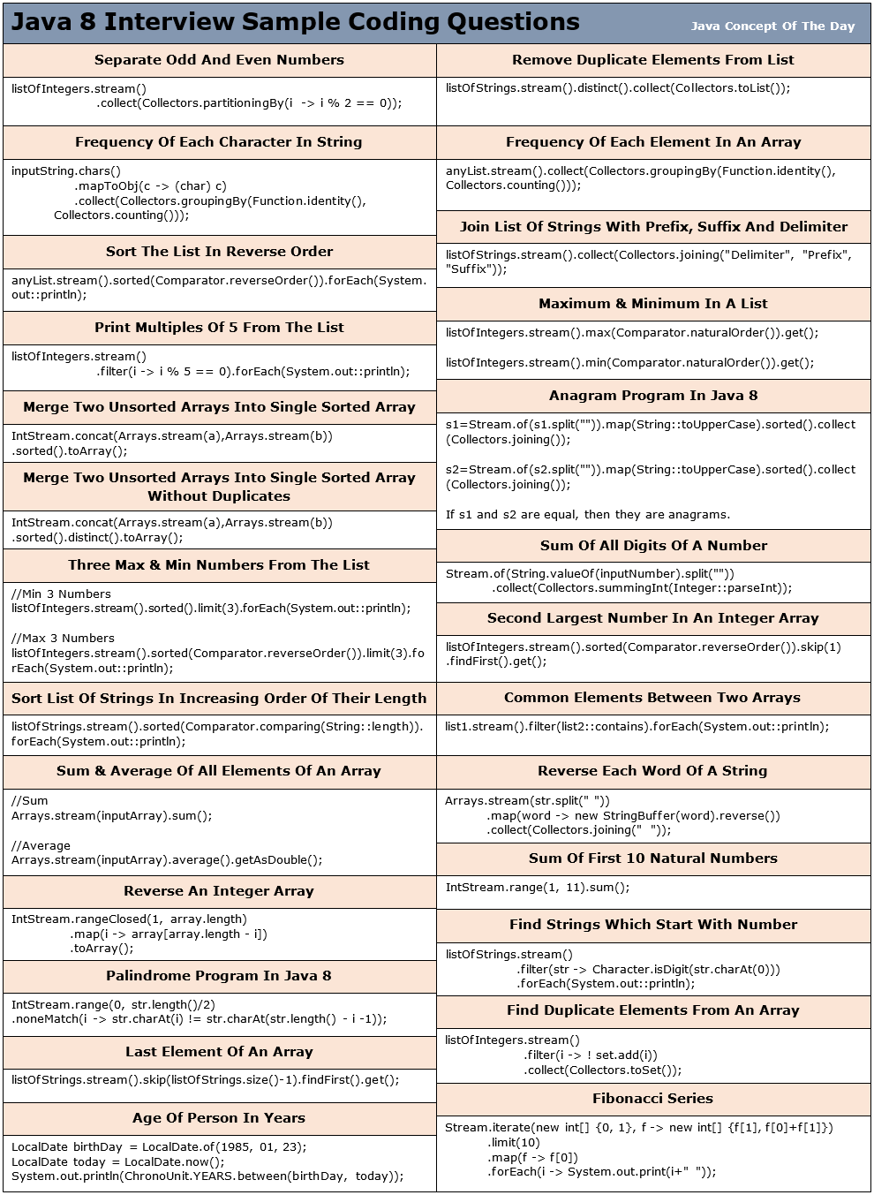](https://i0.wp.com/javaconceptoftheday.com/wp-content/uploads/2023/06/Java_8_Interview_Sample_Coding_Questions.png?ssl=1)

Java 8 Interview [Coding](https://javaconceptoftheday.com/java-8-interview-sample-coding-questions/) Questions And Answers :

**1) Given a list of integers, separate odd and even numbers?**

List<Integer> listOfIntegers = Arrays.asList(71, 18, 42, 21, 67, 32, 95, 14, 56, 87);

Map<Boolean, List<Integer>> oddEvenNumbersMap = listOfIntegers.stream().collect(Collectors.partitioningBy(i -> i % 2 == 0));

Set<Entry<Boolean, List<Integer>>> entrySet = oddEvenNumbersMap.entrySet();

for (Entry<Boolean, List<Integer>> entry : entrySet)

{

System.out.println("--------------");

if (entry.getKey())

{

System.out.println("Even Numbers");

}

else

{

System.out.println("Odd Numbers");

}

System.out.println("--------------");

List<Integer> list = entry.getValue();

for (int i : list)

{

System.out.println(i);

}

}

**Output :**

————–  
Odd Numbers  
————–  
71  
21  
67  
95  
87  
————–  
Even Numbers  
————–  
18  
42  
32  
14  
56

**2) How do you remove duplicate elements from a list using Java 8 streams?**

List<String> listOfStrings = Arrays.asList("Java", "Python", "C#", "Java", "Kotlin", "Python");

List<String> uniqueStrngs = listOfStrings.stream().distinct().collect(Collectors.toList());

System.out.println(uniqueStrngs);

**Output :**

[Java, Python, C#, Kotlin]

**3) How do you find frequency of each character in a string using Java 8 streams?**

String inputString = "Java Concept Of The Day";

Map<Character, Long> charCountMap = inputString.chars().mapToObj(c -> (char) c) .collect(Collectors.groupingBy(Function.identity(), Collectors.counting()));

System.out.println(charCountMap);

**Output :**

{ =4, a=3, c=1, C=1, D=1, e=2, f=1, h=1, J=1, n=1, O=1, o=1, p=1, T=1, t=1, v=1, y=1}

**4) How do you find frequency of each element in an array or a list?**

import java.util.Arrays;

import java.util.List;

import java.util.Map;

import java.util.function.Function;

import java.util.stream.Collectors;

public class Java8Code

{

public static void main(String[] args)

{

List<String> stationeryList = Arrays.asList("Pen", "Eraser", "Note Book", "Pen", "Pencil", "Stapler", "Note Book", "Pencil");

Map<String, Long> stationeryCountMap =

stationeryList.stream().collect(Collectors.groupingBy(Function.identity(), Collectors.counting()));

System.out.println(stationeryCountMap);

}

}

**Output :**

{Pen=2, Stapler=1, Pencil=2, Note Book=2, Eraser=1}

**5) How do you sort the given list of decimals in reverse order?**

import java.util.Arrays;

import java.util.Comparator;

import java.util.List;

public class Java8Code

{ public static void main(String[] args)

{

List<Double> decimalList = Arrays.asList(12.45, 23.58, 17.13, 42.89, 33.78, 71.85, 56.98, 21.12);

decimalList.stream().sorted(Comparator.reverseOrder()).forEach(System.out::println);

}

}

**Output :**

71.85  
56.98  
42.89  
33.78  
23.58  
21.12  
17.13  
12.45

**6) Given a list of strings, join the strings with ‘[‘ as prefix, ‘]’ as suffix and ‘,’ as delimiter?**

import java.util.Arrays;

import java.util.List;

import java.util.stream.Collectors;

public class Java8Code

{

public static void main(String[] args)

{

List<String> listOfStrings = Arrays.asList("Facebook", "Twitter", "YouTube", "WhatsApp", "LinkedIn");

String joinedString = listOfStrings.stream().collect(Collectors.joining(", ", "[", "]"));

System.out.println(joinedString);

}

}

**Output :**

[Facebook, Twitter, YouTube, WhatsApp, LinkedIn]

**7) From the given list of integers, print the numbers which are multiples of 5?**

import java.util.Arrays;

import java.util.List;

public class Java8Code

{

public static void main(String[] args)

{

List<Integer> listOfIntegers = Arrays.asList(45, 12, 56, 15, 24, 75, 31, 89);

listOfIntegers.stream().filter(i -> i % 5 == 0).forEach(System.out::println);

}

}

**Output :**

45  
15  
75

**8) Given a list of integers, find maximum and minimum of those numbers?**

import java.util.Arrays;

import java.util.Comparator;

import java.util.List;

public class Java8Code

{

public static void main(String[] args)

{

List<Integer> listOfIntegers = Arrays.asList(45, 12, 56, 15, 24, 75, 31, 89);

int max = listOfIntegers.stream().max(Comparator.naturalOrder()).get();

System.out.println("Maximum Element : "+max);

int min = listOfIntegers.stream().min(Comparator.naturalOrder()).get();

System.out.println("Minimum Element : "+min);

}

}

**Output :**

Maximum Element : 89  
Minimum Element : 12

**9) How do you merge two unsorted arrays into single sorted array using Java 8 streams?**

import java.util.Arrays;

import java.util.stream.IntStream;

public class Java8Code

{

public static void main(String[] args)

{

int[] a = new int[] {4, 2, 7, 1};

int[] b = new int[] {8, 3, 9, 5};

int[] c = IntStream.concat(Arrays.stream(a), Arrays.stream(b)).sorted().toArray();

System.out.println(Arrays.toString(c));

}

}

**Output :**

[1, 2, 3, 4, 5, 7, 8, 9]

**10) How do you merge two unsorted arrays into single sorted array without duplicates?**

import java.util.Arrays;

import java.util.stream.IntStream;

public class Java8Code

{

public static void main(String[] args)

{

int[] a = new int[] {4, 2, 5, 1};

int[] b = new int[] {8, 1, 9, 5};

int[] c = IntStream.concat(Arrays.stream(a), Arrays.stream(b)).sorted().distinct().toArray();

System.out.println(Arrays.toString(c));

}

}

**Output :**

[1, 2, 4, 5, 8, 9]

**11) How do you get three maximum numbers and three minimum numbers from the given list of integers?**

import java.util.Arrays;

import java.util.Comparator;

import java.util.List;

public class Java8Code

{

public static void main(String[] args)

{

List<Integer> listOfIntegers = Arrays.asList(45, 12, 56, 15, 24, 75, 31, 89);

//3 minimum Numbers

System.out.println("-----------------");

System.out.println("Minimum 3 Numbers");

System.out.println("-----------------");

listOfIntegers.stream().sorted().limit(3).forEach(System.out::println);

//3 Maximum Numbers

System.out.println("-----------------");

System.out.println("Maximum 3 Numbers");

System.out.println("-----------------");

listOfIntegers.stream().sorted(Comparator.reverseOrder()).limit(3).forEach(System.out::println);

}

}

**Output :**

—————–  
Minimum 3 Numbers  
—————–  
12  
15  
24  
—————–  
Maximum 3 Numbers  
—————–  
89  
75  
56

**12) Java 8 program to check if two strings are anagrams or not?**

import java.util.stream.Collectors;

import java.util.stream.Stream;

public class Java8Code

{

public static void main(String[] args)

{

String s1 = "RaceCar";

String s2 = "CarRace";

s1 = Stream.of(s1.split("")).map(String::toUpperCase).sorted().collect(Collectors.joining());

s2 = Stream.of(s2.split("")).map(String::toUpperCase).sorted().collect(Collectors.joining());

if (s1.equals(s2))

{

System.out.println("Two strings are anagrams");

}

else

{

System.out.println("Two strings are not anagrams");

}

}

}

**Output :**

Two strings are anagrams

**13) Find sum of all digits of a number in Java 8?**

import java.util.stream.Collectors;

import java.util.stream.Stream;

public class Java8Code

{

public static void main(String[] args)

{

int i = 15623;

Integer sumOfDigits = Stream.of(String.valueOf(i).split("")).collect(Collectors.summingInt(Integer::parseInt));

System.out.println(sumOfDigits);

}

}

**Output :**

17

**14) Find second largest number in an integer array?**

import java.util.Arrays;

import java.util.Comparator;

import java.util.List;

public class Java8Code

{

public static void main(String[] args)

{

List<Integer> listOfIntegers = Arrays.asList(45, 12, 56, 15, 24, 75, 31, 89);

Integer secondLargestNumber = listOfIntegers.stream().sorted(Comparator.reverseOrder()).skip(1).findFirst().get();

System.out.println(secondLargestNumber);

}

}

**Output :**

75

**15) Given a list of strings, sort them according to increasing order of their length?**

import java.util.Arrays;

import java.util.Comparator;

import java.util.List;

public class Java8Code

{

public static void main(String[] args)

{

List<String> listOfStrings = Arrays.asList("Java", "Python", "C#", "HTML", "Kotlin", "C++", "COBOL", "C");

listOfStrings.stream().sorted(Comparator.comparing(String::length)).forEach(System.out::println);

}

}

**Output :**

C  
C#  
C++  
Java  
HTML  
COBOL  
Python  
Kotlin

**16) Given an integer array, find sum and average of all elements?**

import java.util.Arrays;

public class Java8Code

{

public static void main(String[] args)

{

int[] a = new int[] {45, 12, 56, 15, 24, 75, 31, 89};

int sum = Arrays.stream(a).sum();

System.out.println("Sum = "+sum);

double average = Arrays.stream(a).average().getAsDouble();

System.out.println("Average = "+average);

}

}

**Output :**

Sum = 347  
Average = 43.375

**17) How do you find common elements between two arrays?**

import java.util.Arrays;

import java.util.List;

public class Java8Code

{

public static void main(String[] args)

{

List<Integer> list1 = Arrays.asList(71, 21, 34, 89, 56, 28);

List<Integer> list2 = Arrays.asList(12, 56, 17, 21, 94, 34);

list1.stream().filter(list2::contains).forEach(System.out::println);

}

}

**Output :**

21  
34  
56

**18) Reverse each word of a string using Java 8 streams?**

import java.util.Arrays;

import java.util.stream.Collectors;

public class Java8Code

{

public static void main(String[] args)

{

String str = "Java Concept Of The Day";

String reversedStr = Arrays.stream(str.split(" "))

.map(word -> new StringBuffer(word).reverse())

.collect(Collectors.joining(" "));

System.out.println(reversedStr);

}

}

**Output :**

avaJ tpecnoC fO ehT yaD

**19) How do you find sum of first 10 natural numbers?**

import java.util.stream.IntStream;

public class Java8Code

{

public static void main(String[] args)

{

int sum = IntStream.range(1, 11).sum();

System.out.println(sum);

}

}

**Output :**

55

**20) Reverse an integer array**

import java.util.Arrays;

import java.util.stream.IntStream;

public class Java8Code

{

public static void main(String[] args)

{

int[] array = new int[] {5, 1, 7, 3, 9, 6};

int[] reversedArray = IntStream.rangeClosed(1, array.length).map(i -> array[array.length - i]).toArray();

System.out.println(Arrays.toString(reversedArray));

}

}

**Output :**

[6, 9, 3, 7, 1, 5]

**21) Print first 10 even numbers**

import java.util.stream.IntStream;

public class Java8Code

{

public static void main(String[] args)

{

IntStream.rangeClosed(1, 10).map(i -> i * 2).forEach(System.out::println);

}

}

**Output :**

2  
4  
6  
8  
10  
12  
14  
16  
18  
20

**22) How do you find the most repeated element in an array?**

import java.util.Arrays;

import java.util.List;

import java.util.Map;

import java.util.Map.Entry;

import java.util.function.Function;

import java.util.stream.Collectors;

public class Java8Code

{

public static void main(String[] args)

{

List<String> listOfStrings = Arrays.asList("Pen", "Eraser", "Note Book", "Pen", "Pencil", "Pen", "Note Book", "Pencil");

Map<String, Long> elementCountMap = listOfStrings.stream()

.collect(Collectors.groupingBy(Function.identity(), Collectors.counting()));

Entry<String, Long> mostFrequentElement = elementCountMap.entrySet().stream().max(Map.Entry.comparingByValue()).get();

System.out.println("Most Frequent Element : "+mostFrequentElement.getKey());

System.out.println("Count : "+mostFrequentElement.getValue());

}

}

**Output :**

Most Frequent Element : Pen  
Count : 3

**23) Palindrome program using Java 8 streams**

import java.util.stream.IntStream;

public class Java8Code

{

public static void main(String[] args)

{

String str = "ROTATOR";

boolean isItPalindrome = IntStream.range(0, str.length()/2).

noneMatch(i -> str.charAt(i) != str.charAt(str.length() - i -1));

if (isItPalindrome)

{

System.out.println(str+" is a palindrome");

}

else

{

System.out.println(str+" is not a palindrome");

}

}

}

**Output :**

ROTATOR is a palindrome

**24) Given a list of strings, find out those strings which start with a number?**

import java.util.Arrays;

import java.util.List;

public class Java8Code

{

public static void main(String[] args)

{

List<String> listOfStrings = Arrays.asList("One", "2wo", "3hree", "Four", "5ive", "Six");

listOfStrings.stream().filter(str -> Character.isDigit(str.charAt(0))).forEach(System.out::println);

}

}

**Output :**

2wo  
3hree  
5ive

**25) How do you extract duplicate elements from an array?**

import java.util.Arrays;

import java.util.HashSet;

import java.util.List;

import java.util.Set;

import java.util.stream.Collectors;

public class Java8Code

{

public static void main(String[] args)

{

List<Integer> listOfIntegers = Arrays.asList(111, 222, 333, 111, 555, 333, 777, 222);

Set<Integer> uniqueElements = new HashSet<>();

Set<Integer> duplicateElements = listOfIntegers.stream().filter(i -> ! uniqueElements.add(i)).collect(Collectors.toSet());

System.out.println(duplicateElements);

}

}

**Output :**

[333, 222, 111]

**26) Print duplicate characters in a string?**

import java.util.Arrays;

import java.util.HashSet;

import java.util.Set;

import java.util.stream.Collectors;

public class Java8Code

{

public static void main(String[] args)

{

String inputString = "Java Concept Of The Day".replaceAll("\\s+", "").toLowerCase();

Set<String> uniqueChars = new HashSet<>();

Set<String> duplicateChars =

Arrays.stream(inputString.split(""))

.filter(ch -> ! uniqueChars.add(ch))

.collect(Collectors.toSet());

System.out.println(duplicateChars);

}

}

**Output :**

[a, c, t, e, o]

**27) Find first repeated character in a string?**

import java.util.Arrays;

import java.util.LinkedHashMap;

import java.util.Map;

import java.util.function.Function;

import java.util.stream.Collectors;

public class Java8Code

{

public static void main(String[] args)

{

String inputString = "Java Concept Of The Day".replaceAll("\\s+", "").toLowerCase();

Map<String, Long> charCountMap =

Arrays.stream(inputString.split(""))

.collect(Collectors.groupingBy(Function.identity(), LinkedHashMap::new, Collectors.counting()));

String firstRepeatedChar = charCountMap.entrySet()

.stream()

.filter(entry -> entry.getValue() > 1)

.map(entry -> entry.getKey())

.findFirst()

.get();

System.out.println(firstRepeatedChar);

}

}

**Output :**

a

**28) Find first non-repeated character in a string?**

import java.util.Arrays;

import java.util.LinkedHashMap;

import java.util.Map;

import java.util.function.Function;

import java.util.stream.Collectors;

public class Java8Code

{

public static void main(String[] args)

{

String inputString = "Java Concept Of The Day".replaceAll("\\s+", "").toLowerCase();

Map<String, Long> charCountMap =

Arrays.stream(inputString.split(""))

.collect(Collectors.groupingBy(Function.identity(), LinkedHashMap::new, Collectors.counting()));

String firstNonRepeatedChar = charCountMap.entrySet()

.stream()

.filter(entry -> entry.getValue() == 1)

.map(entry -> entry.getKey())

.findFirst()

.get();

System.out.println(firstNonRepeatedChar);

}

}

**Output :**

j

**29) Fibonacci series**

import java.util.stream.Stream;

public class Java8Code

{

public static void main(String[] args)

{

Stream.iterate(new int[] {0, 1}, f -> new int[] {f[1], f[0]+f[1]})

.limit(10)

.map(f -> f[0])

.forEach(i -> System.out.print(i+" "));

}

}

**Output :**

0 1 1 2 3 5 8 13 21 34

**30) First 10 odd numbers**

import java.util.stream.Stream;

public class Java8Code

{

public static void main(String[] args)

{

Stream.iterate(new int[] {1, 3}, f -> new int[] {f[1], f[1]+2})

.limit(10)

.map(f -> f[0])

.forEach(i -> System.out.print(i+" "));

}

}

**Output :**

1 3 5 7 9 11 13 15 17 19

**31) How do you get last element of an array?**

import java.util.Arrays;

import java.util.List;

public class Java8Code

{

public static void main(String[] args)

{

List<String> listOfStrings = Arrays.asList("One", "Two", "Three", "Four", "Five", "Six");

String lastElement = listOfStrings.stream().skip(listOfStrings.size() - 1).findFirst().get();

System.out.println(lastElement);

}

}

**Output :**

Six

**32) Find the age of a person in years if the birthday has given?**

import java.time.LocalDate;

import java.time.temporal.ChronoUnit;

public class Java8Code

{

public static void main(String[] args)

{

LocalDate birthDay = LocalDate.of(1985, 01, 23);

LocalDate today = LocalDate.now();

System.out.println(ChronoUnit.YEARS.between(birthDay, today));

}

}

**Also Read :**