Implementacja

# Kod po stronie serwera (procedury wbudowane i triggery)

## **Domyślne contratinty:**

ALTER TABLE order_t MODIFY order_date DEFAULT SYSDATE;

ALTER TABLE service MODIFY begin_date DEFAULT SYSDATE;

ALTER TABLE service MODIFY cost DEFAULT 0;

## **Sekwencje i triggery automatycznie inkrementujące ID:**

CREATE SEQUENCE vehicles_sequence

START WITH 1

INCREMENT BY 1

CACHE 100;

CREATE OR REPLACE TRIGGER vehicles_sequence_trigger

BEFORE INSERT ON vehicle

FOR EACH ROW

BEGIN

:new.vehicle_id := vehicles_sequence.nextval;

END;

CREATE SEQUENCE clients_sequence

START WITH 1

INCREMENT BY 1

CACHE 100;

CREATE OR REPLACE TRIGGER clients_sequence_trigger

BEFORE INSERT ON client

FOR EACH ROW

BEGIN

:new.client_id := clients_sequence.nextval;

END;

CREATE SEQUENCE orders_sequence

START WITH 1

INCREMENT BY 1

CACHE 100;

CREATE OR REPLACE TRIGGER orders_sequence_trigger

BEFORE INSERT ON order_t

FOR EACH ROW

BEGIN

:new.order_id := orders_sequence.nextval;

END;

CREATE SEQUENCE vversion_sequence

START WITH 1

INCREMENT BY 1

CACHE 100;

CREATE OR REPLACE TRIGGER vversion_sequence_trigger

BEFORE INSERT ON vehicle_version

FOR EACH ROW

BEGIN

:new.vversion_id := vversion_sequence.nextval;

END;

## **Zmiana kosztu realizacji usługi, zwiększa/zmniejsza koszt zamówienia:**

CREATE OR REPLACE TRIGGER update_order_cost_by_service

before UPDATE OF cost ON service

FOR EACH ROW

BEGIN

if (:new.cost <> :old.cost) then

update order_t set value = value + :new.cost - :old.cost where order_id = :old.order_id;

end if;

END;

/

## **Zliczanie sumy kosztów zamówień dla klienta o podanym id:**

create or replace function get_sum_of_client_orders (i_client_id in client.client_id%type) return order_t.value%type is

val order_t.value%type;

begin

select sum(value) into val from order_t where client_id = i_client_id;

if val is null then

val := 0;

end if;

return val;

end;

/

/** Example */

set serveroutput on;

begin

dbms_output.put_line('Sum of orders: ' || get_sum_of_client_orders(0));

end;

/

## **Procedura licząca i wypisująca klientów którzy nie złożyli zamówienia:**

create or replace procedure get_clients_without_orders is

amount NUMBER(5,0);

cursor cur is select * from client where client_id not in (select distinct client_id from order_t);

os client%rowtype;

begin

amount := 0;

open cur;

loop

fetch cur into os;

exit when cur%notfound;

dbms_output.put_line(os.client_id || ': ' || os.first_name || ' ' || os.last_name || ' ' || os.name);

amount := amount + 1;

end loop;

close cur;

dbms_output.put_line(' Total amount of clients without orders: ' || amount);

end;

/

/** Example */

set serveroutput on;

begin

get_clients_without_orders();

end;

/

# Screenshot'y z aplikacji

Dodawanie zamówienia (kolejne ekrany transakcji):

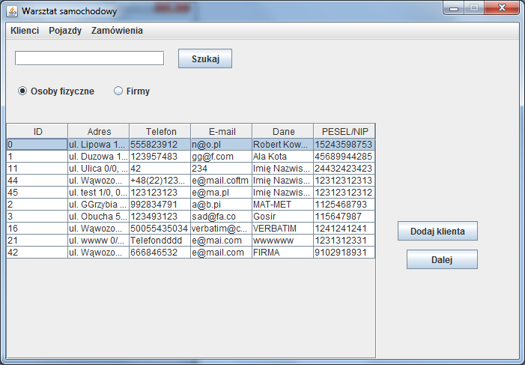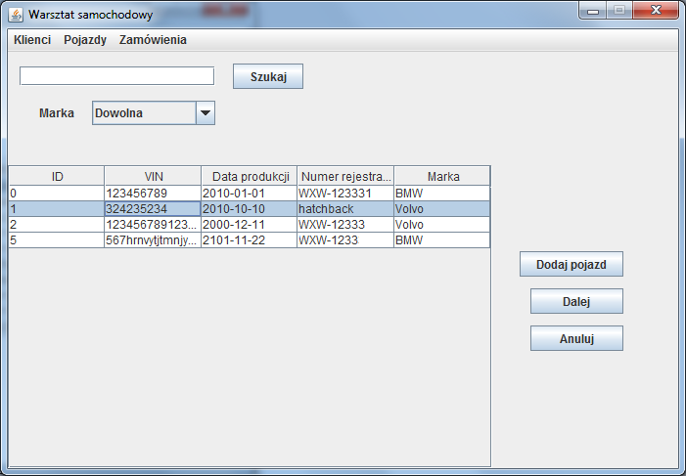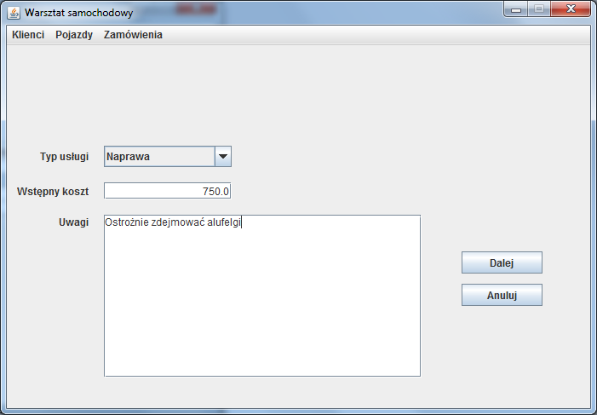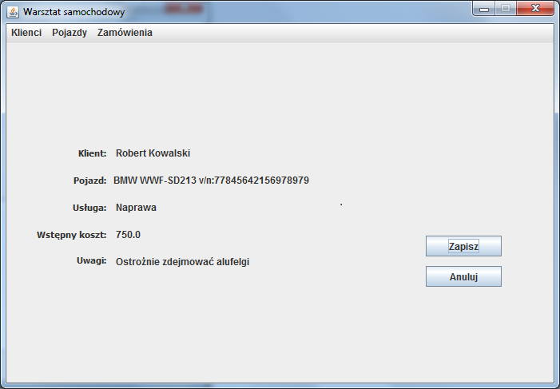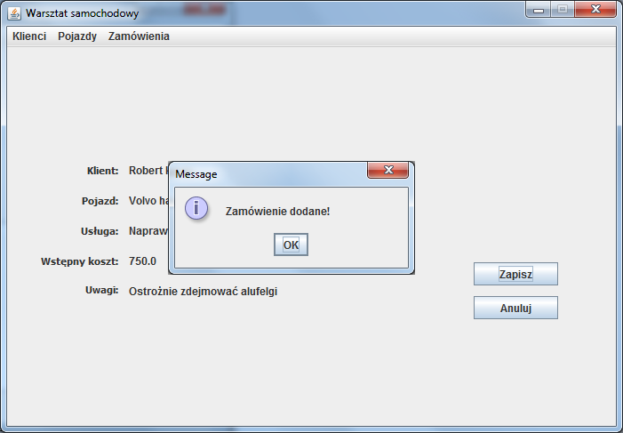

Wyświetlenie zamówień na zakończenie:

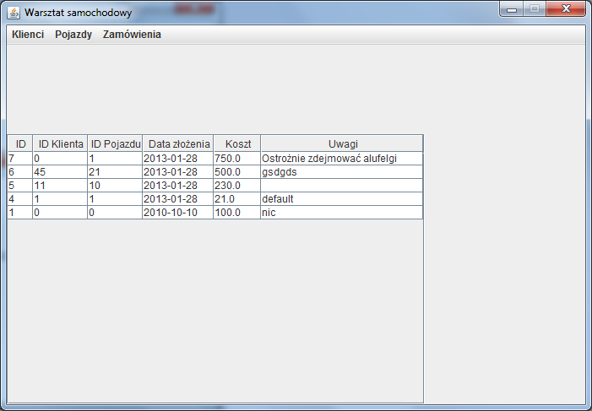

Wyświetlenie klientów:

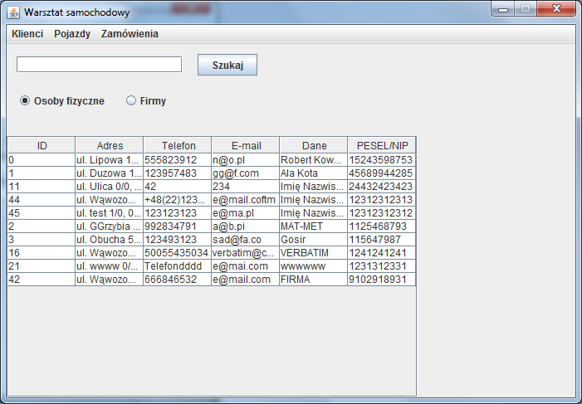

Wyświetlenie pojazdów:

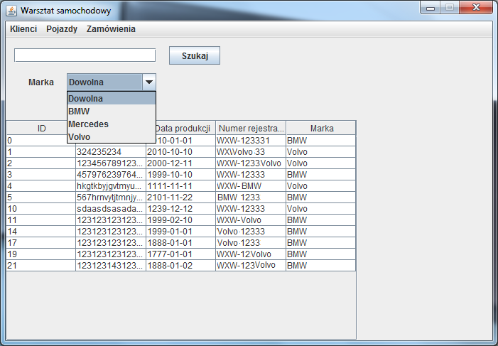

Dodawanie klienta (osoby):

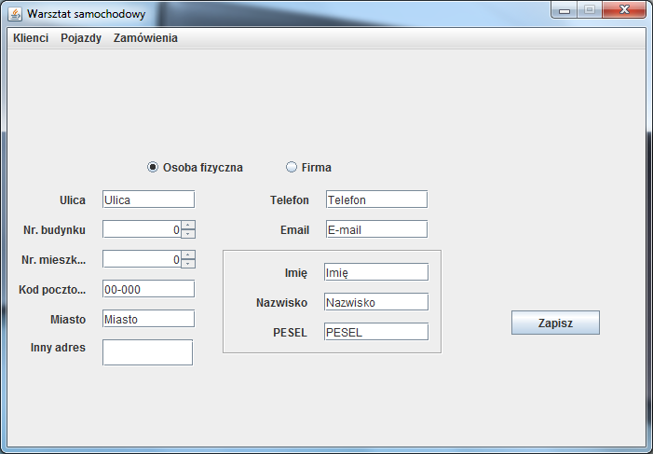

Dodawanie klienta (firmy):

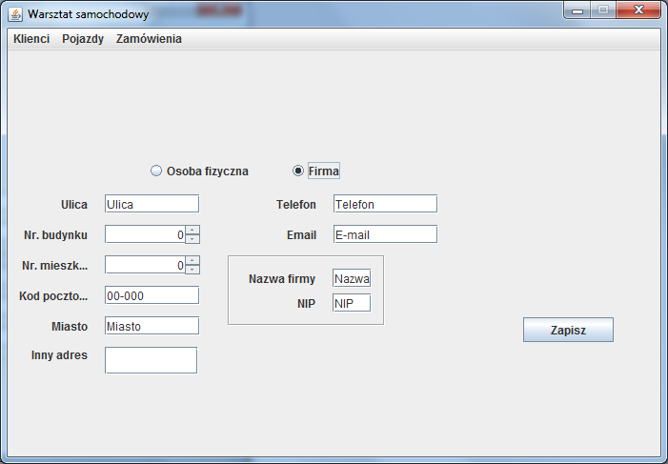

Dodawanie pojazdu:

