AI Ecosystem for Fake Job Scam Detection and Fraud-Aware Job Recommendation

R26-SE-002

Project Proposal Report
Santhosh S – IT22113740

B.Sc. (Hons) Degree in Information Technology Specialized in
Software Engineering

Department of Information Technology

Sri Lanka Institute of Information Technology Sri Lanka

March 2026

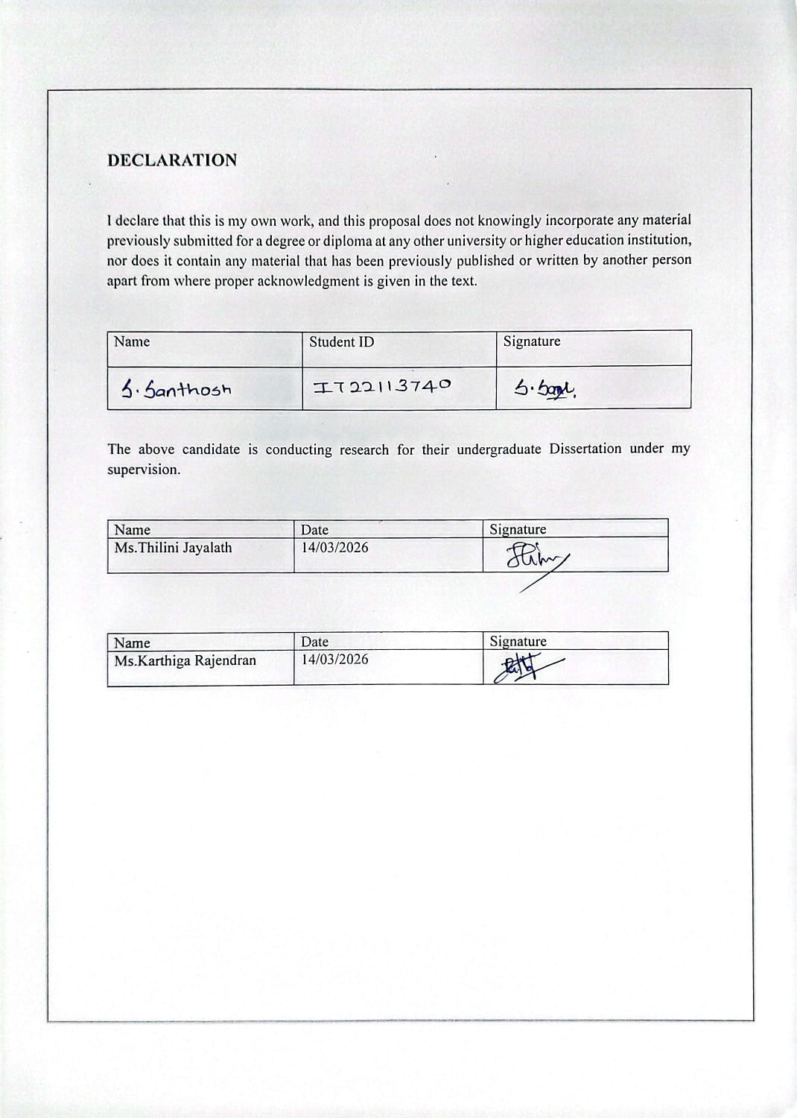

Abstract
Online employment fraud has become a severe and growing threat across global digital recruitment platforms, with Sri Lanka experiencing a sharp rise in fake job scam incidents that disproportionately target Sinhala and Tamil-speaking job seekers. All existing automated detection systems operate exclusively on English-language data and produce only binary real-or-fake verdicts with no explanation or risk guidance, leaving millions of multilingual users entirely unprotected.
This research proposes a multilingual AI-powered fake job post detection system supporting English, Sinhala, and Tamil. The system accepts both typed text and image-based job posts — including WhatsApp screenshots and scanned flyers — extracting text via Tesseract OCR before analysis. A cross-lingual transformer model, XLM-RoBERTa, is fine-tuned on a newly constructed trilingual dataset scraped directly from Sri Lankan job portals — topjobs.lk and ikman.lk — and manually labelled as fake or legitimate by trained annotators. A novel three-tier Suspicion Scoring Mechanism maps each posting to a Low, Medium, or High risk level using a weighted composite of model probability, heuristic keyword signals, structural completeness, and email domain type. SHAP and LIME explainability frameworks generate human-readable per-prediction explanations in the user’s language. The complete system is deployed as a React Native mobile application backed by a FastAPI REST API on AWS infrastructure.
The expected outcomes include a validated multilingual detection model achieving a minimum F1-score of 90% across all three languages, the first trilingual fake job dataset for South Asia built from real Sri Lankan job portal data, and a production-ready mobile application evaluated through a user study of at least 50 participants targeting a System Usability Scale score above 70. Socially, the system protects vulnerable job seekers from financial harm and advances SDG 8 and SDG 16. Commercially, the system offers a freemium mobile product and a B2B API licensing model targeting Sri Lankan job portals.
Keywords: Fake Job Detection, XLM-RoBERTa, Multilingual NLP, Suspicion Scoring, Explainable AI

Table of Contents
Introduction 11
Background and Context 11
Literature Review 12
Research Gab 14
Objectives 15
Main Objective 15
Specific Objective 15
Methodology 16
High-Level System Architecture 19
User Requirements 24
Commercialization Plan 25
Budget and Justification 27
Work Breakdown Structure 28
Gantt Chart 29
References 30
Appendices 31

List of Tables
Table 1 List of Abbreviations 7
Table 2Tools and Platforms 18
Table 3 Stakeholder Identification 24
Table 4 Budget and Justification 27
Table 5 Risk Analysis 37

List of Figures
Figure 1Data Flow 20
Figure 2 System Diagram of the Component 21
Figure 3 Work Break Down Structure 26
Figure 4 Gantt Chart 27

List of Abbreviations
Table 1 List of Abbreviations
Abbreviation | Full Form
AI | Artificial Intelligence
API | Application Programming Interface
AWS | Amazon Web Services
BLEU | Bilingual Evaluation Understudy
B2B | Business to Business
CCID | Computer Crimes Investigation Division
CER | Character Error Rate
CI/CD | Continuous Integration / Continuous Deployment
CoA | Centroid of Area
DSR | Design Science Research
ECS | Elastic Container Service
ELFJP | Elevated Learning strategy for Fake Job Post identification
EMSCAD | Employment Scam Arabic Dataset
ENN | Edited Nearest Neighbours
F1 | F1-Score (Harmonic Mean of Precision and Recall)
FastAPI | Fast Application Programming Interface (Python Framework)
FLIS | Fuzzy Logic Inference System
GAN | Generative Adversarial Network
GST | Goods and Services Tax
HTTPS | Hypertext Transfer Protocol Secure
IC3 | Internet Crime Complaint Center
iOS | iPhone Operating System
IT | Information Technology
JWT | JSON Web Token
K-NN | K-Nearest Neighbours
LKR | Sri Lankan Rupee
LIME | Local Interpretable Model-Agnostic Explanations
LLM | Large Language Model
MLP | Multi-Layer Perceptron
ML | Machine Learning
MongoDB | MongoDB (Document-oriented NoSQL Database)
NLP | Natural Language Processing
NoSQL | Non-relational Structured Query Language
OCR | Optical Character Recognition
POS | Part-of-Speech
REST | Representational State Transfer
ROC-AUC | Receiver Operating Characteristic — Area Under the Curve
S3 | Simple Storage Service
SDG | Sustainable Development Goal
SHAP | SHapley Additive exPlanations
SLIIT | Sri Lanka Institute of Information Technology
SMOTE | Synthetic Minority Oversampling Technique
SMOTE-ENN | Synthetic Minority Oversampling Technique — Edited Nearest Neighbours
SUS | System Usability Scale
SVM | Support Vector Machine
TF-IDF | Term Frequency — Inverse Document Frequency
TLS | Transport Layer Security
UI | User Interface
URL | Uniform Resource Locator
USD | United States Dollar
XAI | Explainable Artificial Intelligence
XLM-RoBERTa | Cross-lingual Language Model — Robustly Optimised BERT Pre-training Approach

List of Appendices
Appendices - A | Survey Instrument
Appendices - B | Detailed Diagram
Appendices – C | UI Mockups
Appendices - D | Risk Analysis

Acknowledgement

I want to express my sincere appreciation to everyone who assisted me in completing my fourth-year research project. I am particularly grateful to Ms. Karthiga Rajendran, our Research Project supervisor, for her guidance and support which played a vital role in the successful completion of this project. Additionally, I am thankful to Ms. Thilini Jayalath, our co-supervisor, who gave us valuable advice to carry out our work more effectively.

Furthermore, we would also like to acknowledge with much appreciation the panels, especially in our project presentations, for giving us very useful feedback and suggestions to make our research more successful.

I would also like to recognize the efforts of my Research Project leader, U. Kajanthan and my other group members who helped me along the way. Lastly, I would like to thank our friends and family members for their unwavering support and encouragement. Their emotional support has been crucial in helping me stay motivated throughout the project.

Once again, I express my gratitude to all those who have contributed to this project. Thank you

Introduction

Background and Context
Online recruitment fraud has emerged as one of the most pervasive forms of digital deception in the modern labor market. As job seekers increasingly rely on internet-based platforms to find employment, malicious actors have exploited these channels to post fraudulent job advertisements designed to harvest personal data, extort fees, or commit identity theft.
According to the Internet Crime Complaint Center (IC3), employment fraud caused over USD 214 million in losses in the United States alone in 2023. In the South Asian context, Sri Lanka has experienced a significant surge in fake recruitment advertisements, particularly targeting youth and recent graduates seeking employment. The Sri Lanka Police's Computer Crimes Investigation Division (CCID) reported a sharp increase in online employment scam complaints in recent years, with victims losing substantial sums to fake employers demanding upfront payments for non-existent positions.
The problem is compounded by a critical linguistic gap: the Sri Lankan workforce communicates predominantly in three languages — Sinhala, Tamil, and English. Yet every existing automated fake job detection system operates exclusively in English, leaving Sinhala- and Tamil-speaking job seekers entirely unprotected by current technology.
Furthermore, existing detection systems produce only a binary verdict (real or fake) without explaining their reasoning or providing users with an actionable risk level. This lack of transparency erodes user trust and provides no guidance on how serious the threat may be.
This research directly addresses SDG 8 (Decent Work and Economic Growth) by protecting workers from fraudulent employment schemes, and SDG 16 (Peace, Justice and Strong Institutions) by reducing digital crime and strengthening the integrity of digital labor market infrastructure in Sri Lanka.

Literature Review
A review of recent scholarly literature reveals significant progress in automated fake job detection, yet also exposes clear boundaries that current research has not crossed.
Dutta and Bandyopadhyay [1] conducted one of the earliest comprehensive evaluations using the EMSCAD Kaggle dataset (17,880 job postings), comparing Naive Bayes, K-NN, Decision Tree, Multi-Layer Perceptron, Random Forest, AdaBoost, and Gradient Boosting classifiers. Random Forest achieved 98.27% accuracy with a Cohen-Kappa score of 0.74, establishing a strong baseline. However, the study employs no natural language processing techniques beyond basic feature extraction and does not address the severe class imbalance inherent in the dataset.
Pillai [2] advanced this work by applying Bidirectional LSTM with word embeddings to the same dataset, achieving 98.71% accuracy and a ROC-AUC of 0.91. While this represents a notable improvement in sequential language modelling, the study lacks interpretability mechanisms and any form of risk stratification for end users.
Allam et al. [3] made the most thorough attempt at addressing class imbalance, evaluating six balancing strategies — including SMOTE-NC, Cluster-SMOTE, cost-sensitive learning, ensemble methods, GAN-based deep learning augmentation, and hybrid approaches — across four classifiers. Their best result (Random Forest with DL Augmentation) achieved precision of 98.6% and recall of 97.1%. However, the system remains a research prototype with no deployment interface and no explainability layer.
Pangare et al. [4] proposed JobScamShield, a notable system that integrates machine learning classification with external company verification via GST registry and Glassdoor API lookups. While architecturally innovative, the system is geographically constrained to India due to its dependence on the Indian GST registration system, and carries significant latency risk due to real-time external API calls at scale.
Singh et al. [5] introduced heuristic fraud signals such as free email domain detection (Gmail, Yahoo) and suspicious keyword identification ("urgent hiring", "no experience required"), achieving 94.2% accuracy with Logistic Regression. These engineered features represent useful domain knowledge but the system lacks deep semantic understanding from transformer-based models.
Sathwika et al. [6] deployed a Django web application integrating Random Forest, Naive Bayes, Logistic Regression, and SVM classifiers, with Logistic Regression achieving 98% accuracy. This represents one of the few production-facing deployments in the literature, yet the system remains English-only, static (no retraining pipeline), and provides no user-facing explanation.
Vijayalakshmi et al. [7] proposed an Elevated Learning strategy (ELFJP) — a custom deep learning ensemble — achieving 97.42% test accuracy. However, the ELFJP architecture is not fully described, constituting a black-box system with no explainability mechanism.
Devi et al. [8] compared supervised and unsupervised methods including Isolation Forest and Gaussian Mixture Models, achieving 98.27% with Random Forest. The study confirms ensemble methods as the dominant approach but does not explore NLP feature engineering or multilingual support.
In the domain of explainability, one recent study applied SHAP (Shapley Additive explanations) to XGBoost-based fraud detection for job postings, identifying top contributing features [9]. However, this study does not use transformer-based embeddings. Separately, XLM-RoBERTa has been fine-tuned for Sinhala text classification tasks including sentiment analysis and hate speech detection [10], demonstrating the viability of cross-lingual models for low-resource Sri Lankan languages — yet no study applies this capability to job fraud detection.
A review of existing products and services reveals that LinkedIn and Indeed implement proprietary fraud filters, but these are English-centric, opaque in their decision-making, and not tailored to South Asian job markets. No publicly available tool currently supports Tamil or Sinhala language job post analysis.

Research Gab
The review of existing literature exposes four critical and interconnected research gaps that this study addresses:
First, every published study on fake job detection — without exception — operates exclusively on English-language data. Sinhala and Tamil, the primary languages of Sri Lanka's workforce, remain entirely absent from the fake job detection research landscape. This represents a critical equity gap that leaves millions of job seekers without protection.
Second, all existing systems reduce detection to a binary classification (real or fake) or a raw probability score. No system provides a structured, tiered risk assessment that communicates to a lay user whether a posting is of low, medium, or high suspicion. This absence limits practical utility for users who need actionable guidance, not just a prediction.
Third, while BERT and transformer-based models have been applied to fake job detection, and while SHAP/LIME have been applied to other fraud detection tasks, no study combines transformer-based contextual embeddings with post-hoc explainability in the specific domain of fake job post detection. Users currently receive no explanation for why a posting is flagged.
Fourth, no publicly available multilingual fake job dataset exists for Tamil, Sinhala, and English drawn from real South Asian job portals. Constructing such a dataset — by scraping and manually labelling postings from live Sri Lankan platforms — is a prerequisite to advancing this field for South Asian markets and produces a more authentic and locally representative resource than translation-based approaches.
This research fills all four gaps simultaneously: it is the first to (i) support Tamil, Sinhala, and English; (ii) provide a three-tier Suspicion Scoring Mechanism; (iii) integrate SHAP/LIME explainability with a transformer model in this domain; and (iv) produce a trilingual labelled dataset scraped from real Sri Lankan job portals as a reusable research artefact.

Objectives

Main Objective
To design, develop, and evaluate a multilingual AI-powered mobile application that detects fake job postings in Sinhala, Tamil, and English using XLM-RoBERTa, assigns a three-tier Suspicion Score (Low / Medium / High), and provides SHAP/LIME-based natural language explanations — achieving a minimum F1-score of 90% across all three languages by the end of the academic year.

Specific Objective
- To construct a Sri Lanka-specific trilingual fake job posting dataset by scraping job advertisements from topjobs.lk and ikman.lk using automated web scraping tools (Scrapy and Selenium), collecting fields including job title, company name, description, requirements, salary, and contact email, and manually labelling each posting as fake or legitimate through a structured annotation process by trained reviewers, achieving a minimum inter-annotator agreement of Cohen’s Kappa ≥ 0.80 across a validation sample.
- To fine-tune the XLM-RoBERTa cross-lingual transformer model on the trilingual dataset, applying SMOTE-based class balancing to address the class imbalance observed in the collected dataset, and achieve a minimum classification F1-score of 90% across English, Sinhala, and Tamil test sets.
- To design and implement a three-tier Suspicion Scoring Mechanism that computes a weighted composite score from classifier probability, heuristic fraud signals (keyword presence, free email domain, missing structural fields), and structural metadata — mapping scores to Low, Medium, and High risk levels with defined score thresholds.
- To integrate SHAP and LIME post-hoc explainability frameworks to generate human-readable, per-posting explanations identifying the top contributing features to the suspicion classification, validated through a user comprehension study with at least 30 participants.
- To develop and deploy a cross-platform mobile application (Android and iOS using React Native) exposing the detection system via a RESTful API backend, supporting all three languages in the user interface.
- To evaluate the complete system end-to-end on a held-out test set and through a user study measuring perceived trustworthiness, usefulness, and comprehension of explanations using a Likert-scale questionnaire administered to a minimum of 50 participants.

Methodology
  - Research Approach
This research adopts a Design Science Research (DSR) methodology, which is appropriate for studies that produce and evaluate an IT artefact addressing a real-world problem. The research proceeds through five iterative phases: problem identification, solution design, artefact development, evaluation, and communication.
  - Technical Methods and Algorithms
Dataset Construction
Job postings are collected directly from two major Sri Lankan job portals — topjobs.lk and ikman.lk — using automated web scraping built with Scrapy and Selenium. The scraper collects publicly visible posting fields including job title, company name, description, requirements, salary range, and contact email address, while respecting each site’s robots.txt rules and applying request rate limiting to avoid server burden. Postings are collected across English, Sinhala, and Tamil languages as they naturally appear on these platforms. Each collected posting is then manually labelled as fake or legitimate by trained annotators following a structured annotation guideline. A minimum inter-annotator agreement of Cohen’s Kappa ≥ 0.80 is required across a random validation sample before the labelled data is accepted for model training. The target dataset size is approximately 5,000–10,000 labelled postings across the three languages.

Class Imbalance Handling
The scraped and labelled dataset is expected to exhibit class imbalance between real and fake postings. The actual ratio will be determined after the labelling phase is complete. SMOTE-ENN (Synthetic Minority Oversampling Technique combined with Edited Nearest Neighbors) is applied during training to synthesize minority class examples and clean borderline majority class samples.

Model Architecture
XLM-RoBERTa (xlm-roberta-base) — a cross-lingual transformer model pre-trained on 100 languages including Sinhala and Tamil — is fine-tuned using the Hugging Face Transformers library. The model input comprises concatenated job posting fields (title + company profile + description + requirements + benefits). A classification head (linear layer + SoftMax) is attached for binary prediction. Training uses AdamW optimizer with a learning rate of 2e-5, batch size of 16, and early stopping with patience of 3 epochs.

Suspicion Scoring Mechanism
The Suspicion Score is computed as a weighted composite:
Suspicion Score = 0.50 × P(fake) + 0.20 × Keyword Score + 0.15 × Structural Penalty + 0.15 × Domain Score
- P(fake): Model's predicted probability of fraudulence (XLM-RoBERTa output)
- Keyword Score: Normalized count of high-risk phrases (e.g., 'urgent hiring', 'no experience needed', 'work from home — earn daily')
- Structural Penalty: Proportion of critical fields (company profile, salary, requirements) that are empty or implausibly short
- Domain Score: Binary flag (1 = free email domain such as Gmail or Yahoo; 0 = corporate domain)
Score thresholds: Low Risk = 0.00–0.39 | Medium Risk = 0.40–0.69 | High Risk = 0.70–1.00

Explainability Layer
SHAP (Shapley Additive explanations) is applied to generate global feature importance rankings across the test set. LIME (Local Interpretable Model-agnostic Explanations) is applied per-prediction to highlight the top five words and features contributing to the classification. Both outputs are converted to natural language explanation templates displayed within the mobile application.

  - Tools and Platforms
Table 2 Tools and Platforms
Tools / Platform | Purpose | Justification
Python 3.10 | ML development | Industry standard for NLP/ML
Hugging Face Transformers | XLM-RoBERTa fine-tuning | Best library for transformer models
SHAP / LIME libraries | Post-hoc explainability | State-of-the-art XAI frameworks
React Native | Mobile app (iOS & Android) | Cross-platform, single codebase
FastAPI | REST API backend | High-performance Python API framework
Scrapy / Selenium | Web scraping (topjobs.lk & ikman.lk) | Industry-standard Python scraping frameworks
AWS EC2 / Lambda | Model serving & deployment | Scalable cloud infrastructure
MongoDB Atlas | Data storage | Schema-flexible NoSQL for varied job structures
GitHub Actions | CI/CD pipeline | Automated testing and deployment

  - Data Collection and Ethical Considerations
Job posting data is collected from publicly visible pages on topjobs.lk and ikman.lk using automated web scraping. Scraping is conducted ethically: the scraper respects each site’s robots.txt directives, applies request rate limiting to avoid placing undue load on the servers, and complies with the sites’ terms of service. No recruiter personal data beyond what is publicly displayed in the job advertisement is collected or stored. All data is used solely for academic research purposes.
A user study will be conducted following ethical approval from the SLIIT Research Ethics Committee. Participants will provide informed consent, participation will be voluntary and anonymous, and no personal data beyond Likert-scale responses will be recorded. Survey instruments are included in Appendix A.

  - Validation Strategy and Performance Metrics
Model performance is evaluated using a stratified 80/20 train-test split with 5-fold cross-validation. Primary metrics include Precision, Recall, F1-Score, and ROC-AUC. The class-weighted F1-score is the primary optimization target due to class imbalance. Dataset labelling quality is measured using Cohen’s Kappa across a random validation sample of annotated postings, with a minimum threshold of ≥ 0.80 required before the dataset is accepted for training. Explainability quality is assessed through a user comprehension study using a Likert-scale instrument (1–5). System performance is measured by API response latency (target: < 2 seconds per query).

High-Level System Architecture
  - Overview of the Proposed Solution and Its Components
The proposed system is a multilingual AI-powered fake job post detection system deployed as a cross-platform mobile application supporting English, Sinhala, and Tamil. The system accepts both text and image-based job postings, analyses them through a transformer-based classification pipeline, and returns a risk-tiered suspicion score with a human-readable explanation — all within a single mobile interface.
The solution is structured across four layers. The Presentation Layer comprises a React Native mobile application providing the user-facing interface including language selection, job post submission, suspicion score display, SHAP/LIME explanation view, and safety checklist. The Backend Intelligence Layer hosts the core processing pipeline — Tesseract OCR, language detection, XLM-RoBERTa inference, heuristic signal extraction, Fuzzy Logic suspicion scoring, and SHAP/LIME explainability — all orchestrated through a FastAPI REST API deployed on AWS. The Data Layer consists of MongoDB Atlas for prediction and feedback storage and AWS S3 for versioned model weight management. The Security Layer enforces JWT authentication, TLS 1.3 encryption, and input sanitisation across all API endpoints.
Together these four layers form a cohesive, scalable, and explainable fake job detection system specifically designed for the Sri Lankan multilingual job market.
  - Data Flow
A user submits a job posting (text or URL) via the mobile application. The backend automatically detects the language and routes the text through the XLM-RoBERTa inference engine. Simultaneously, the Heuristic Signal Extractor evaluates keyword patterns, structural completeness, and email domain type. The Suspicion Score Calculator combines these outputs into a weighted composite score mapped to a Low/Medium/High risk tier. The SHAP/LIME engine generates a per-prediction explanation identifying the top contributing features. All results are returned to the mobile application in under two seconds.
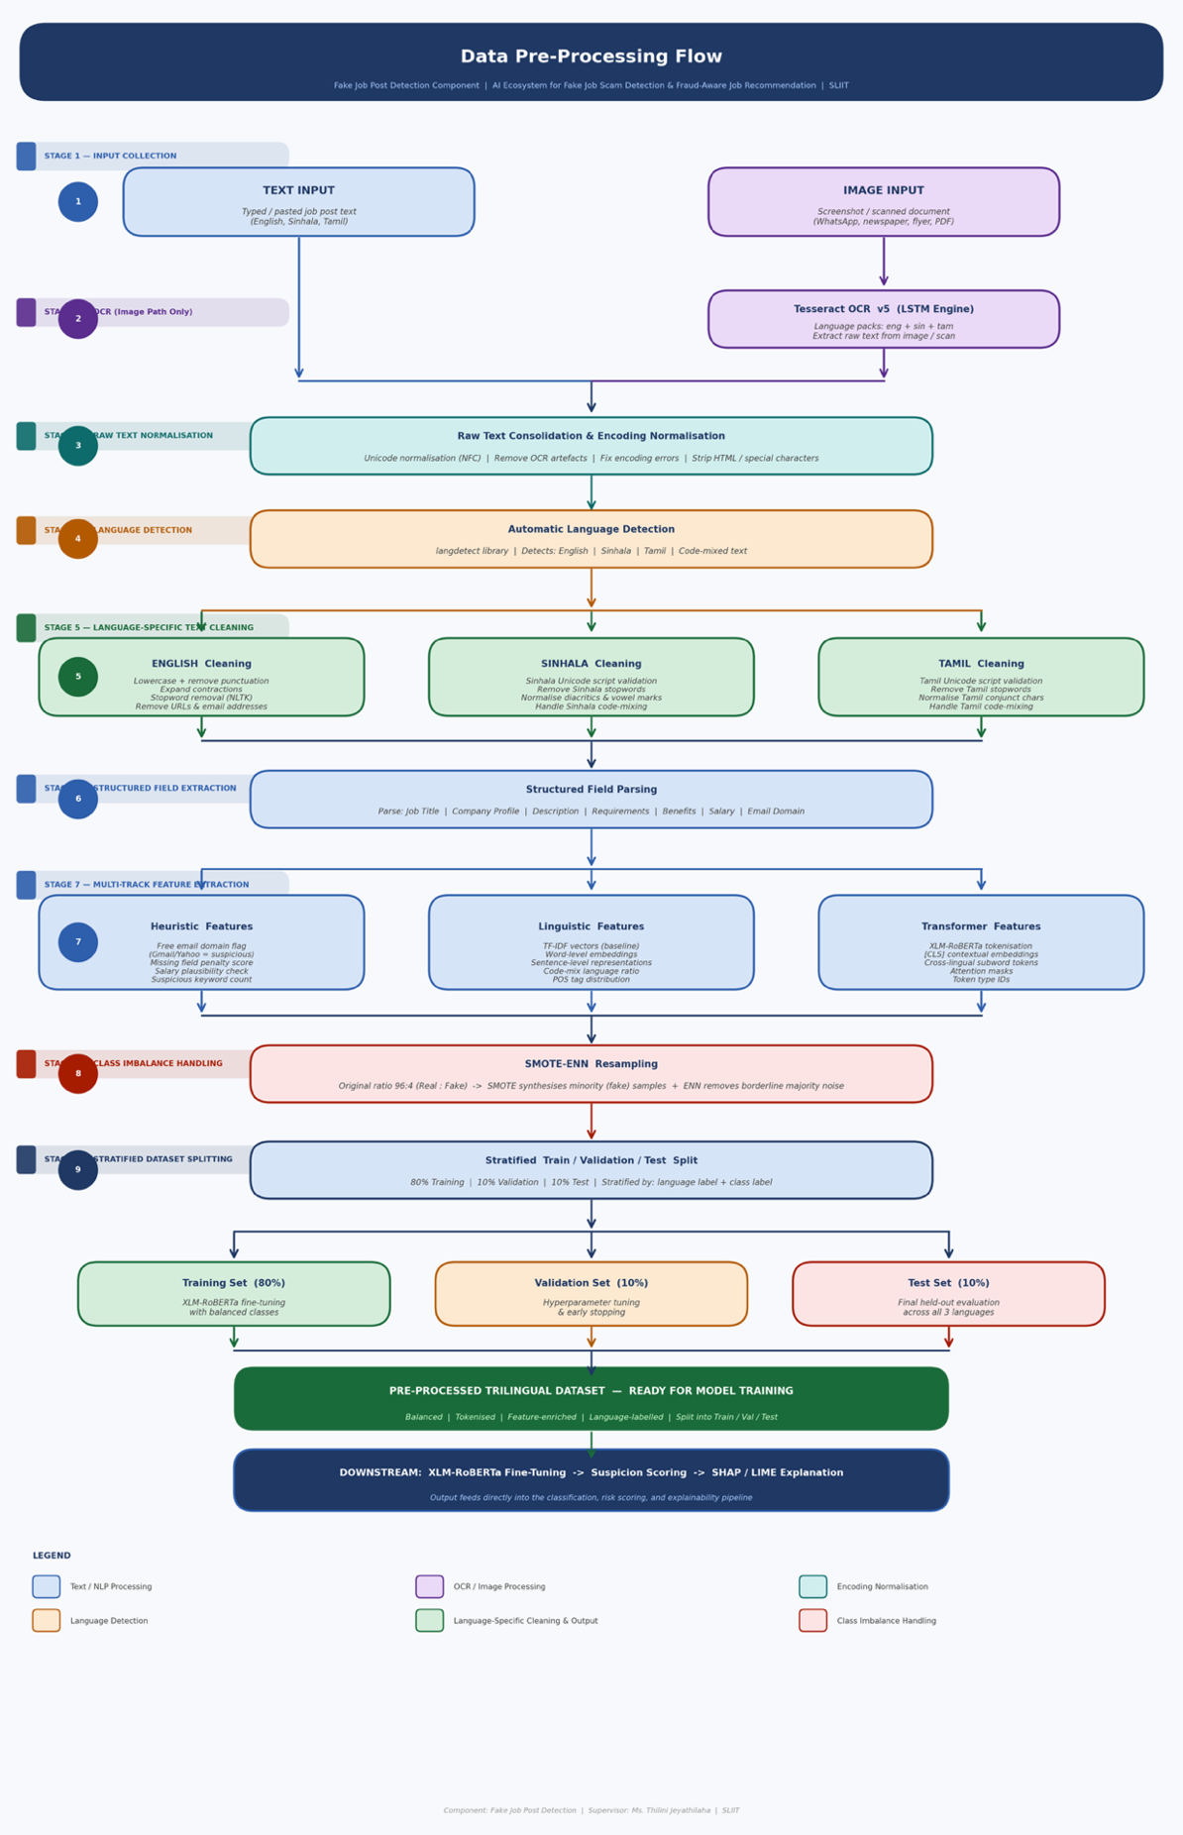
Figure 1Data Flow
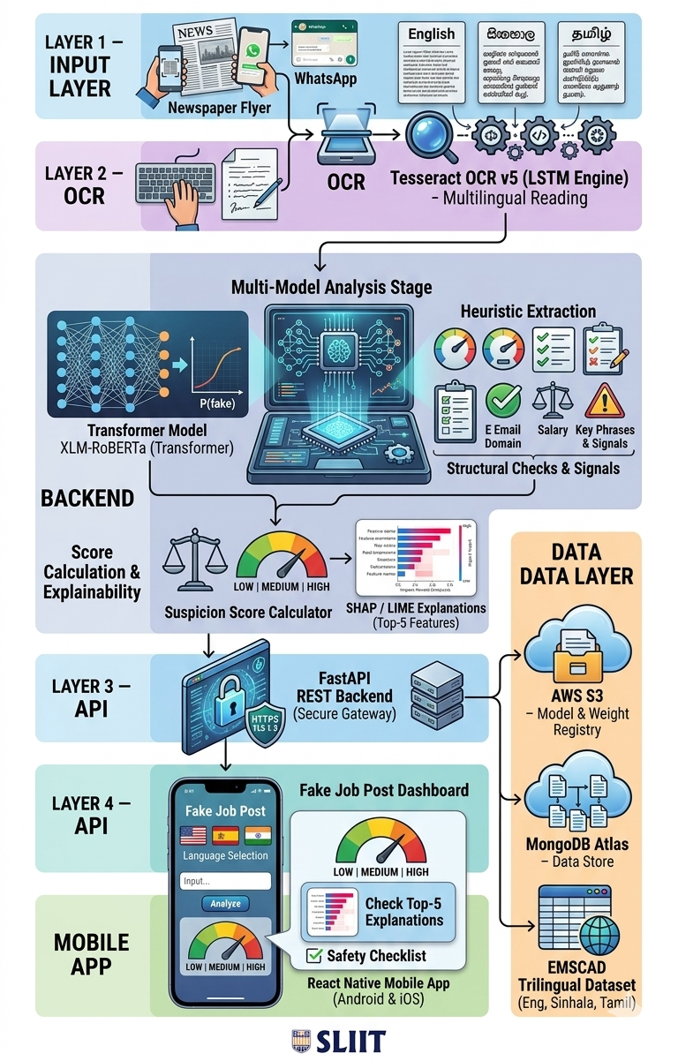
System Diagram of the Component
Figure 2 System Diagram of the Component
  - Component Interactions
The six core components of the system interact in a sequential pipeline coordinated by the FastAPI REST API. The Mobile Application dispatches user input — text or image — to the API via authenticated HTTPS requests. For image inputs, the Tesseract OCR Engine first extracts raw text before passing it downstream. The Language Detection Module then identifies the language (English, Sinhala, Tamil, or code-mixed) to govern tokenization.
The XLM-RoBERTa Inference Engine and the Heuristic Signal Extractor operate in parallel — the former producing a fraud probability P(fake), the latter extracting keyword density, structural completeness, and domain credibility signals. These four inputs are fed into the Fuzzy Logic Suspicion Score Calculator, which applies Mamdani inference rules and Centroid of Area defuzzification to produce a crisp risk score mapped to Low, Medium, or High tier.
The SHAP/LIME Explainability Engine then generates a per-prediction natural language explanation identifying the top five contributing features, returned to the mobile application alongside the score and verdict. All prediction records are written asynchronously to MongoDB Atlas, while model weights are fetched from and versioned on AWS S3.
  - Scalability Considerations
The backend is deployed as containerized microservices on AWS using Docker and orchestrated with AWS ECS. The XLM-RoBERTa model is served via AWS Lambda with auto-scaling policies to handle variable request volumes. MongoDB Atlas provides horizontal sharding for the data layer. API Gateway rate limiting prevents abuse.

  - Security Considerations
All API endpoints require JWT-based authentication. Data in transit is encrypted via TLS 1.3. No personally identifying information is stored server-side. User-submitted job postings are hashed before storage for duplicate detection. Input validation and sanitization are applied at the API gateway layer to prevent injection attacks.

User Requirements
  - Stakeholder Identification
Table 3 Stakeholder Identification
Stakeholder | Role | Primary Need
Job Seekers | End users submitting job posts for analysis | Understand risk level and explanation in their language
System Administrators | Manage model updates, user reports, and system health | Dashboard for monitoring predictions and flagged posts
Researchers / Academics | Access to model performance data and dataset | Reproducible results and open dataset access
Sri Lankan Job Portals | Potential integration partners via API | Automated pre-screening of posted jobs

  - Functional Requirements
- The system shall accept a job posting as free-text input or URL in English, Sinhala, or Tamil and automatically detect the input language.
- The system shall classify each job posting as Real or Fake using the fine-tuned XLM-RoBERTa model with a minimum confidence threshold of 60%.
- The system shall compute and display a Suspicion Score on a 0–1 scale and map it to a colour-coded risk tier: Low (green), Medium (amber), or High (red).
- The system shall generate a SHAP/LIME-based explanation in the user's language identifying the top five features contributing to the prediction.
- The system shall allow users to report false positives or false negatives, storing feedback for model retraining cycles.
- The system shall provide a job safety checklist based on the suspicion score, advising users on precautions for Medium and High risk posts.
- The system shall maintain a personal history log of all job posts a user has submitted for analysis, accessible within the mobile application.
- The system shall support English, Sinhala, and Tamil in the complete user interface, including all labels, explanations, risk descriptions, and alerts.

  - Non-Functional Requirements
Security
All user data must be transmitted over TLS 1.3. JWT tokens must expire within 24 hours. No personally identifiable information shall be stored without explicit consent.
Performance
The system shall return a complete prediction, suspicion score, and explanation within 2 seconds for 95% of requests under normal load (up to 500 concurrent users).
Usability
The mobile application shall achieve a System Usability Scale (SUS) score of at least 70 in user testing across all three language groups.
Scalability
The backend architecture shall support horizontal scaling to accommodate a tenfold increase in request volume without architectural changes.
Reliability
The system shall achieve 99.5% uptime measured monthly, with automated health checks and failover mechanisms in place.
Maintainability
Model weights and application code shall be versioned using semantic versioning. A retraining pipeline shall be triggered automatically when user feedback accumulates beyond 500 new labelled samples.

Commercialization Plan

  - Target Market and Customer Persona
Primary market: Sri Lankan job seekers aged 18–35, particularly recent graduates and those actively using online job portals. Secondary market: Sri Lankan recruitment agencies and job portals (TopJobs.lk, XpressJobs.lk) seeking to improve platform integrity. Tertiary market: South Asian markets where Tamil is widely spoken (India — Tamil Nadu, Singapore, Malaysia).

  - Value Proposition
The proposed system is the only fake job detection tool that speaks your language — literally. Unlike global fraud filters that operate only in English, the system analyses job postings in Sinhala, Tamil, and English, tells you exactly why a posting is suspicious, and gives you a clear Low/Medium/High risk rating so you know whether to apply, proceed cautiously, or walk away.

  - Revenue Model
- Freemium Mobile App: Free tier (5 analyses/day); Premium subscription at LKR 299/month (unlimited analyses, history, priority processing)
- B2B API Licensing: Job portal integration via API at LKR 15,000/month for up to 10,000 API calls
- Enterprise Partnership: Custom deployment for large recruitment agencies or government employment portals

  - Cost Estimation
- AWS EC2 / Lambda (model serving): LKR 8,000/month
- MongoDB Atlas (data storage): LKR 3,000/month
- Scraping infrastructure & proxy service (ongoing): LKR 2,000/month
- App Store / Play Store developer accounts: LKR 15,000 one-time

  - Competitive Advantage
No existing product — commercial or open-source — offers fake job detection in Sinhala or Tamil. This linguistic specificity, combined with transparent AI explanations and risk-tiered scoring, creates a defensible differentiation in the Sri Lankan market that cannot be replicated by global platforms without significant localisation investment.

  - Intellectual Property Considerations
The trilingual fake job posting dataset scraped and labelled during this research will be published under a Creative Commons Attribution licence to advance the research community. The Suspicion Scoring algorithm and XLM-RoBERTa fine-tuning pipeline will be considered for provisional patent filing through SLIIT’s technology transfer office upon completion of the research.

Budget and Justification
Table 4 Budget and Justification
Item | Cost | Justification
AWS EC2 | 20,000 | Required for XLM-RoBERTa inference at scale
Scraping Infrastructure & Proxy Service | 8,000 | Web scraping of topjobs.lk & ikman.lk for dataset construction
MongoDB Atlas (12 months) | 18,000 | Cloud database for job post and feedback storage
Google Play Developer Account | 9,000 | Required for Android Play Store deployment
Research Materials & Printing | 7,000 | Survey instruments, interim and final reports
 | 62,000

Work Breakdown Structure
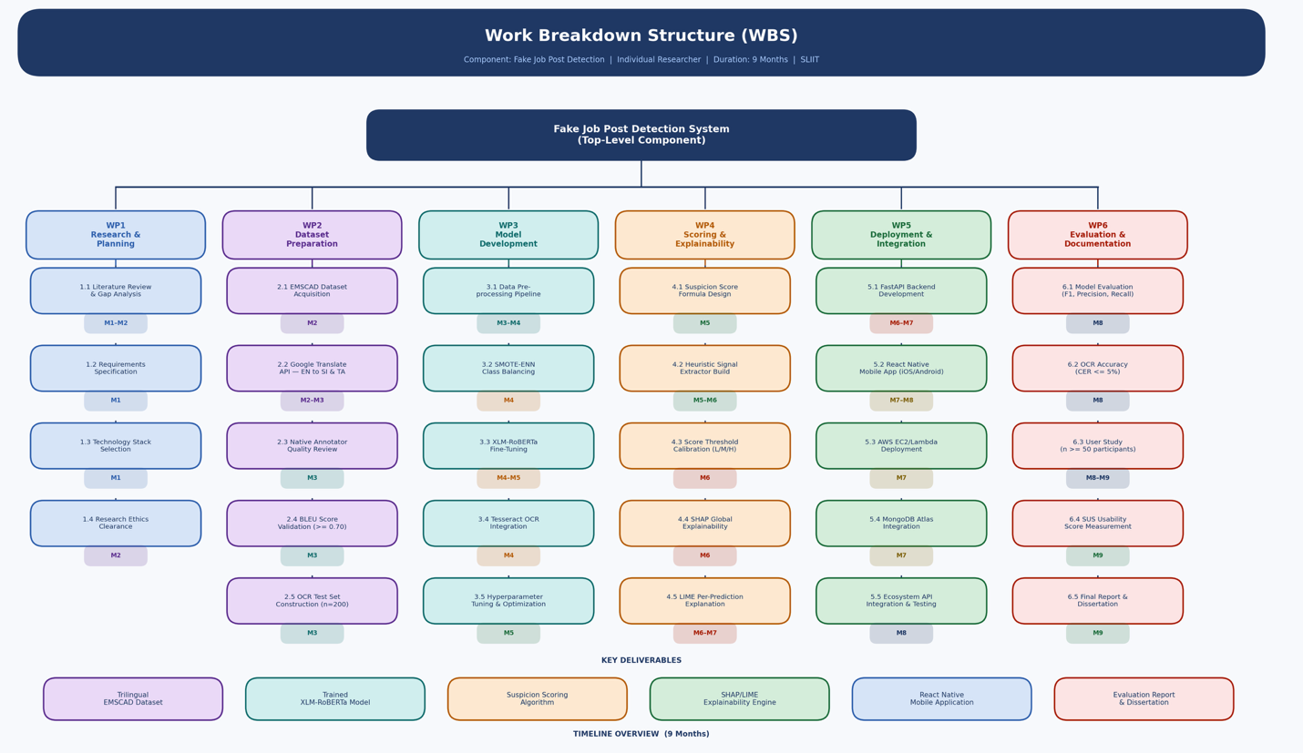
Figure 3 Work Break Down Structure

Gantt Chart
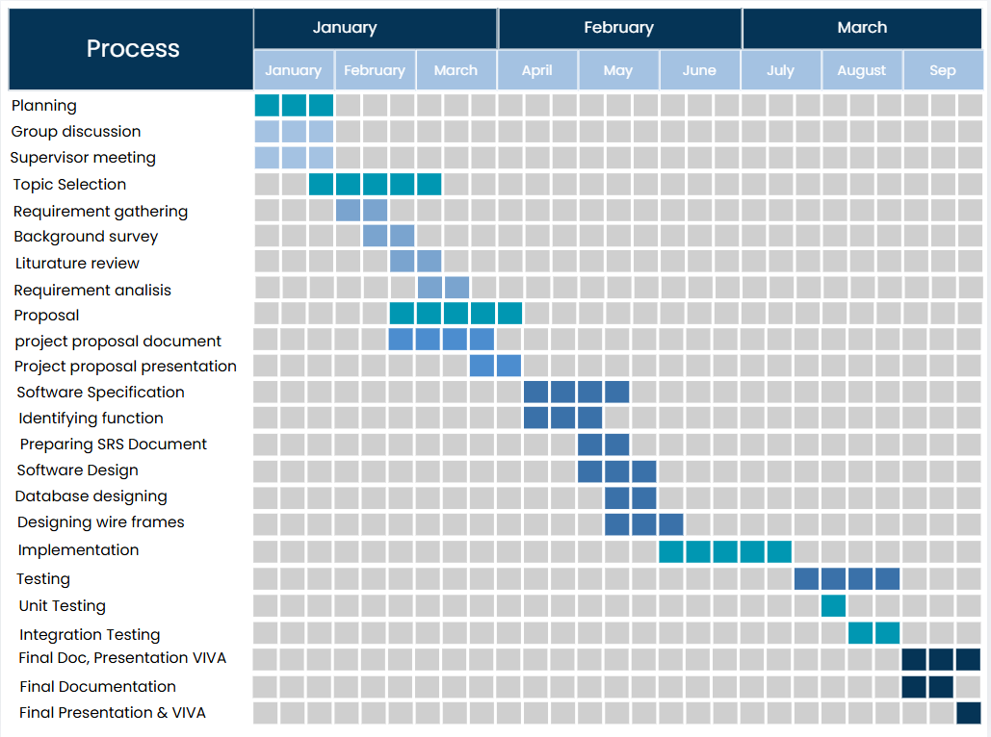
Figure 4 Gantt Chart

References

[1] | D. &. Bandyopadhyay, "Fake Job Recruitment Detection Using ML, IJETT 2020".
[2] | Pillai, "Detecting Fake Job Postings Using Bidirectional LSTM, IRJMETS 2023".
[3] | A. e. al., "Comprehensive Detection Using Advanced Data Balancing, IEEE RAIT 2025".
[4] | P. e. al., "JobScamShield, IJFMR 2026".
[5] | S. e. al., "Protecting Job Seekers, IRJMETS 2025".
[6] | S. e. al., "Fake Job Posting Detection, JETIR 2024".
[7] | V. e. al., "ELFJP, IEEE ASIANCON 2024".
[8] | D. e. al., "Detection of Fake Job Recruitment Using ML, IJCRT 2022".
[9] | C. e. al., "XLM-RoBERTa, ACL 2020".
[10] | Molnar, "Interpretable Machine Learning (Book), 2022".
[11] | L. &. Lee, "SHAP, NeurIPS 2017".

Appendices
  - Appendices – A
This survey was administered via Google Forms between 5 March 2026 and 9 March 2026 as part of the preliminary needs assessment for this research. The purpose of the survey was to assess participant awareness of online job scams, experience with fake job postings, and attitudes toward AI-based detection tools. A total of 57 valid responses were collected from job seekers, undergraduate students, and working professionals in Sri Lanka. Participation was voluntary and all responses were collected anonymously.
Survey Title: Online Job Scam Awareness & AI Detection System Survey
Target Audience: Job seekers, undergraduate students, and working professionals in Sri Lanka Total Respondents: 57
Distribution Period: 5 March 2026 – 9 March 2026
Distribution Method: Google Forms (online link shared via WhatsApp)
Section 1 — Demographic Information
Q1. What is your age group? 18–22 / 23–27 / 28–35 / Above 35
Q2. What is your current status? Undergraduate student / Job seeker / Working professional / Graduate
Q3. Have you ever searched for jobs online? Yes / No
Section 2 — Online Job Search Behaviour
Q4. Which platforms do you use to search for jobs? LinkedIn / Job websites (TopJobs, Indeed, etc.) / WhatsApp groups / Email invitations / Facebook job groups / Telegram / Other
Q5. Have you ever seen fake or suspicious job advertisements online? Yes / No / Not sure
Q6. What characteristics make a job advertisement look suspicious? Unrealistically high salary / Very little experience required / Lack of company information / Urgent hiring messages / Poorly written job descriptions

Section 3 — Recruiter Communication Experience
Q7. Do you usually check the company details before applying for a job? Yes / No / Sometimes
Q8. Which company-related factors increase your trust in a job opportunity? Official company website / Corporate email address / Contact information / Social media presence / Company reputation
Q9. Have you ever received suspicious messages from someone claiming to be a recruiter? Yes / No / Not sure
Q10. Through which platforms did you receive suspicious recruiter messages? WhatsApp / Email / LinkedIn / Facebook / Telegram / Other / I have never received suspicious recruiter messages
Q11. What type of suspicious behavior did you notice in those messages? Asking for money or a processing fee / Asking for personal documents / Urgent pressure to respond quickly / Suspicious links / Fake company name / Unrealistic salary offers
Q12. Have you ever been asked to pay money for a job opportunity? Yes / No / Not sure
Section 4 — System Need and Feature Preferences
Q13. How confident are you in identifying fake job offers or recruitment scams? (Scale: 1 = Not confident at all — 5 = Very confident)
Q14. Do you think recruitment scams are increasing on online platforms? Yes / No / Not sure
Q15. Would you use a system that automatically detects scam job messages? Yes / No / Maybe
Q16. Which features would help you detect job scams more effectively? Scam risk score for messages / Explanation of why a message is suspicious / Warning for suspicious links / Verification of recruiter details / Alerts for possible scam messages
Q17. Do you think AI technology can help reduce recruitment scams and protect job seekers? Yes / No / Not sure
Q18. In your opinion, what is the biggest risk when applying for jobs online? (Open-ended)

  - Appendices - B
  - Appendices – C
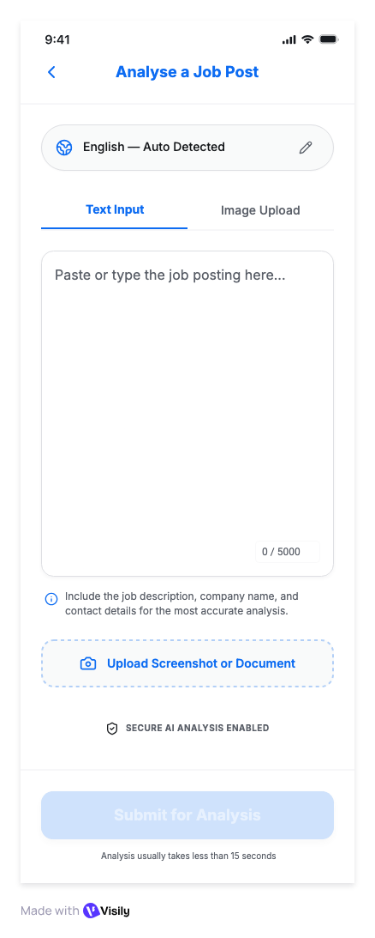
  - 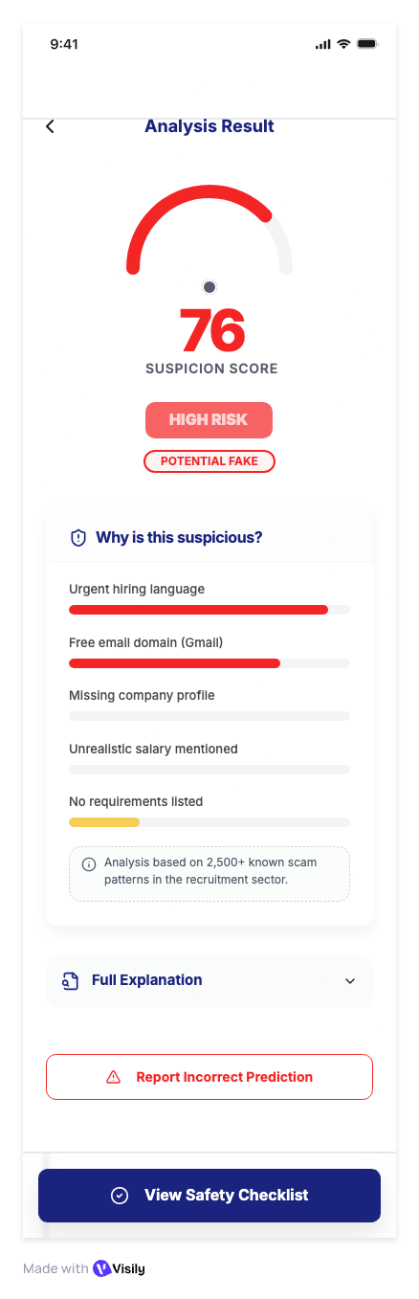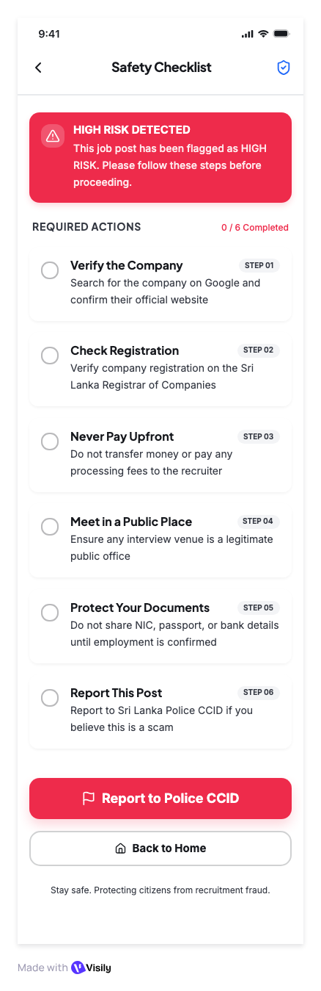
  - Appendices – D Risk Analysis
Table 5 Risk Analysis
ID | Risk Description | Likelihood | Impact | Mitigation Strategy
R1 | Annotator labelling inconsistency producing low inter-annotator agreement | Medium | High | Set Cohen’s Kappa ≥ 0.80 as the labelling quality gate; provide detailed annotation guidelines with worked examples; conduct calibration sessions before full labelling begins; re-adjudicate disagreed samples
R2 | XLM-RoBERTa F1-score below 90% on non-English sets | Medium | High | Data augmentation; increase annotated sample size; hyperparameter tuning; try larger model variant
R3 | Tesseract OCR accuracy below target CER <= 5% | Medium | Medium | Pre-process images (denoise, binarise, deskew); test multiple Tesseract PSM modes; supplement with Google Vision API
R4 | AWS cost overruns exceeding budget | Low | Medium | Set AWS Budgets alerts at 80% threshold; use Lambda with concurrency caps; monitor monthly via Cost Explorer
R5 | Insufficient user study participants (target n >= 50) | Low | Medium | Recruit via SLIIT student portal, community networks, and WhatsApp; offer incentives; begin recruitment early
R6 | App Store / Play Store rejection | Low | High | Review Apple and Google content policies before submission; ensure no data collected without explicit user consent
R7 | Model bias against legitimate informal job postings | Medium | Medium | Threshold calibration; adversarial test cases; user feedback loop for false positive correction
R8 | Fuzzy logic rule base produces inconsistent risk tiers | Low | Medium | Validate all 18 rules against manually labelled test cases; cross-check outputs with domain expert review
R9 | Scraped job postings contain incomplete or corrupted fields due to dynamic page rendering or site structure changes | Medium | High | Use Selenium for JavaScript-heavy pages; implement field-level validation to flag posts with missing critical fields; schedule periodic scraper maintenance checks; maintain fallback CSS selectors for common layout changes
R10 | Project timeline slippage due to technical complexity | Medium | Medium | Build 2-week buffers into each WBS milestone; weekly supervisor check-ins; priorities core MVP features first

