**Assignment – 1**

**Problem Statement:**

Create an account in AWS and configure a budget.

**Steps for creating an AWS account:**

1. Go to ‘https://console.aws.amazon.com’ & click ‘Create a new AWS account button.
2. Enter an email address, an AWS account name & click ‘verify email address’.

1. Enter the verification code send to the given email address & click  
   ‘Verify’.

1. After email verification set a new password for AWS account and  
   click ‘Continue’.

1. In contact information page, select account type ; give name, phone no,  
   country, address, city, state, pin; Accept agreement and click ‘Continue’.

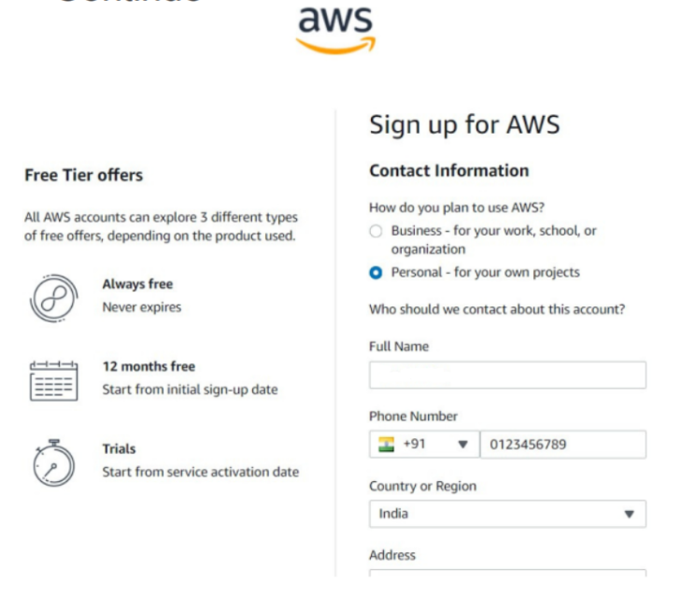

1. In billing info page give credit or debit card no, expiration date, cvv, cardholder name, pan card no, address & click ‘Continue’.

1. Next, select phone verification method, give phone no & click ‘Continue’.

1. Give verification code send to the given mobile no. & click ‘Continue’.

1. Select suitable support plan & click ‘Complete sign up’.

1. AWS account creation is completed. click ‘Go to the AWS Management Console’ or go to ‘https://console.aws.amazon.com’ in browser for log in.

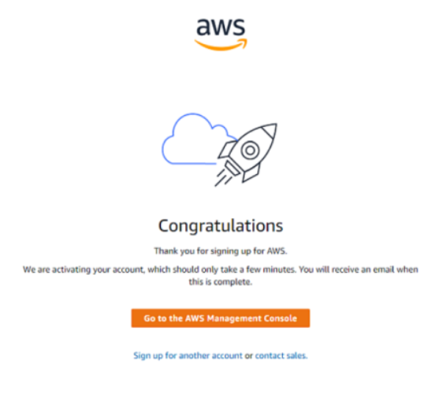

**Steps for configuring budget in AWS**

1. Go to ‘https://console.aws.amazon.com’ & sign in to AWS account.
2. Click the account name in top-right corner & go to ‘Billing and Cost  
   Management’.

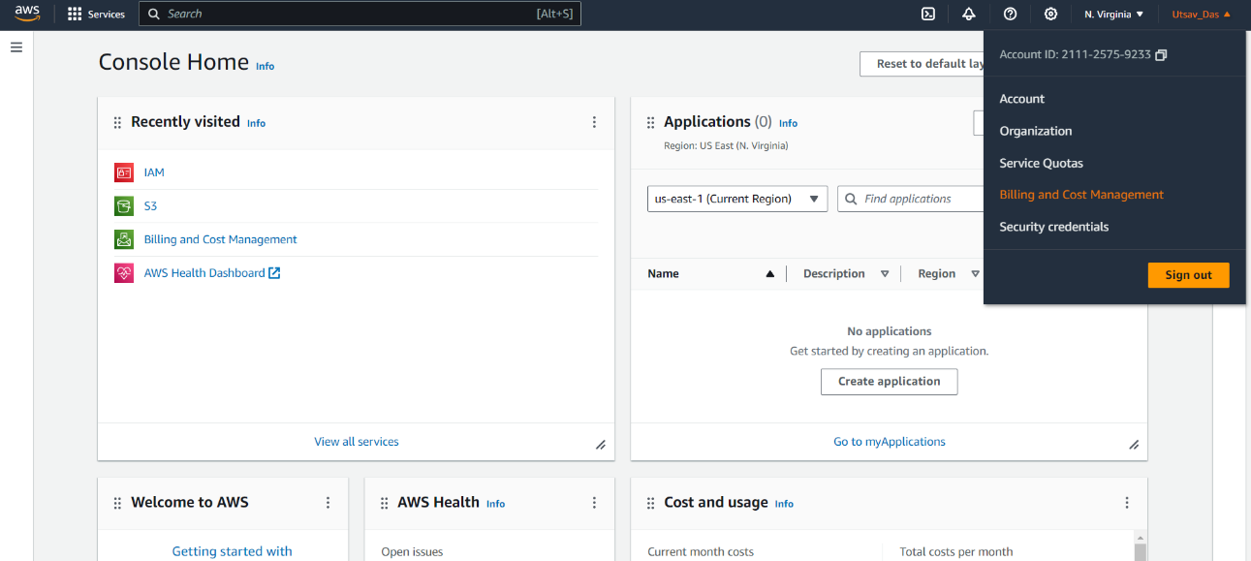

1. From left panel go to ‘Budgets’ under ‘Budgets and Planning’ and click  
   ‘Create a budget’. A screenshot of a computer

   Description automatically generated
2. Select Budget setup ‘Customize’ , Budget types ‘Cost budget’ & click ‘Next’.

1. In **Details** give ‘Budget name’.   
   In **Set budget amount** select ‘Period’ , select ‘Budget renewal type’, give start month, select ‘Budgeting method’ , enter ‘budgeted amount’.   
   In **Budget Scope** select ‘scope options’, Click ‘Next’.

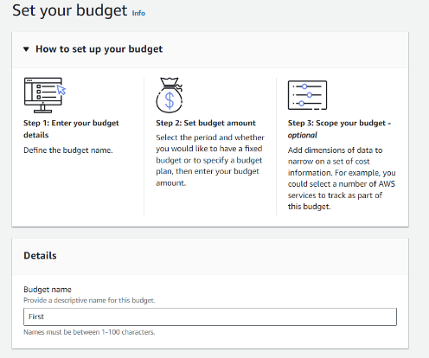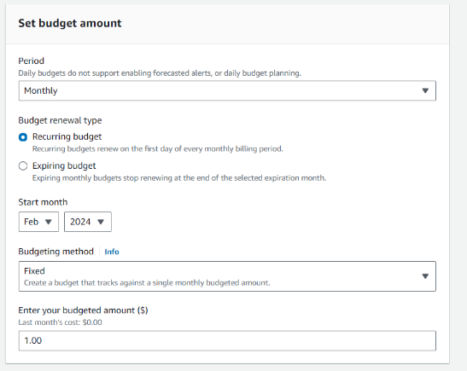 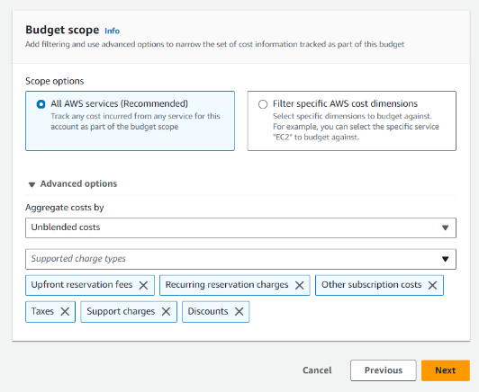

1. A screenshot of a computer screen

   Description automatically generated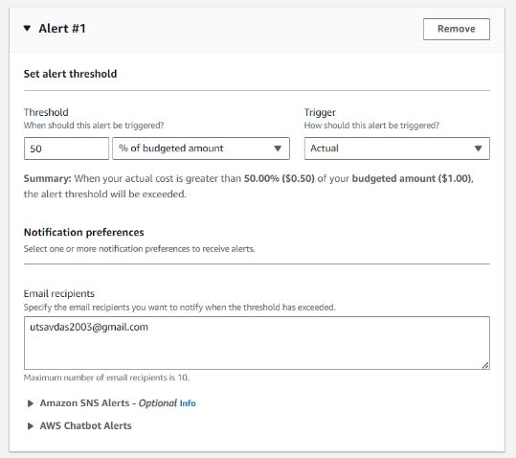Click ‘Add an alert threshold’.  
   Give a threshold value.   
   Set ‘Email recipients’.   
   Click ‘Next’.  
   Click ‘Next’.

1. A screenshot of a budget

   Description automatically generatedReview all filled up details & click ‘Create Budget’.

1. Now a budget is created in our aws account.

