**Assignment – 12**

**Problem Statement:**

**Deploy and run the project in AWS without using port.**

1. Go to EC2 -> Security groups and click on Create Security Group option.

1. Give name of Security Group and description.

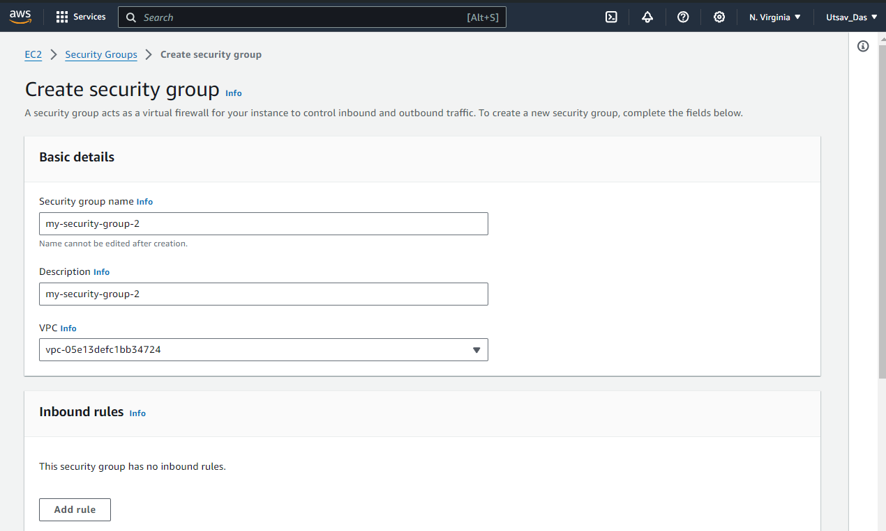

1. In Inbound rules click on Add rule. Here, we add all 4 rules: Custom TCP, SSH, HTTP, HTTPS and in Source select 0.0.0.0/0

In port range of Custom TCP give 4000. Rest have default port number.

1. Go back to instance and click on Launch instance. A screenshot of a computer

   Description automatically generated
2. Give name of instance and in Application and OS Images select Ubuntu.

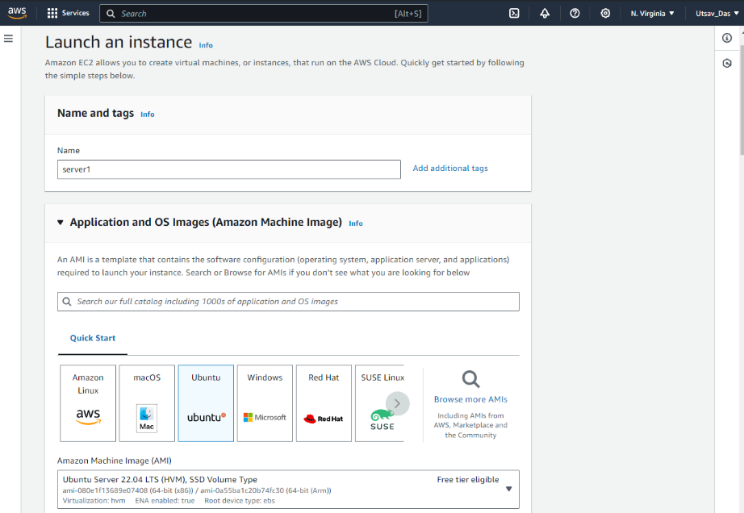

1. Select existing key pair and then click on Common Security group dropdown and select the created security group. Then click on Launch Instance.

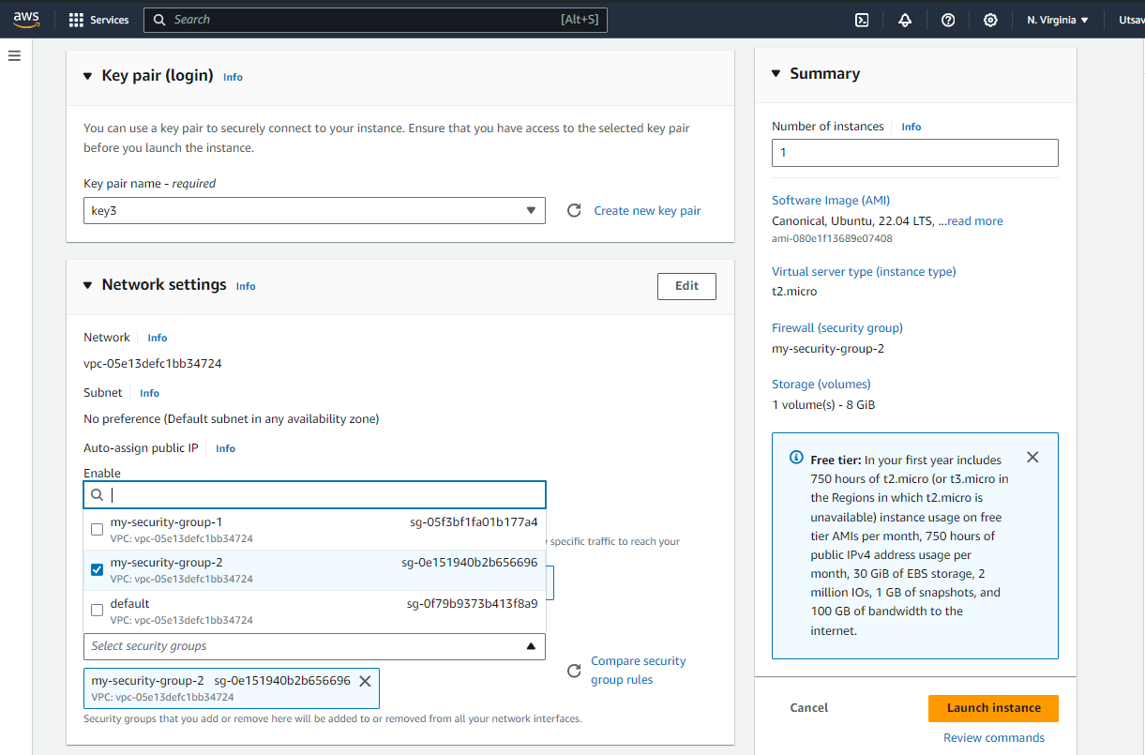

1. Go to Instances and copy Public IPv4 address.

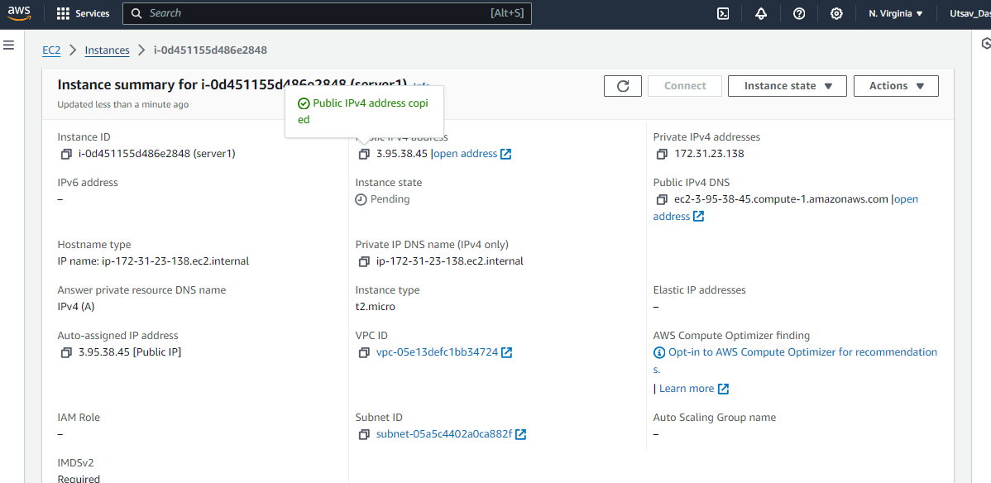

1. In Bitvise SSH Client, paste Copied IPv4 address, import the required key and click on Log In.

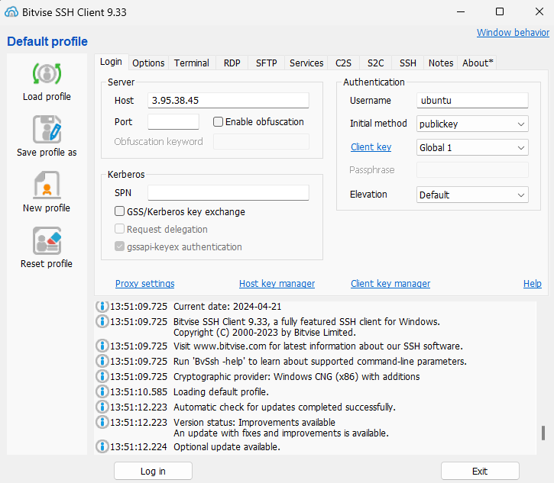

1. Open New Terminal Console and enter the following commands:

* sudo apt-get update
* sudo apt upgrade
* sudo apt-get install nginx
* curl –SL https://deb.nodesource.com/setup_16.x|sudo -E bash –
* sudo apt install nodejs
* git clone https://github.com/UnderDevelopment10/new-repo1.git
* cd repo2
* npm install
* node index.js

1. Paste the copied URL in browser. Then stop the server.

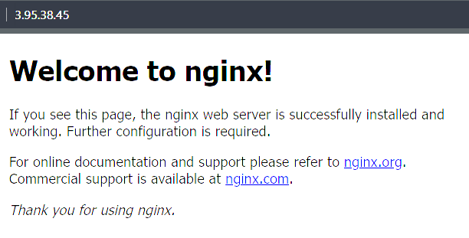

1. Now type the following commands:
   * cd /
   * pwd
   * cd etc/nginx/sites-available/
   * sudo nano default



1. In the “default” file, comment out all lines under location. Then type the following lines in place of location.
   * location / {

proxy_pass http://localhost:4000;

proxy_http_version 1.1;

proxy_set_header Upgrade $http_upgrade;

proxy_set_header Connection ‘upgrade’;

proxy_set_header Host $host;

proxy_cache_bypass $http_upgrade;

}

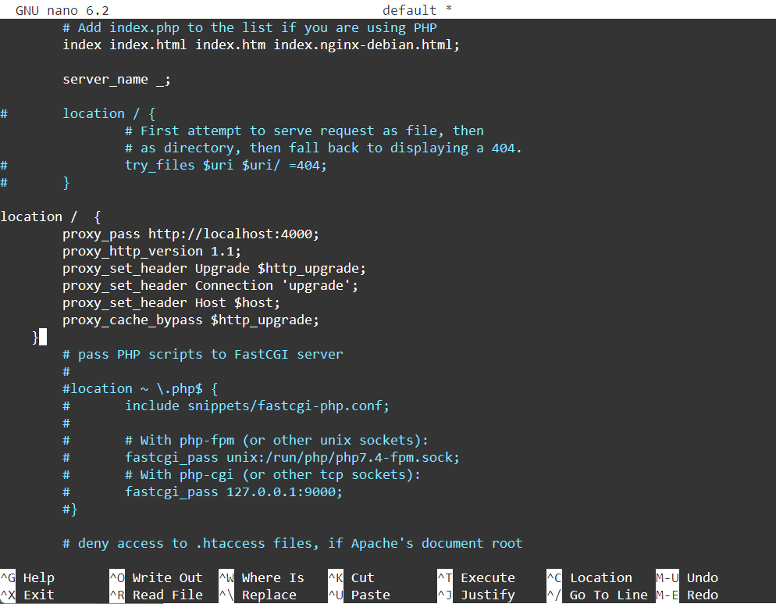

To save and exit, press Ctrl+X, then Y and press Enter.

1. Open new server terminal and type
   * cd new-repo1
   * sudo systemctl restart nginx
2. Paste the copied IPv4 address in browser.



Here, the page has been accessed without using any port number with the IPv4 address.