**Assignment – 13**

**Problem Statement:**

**Create a work mail for your organization.**

1. First, go to Amazon Workmail.

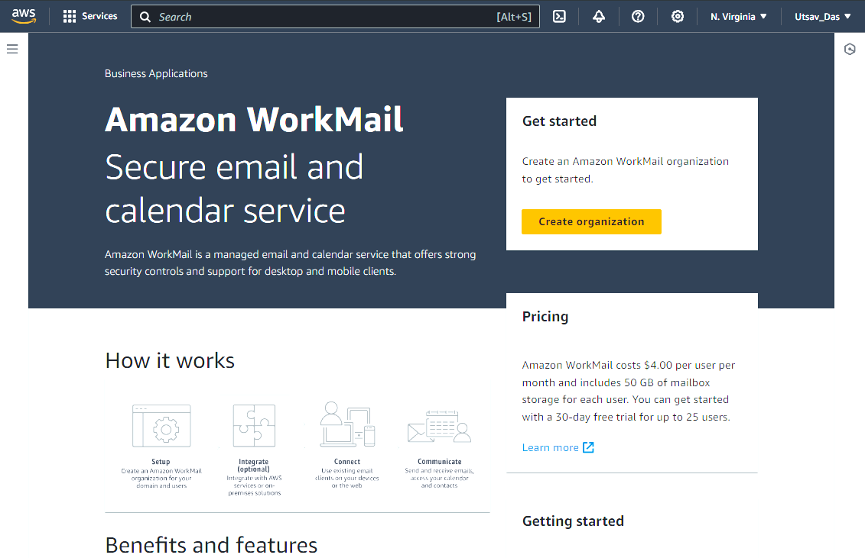

1. Click on Create organization and select Free test domain in Organization settings and give alias name.

1. Click on Create organization and now click on it.

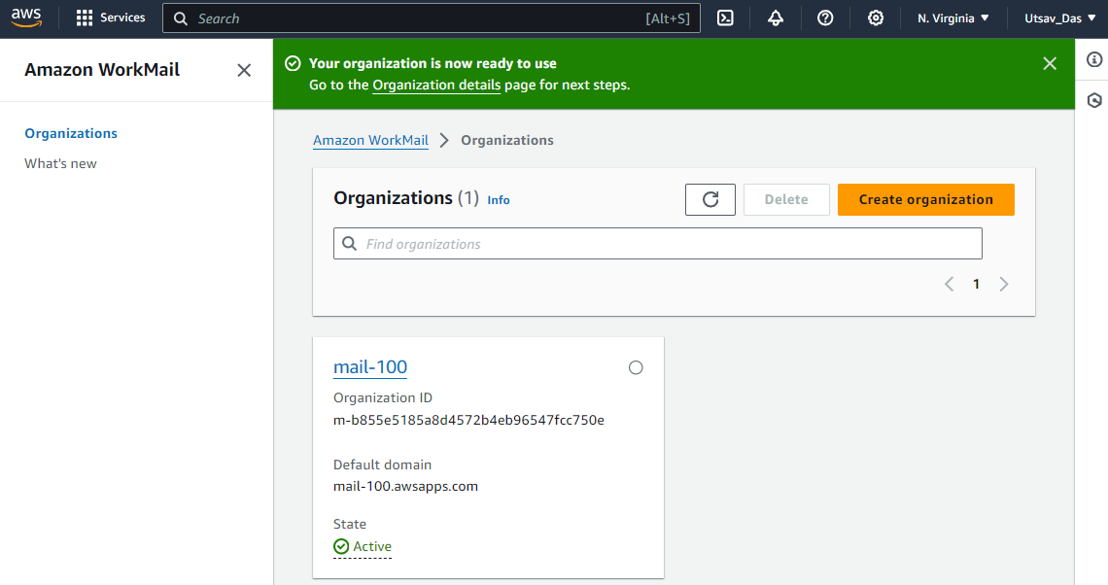

1. Now in left pane click on Users in Organization.

1. Click on Add user.

1. Fill all User details.

1. Give password and Repeat password and click on Add user.

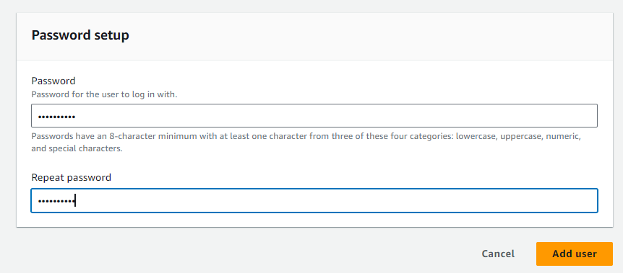

1. You can also click on User details to check all info.

1. Go back to Organization and click on link in Amazon Workmail web application.

1. Give username and password and then Sign in.

1. Click on New item then New email.

1. Now give receiver’s email id and subject and click on Send.

1. In Sent Items you can see all send sent emails.

1. Open email and you can see your sent email to given email id.

1. Now log out from opened Amazon Workmail and then select your created organization and then click on Delete.

1. Confirm deleting by giving organization name and click on Delete Organization.

