**Assignment – 14**

**Problem Statement:**

**Create an Elastic IP for an Instance.**

1. Click on Launch Instance and then give name of instance and then select Ubuntu.

1. Select existing key pair. Under Create security group select all SSH, HTTP, HTTPS options.

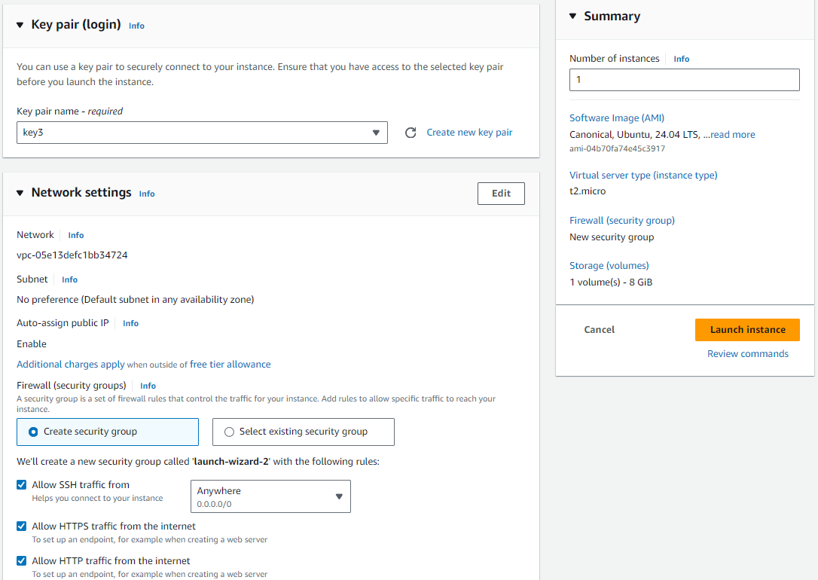

1. Copy the public IPv4 address in notepad.
2. Stop the created instance.

1. Start the stopped instance.

1. Again copy the public IPv4 address in notepad and here you can see that IPv4 address changed as it fetches new one from AWS pool of IPv4 address.

1. So not to change IP address we use elastic IP. So go to Elastic IPs in Network & Security group and click on Allocate Elastic IP address.

1. Now click on Allocate.

1. Click on Allocate IPv4 address.

1. Click on Associate Elastic IP address.

1. Select on instance and then click on Associate.

1. Go back to EC2 instance and then copy public and public IPv4 address and paste in notepad.

1. Stop and start instance again then paste that newly restarted instance public IPv4 address in notepad. They are the same IPv4 address.

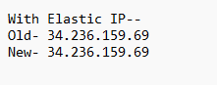

1. Delete elastic IP select that and click on Disassociate Elastic Ipv4 address.

1. Click on Disassociate.

