**Assignment – 15**

**Problem Statement:**

**Create a Serverless computing service.**

1. Go to Lambda then click on Create a function.

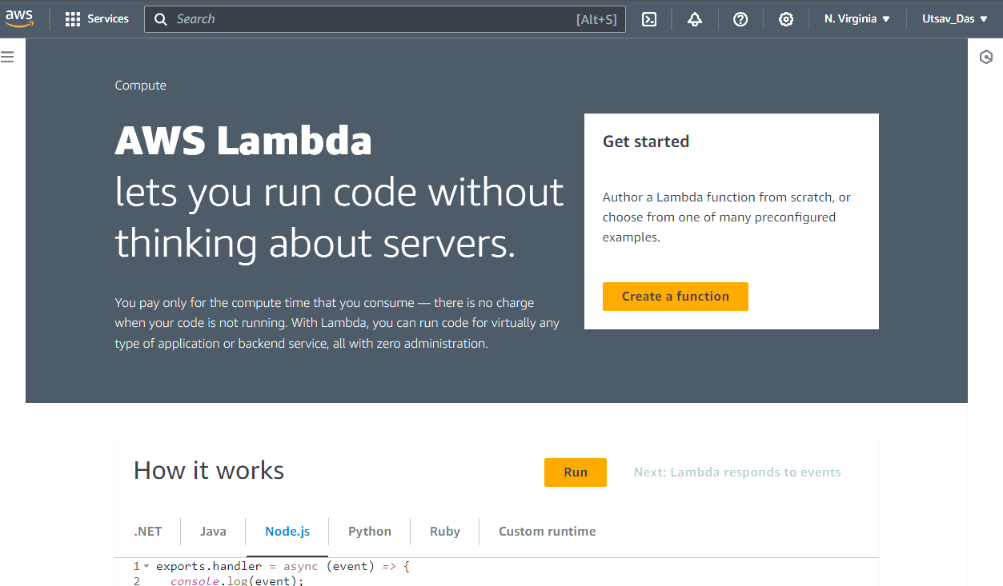

1. Give a function name and then in Runtime, select any language like

Python 3.12

1. In Advanced settings click on Enable function URL then in NONE option in Auth type. Click on Create function.

1. In Code section change the code and then Deploy.

1. In Test, click on Create new event and give name test1 and then click on Test.

1. In Configuration copy function URL.

1. Paste URL in new tab and you can see changed code.

1. Go back to Function, select it and then in Actions click on Delete.

1. Confirm your delete and close.

