**Assignment – 3**

**Problem Statement:**

Create IAM user and give full access to S3.

1. Go to ‘https://console.aws.amazon.com’ & sign in to AWS account.
2. Search for ‘IAM’ & go to ‘IAM’.

1. Go to ‘Users’ under ‘Access management’ & click ‘Create user’.

1. Give user name.   
   Select ‘I want to create an IAM user’.  
   Select ‘Custom password’.  
   Give a password according to the constrains.   
   Uncheck ‘Users must create a new password at next sign-in’.  
   Click ‘Next’.

1. Select ‘Add user to group’.  
   Click ‘Create group’.

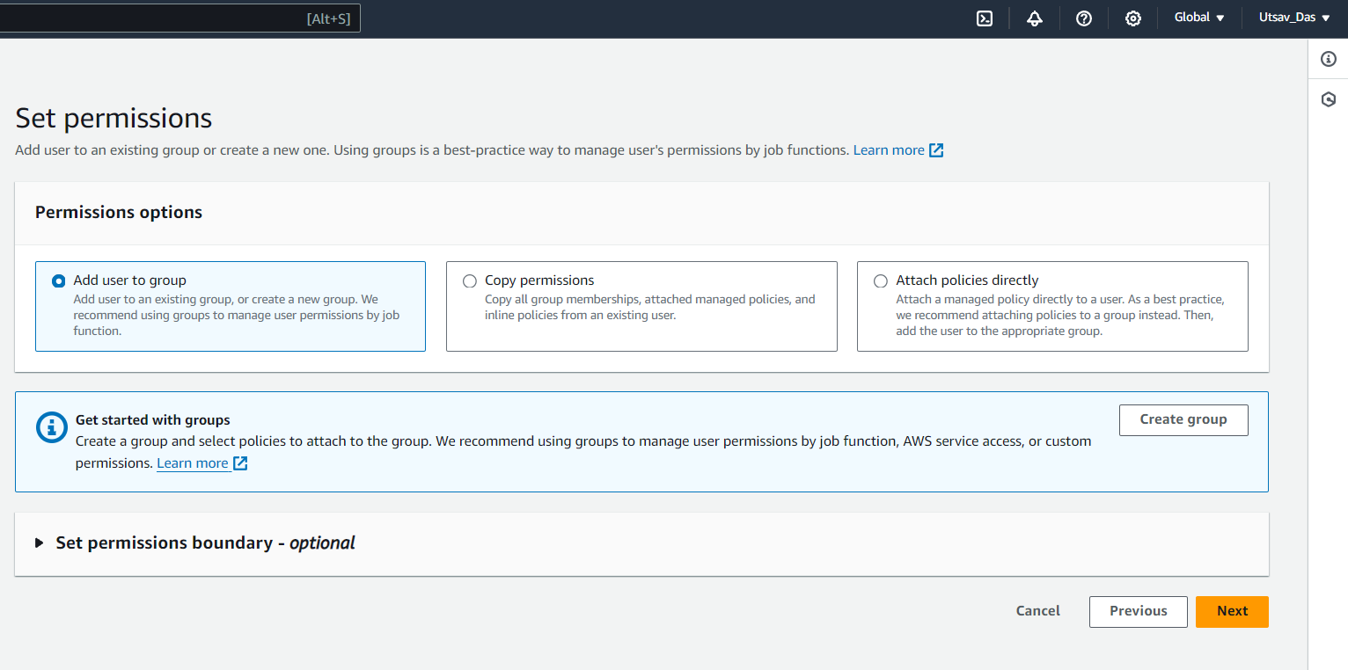

1. Give ‘User group name’.  
   Search for S3 permission.  
   Check the row with policy name ‘AmazonS3FullAccess’.  
   Click ‘Create user group’.

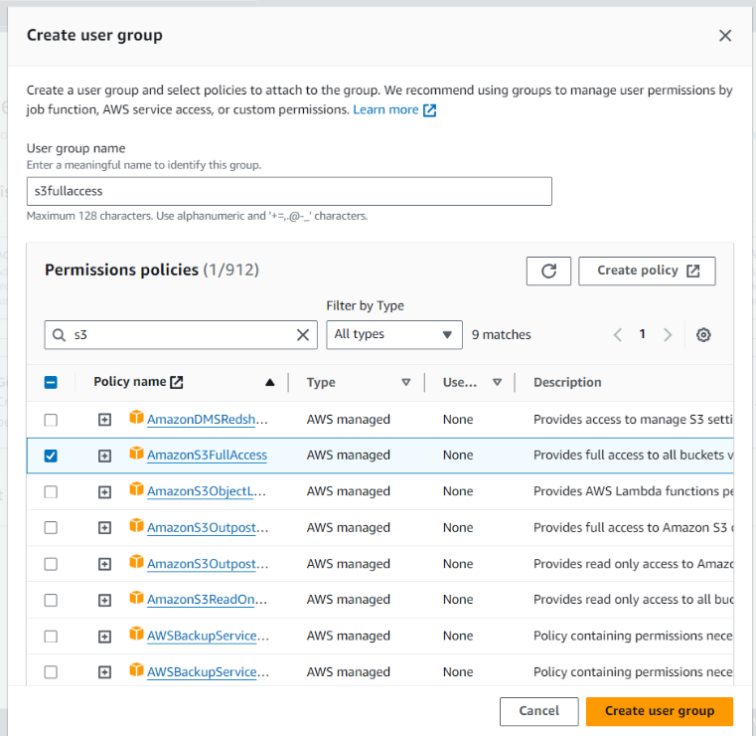

1. Check the user group ‘s3fullaccess’.  
   Click ‘Next’.

1. Review all details & click ‘Create user’.

1. A screenshot of a computer

   Description automatically generatedA screenshot of a computer

   Description automatically generatedIAM user is created. Download the csv file for future use.  
   Click ‘Return to users list’.
2. Signout from the root user.  
   Go to login page of AWS console.  
   Select ‘IAM user’.  
   Give 12 digit account ID from the url in downloaded csv file.(Ex-632288837993)  
   Click ‘Next’.  
   Give ‘IAM user name’ (Ex-user1) & ‘Password’ (Ex-User1@1234) from the  
   downloaded csv file & click ‘Sign in’.  
   Now IAM user login successfully completed.

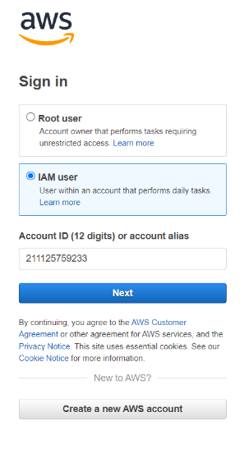

1. Now search for ‘S3’ & go to ‘S3’.

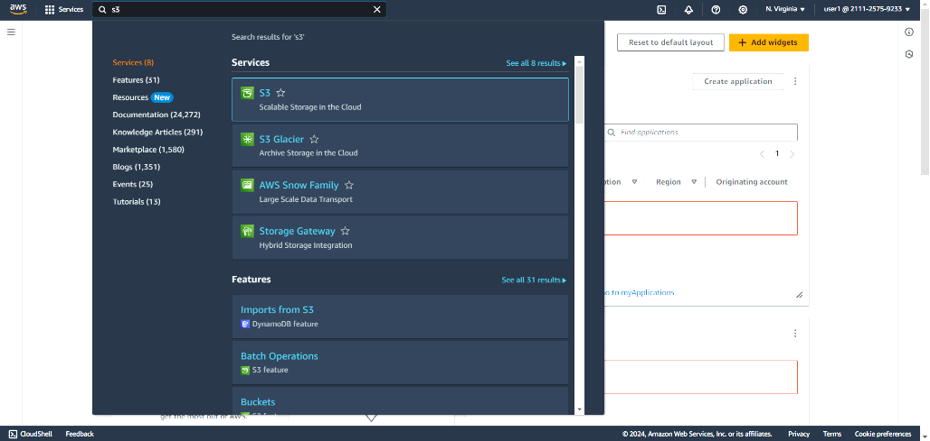

1. We can use the features of ‘S3’ as ‘user1’ has full access to ‘S3’.

1. Now search for ‘EC2’ & go to ‘EC2’.

1. We cannot use the features of ‘EC2’ as ‘user1’ has no access to ‘EC2’.

