**Assignment – 4**

**Problem Statement:**

Create a private bucket in AWS Upload a file and check by reassigned URL whether you can access the file or not.

1. Search S3 in search bar and click on it.

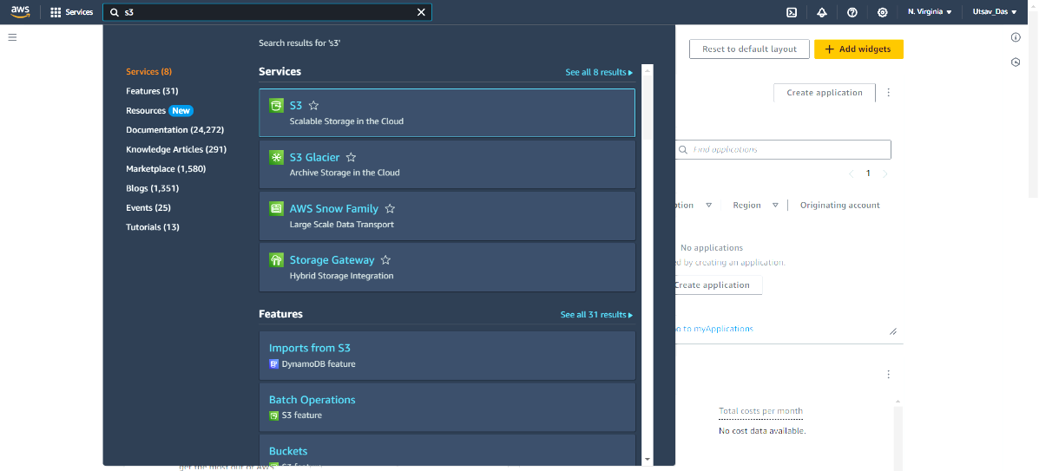

1. Now click on Buckets in left side panel.

1. Now click on Create bucket.

1. A screenshot of a bucket

   Description automatically generatedA screenshot of a computer

   Description automatically generatedSelect AWS region Mumbai and give bucket name and remember this name should be unique as it is global. ACLs(Access Control List) is disabled. We have also kept ‘Block all public access’ checked. Now click on Create bucket.

1. Click on newly created bucket.

1. Click on Upload.

1. Click on Add files.

1. After selecting file click on Upload.

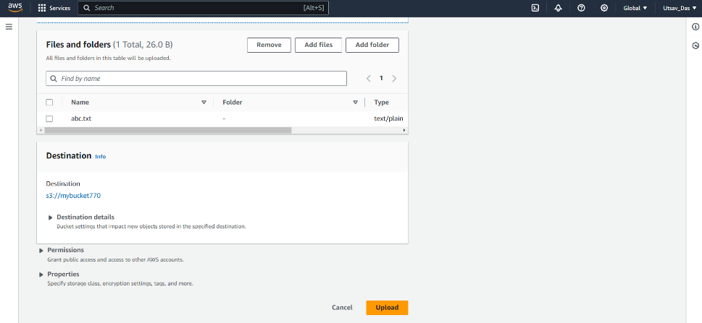

1. Now Upload has succeeded. Click on Close.

1. Go back to Buckets. Click on bucket name and click on checkbox of uploaded file name. Click on Actions dropdown and click on 'Share with a Presigned URL'.

1. Select time intervals for presigned URL as Minute. And give number of minutes and click on Create Presigned URL.

1. Now paste and enter this URL in new tab and as we have given 10 minutes time interval so after 10 minutes no one can access it again.

