**Assignment – 5**

**Problem Statement:**

Create a public Bucket in AWS. Upload a file and give the necessary permission to check whether the file URL is working.

1. Click on S3 and click on Create bucket.

1. Give region Mumbai and give bucket name.

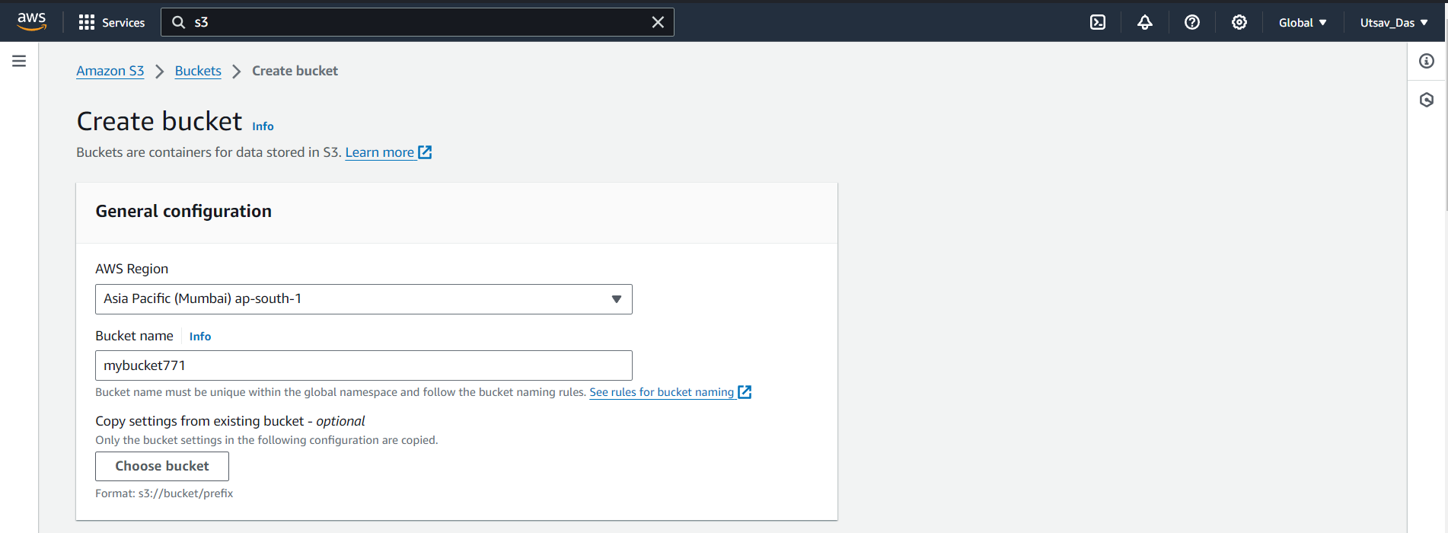

1. Click on ACLs enabled.

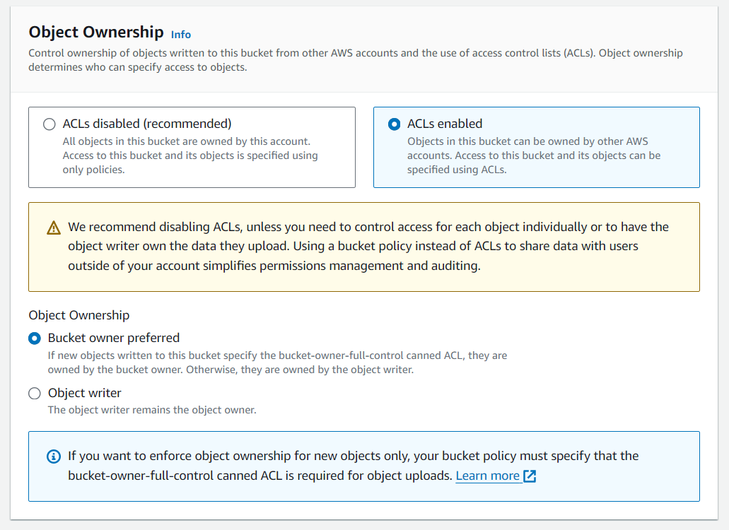

1. Uncheck Block all public access and click on check box 'I acknowledge that the current settings might result in this bucket and the objects within becoming public'.

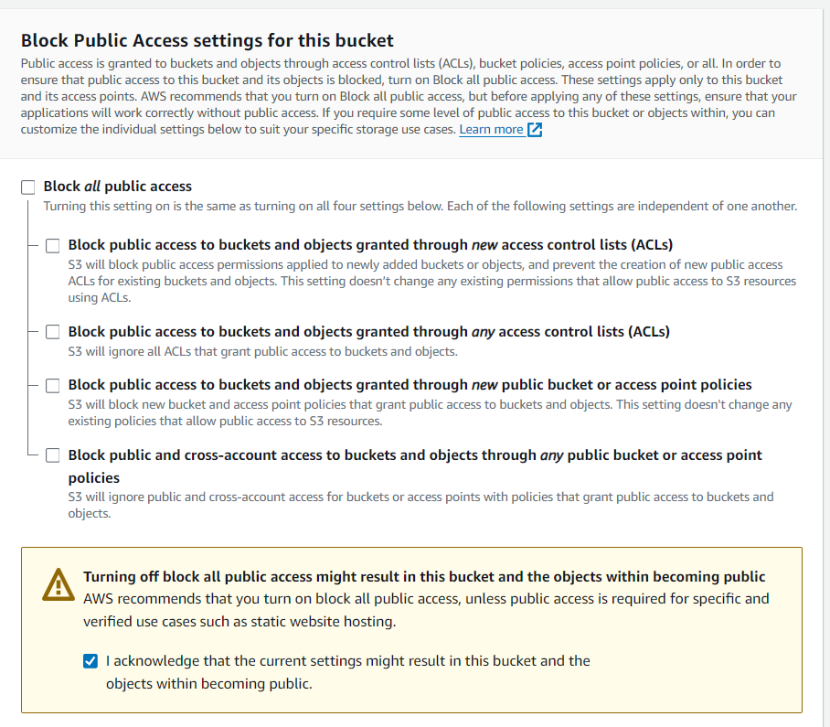

1. Click on Create bucket.

1. Click on bucket name.

1. Click on Permission.

1. Click on edit option of ACLs

1. Click on check box of list and read in Everyone(public access).

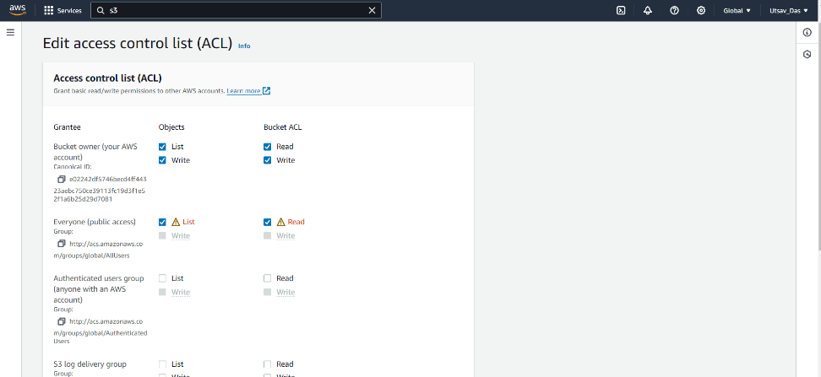

1. Click on check box 'I understand the effects of these changes on my objects and buckets' and finally click on Save changes.

1. Go back to Buckets option and click on bucket name and click on Upload.

1. Click on Add files and upload any file.

1. After uploading click on Permission dropdown and click on check box Specify individual ACL permissions. Click on check box of 'Read in Everyone(public access)'.

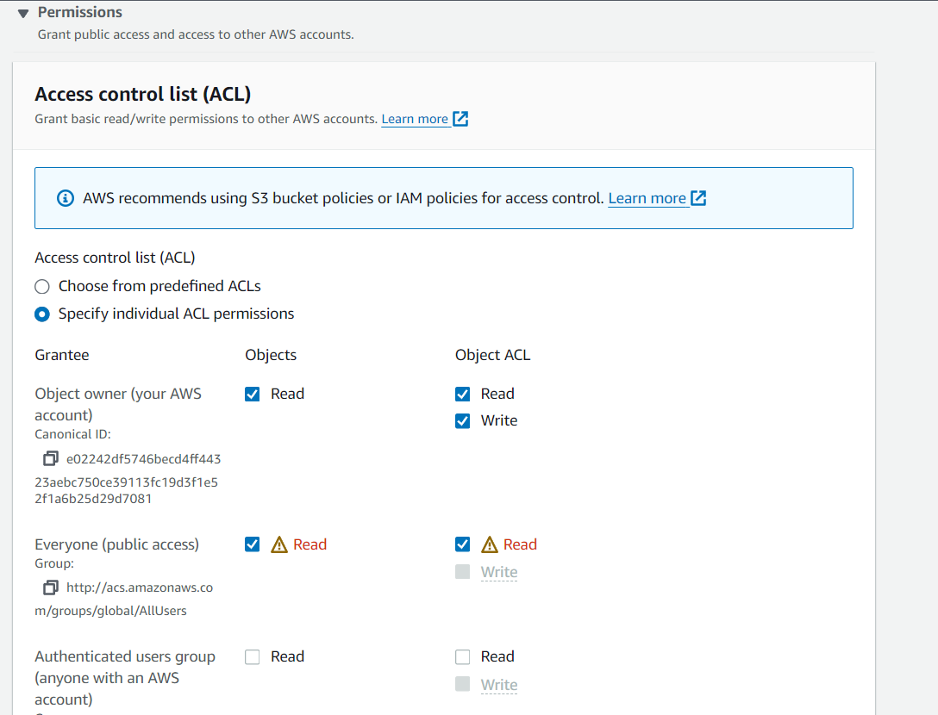

1. Now click on 'I understand the effects of these changes on the specified objects' checkbox and click on Upload option.

1. After successful upload now go back to Bucket again. Click on bucket name and now click on file option checkbox. Then click on Copy URL option.

1. Paste URL in incognito mode.

1. Anyone can access it now as it is public.