**Assignment – 6**

**Problem Statement:**

**Upload a static website on S3.**

1. First, 3 static webpages index.html, about.html, home.html are created.

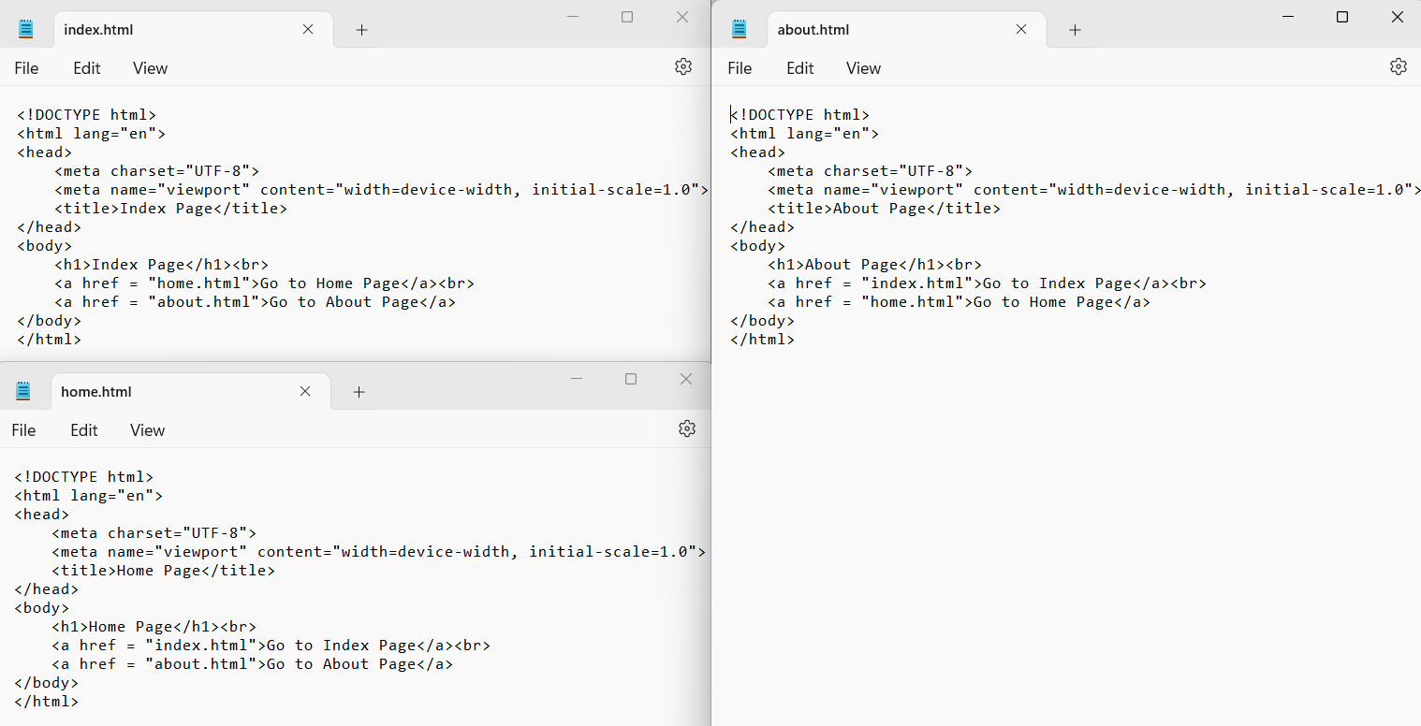

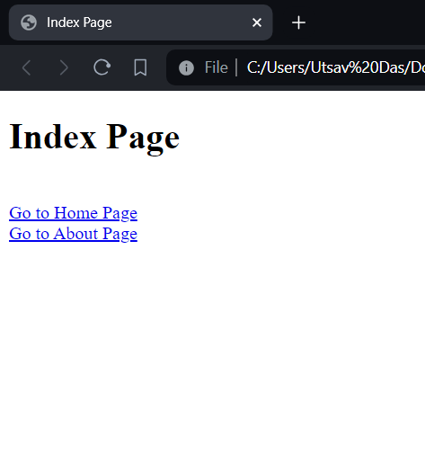 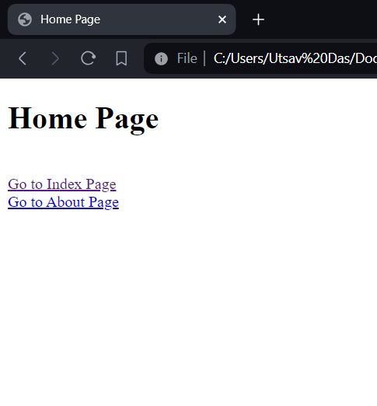 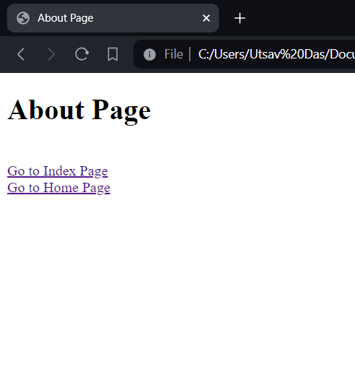

1. Open S3.

1. Click on Create bucket.

1. Select region Mumbai and give name of bucket and this name should be unique.

1. Enable ACLs for public access purpose.

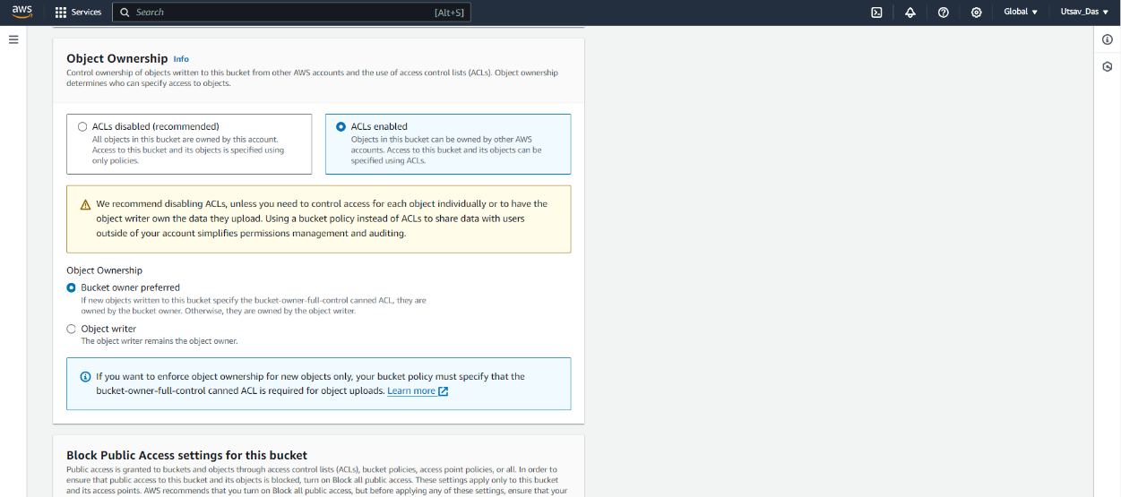

1. Uncheck block all public access option and click on checkbox I acknowledge that the current settings might result in this bucket and the objects within becoming public.

1. Click on Create bucket. Bucket will be successfully created.

1. Enter in newly created bucket and by clicking it.

1. Start to upload each index, home, about pages. Click on upload and then Add files. Click on all checkboxes of uploaded files and click on Upload.

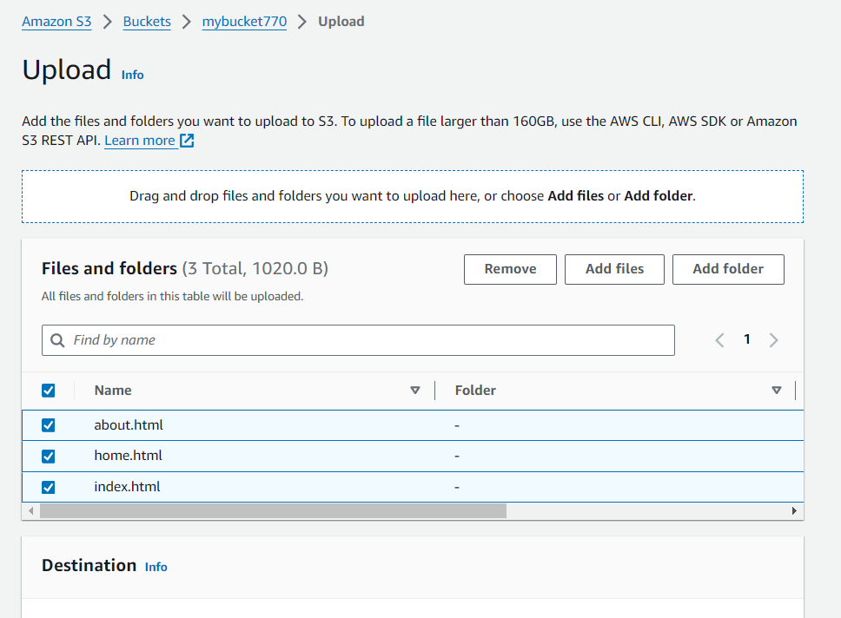

1. Click on Close.

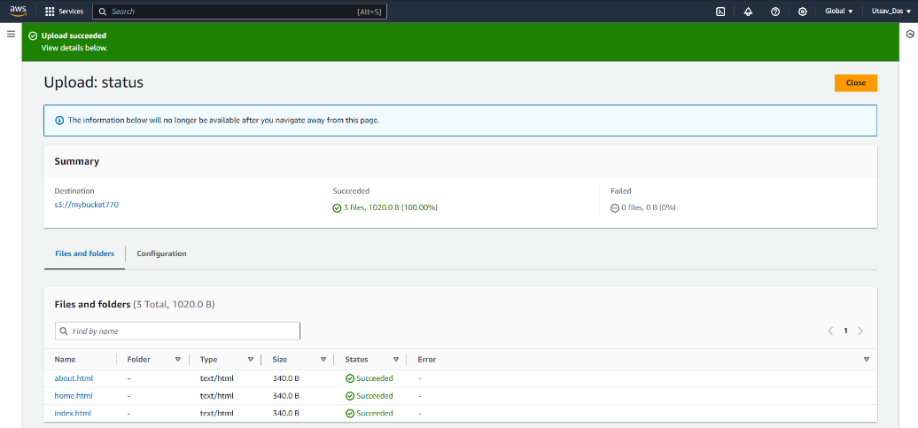

1. Go to Properties option and go to Static website hosting and click on Edit.

1. Click on Static website hosting Enable.

1. Give name of index document as index.html. Click on Save changes.

1. Go to Permission for bucket and then to ACLs and click on edit option. Then click on List and Read checkbox.

1. Click on check box ‘I understand the effects of these changes on my objects and buckets’ and click on save changes.

1. Each uploaded files has to be made public. So at first we enter in index.html and go to Permission section and click on Read option of Everyone(public access) in ACL.

1. Click on I understand checkbox and click on Save changes.

1. We do same for home.html and about.html.
2. Then go to Properties and go to Static Website Hosting and copy the link generated at that section.

1. Paste this link after copying in another tab and there we can see the website. All 3 pages are working.

