**Assignment – 7**

**Problem Statement:**

**Hosting a Website on EC2.**

1. Create 3 Static Webpages using HTML.
2. Click on the “EC2” button.

1. Click on the “Launch Instance” button.

1. Give a name to the instance & select “Ubuntu”.

1. Create a new one by clicking on “Create New Key Pair” button

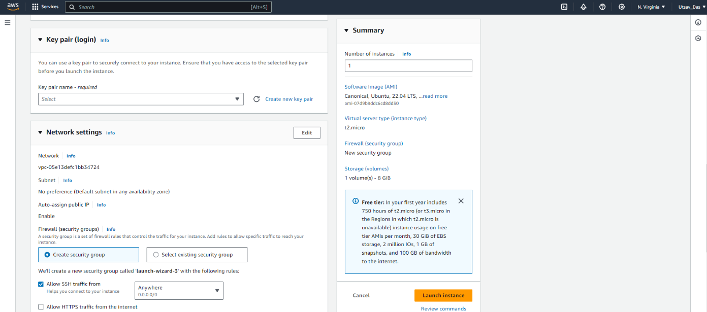

1. Give a name to the key pair. Then click “Create Key Pair”.

1. Select all the Security options. Then click on “Launch Instance”.

1. The new instance is thus created successfully. A screenshot of a computer

   Description automatically generated
2. To Enter the Instance click on its ID. Copy the “Public IPv4 Address” of the instance.

1. Paste IP address under Host. Then go to the “Client Key Manager” option.

1. Click on the “Import” button & select the key & click “Import”.

1. The new key is successfully added. Click “Import”.

1. Give the username as “ubuntu, select “Public Key” & ” select “Global1”. Then click the “Log in” button.

1. Click on the “Accept & Save” button.

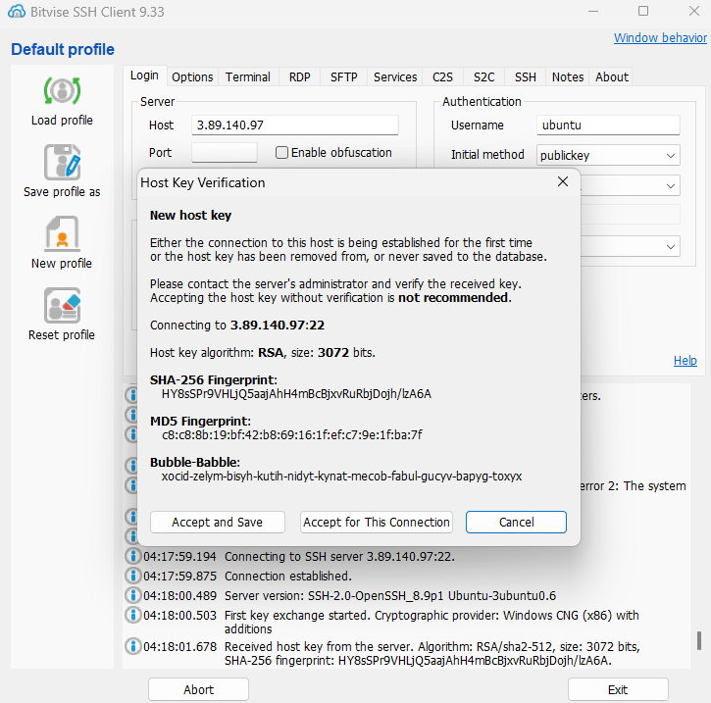

1. Now the client is connected.

1. Click on the “New SFTP Window” button.

1. Under Local Files open the folder where the HTML files are present.

1. Go to the terminal and type the following commands.

“ sudo apt-get update “ , ” sudo apt-get upgrade “ , “ sudo apt-get install nginx ”



1. Go to the ‘/var/www’ folder and type the command

“sudo chmod 777 html” and press “Enter”.

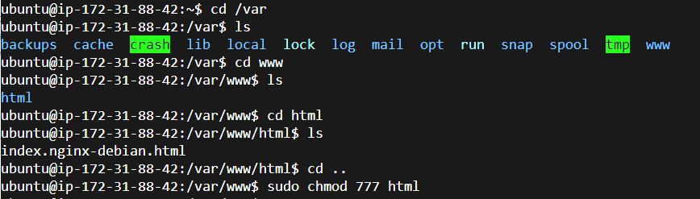

1. Now going back to the “SFTP Window” under the “Remote Files” open the HTML directory and drag & drop the HTML files.

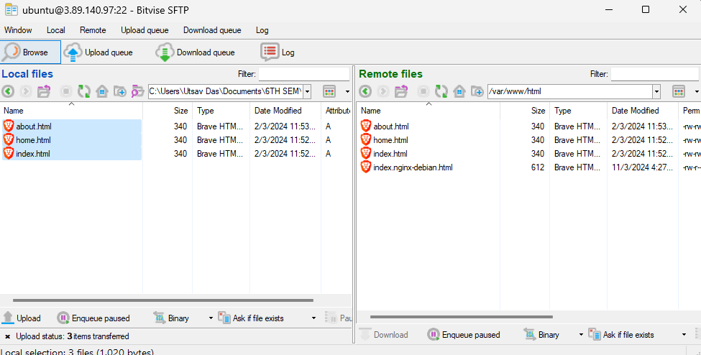

1. Now go back to the “AWS Window” and click on the “Open Address” button beside the IP address.

1. A new window will open with the webpage.

