**Assignment – 8**

**Problem Statement:**

**Deploy a project from a local machine to GitHub and vice versa.**

1. First, create a new repository by clicking New.

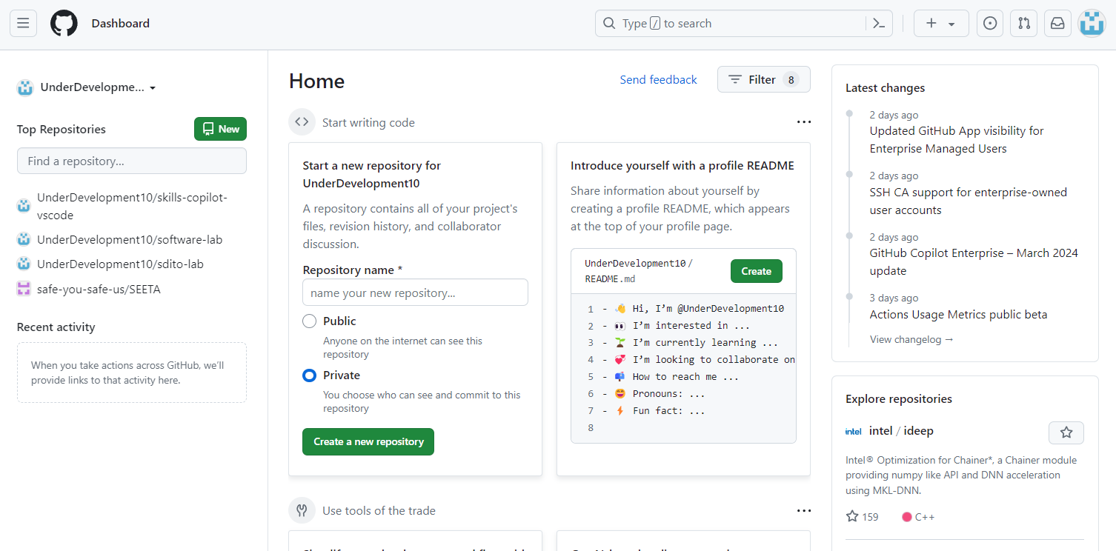

1. Give repository name and make it public.

1. Click on Create repository.

1. Click on Account section and then go to Settings.

1. Click on Developer settings.

1. Click on Personal access tokens dropdown, select Tokens(classic). Then, from Generate new tokens, click Generate new token(classic).

1. In Expiration select No expiration.

1. In Select scopes select all options and click Generate token.

1. After generating token click on copy option for token and save it in text document.

1. Then, go to Control Panel and click on User’s account.

1. Go to Manage Windows Credentials.

1. In Generic Credential remove any previous GitHub account.

1. Now, right click on website folder and open git bash here.

1. Write all the following commands:
   * git init :– to initialize git repository
   * dir :– to see what files present in folder
   * git add . :– to add all files to git repository
   * git status :– to check status of files(committed or not)
   * git commit –m “Done” :– Commit files with given message
   * git remote add origin https://github.com/UnderDevelopment10/software-lab.git :– to connect remote repository to the local repository
   * git push –u origin master :– to push the commits from local "master" branch to the remote repository named "origin"

1. After push command a new window opens. Go to token option, paste the copied token text, and click on Sign in.

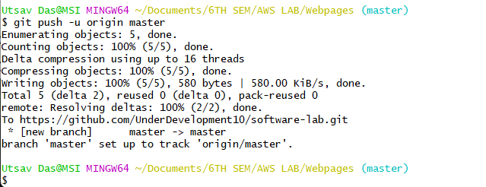

1. Go back to GitHub and enter created repository, where all uploaded files can be seen.

1. Click on Code and copy Clone HTTPS link.

1. Make a new folder and open with git bash.

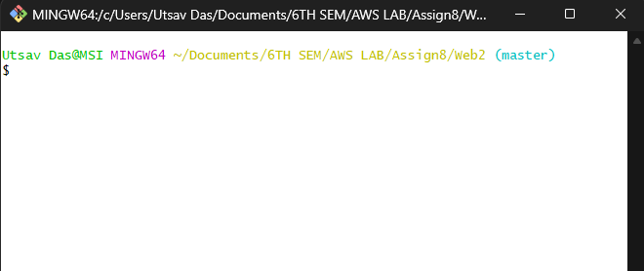

1. Now write all following commands:
   * git init :– to initialize git repository
   * git clone :– to create a copy of a remote Git repository on local machine.

1. We can see that repository is copied into new folder Web2.

1. In this way we have deployed a project from local machine to GitHub and vice versa.