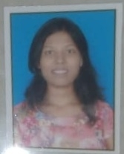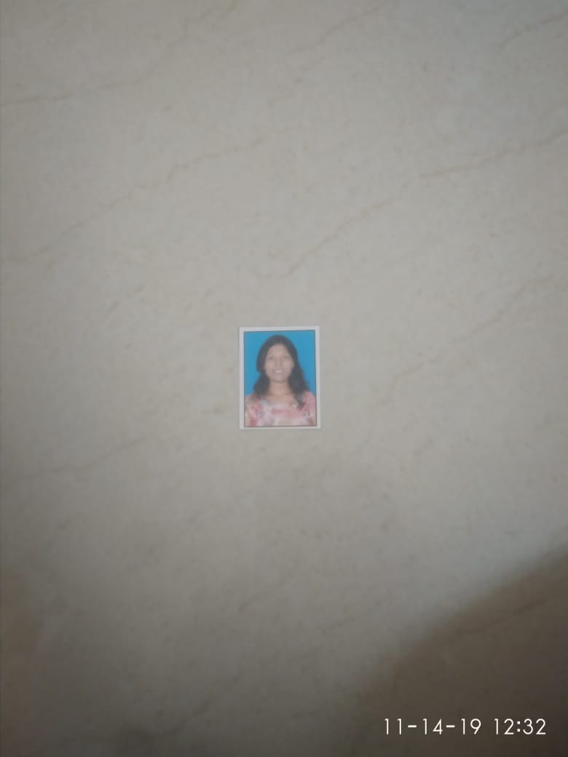

|  |  |
| --- | --- |
| **Pooja Laxman** **Pawar**  Mobile No. - 9834676093  Email Id - [poojalaxmanpawar03@gmail.com](mailto:sapnadeshmukh249@gmail.com) |  |

|  |
| --- |
| **CAREER OBJECTIVE** |

Career in a leading corporate environment with committed and dedicated people Where I can utilize my education skill ,abilities and work in a challenging and creative environment..

|  |
| --- |
| **TECHNICAL SKILLS** |

* Strong in SDLC, STLC and Defect Life Cycle
* Knowledge of Writing, reviewing and executing Test Cases and creating Defect Report
* Knowledge of Levels of Testing, Methods of Testing and Types of Testing
* Experience in Testing Web Applications
* **Data base:** MYSQL in oracle environment
* **Tools:** Mantis BT, Tarantula
* **Programming language**: Core java, PHP, HTML, CSS, Java script.
* Selenium Java, Selenium Oops, Selenium Web driver, TestNG

|  |
| --- |
| **PROJECT** |

**Manual Testing project:**

**Project name 1: - Front** Accounting

**Project Description:**

Front Accounting is a professional Web-based Accounting System for Enterprise Resource Planning (ERP). It is Developed in PHP/Ajax using MySQL database management system. The recommended HTTP web servers are Apache and Internet Information Services (IIS). Purchases, controlling stock, issuing offers, registering orders and sending invoices.

**Roles:**

* Requirement Analysis
* Test Cases Creation and Execution
* Defect Reporting with Excel Application.

**Project name 2: Agro Agency Mgnt System**

**Project Description:**

Agro Agency Mgnt System is Desktop based application .This system maintain all details about Stock, Customers, Suppliers.

The computerized Agro Agency system software collects & maintain a databases having information about & daily reports, Monthly reports.

The computerized system is provides the storage & Instance access of all critical information. It manages everything form data entry, daily reports etc.

|  |
| --- |
| **EDUCATIONAL QUALIFICATION** |

|  |  |  |  |  |
| --- | --- | --- | --- | --- |
| **Year** | **Degree** | **Institute** | **University** | **Aggregate**  **(%)** |
| 2018 | BBA (CA) | C. D. J college | Pune | 51.66 |
| 2015 | HHS | R. B. N. B college | Pune | 47.69 |
| 2013 | SSC | J. W. Adik Vidyalay Khanapur | Pune | 76.80 |

|  |
| --- |
| **PERSONAL SKILLS** |

* Good in Team Work
* Problem Solving Ability
* Quick Learner

|  |
| --- |
| **PERSONAL DETAILS** |

|  |  |
| --- | --- |
| Date of Birth: | 3 April 1998 |
| Gender: | Female |
| Marital Status: | Unmarried |
| Languages Known: | English, Hindi, Marathi |
| Address: | Near Tapodham bus stop, Warje, Pune |

|  |
| --- |
| **DECLARATION** |

I hereby certify that all the above details are true and correct to the best of my knowledge and belief.

**Place: Pune Signature:**

**Date: Name: Pooja Laxman Pawar**