**Personal Slot Animal Reflection**

Our second project for ED1 was slot animal creation using the laser cutter on plywood.

**The steps we used were:**

* Brainstorm ideas for animal of choice and how to incorporate slots into the design.
* Create drawings and design how the overall image is meant to look.
* Create paper prototypes with all the slots and dimensions; make modifications and measurement changes if need be.
* Take photos and visualize the paper prototypes – patterns are flexible at this point so additions or retractions were made.
* Us Adobe illustrator to digitalize our ideas from our paper prototype exploded view images, using raster and score layers to prepare the images for laser machine interpretation.
* Finalize the digital version of slot animal exploded image file in illustrator.
* Ms. Hedstrom kindly assisted the class with this next step by using the laser cutting machine to prepare secondary prototypes (out of carboard); to make sure everything fit in place correctly.
* Once confirmed on dimensions and design, we operated the laser machine to produce the final product using plywood.
* Attached the final pieces of designs together to create the final product.

**My process:**

I created a African leopardsitting on a dead tree. This appealed to me as it is my favorite animal while adding a touch of wildlife from my home country. I incorporated the slots into the tree, making it a bigger platform. It has three three main branches joined by slots with the flexibility to raise the middle branch and create a different desing effect. The leopard itself is a flat carved piece of plywood with three tails – they three tails signify movement while resting. I borrowed some paper and utensils from the ED lab and worked on my paper prototype further at home. I was able to finalize my ideas while being more creative in a close environment. I worked closely with Ms. Riley and Ms. H to understand how to modify my exploded animal design for laser cutting using Adobe illustrator.

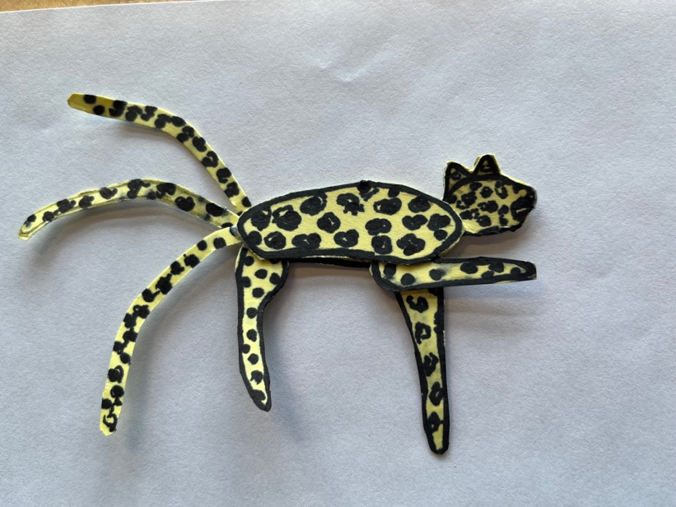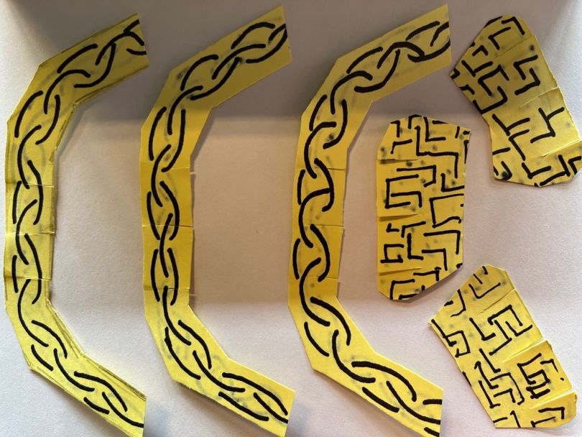

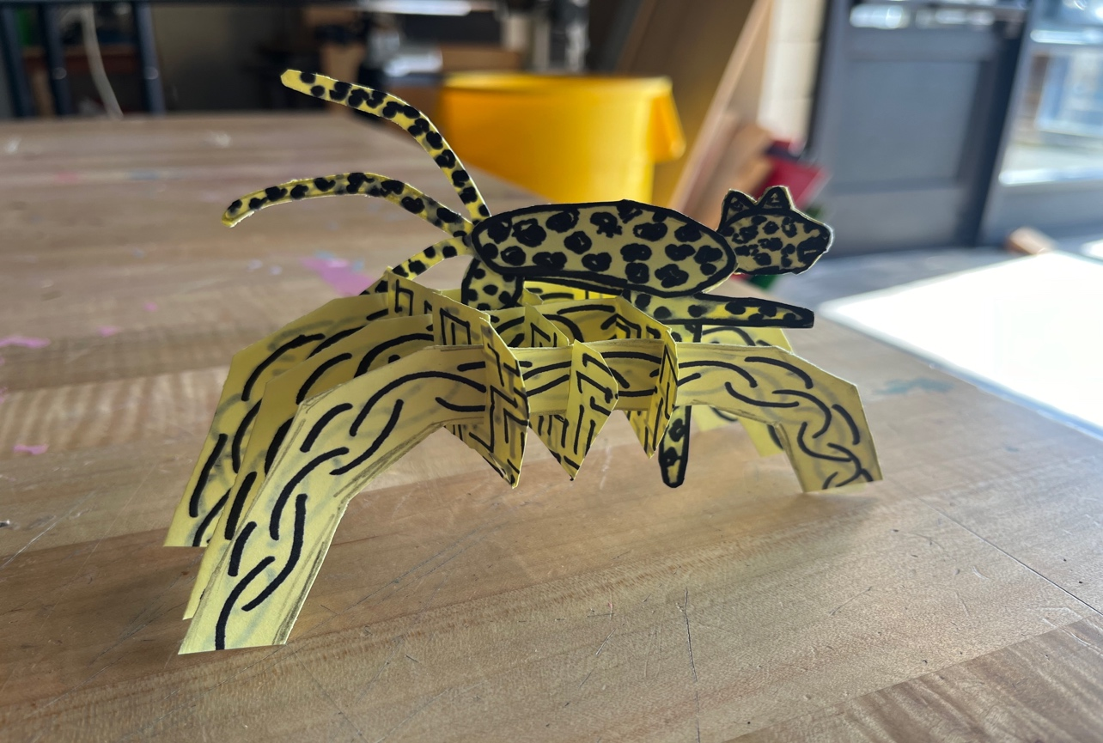

**Challenges, setback and solutions:**

I face two main challenges during this process: getting the slots to fit properly with varying lengths of branches (especially during my paper design) as structural rigidity was a concern for me and making the overall design the correct size for plywood dimension available. I used the three branches approach to support the structure and copied one individual branch three times to give a better fit the slots, meaning I discarded the other individually drawn branches.This made for a better outcome. For the size, I downscaled while in prototype phase of the project.

**Finished Product:**

