Assignment 7: Time Series Analysis

Lehe, Xu

## OVERVIEW

This exercise accompanies the lessons in Environmental Data Analytics on time series analysis.

## Directions

1. Change “Student Name” on line 3 (above) with your name.
2. Work through the steps, **creating code and output** that fulfill each instruction.
3. Be sure to **answer the questions** in this assignment document.
4. When you have completed the assignment, **Knit** the text and code into a single PDF file.
5. After Knitting, submit the completed exercise (PDF file) to the dropbox in Sakai. Add your last name into the file name (e.g., “Fay_A07_TimeSeries.Rmd”) prior to submission.

The completed exercise is due on Monday, March 14 at 7:00 pm.

## Set up

1. Set up your session:

* Check your working directory
* Load the tidyverse, lubridate, zoo, and trend packages
* Set your ggplot theme

#1  
getwd()

## [1] "D:/Documents/Environmental_Data_Analytics_2022"

library(tidyverse)

## -- Attaching packages --------------------------------------- tidyverse 1.3.1 --

## v ggplot2 3.3.5 v purrr 0.3.4  
## v tibble 3.1.6 v dplyr 1.0.8  
## v tidyr 1.2.0 v stringr 1.4.0  
## v readr 2.1.2 v forcats 0.5.1

## -- Conflicts ------------------------------------------ tidyverse_conflicts() --  
## x dplyr::filter() masks stats::filter()  
## x dplyr::lag() masks stats::lag()

library(lubridate)

##   
## 载入程辑包：'lubridate'

## The following objects are masked from 'package:base':  
##   
## date, intersect, setdiff, union

library(trend)  
library(zoo)

##   
## 载入程辑包：'zoo'

## The following objects are masked from 'package:base':  
##   
## as.Date, as.Date.numeric

library(Kendall)  
library(tseries)

## Registered S3 method overwritten by 'quantmod':  
## method from  
## as.zoo.data.frame zoo

mytheme <- theme_classic(base_size = 14) +  
 theme(axis.text = element_text(color = "black"),   
 legend.position = "top")  
theme_set(mytheme)

1. Import the ten datasets from the Ozone_TimeSeries folder in the Raw data folder. These contain ozone concentrations at Garinger High School in North Carolina from 2010-2019 (the EPA air database only allows downloads for one year at a time). Import these either individually or in bulk and then combine them into a single dataframe named GaringerOzone of 3589 observation and 20 variables.

#2  
Ozone0 <- read.csv("./Data/Raw/Ozone_TimeSeries/EPAair_O3_GaringerNC2010_raw.csv", stringsAsFactors = TRUE)  
Ozone1 <- read.csv("./Data/Raw/Ozone_TimeSeries/EPAair_O3_GaringerNC2011_raw.csv", stringsAsFactors = TRUE)  
Ozone2 <- read.csv("./Data/Raw/Ozone_TimeSeries/EPAair_O3_GaringerNC2012_raw.csv", stringsAsFactors = TRUE)  
Ozone3 <- read.csv("./Data/Raw/Ozone_TimeSeries/EPAair_O3_GaringerNC2013_raw.csv", stringsAsFactors = TRUE)  
Ozone4 <- read.csv("./Data/Raw/Ozone_TimeSeries/EPAair_O3_GaringerNC2014_raw.csv", stringsAsFactors = TRUE)  
Ozone5 <- read.csv("./Data/Raw/Ozone_TimeSeries/EPAair_O3_GaringerNC2015_raw.csv", stringsAsFactors = TRUE)  
Ozone6 <- read.csv("./Data/Raw/Ozone_TimeSeries/EPAair_O3_GaringerNC2016_raw.csv", stringsAsFactors = TRUE)  
Ozone7 <- read.csv("./Data/Raw/Ozone_TimeSeries/EPAair_O3_GaringerNC2017_raw.csv", stringsAsFactors = TRUE)  
Ozone8 <- read.csv("./Data/Raw/Ozone_TimeSeries/EPAair_O3_GaringerNC2018_raw.csv", stringsAsFactors = TRUE)  
Ozone9 <- read.csv("./Data/Raw/Ozone_TimeSeries/EPAair_O3_GaringerNC2019_raw.csv", stringsAsFactors = TRUE)  
GaringerOzone <- rbind(Ozone0,Ozone1, Ozone2, Ozone3, Ozone4, Ozone5, Ozone6, Ozone7, Ozone8, Ozone9)

## Wrangle

1. Set your date column as a date class.
2. Wrangle your dataset so that it only contains the columns Date, Daily.Max.8.hour.Ozone.Concentration, and DAILY_AQI_VALUE.
3. Notice there are a few days in each year that are missing ozone concentrations. We want to generate a daily dataset, so we will need to fill in any missing days with NA. Create a new data frame that contains a sequence of dates from 2010-01-01 to 2019-12-31 (hint: as.data.frame(seq())). Call this new data frame Days. Rename the column name in Days to “Date”.
4. Use a left_join to combine the data frames. Specify the correct order of data frames within this function so that the final dimensions are 3652 rows and 3 columns. Call your combined data frame GaringerOzone.

# 3  
GaringerOzone$Date <- as.Date(GaringerOzone$Date, format = "%m/%d/%Y")  
  
# 4  
GaringerOzone.subset <- select(GaringerOzone, Date, Daily.Max.8.hour.Ozone.Concentration, DAILY_AQI_VALUE)  
# 5  
Days <- as.data.frame(seq(as.Date("2010/01/01"), as.Date("2019/12/31"), "day"), row.names=NULL )  
  
colnames(Days)<-c("Date")  
  
# 6  
GaringerOzone <- left_join(Days, GaringerOzone.subset)

## Joining, by = "Date"

## Visualize

1. Create a line plot depicting ozone concentrations over time. In this case, we will plot actual concentrations in ppm, not AQI values. Format your axes accordingly. Add a smoothed line showing any linear trend of your data. Does your plot suggest a trend in ozone concentration over time?

#7  
Ozonec<- ggplot(GaringerOzone,   
 aes(x = Date, y = Daily.Max.8.hour.Ozone.Concentration)) +   
 geom_line() +  
 ylab("Ozone concentration")+  
 xlab("Year")+  
 ggtitle("ozone concentrations over time")+  
 geom_smooth(method="lm", color="red")  
print(Ozonec)

## `geom_smooth()` using formula 'y ~ x'

## Warning: Removed 63 rows containing non-finite values (stat_smooth).

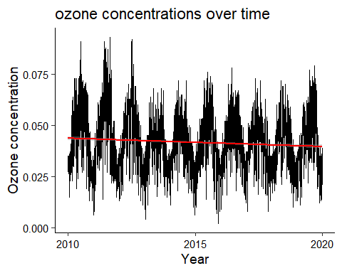

Answer: Yes, the concentration of ozone shows a descending trend over time.

## Time Series Analysis

Study question: Have ozone concentrations changed over the 2010s at this station?

1. Use a linear interpolation to fill in missing daily data for ozone concentration. Why didn’t we use a piecewise constant or spline interpolation?

#8  
GaringerOzone_clean <-   
 GaringerOzone %>%   
 mutate( Daily.Max.8.hour.Ozone.Concentration.clean = zoo::na.approx(Daily.Max.8.hour.Ozone.Concentration) )%>%  
 mutate( DAILY_AQI_VALUE.clean = zoo::na.approx(DAILY_AQI_VALUE) )

Answer: Because the data accord with a linear trend. Spline which applies a quadratic function is not suitable. Piecewise constant makes the data be equal to the measurement made nearest to that date, which also doesn’t accord with the linear trend.

1. Create a new data frame called GaringerOzone.monthly that contains aggregated data: mean ozone concentrations for each month. In your pipe, you will need to first add columns for year and month to form the groupings. In a separate line of code, create a new Date column with each month-year combination being set as the first day of the month (this is for graphing purposes only)

#9  
GaringerOzone.monthly <-  
 GaringerOzone_clean %>%   
 mutate(Month = month(Date)) %>%  
 mutate(Year = year(Date))%>%  
 mutate(Date = my(paste0(Month,"-",Year)))   
  
GaringerOzone.monthly<-  
 GaringerOzone.monthly %>%  
 group_by(Date) %>%  
 summarise(meanozone = mean(Daily.Max.8.hour.Ozone.Concentration.clean)  
 )

1. Generate two time series objects. Name the first GaringerOzone.daily.ts and base it on the dataframe of daily observations. Name the second GaringerOzone.monthly.ts and base it on the monthly average ozone values. Be sure that each specifies the correct start and end dates and the frequency of the time series.

#10  
GaringerOzone.daily.ts <-ts(GaringerOzone_clean$Daily.Max.8.hour.Ozone.Concentration.clean, start = c(2010,01, 01), frequency = 365)  
  
GaringerOzone.monthly.ts <-ts(GaringerOzone.monthly$meanozone, start = c(2010,01,01), frequency = 12)

1. Decompose the daily and the monthly time series objects and plot the components using the plot() function.

#11  
GaringerOzone.daily.ts_Decomposed <- stl(GaringerOzone.daily.ts, s.window = "periodic")  
GaringerOzone.monthly.ts_Decomposed <- stl(GaringerOzone.monthly.ts, s.window = "periodic")  
  
plot(GaringerOzone.daily.ts_Decomposed)

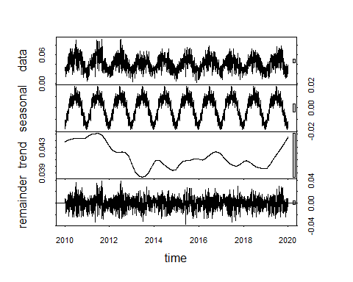

plot(GaringerOzone.monthly.ts_Decomposed)

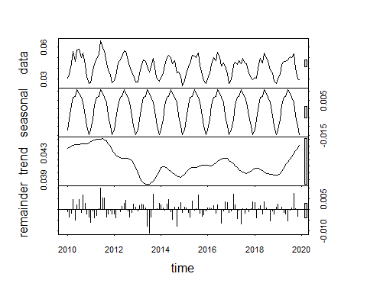

1. Run a monotonic trend analysis for the monthly Ozone series. In this case the seasonal Mann-Kendall is most appropriate; why is this?

#12  
Ozonetrend1.monthly <- Kendall::SeasonalMannKendall(GaringerOzone.monthly.ts)  
  
Ozonetrend1.monthly

## tau = -0.143, 2-sided pvalue =0.046724

summary(Ozonetrend1.monthly)

## Score = -77 , Var(Score) = 1499  
## denominator = 539.4972  
## tau = -0.143, 2-sided pvalue =0.046724

Ozonetrend2.monthly <- trend::smk.test(GaringerOzone.monthly.ts)  
Ozonetrend2.monthly

##   
## Seasonal Mann-Kendall trend test (Hirsch-Slack test)  
##   
## data: GaringerOzone.monthly.ts  
## z = -1.963, p-value = 0.04965  
## alternative hypothesis: true S is not equal to 0  
## sample estimates:  
## S varS   
## -77 1499

summary(Ozonetrend2.monthly)

##   
## Seasonal Mann-Kendall trend test (Hirsch-Slack test)  
##   
## data: GaringerOzone.monthly.ts  
## alternative hypothesis: two.sided  
##   
## Statistics for individual seasons  
##   
## H0  
## S varS tau z Pr(>|z|)   
## Season 1: S = 0 15 125 0.333 1.252 0.21050   
## Season 2: S = 0 -1 125 -0.022 0.000 1.00000   
## Season 3: S = 0 -4 124 -0.090 -0.269 0.78762   
## Season 4: S = 0 -17 125 -0.378 -1.431 0.15241   
## Season 5: S = 0 -15 125 -0.333 -1.252 0.21050   
## Season 6: S = 0 -17 125 -0.378 -1.431 0.15241   
## Season 7: S = 0 -11 125 -0.244 -0.894 0.37109   
## Season 8: S = 0 -7 125 -0.156 -0.537 0.59151   
## Season 9: S = 0 -5 125 -0.111 -0.358 0.72051   
## Season 10: S = 0 -13 125 -0.289 -1.073 0.28313   
## Season 11: S = 0 -13 125 -0.289 -1.073 0.28313   
## Season 12: S = 0 11 125 0.244 0.894 0.37109   
## ---  
## Signif. codes: 0 '***' 0.001 '**' 0.01 '*' 0.05 '.' 0.1 ' ' 1

Answer: Because the data shows a sesonal trend and seasonal Mann-Kendall is the only way to examine the monotic trend.

1. Create a plot depicting mean monthly ozone concentrations over time, with both a geom_point and a geom_line layer. Edit your axis labels accordingly.

# 13  
ozoneplot <-  
ggplot(GaringerOzone.monthly, aes(x = Date, y = meanozone)) +  
 geom_point() +  
 geom_line() +  
 ylab("Average ozone concentration") +  
 xlab("Year")+  
 ggtitle("ozone monthly concentrations over time")+  
 geom_smooth( method = lm )  
print(ozoneplot)

## `geom_smooth()` using formula 'y ~ x'

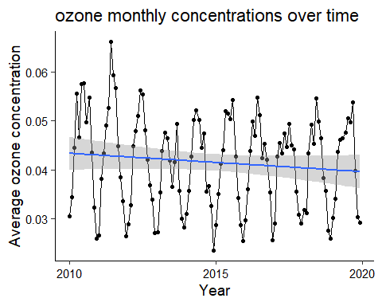

1. To accompany your graph, summarize your results in context of the research question. Include output from the statistical test in parentheses at the end of your sentence. Feel free to use multiple sentences in your interpretation.

Answer: There is a monotonic trend of ozone(p-value = 0.04965). Ozone concentration decreases over time(z = -1.963).

1. Subtract the seasonal component from the GaringerOzone.monthly.ts. Hint: Look at how we extracted the series components for the EnoDischarge on the lesson Rmd file.
2. Run the Mann Kendall test on the non-seasonal Ozone monthly series. Compare the results with the ones obtained with the Seasonal Mann Kendall on the complete series.

#15  
Seasonal_Components <- as.data.frame(GaringerOzone.monthly.ts_Decomposed$time.series[,1:3])  
  
Seasonal_Components <- mutate(Seasonal_Components,  
 Observed = GaringerOzone.monthly$meanozone,   
 Date =GaringerOzone.monthly$Date)  
  
Seasonal_Components<- mutate(Seasonal_Components, non_seasonal = Observed-seasonal)  
  
#16  
GaringerOzone.monthly.nonseasonal.ts <-ts(Seasonal_Components$non_seasonal, start = c(2010,01,01), frequency = 12)  
  
Ozonetrend3.monthly <- Kendall::MannKendall(GaringerOzone.monthly.nonseasonal.ts)  
Ozonetrend3.monthly

## tau = -0.165, 2-sided pvalue =0.0075402

Ozonetrend1.monthly

## tau = -0.143, 2-sided pvalue =0.046724

Answer: The results of a significant trend from seasonal mannkendall are not as significant as the results from the subtracted dataframe. Also, the descending trend is larger than the trend of seasinal mannkendall results.