# **CHAPTER 2**

## **RELATED SYSTEMS**

This chapter gives a background regarding e-learning. This chapter talks why collaboration is important.

**E-learning**

According to Kurthus (2000), E-learning is a form of teaching that can be delivered through CD, flash drive, LAN or over the internet. This adds other aspects like Computer-Based Training (CBT), Electronic Performance Support System (EPSS) and Web-Based Training as well as distant learning. There are questions on what e-learning has to offer or what would be the typical elements found in e-learning. E-learning systems should provide easy access. E-learning gives students or learners with information that can be accessed anywhere. Example, in Computer-Based Training delivered in a device that can read memory. The resource is content-rich in information including audio, video and other files. Typical aspects of e-learning come with good instructional video and are identical to what we see in class. These are the following elements as stated by Kurthus. Introduction/overview, Information Presentation, Practice items with customized and instructive feedback, Assessment and Evaluation feedback.

There are several key points in E-learning according to Sandars and Lakhani (2006). E-learning gives information or learning in any form of computerized content. One of the main forces or reasons has been the development of new technologies. There is potential profit for both students and to those who are giving content. According to the authors, there is a rumored debate about the definition of e-learning, so to make it simple, a useful definition is e-learning is the delivery of information in any for of electronic media according to the authors.

Formal and Informal learning plays a big role setting wise. Formal learning is classroom based. It means that it is compulsory to enroll, attend and pass that class. Since it is classroom based, it would be teacher-directed and also curriculum-based. A good example would be students in the University of San Carlos taking up Bachelor of Science in Information Technology program. These students are in formal learning. Also, formal learning tends to provide specific courses, usually over in a period of time (Sandars and Lakhani, 2006). Informal learning is self-directed by the learner and happens outside borders of institution and professional bodies (Sandars and Lakhani, 2006). Students tend to identify their own learning materials by actively participating in competent activities. There is a need too for students to find different methods in order to understand and apply what they will learn. One important method is that students must be active in participating and collaborating with different peers and colleagues in internet-based discussion forums or in online classes. Another one would be by surfing and browsing through the internet. According to Kyndt, Dochy and Nijs (2009), learning is described as an unplanned and implicit process with unpredicted results. Everyday learning has a way where it takes place in the daily situation. Informal learning is never organized or even planned from the learner’s stand point. It is seen as learners interacting and collaborating with others. Informal learning happens unintentionally and unconsciously without any goals in terms of learning outcomes. Informal learning is a way to determine professionalism of employees and people. (See Table 1 and 2 for the comparison for Formal and Informal Learning)

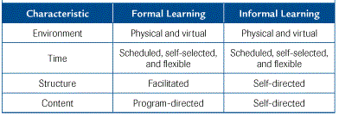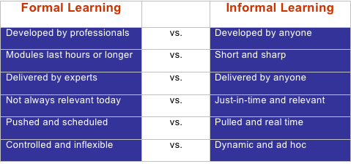

Source: https://www.educause.edu/research-and-publications/books/learning-spaces/chapter-13-assessing-learning-spaces

Table 2

*Another difference between Formal and Informal Learning with Characteristics*

Source: Learning Processes (2015, January) https://wakeupwanderlust.wordpress.com/2015/01/29/learning/

Table 1

*The difference between Formal and Informal Learning*

**Collaboration**

There are two types of method in e-learning which is synchronous and asynchronous methods. Synchronous method is in real time. It means that communication is live. Examples include chat rooms that are available on the Internet websites. Most e-learning systems uses asynchronous method, where messages occur over a period of time (Sandars and Lakhani, 2006). This is usually seen through forums or message being conveyed through email. An example is the posting of questions or ideas in forums. These are read and replied by other people in that forum.

According to Hawkes & Romiszowski (2001), it talks about on what would be the possible outcomes on having an Asynchronous Computer-Mediated Communication. As modern technologies evolve and advance, it is easier and convenient for people to communicate and use that technology to their advantage. As the study states that collaboration is a process of willing cooperation with peers and colleagues to reach educational objectives. Most teachers work alone. The study found that collaboration included little if any sharing of existing materials and ideas that planning and problem solving with colleagues almost didn’t happen at all and that teachers would prefer to keep their problems to themselves. In having a collaborative effort, teachers would achieve high standards. The suggested solution to this problem is to promote an Asynchronous Computer-Mediated Communication where teachers will have the opportunity for communication and the sharing of resources.

Sandars, J., Lakhani, M. (2006). E-learning for GP Educators. Retrieved from <https://books.google.com.ph/books?hl=en&lr=&id=PU-zDAAAQBAJ&oi=fnd&pg=PT15&dq=what+is+e-learning&ots=9Zbf4qU9aV&sig=Ejckma8n6PcRVnGENI5Ez7-1MAw&redir_esc=y#v=onepage&q=what%20is%20e-learning&f=false>

Kyndt, E., Dochy, F., Nijs, H. (2009). Learning conditions for non-formal and informal workplace learning.