**PL/SQL PROGRAMMING**

**CREATION OF TABLES:**

CREATE TABLE Customers (

CustomerID NUMBER PRIMARY KEY,

Name VARCHAR2(100),

DOB DATE,

Balance NUMBER,

LastModified DATE

);

CREATE TABLE Accounts (

AccountID NUMBER PRIMARY KEY,

CustomerID NUMBER,

AccountType VARCHAR2(20),

Balance NUMBER,

LastModified DATE,

FOREIGN KEY (CustomerID) REFERENCES Customers(CustomerID)

);

CREATE TABLE Transactions (

TransactionID NUMBER PRIMARY KEY,

AccountID NUMBER,

TransactionDate DATE,

Amount NUMBER,

TransactionType VARCHAR2(10),

FOREIGN KEY (AccountID) REFERENCES Accounts(AccountID)

);

CREATE TABLE Loans (

LoanID NUMBER PRIMARY KEY,

CustomerID NUMBER,

LoanAmount NUMBER,

InterestRate NUMBER,

StartDate DATE,

EndDate DATE,

FOREIGN KEY (CustomerID) REFERENCES Customers(CustomerID)

);

CREATE TABLE Employees (

EmployeeID NUMBER PRIMARY KEY,

Name VARCHAR2(100),

Position VARCHAR2(50),

Salary NUMBER,

Department VARCHAR2(50),

HireDate DATE

);

**INSERTION OF DATA IN TABLES:**

INSERT INTO Customers2 (CustomerID, Name, DOB, Balance, LastModified)

VALUES (1, 'John Doe', TO_DATE('1985-05-15', 'YYYY-MM-DD'), 1000, SYSDATE);

INSERT INTO Customers (CustomerID, Name, DOB, Balance, LastModified)

VALUES (2, 'Jane Smith', TO_DATE('1990-07-20', 'YYYY-MM-DD'), 1500, SYSDATE);

INSERT INTO Customers (CustomerID, Name, DOB, Balance, LastModified)

VALUES (3, 'Emily Clark', TO_DATE('1970-03-10', 'YYYY-MM-DD'), 12000, SYSDATE);

INSERT INTO Customers (CustomerID, Name, DOB, Balance, LastModified)

VALUES (4, 'David Wilson', TO_DATE('1960-12-01', 'YYYY-MM-DD'), 3000, SYSDATE);

INSERT INTO Customers (CustomerID, Name, DOB, Balance, LastModified)

VALUES (5, 'Olivia Martin', TO_DATE('1995-11-25', 'YYYY-MM-DD'), 800, SYSDATE);

INSERT INTO Accounts (AccountID, CustomerID, AccountType, Balance, LastModified)

VALUES (1, 1, 'Savings', 1000, SYSDATE);

INSERT INTO Accounts (AccountID, CustomerID, AccountType, Balance, LastModified)

VALUES (2, 2, 'Checking', 1500, SYSDATE);

INSERT INTO Accounts (AccountID, CustomerID, AccountType, Balance, LastModified)

VALUES (3, 3, 'Savings', 12000, SYSDATE);

INSERT INTO Accounts (AccountID, CustomerID, AccountType, Balance, LastModified)

VALUES (4, 4, 'Savings', 3000, SYSDATE);

INSERT INTO Accounts (AccountID, CustomerID, AccountType, Balance, LastModified)

VALUES (5, 5, 'Checking', 800, SYSDATE);

INSERT INTO Transactions (TransactionID, AccountID, TransactionDate, Amount, TransactionType) VALUES (1, 1, SYSDATE, 200, 'Deposit');

INSERT INTO Transactions (TransactionID, AccountID, TransactionDate, Amount, TransactionType) VALUES (2, 2, SYSDATE, 300, 'Withdrawal');

INSERT INTO Transactions (TransactionID, AccountID, TransactionDate, Amount, TransactionType) VALUES (3, 3, SYSDATE, 500, 'Deposit');

INSERT INTO Transactions (TransactionID, AccountID, TransactionDate, Amount, TransactionType) VALUES (4, 4, SYSDATE, 1000, 'Withdrawal');

INSERT INTO Transactions (TransactionID, AccountID, TransactionDate, Amount, TransactionType) VALUES (5, 5, SYSDATE, 250, 'Deposit');

INSERT INTO Loans (LoanID, CustomerID, LoanAmount, InterestRate, StartDate, EndDate) VALUES (1, 1, 5000, 7.5, SYSDATE, ADD_MONTHS(SYSDATE, 15));

INSERT INTO Loans (LoanID, CustomerID, LoanAmount, InterestRate, StartDate, EndDate) VALUES (2, 2, 6000, 4.5, SYSDATE, ADD_MONTHS(SYSDATE, 24));

INSERT INTO Loans (LoanID, CustomerID, LoanAmount, InterestRate, StartDate, EndDate) VALUES (3, 3, 8000, 6.0, SYSDATE, ADD_MONTHS(SYSDATE, 12));

INSERT INTO Loans (LoanID, CustomerID, LoanAmount, InterestRate, StartDate, EndDate) VALUES (4, 4, 12000, 5.5, SYSDATE, SYSDATE + 10);

INSERT INTO Loans (LoanID, CustomerID, LoanAmount, InterestRate, StartDate, EndDate) VALUES (5, 5, 4000, 4.0, SYSDATE, SYSDATE + 15);

INSERT INTO Employees (EmployeeID, Name, Position, Salary, Department, HireDate)

VALUES (1, 'Alice Johnson', 'Manager', 70000, 'HR', TO_DATE('2015-06-15', 'YYYY-MM-DD'));

INSERT INTO Employees (EmployeeID, Name, Position, Salary, Department, HireDate)

VALUES (2, 'Bob Brown', 'Developer', 60000, 'IT', TO_DATE('2017-03-20', 'YYYY-MM-DD'));

INSERT INTO Employees (EmployeeID, Name, Position, Salary, Department, HireDate)

VALUES (3, 'Charlie Adams', 'Analyst', 55000, 'Finance', TO_DATE('2019-08-10', 'YYYY-MM-DD'));

INSERT INTO Employees (EmployeeID, Name, Position, Salary, Department, HireDate)

VALUES (4, 'Grace Bennett', 'Tester', 50000, 'QA', TO_DATE('2020-01-05', 'YYYY-MM-DD'));

INSERT INTO Employees (EmployeeID, Name, Position, Salary, Department, HireDate)

VALUES (5, 'Henry Davis', 'Developer', 62000, 'IT', TO_DATE('2021-03-15', 'YYYY-MM-DD'));

**Customer Table:**

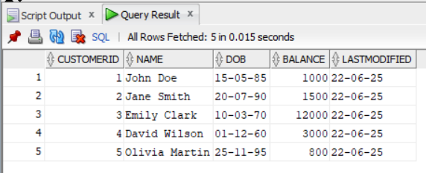

**Accounts Table:**

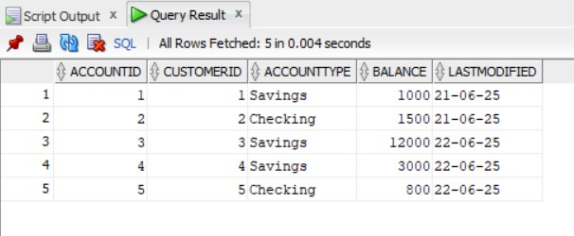

**Transactions Table:**

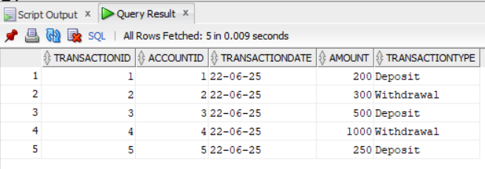

**Loans Table:**

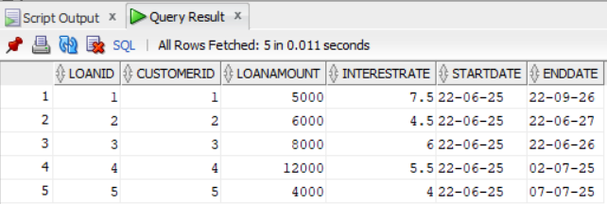

**Employees Table:**

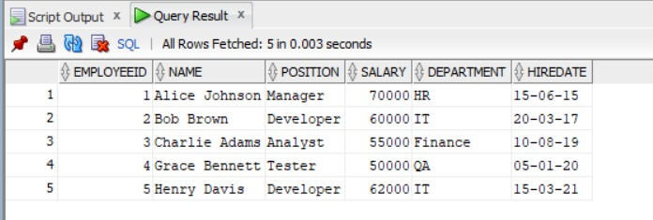

**EXERCISE – 1: CONTROL STRUCTURES**

**Scenario 1:** The bank wants to apply a discount to loan interest rates for customers above 60 years old.

**Question:** Write a PL/SQL block that loops through all customers, checks their age, and if they are above 60, apply a 1% discount to their current loan interest rates.

BEGIN

FOR cust IN (

SELECT c.CustomerID, c.DOB, l.LoanID, l.InterestRate

FROM Customers c

JOIN Loans l ON c.CustomerID = l.CustomerID

) LOOP

IF MONTHS_BETWEEN(SYSDATE, cust.DOB) / 12 > 60 THEN

UPDATE Loans

SET InterestRate = InterestRate - 1

WHERE LoanID = cust.LoanID;

END IF;

END LOOP;

END;

/

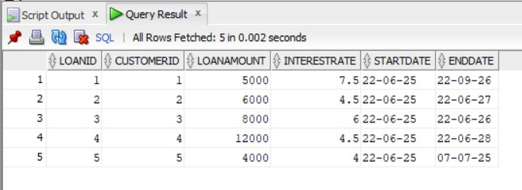

**Scenario 2:** A customer can be promoted to VIP status based on their balance.

**Question:** Write a PL/SQL block that iterates through all customers and sets a flag IsVIP to TRUE for those with a balance over $10,000.

ALTER TABLE Customers1 ADD IsVIP VARCHAR2(5);

BEGIN

FOR cust IN (SELECT CustomerID, Balance FROM Customers1) LOOP

IF cust.Balance > 10000 THEN

UPDATE Customers1

SET IsVIP = 'TRUE'

WHERE CustomerID = cust.CustomerID;

ELSE

UPDATE Customers1

SET IsVIP = 'FALSE'

WHERE CustomerID = cust.CustomerID;

END IF;

END LOOP;

END;

/

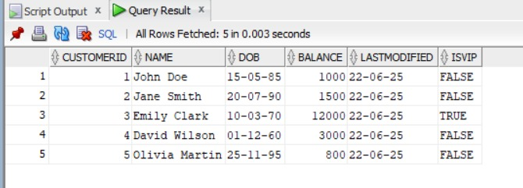

**Scenario 3:** The bank wants to send reminders to customers whose loans are due within the next 30 days.

**Question:** Write a PL/SQL block that fetches all loans due in the next 30 days and prints a reminder message for each customer.

SET SERVEROUTPUT ON;

BEGIN

FOR loan_rec IN (

SELECT l.LoanID, c.Name, l.EndDate

FROM Loans3 l

JOIN Customers1 c ON c.CustomerID = l.CustomerID

WHERE l.EndDate BETWEEN SYSDATE AND SYSDATE + 30

) LOOP

DBMS_OUTPUT.PUT_LINE('Reminder: Loan ID ' || loan_rec.LoanID ||

' for customer ' || loan_rec.Name ||

' is due on ' || TO_CHAR(loan_rec.EndDate, 'YYYY-MM-DD'));

END LOOP;

END;

/

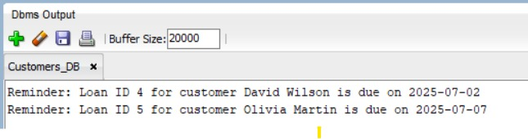

**EXERCISE – 3: STORED PROCEDURES**

**Scenario 1:** The bank needs to process monthly interest for all savings accounts.

**Question:** Write a stored procedure **ProcessMonthlyInterest** that calculates and updates the balance of all savings accounts by applying an interest rate of 1% to the current balance.

CREATE OR REPLACE PROCEDURE ProcessMonthlyInterest IS

BEGIN

UPDATE Accounts

SET Balance = Balance + (Balance * 0.01)

WHERE AccountType = 'Savings';

END;

/

**Calling procedure:**

EXEC ProcessMonthlyInterest;

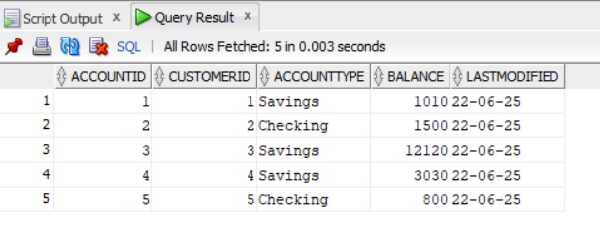

**Scenario 2:** The bank wants to implement a bonus scheme for employees based on their performance.

**Question:** Write a stored procedure **UpdateEmployeeBonus** that updates the salary of employees in a given department by adding a bonus percentage passed as a parameter.

CREATE OR REPLACE PROCEDURE UpdateEmployeeBonus (

passed_department IN VARCHAR2,

passed_bonus_percent IN NUMBER

) IS

BEGIN

UPDATE Employees

SET Salary = Salary + (Salary * passed_bonus_percent / 100)

WHERE Department = passed_department;

END;

/

**Calling procedure:**

EXEC UpdateEmployeeBonus('IT', 10);

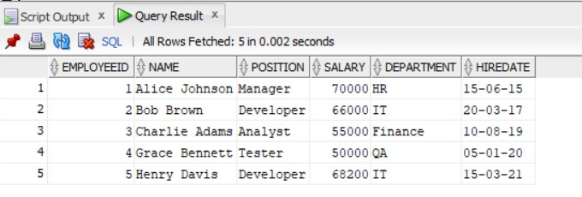

**Scenario 3:** Customers should be able to transfer funds between their accounts.

**Question:** Write a stored procedure **TransferFunds** that transfers a specified amount from one account to another, checking that the source account has sufficient balance before making the transfer.

CREATE OR REPLACE PROCEDURE TransferFunds (

p_from_account IN NUMBER,

p_to_account IN NUMBER,

p_amount IN NUMBER

) IS

v_from_balance NUMBER;

BEGIN

SELECT Balance INTO v_from_balance

FROM Accounts

WHERE AccountID = p_from_account;

IF v_from_balance < p_amount THEN

RAISE_APPLICATION_ERROR(-20001, 'Insufficient funds in source account.');

END IF;

UPDATE Accounts

SET Balance = Balance - p_amount,

LastModified = SYSDATE

WHERE AccountID = p_from_account;

UPDATE Accounts

SET Balance = Balance + p_amount,

LastModified = SYSDATE

WHERE AccountID = p_to_account;

END;

/

**Calling procedure:**

EXEC TransferFunds(2, 4, 300);

