**SPRING CORE AND MAVEN**

**EXERCISE – 1 : CONFIGURING A BASIC SPRING APPLICATION**

1. Create a new Maven project named “LibraryManagement”
2. Create a pom.xml and add the spring core dependencies.

**pom.xml:**

<?xml version="1.0" encoding="UTF-8"?>

<project xmlns="http://maven.apache.org/POM/4.0.0" xmlns:xsi="http://www.w3.org/2001/XMLSchema-instance"

xsi:schemaLocation="http://maven.apache.org/POM/4.0.0 http://maven.apache.org/xsd/maven-4.0.0.xsd">

<modelVersion>4.0.0</modelVersion>

<groupId>com.library</groupId>

<artifactId>LibraryManagement</artifactId>

<version>0.0.1-SNAPSHOT</version>

<name>LibraryManagement</name>

<!-- FIXME change it to the project's website -->

<url>http://www.example.com</url>

<properties>

<project.build.sourceEncoding>UTF-8</project.build.sourceEncoding>

<maven.compiler.release>17</maven.compiler.release>

</properties>

<dependencies>

<dependency>

<groupId>org.springframework</groupId>

<artifactId>spring-core</artifactId>

<version>6.2.6</version>

</dependency>

<dependency>

<groupId>org.springframework</groupId>

<artifactId>spring-context</artifactId>

<version>6.2.7</version>

</dependency>

</dependencies>

</project>

1. Now create an xml file named “ApplicationContext.xml” that is used to define the beans to the classes BookService and BookRepository.

**ApplicationContext.xml:**

<?xml version="1.0" encoding="UTF-8"?>

<beans xmlns="http://www.springframework.org/schema/beans"

xmlns:xsi="http://www.w3.org/2001/XMLSchema-instance"

xsi:schemaLocation="http://www.springframework.org/schema/beans

https://www.springframework.org/schema/beans/spring-beans.xsd">

<bean id="bookRepository" class="com.library.repository.BookRepository" />

<bean id="bookService" class="com.library.service.BookService">

</bean>

</beans>

1. Now create a new package in src/main/java and name the package as com.library.service. Create a new class named “BookServices”

**BookService.java:**

package com.library.service;

public class BookService {

public void bookServices(String title) {

System.*out*.println("This is book services and you can reserve book titled " + title);

}

}

1. Now create a new package in src/main/java and name the package as com.library.repository. Create a new class named “BookRepository”

**BookRepository.java:**

package com.library.repository;

public class BookRepository {

public void bookRepo(String title) {

System.*out*.println("This is the repository where you can find the book titled: " + title);

}

}

**Main.java:**

package com.library.main;

import com.library.service.BookService;

import com.library.repository.BookRepository;

import org.springframework.context.ApplicationContext;

import org.springframework.context.support.ClassPathXmlApplicationContext;

public class Main {

public static void main(String[] args) {

ApplicationContext context = new ClassPathXmlApplicationContext("applicationContext.xml");

BookService bookService = context.getBean("bookService", BookService.class);

bookService.bookServices("Java Programming");

BookRepository bookrepo = context.getBean("bookRepository", BookRepository.class);

bookrepo.bookRepo("C++");

((ClassPathXmlApplicationContext) context).close();

}

}

**OUTPUT:**

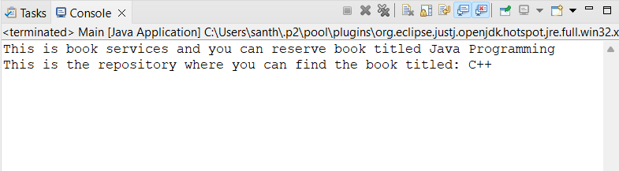

**EXERCISE – 2 : IMPLEMENTING DEPENDENCY INJECTION:**

**ApplicationContext.xml:**

<?xml version="1.0" encoding="UTF-8"?>

<beans xmlns="http://www.springframework.org/schema/beans"

xmlns:xsi="http://www.w3.org/2001/XMLSchema-instance"

xsi:schemaLocation="http://www.springframework.org/schema/beans

https://www.springframework.org/schema/beans/spring-beans.xsd">

<bean id="bookRepository" class="com.library.repository.BookRepository" />

<bean id="bookService" class="com.library.service.BookService">

<property name="bookRepository" ref="bookRepository" />

</bean>

</beans>

**BookService.java:**

package com.library.service;

import com.library.repository.BookRepository;

public class BookService {

private BookRepository bookRepository;

public void setBookRepository(BookRepository bookRepository) {

this.bookRepository = bookRepository;

}

public void bookServices() {

System.*out*.println("Using book services to find the book in repository");

bookRepository.bookRepo("Java Programming");

}

}

**BookRepository.java:**

package com.library.repository;

public class BookRepository {

public void bookRepo(String title) {

System.*out*.println("This is the repository where you can find the book titled: " + title);

}

}

**Main.java:**

package com.library.main;

import com.library.service.BookService;

import org.springframework.context.ApplicationContext;

import org.springframework.context.support.ClassPathXmlApplicationContext;

public class Main {

public static void main(String[] args) {

ApplicationContext context = new ClassPathXmlApplicationContext("applicationContext.xml");

BookService bookService = context.getBean("bookService", BookService.class);

bookService.bookServices();

((ClassPathXmlApplicationContext) context).close();

}

}

**OUTPUT:**

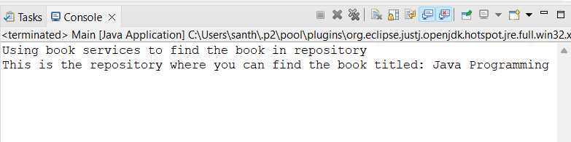

**EXERCISE – 4 :CREATING AND CONFIGURING A MAVEN PROJECT**

**pom.xml:**

<?xml version="1.0" encoding="UTF-8"?>

<project xmlns="http://maven.apache.org/POM/4.0.0"

xmlns:xsi="http://www.w3.org/2001/XMLSchema-instance"

xsi:schemaLocation="http://maven.apache.org/POM/4.0.0 http://maven.apache.org/xsd/maven-4.0.0.xsd">

<modelVersion>4.0.0</modelVersion>

<groupId>com.library</groupId>

<artifactId>LibraryManagement</artifactId>

<version>0.0.1-SNAPSHOT</version>

<name>LibraryManagement</name>

<url>http://www.example.com</url>

<properties>

<project.build.sourceEncoding>UTF-8</project.build.sourceEncoding>

<maven.compiler.source>1.8</maven.compiler.source>

<maven.compiler.target>1.8</maven.compiler.target>

</properties>

<dependencies>

<dependency>

<groupId>org.springframework</groupId>

<artifactId>spring-context</artifactId>

<version>5.3.34</version>

</dependency>

<dependency>

<groupId>org.springframework</groupId>

<artifactId>spring-aop</artifactId>

<version>5.3.34</version>

</dependency>

<dependency>

<groupId>org.springframework</groupId>

<artifactId>spring-webmvc</artifactId>

<version>5.3.34</version>

</dependency>

</dependencies>

<build>

<plugins>

<plugin>

<groupId>org.apache.maven.plugins</groupId>

<artifactId>maven-compiler-plugin</artifactId>

<version>3.11.0</version>

<configuration>

<source>1.8</source>

<target>1.8</target>

</configuration>

</plugin>

</plugins>

</build>

</project>