**SPRING REST USING SPRING BOOT 3**

**SPRING REST HANDS-ON 1:**

**EXERCISE – 1 : CREATE A SPRING WEB PROJECT USING MAVEN**

1. Go to <https://start.spring.io/>
2. Change Group as “com.cognizant” and Artifact Id as “spring-learn”
3. Select Spring Boot DevTools and Spring Web
4. Create and download the project as zip
5. Extract the zip in root folder to Eclipse Workspace
6. Build the project using ‘mvn clean package -Dhttp.proxyHost=proxy.cognizant.com -Dhttp.proxyPort=6050 -Dhttps.proxyHost=proxy.cognizant.com -Dhttps.proxyPort=6050 -Dhttp.proxyUser=123456’ command in command line
7. Import the project in Eclipse "File > Import > Maven > Existing Maven Projects > Click Browse and select extracted folder > Finish"

**pom.xml**

<?xml version="1.0" encoding="UTF-8"?>

<project xmlns="http://maven.apache.org/POM/4.0.0" xmlns:xsi="http://www.w3.org/2001/XMLSchema-instance"

xsi:schemaLocation="http://maven.apache.org/POM/4.0.0 https://maven.apache.org/xsd/maven-4.0.0.xsd">

<modelVersion>4.0.0</modelVersion>

<parent>

<groupId>org.springframework.boot</groupId>

<artifactId>spring-boot-starter-parent</artifactId>

<version>3.5.3</version>

<relativePath/> <!-- lookup parent from repository -->

</parent>

<groupId>com.cognizant</groupId>

<artifactId>spring-learn</artifactId>

<version>0.0.1-SNAPSHOT</version>

<name>spring-learn</name>

<url/>

<licenses><license/></licenses>

<developers><developer/></developers>

<scm><connection/><developerConnection/><tag/><url/>

</scm>

<properties>

<java.version>17</java.version>

</properties>

<dependencies>

<dependency>

<groupId>org.springframework.boot</groupId>

<artifactId>spring-boot-starter-web</artifactId>

</dependency>

<dependency>

<groupId>org.springframework.boot</groupId>

<artifactId>spring-boot-devtools</artifactId>

<scope>runtime</scope>

<optional>true</optional>

</dependency>

<dependency>

<groupId>org.springframework.boot</groupId>

<artifactId>spring-boot-starter-test</artifactId>

<scope>test</scope>

</dependency>

</dependencies>

<build><plugins><plugin>

<groupId>org.springframework.boot</groupId>

<artifactId>spring-boot-maven-plugin</artifactId>

</plugin>

</plugins>

</build>

</project>

**SpringLearnApplication.java**

package com.cognizant.spring_learn;

import org.springframework.boot.SpringApplication;

import org.springframework.boot.autoconfigure.SpringBootApplication;

@SpringBootApplication

public class SpringLearnApplication {

public static void main(String[] args) {

System.out.println("Initializing the Spring Learn Application");

SpringApplication.run(SpringLearnApplication.class, args);

System.out.println("Spring learn Application is started and running!");

}

}

**OUTPUT:**

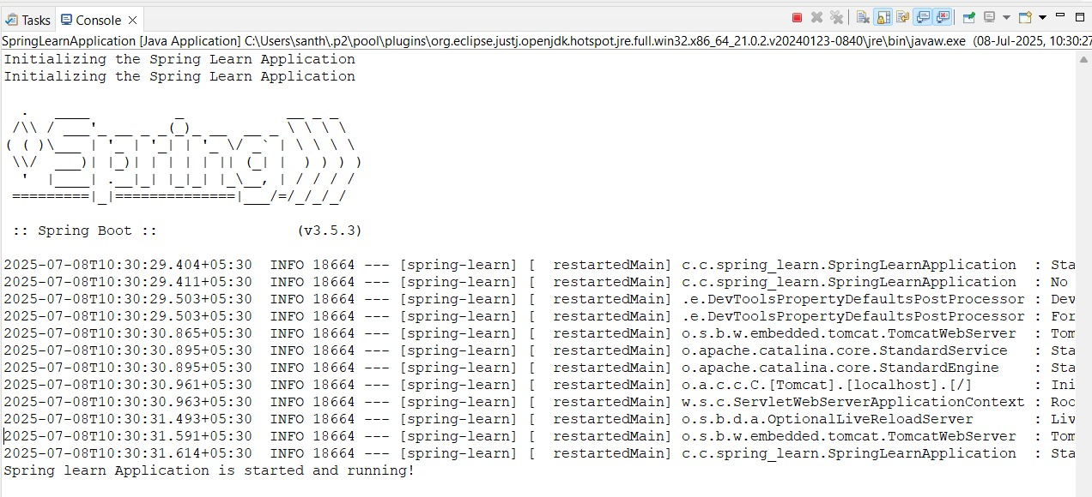

**EXERCISE – 4 : LOAD COUNTRY FROM SPRING CONFIGURATION XML**

**Country.xml**

<?xml version="1.0" encoding="UTF-8"?>

<beans xmlns="http://www.springframework.org/schema/beans"

xmlns:xsi="http://www.w3.org/2001/XMLSchema-instance"

xsi:schemaLocation="http://www.springframework.org/schema/beans

http://www.springframework.org/schema/beans/spring-beans.xsd">

<bean id="country" class="com.cognizant.spring_learn.Country">

<property name="code" value="IN" />

<property name="name" value="India" />

</bean>

</beans>

**SpringLearnApplication.java**

package com.cognizant.spring_learn;

import org.slf4j.Logger;

import org.slf4j.LoggerFactory;

import org.springframework.context.ApplicationContext;

import org.springframework.context.support.ClassPathXmlApplicationContext;

import org.springframework.boot.SpringApplication;

import org.springframework.boot.autoconfigure.SpringBootApplication;

@SpringBootApplication

public class SpringLearnApplication {

private static final Logger Logger = LoggerFactory.getLogger(SpringLearnApplication.class);

public static void displayCountry() {

ApplicationContext context = new ClassPathXmlApplicationContext("country.xml");

Country country = context.getBean("country", Country.class);

Logger.debug("Country : {}", country.toString());

}

public static void main(String[] args) {

SpringApplication.run(SpringLearnApplication.class, args);

displayCountry();

}

}

**Country.java**

package com.cognizant.spring_learn;

import org.slf4j.Logger;

import org.slf4j.LoggerFactory;

public class Country {

private static final Logger LOGGER = LoggerFactory.getLogger(Country.class);

private String code;

private String name;

public Country() {

LOGGER.debug("Country Constructor.");

}

public void setCode(String code) {

LOGGER.debug("Setting country code");

this.code = code;

}

public String getCode() {

LOGGER.debug("Retrieving Country code");

return code;

}

public void setName(String name) {

LOGGER.debug("Setting country name");

this.name = name;

}

public String getName() {

LOGGER.debug("Retrieving Country name");

return name;

}

@Override

public String toString() {

return " code=" + code + ", name=" + name;

}

}

**Application.properties**

spring.application.name=spring-learn

logging.level.com.cognizant.spring_learn=DEBUG

logging.level.root=DEBUG

**OUTPUT:**

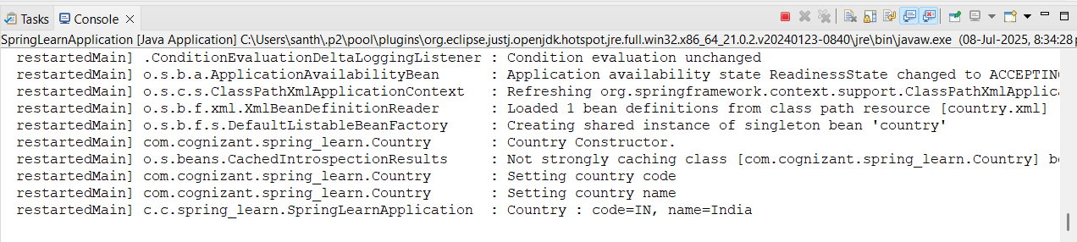

**SPRING REST HANDS-ON 2:**

**EXERCISE – 2 : HELLO WORLD RESTFUL WEB SERVICES**

* **Method:** GET
* **URL:** /hello

**SpringLearnApplication.java**

package com.cognizant.spring_learn;

import org.slf4j.Logger;

import org.slf4j.LoggerFactory;

import org.springframework.context.ApplicationContext;

import org.springframework.context.support.ClassPathXmlApplicationContext;

import org.springframework.boot.SpringApplication;

import org.springframework.boot.autoconfigure.SpringBootApplication;

@SpringBootApplication

public class SpringLearnApplication {

private static final Logger Logger = LoggerFactory.getLogger(SpringLearnApplication.class);

public static void main(String[] args) {

Logger.debug("Spring Application Started");

SpringApplication.run(SpringLearnApplication.class, args);

}

}

**HelloController.java**

package com.cognizant.spring_learn.controller;

import org.slf4j.Logger;

import org.slf4j.LoggerFactory;

import org.springframework.web.bind.annotation.GetMapping;

import org.springframework.web.bind.annotation.RestController;

@RestController

public class HelloController {

private static final Logger LOGGER = LoggerFactory.getLogger(HelloController.class);

@GetMapping("/hello")

public String sayHello() {

String message = "Hello World!!";

return message;

}

}

**application.properties**

spring.application.name=spring-learn

logging.level.com.cognizant.spring_learn=DEBUG

logging.level.root=DEBUG

server.port=8083

**OUTPUT:**

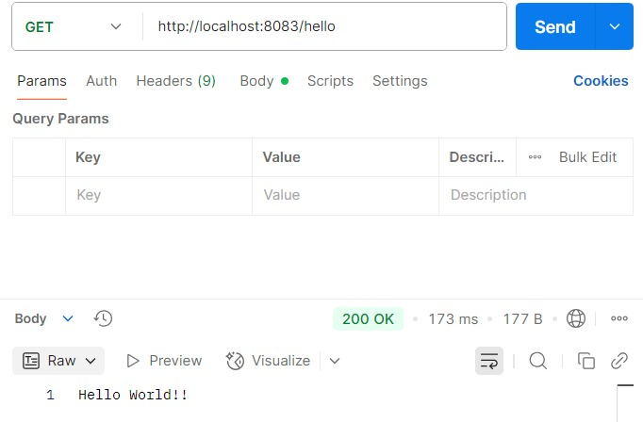

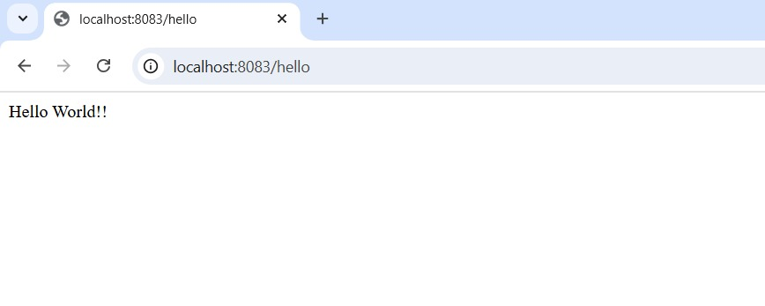

**EXERCISE – 3 : COUNTRY WEB SERVICE**

**SpringLearnApplication.java**

package com.cognizant.spring_learn;

import org.slf4j.Logger;

import org.slf4j.LoggerFactory;

import org.springframework.context.ApplicationContext;

import org.springframework.context.support.ClassPathXmlApplicationContext;

import org.springframework.boot.SpringApplication;

import org.springframework.boot.autoconfigure.SpringBootApplication;

@SpringBootApplication

public class SpringLearnApplication {

private static final Logger Logger = LoggerFactory.getLogger(SpringLearnApplication.class);

public static void main(String[] args) {

Logger.debug("Spring Application Started");

SpringApplication.run(SpringLearnApplication.class, args);

}

}

**CountryController.java**

package com.cognizant.spring_learn.controller;

import com.cognizant.spring_learn.Country;

import org.slf4j.Logger;

import org.slf4j.LoggerFactory;

import org.springframework.context.ApplicationContext;

import org.springframework.context.support.ClassPathXmlApplicationContext;

import org.springframework.web.bind.annotation.RequestMapping;

import org.springframework.web.bind.annotation.RestController;

@RestController

public class CountryController {

private static final Logger LOGGER = LoggerFactory.getLogger(CountryController.class);

@RequestMapping("/country")

public Country getCountryIndia() {

ApplicationContext context = new ClassPathXmlApplicationContext("country.xml");

Country country = (Country) context.getBean("country", Country.class);

return country;

}

}

**OUTPUT:**

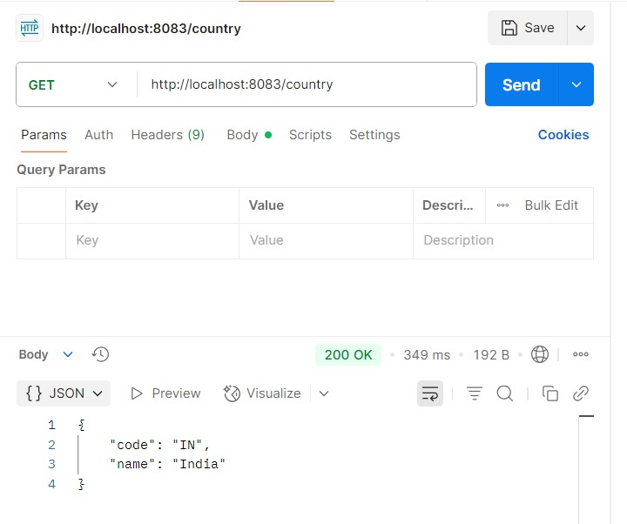

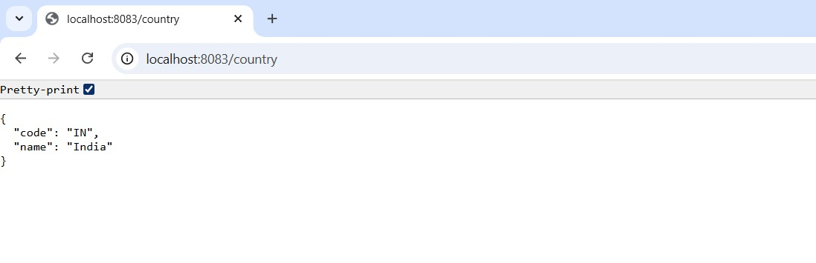

**EXERCISE – 5 : GET COUNTRY BASED ON COUNRTY CODE**

**SpringLearnApplication.java**

package com.cognizant.spring_learn;

import org.slf4j.Logger;

import org.slf4j.LoggerFactory;

import org.springframework.context.ApplicationContext;

import org.springframework.context.support.ClassPathXmlApplicationContext;

import org.springframework.boot.SpringApplication;

import org.springframework.boot.autoconfigure.SpringBootApplication;

@SpringBootApplication

public class SpringLearnApplication {

private static final Logger Logger = LoggerFactory.getLogger(SpringLearnApplication.class);

public static void main(String[] args) {

Logger.debug("Spring Application Started");

SpringApplication.run(SpringLearnApplication.class, args);

}

}

**CountryController.java**

package com.cognizant.spring_learn.controller;

import com.cognizant.spring_learn.Country;

import com.cognizant.spring_learn.service.CountryService;

import org.slf4j.Logger;

import org.slf4j.LoggerFactory;

import org.springframework.beans.factory.annotation.Autowired;

import org.springframework.web.bind.annotation.*;

@RestController

public class CountryController {

private static final Logger LOGGER = LoggerFactory.getLogger(CountryController.class);

@Autowired

private CountryService countryService;

@GetMapping("/countries/{code}")

public Country getCountry(@PathVariable String code) {

Country country = countryService.getCountry(code);

return country;

}

}

**CountryService.java**

package com.cognizant.spring_learn.service;

import com.cognizant.spring_learn.Country;

import org.springframework.context.ApplicationContext;

import org.springframework.context.support.ClassPathXmlApplicationContext;

import org.springframework.stereotype.Service;

import java.util.List;

@Service

public class CountryService {

public Country getCountry(String code) {

ApplicationContext context = new ClassPathXmlApplicationContext("country.xml");

List<Country> countryList = context.getBean("countryList", List.class);

for (Country country : countryList) {

if (country.getCode().equalsIgnoreCase(code)) {

return country;

}

}

}

}

**country.xml**

<?xml version="1.0" encoding="UTF-8"?>

<beans xmlns="http://www.springframework.org/schema/beans"

xmlns:xsi="http://www.w3.org/2001/XMLSchema-instance"

xsi:schemaLocation="http://www.springframework.org/schema/beans

http://www.springframework.org/schema/beans/spring-beans.xsd">

<bean id="in" class="com.cognizant.spring_learn.Country">

<property name="code" value="IN"/>

<property name="name" value="India"/>

</bean>

<bean id="us" class="com.cognizant.spring_learn.Country">

<property name="code" value="US"/>

<property name="name" value="United States"/>

</bean>

<bean id="au" class="com.cognizant.spring_learn.Country">

<property name="code" value="AU"/>

<property name="name" value="Australia"/>

</bean>

<bean id="fr" class="com.cognizant.spring_learn.Country">

<property name="code" value="FR"/>

<property name="name" value="France"/>

</bean>

<bean id="countryList" class="java.util.ArrayList">

<constructor-arg>

<list>

<ref bean="in"/>

<ref bean="us"/>

<ref bean="au"/>

<ref bean="fr"/>

</list>

</constructor-arg>

</bean>

</beans>

**OUTPUT:**

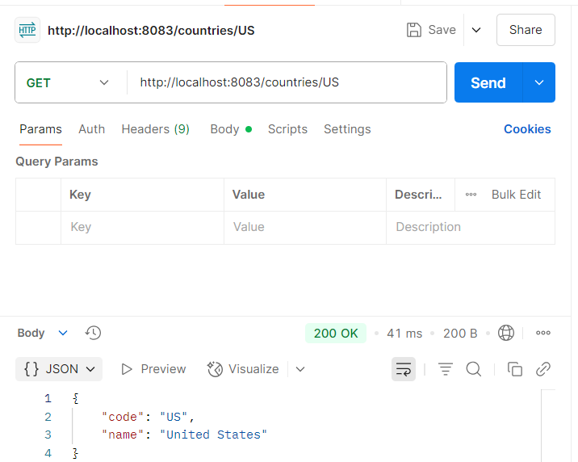

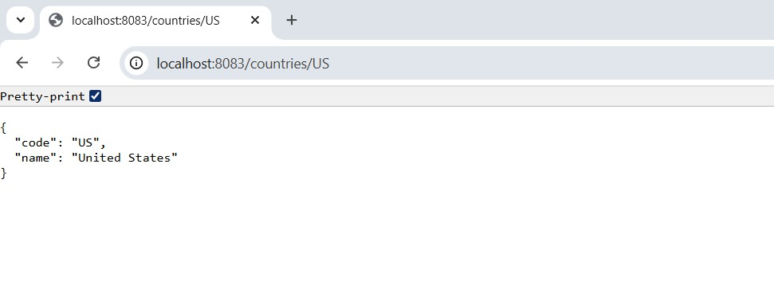

**CREATE AUTHENTICATION SERVICE THAT RETURNS JWT**

**pom.xml**

<?xml version="1.0" encoding="UTF-8"?>

<project xmlns="http://maven.apache.org/POM/4.0.0" xmlns:xsi="http://www.w3.org/2001/XMLSchema-instance"

xsi:schemaLocation="http://maven.apache.org/POM/4.0.0 https://maven.apache.org/xsd/maven-4.0.0.xsd">

<modelVersion>4.0.0</modelVersion>

<parent>

<groupId>org.springframework.boot</groupId>

<artifactId>spring-boot-starter-parent</artifactId>

<version>3.5.3</version>

<relativePath/> <!-- lookup parent from repository -->

</parent>

<groupId>com.cognizant</groupId>

<artifactId>spring-learn</artifactId>

<version>0.0.1-SNAPSHOT</version>

<name>spring-learn</name>

<description>Demo project for Spring Boot</description>

<url/>

<licenses>

<license/>

</licenses>

<developers>

<developer/>

</developers>

<scm>

<connection/>

<developerConnection/>

<tag/>

<url/>

</scm>

<properties>

<java.version>17</java.version>

</properties>

<dependencies>

<dependency>

<groupId>org.springframework.boot</groupId>

<artifactId>spring-boot-starter-web</artifactId>

</dependency>

<dependency>

<groupId>org.springframework.boot</groupId>

<artifactId>spring-boot-starter-security</artifactId>

</dependency>

<dependency>

<groupId>org.springframework.boot</groupId>

<artifactId>spring-boot-devtools</artifactId>

<scope>runtime</scope>

<optional>true</optional>

</dependency>

<dependency>

<groupId>org.springframework.boot</groupId>

<artifactId>spring-boot-starter-test</artifactId>

<scope>test</scope>

</dependency>

<dependency>

<groupId>io.jsonwebtoken</groupId>

<artifactId>jjwt-api</artifactId>

<version>0.11.5</version>

</dependency>

<dependency>

<groupId>io.jsonwebtoken</groupId>

<artifactId>jjwt-impl</artifactId>

<version>0.11.5</version>

<scope>runtime</scope>

</dependency>

<dependency>

<groupId>io.jsonwebtoken</groupId>

<artifactId>jjwt-jackson</artifactId>

<version>0.11.5</version>

<scope>runtime</scope>

</dependency>

</dependencies>

<build>

<plugins>

<plugin>

<groupId>org.springframework.boot</groupId>

<artifactId>spring-boot-maven-plugin</artifactId>

</plugin>

</plugins>

</build>

</project>

**SpringLearnApplication.java**

package com.cognizant.spring_learn;

import org.springframework.boot.SpringApplication;

import org.springframework.boot.autoconfigure.SpringBootApplication;

import org.springframework.context.annotation.ComponentScan;

@SpringBootApplication

@ComponentScan("com.cognizant.spring_learn")

public class SpringLearnApplication {

public static void main(String[] args) {

SpringApplication.run(SpringLearnApplication.class, args);

}

}

**SecurityConfig.java**

package com.cognizant.spring_learn.config;

import org.springframework.context.annotation.Bean;

import org.springframework.context.annotation.Configuration;

import org.springframework.security.config.Customizer;

import org.springframework.security.config.annotation.web.builders.HttpSecurity;

import org.springframework.security.core.userdetails.User;

import org.springframework.security.core.userdetails.UserDetailsService;

import org.springframework.security.provisioning.InMemoryUserDetailsManager;

import org.springframework.security.web.SecurityFilterChain;

@Configuration

public class SecurityConfig {

@Bean

public UserDetailsService userDetailsService() {

return new InMemoryUserDetailsManager(

User.withUsername("user").password("{noop}pwd").roles("USER").build(),

User.withUsername("admin").password("{noop}adminpwd").roles("ADMIN").build()

);

}

@Bean

public SecurityFilterChain filterChain(HttpSecurity http) throws Exception {

http.csrf().disable()

.authorizeHttpRequests(auth -> auth

.requestMatchers("/authenticate").hasAnyRole("USER", "ADMIN")

.anyRequest().authenticated()

)

.httpBasic(Customizer.withDefaults());

return http.build();

}

}

**AuthenticationController.java**

package com.cognizant.spring_learn.controller;

import io.jsonwebtoken.Jwts;

import io.jsonwebtoken.SignatureAlgorithm;

import io.jsonwebtoken.security.Keys;

import org.springframework.web.bind.annotation.*;

import java.util.Base64;

import java.util.Date;

import java.util.HashMap;

import java.util.Map;

@RestController

public class AuthenticationController {

@GetMapping("/authenticate")

public Map<String, String> authenticate(@RequestHeader("Authorization") String authHeader) {

String user = extractUsername(authHeader);

String token = generateJwt(user);

Map<String, String> map = new HashMap<>();

map.put("token", token);

return map;

}

private String extractUsername(String authHeader) {

String base64Credentials = authHeader.substring("Basic".length()).trim();

byte[] decodedBytes = Base64.getDecoder().decode(base64Credentials);

String decoded = new String(decodedBytes);

return decoded.split(":")[0];

}

private String generateJwt(String user) {

return Jwts.builder()

.setSubject(user)

.setIssuedAt(new Date())

.setExpiration(new Date(System.currentTimeMillis() + 1000* 60* 60))

.signWith(Keys.hmacShaKeyFor("mysecretkeymysecretkeymysecretkey!".getBytes()), SignatureAlgorithm.HS256)

.compact();

}

}

**OUTPUT:**

