**MICROSERVICES WITH SPRING BOOT 3 AND SPRING CLOUD**

**CREATING MICROSERVICES FOR ACCOUNT AND LOAN:**

**Account Microservice:**

1.Create folder with employee id in D: drive

2.Create folder named 'microservices' in the new folder created in previous step.

3.Open https://start.spring.io/ in browser

4.Enter form field values as specified below:

**Group:** com.cognizant

**Artifact:** account

5.Select the following modules

Developer Tools > Spring Boot DevTools

Web > Spring Web

6.Click generate and download the zip file

7.Extract 'account' folder from the zip and place this folder in the 'microservices' folder.

8.Open command prompt in account folder and build using mvn clean package command.

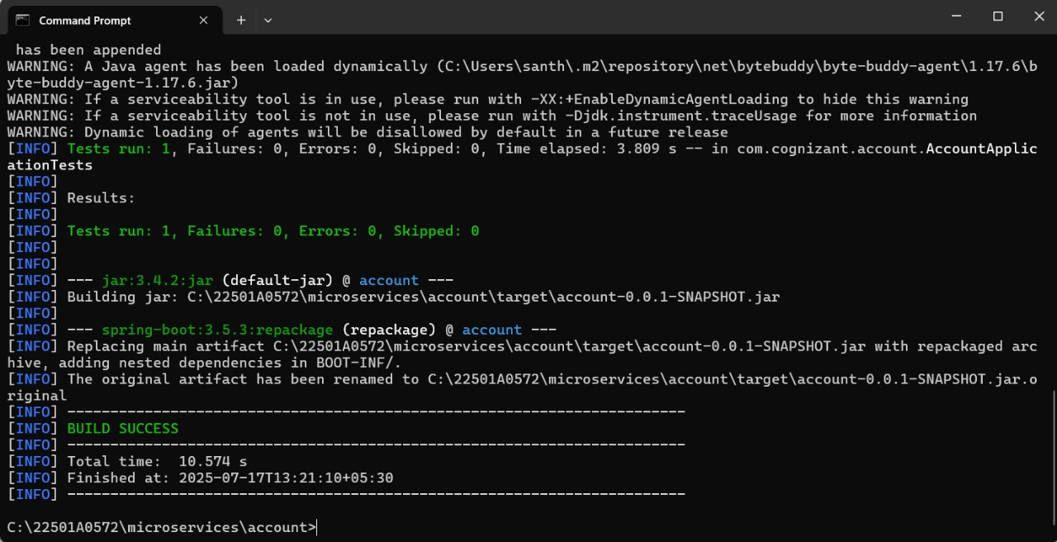

9.Import this project in Eclipse.

**pom.xml**

<dependencies>

<dependency>

<groupId>org.springframework.boot</groupId>

<artifactId>spring-boot-starter-web</artifactId>

</dependency>

<dependency>

<groupId>org.springframework.boot</groupId>

<artifactId>spring-boot-devtools</artifactId>

<scope>runtime</scope>

<optional>true</optional>

</dependency>

<dependency>

<groupId>org.springframework.boot</groupId>

<artifactId>spring-boot-starter-test</artifactId>

<scope>test</scope>

</dependency>

</dependencies>

**AccountController.java**

package com.cognizant.account;

import org.springframework.web.bind.annotation.*;

@RestController

@RequestMapping("/accounts")

public class AccountController {

@GetMapping("/{number}")

public Account getAccountDetails(@PathVariable String number) {

Account account = new Account();

account.setNumber(number);

account.setType("savings");

account.setBalance(234343);

return account;

}

}

**Account.java**

package com.cognizant.account;

public class Account {

private String number;

private String type;

private double balance;

public Account() {

}

public void setNumber(String number) {

this.number = number;

}

public String getNumber() {

return number;

}

public void setType(String type) {

this.type = type;

}

public String getType() {

return type;

}

public void setBalance(double balance) {

this.balance = balance;

}

public double getBalance() {

return balance;

}

}

**AccountApplication.java**

package com.cognizant.account;

import org.springframework.boot.SpringApplication;

import org.springframework.boot.autoconfigure.SpringBootApplication;

@SpringBootApplication

public class AccountApplication {

public static void main(String[] args) {

SpringApplication.run(AccountApplication.class, args);

}

}

**OUTPUT:**

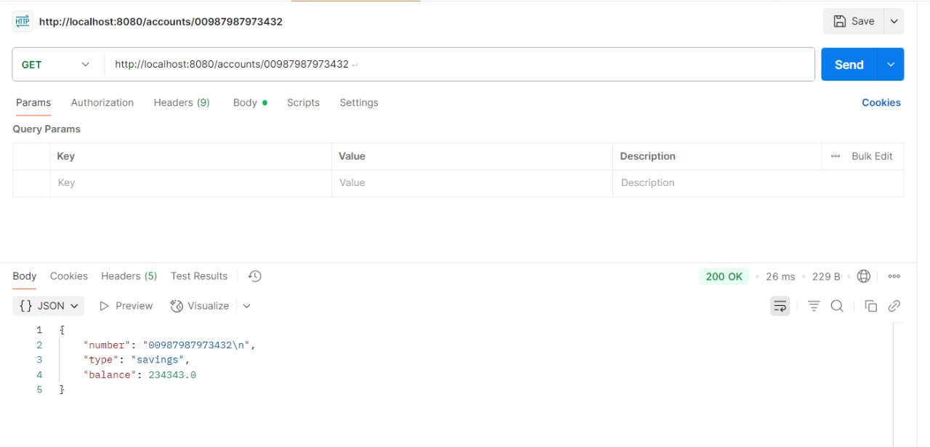

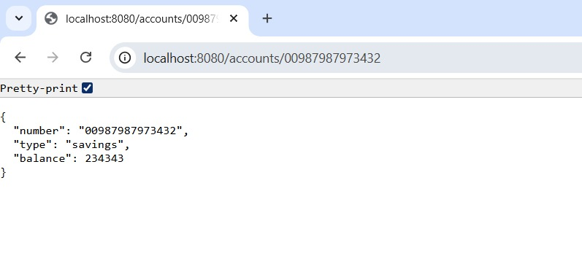

**Loan Microservice:**

1.Open https://start.spring.io/ in browser

2.Enter form field values as specified below:

**Group:** com.cognizant

**Artifact:** loan

3.Select the following modules

Developer Tools > Spring Boot DevTools

Web > Spring Web

4.Click generate and download the zip file

5.Extract 'loan' folder from the zip and place this folder in the 'microservices' folder.

6.Open command prompt in loan folder and build using mvn clean package command.

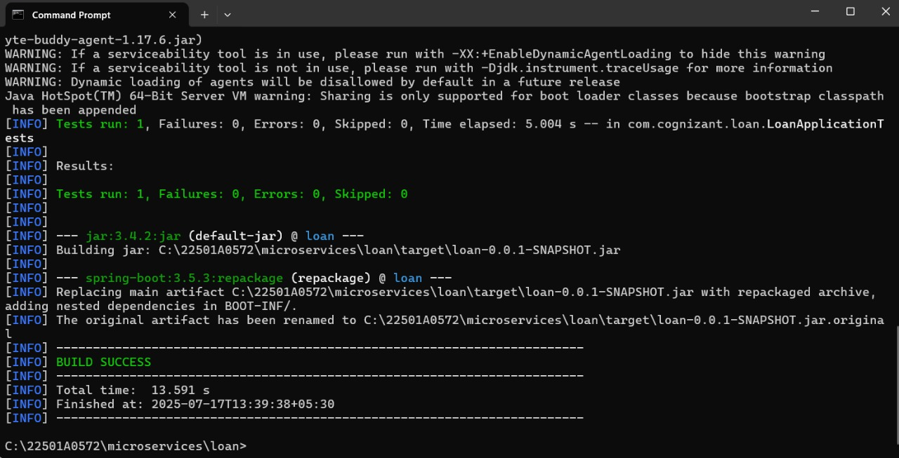

7.Import this project in Eclipse.

**LoanController.java**

package com.cognizant.loan;

import org.springframework.web.bind.annotation.*;

@RestController

@RequestMapping("/loans")

public class LoanController {

@GetMapping("/{number}")

public Loan getLoanDetails(@PathVariable String number) {

Loan loan = new Loan();

loan.setNumber(number);

loan.setType("car");

loan.setLoan(400000);

loan.setEmi(3258);

loan.setTenure(18);

return loan;

}

}

**Loan.java**

package com.cognizant.loan;

public class Loan {

private String number;

private String type;

private double loan;

private double emi;

private int tenure;

public Loan() {

}

public void setNumber(String number) {

this.number = number;

}

public String getNumber() {

return number;

}

public void setType(String type) {

this.type = type;

}

public String getType() {

return type;

}

public void setLoan(double loan) {

this.loan = loan;

}

public double getLoan() {

return loan;

}

public void setEmi(double emi) {

this.emi = emi;

}

public double getEmi() {

return emi;

}

public void setTenure(int tenure) {

this.tenure = tenure;

}

public int getTenure() {

return tenure;

}

}

**LoanApplication.java**

package com.cognizant.loan;

import org.springframework.boot.SpringApplication;

import org.springframework.boot.autoconfigure.SpringBootApplication;

@SpringBootApplication

public class LoanApplication {

public static void main(String[] args) {

SpringApplication.run(LoanApplication.class, args);

}

}

**application.properties:**

spring.application.name=loan

server.port=8081

**OUTPUT:**

