**9. REACTJS-HOL**

**Creating a “cricketapp” Application:**

1. Create a React Application with the name of “cricketapp”.

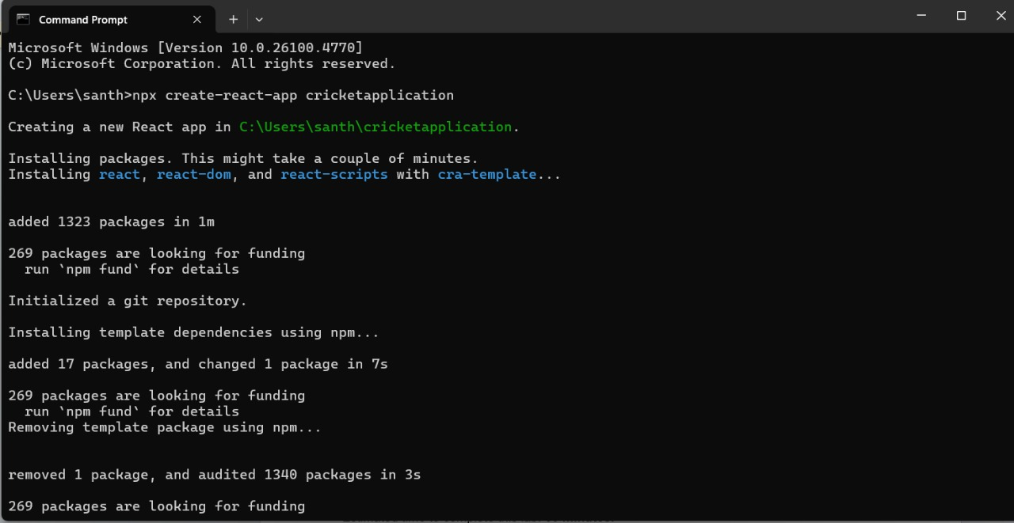

2. Once the App is created, navigate into the folder of cricketapp.

3. Open the folder of cricketapp in Visual Studio Code.

4. Create a folder named ‘components’ in src folder and create the components named EvenPlayers.js, OddPlayers.js, IndianTeamDetails.js, ListOfIndianPlayers.js, ScoreBelow70.js

**EvenPlayers.js**

export function EvenPlayers([, second, , fourth, , sixth]) {

  return (

    <div>

      <li>Second : {second}</li>

      <li>Fourth : {fourth}</li>

      <li>Sixth : {sixth}</li>

    </div>

  );

}

**IndianTeamDetails.js**

export const IndianTeam = ['Sachin1', 'Dhoni2', 'Virat3', 'Rohit4', 'Yuvaraj5', 'Raina6'];

const T20Players = ['First Player', 'Second Player', 'Third Player'];

const RanjiTrophyPlayers = ['Fourth Player', 'Fifth Player', 'Sixth Player'];

export const IndianPlayers = [...T20Players, ...RanjiTrophyPlayers];

**ListOfIndianPlayers.js**

import React from 'react';

const ListofIndianPlayers = ({ IndianPlayers }) => {

  return (

    <ul>

      {IndianPlayers.map((item, index) => (

        <li key={index}>Mr. {item}</li>

      ))}

    </ul>

  );

};

export default ListofIndianPlayers;

**ListOfPlayers.js**

import React from 'react';

const ListofPlayers = ({ players }) => {

  return (

    <ul>

      {players.map((item, index) => (

        <li key={index}>

          Mr. {item.name} <span>{item.score}</span>

        </li>

      ))}

    </ul>

  );

};

export default ListofPlayers;

**OddPlayers.js**

export function OddPlayers([first, , third, , fifth]) {

  return (

    <div>

      <li>First : {first}</li>

      <li>Third : {third}</li>

      <li>Fifth : {fifth}</li>

    </div>

  );

}

**ScoreBelow70.js**

import React from 'react';

const ScoreBelow70 = ({ players }) => {

  const players70 = [];

  players.map((item) => {

    if (item.score <= 70) {

      players70.push(item);

    }

    return null;

  });

  return (

    <ul>

      {players70.map((item, index) => (

        <li key={index}>

          Mr. {item.name} <span>{item.score}</span>

        </li>

      ))}

    </ul>

  );

};

export default ScoreBelow70;

5. Run the following command to execute the React application.

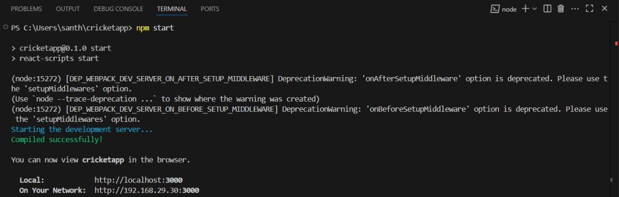

**OUTPUT:**

When flag = true

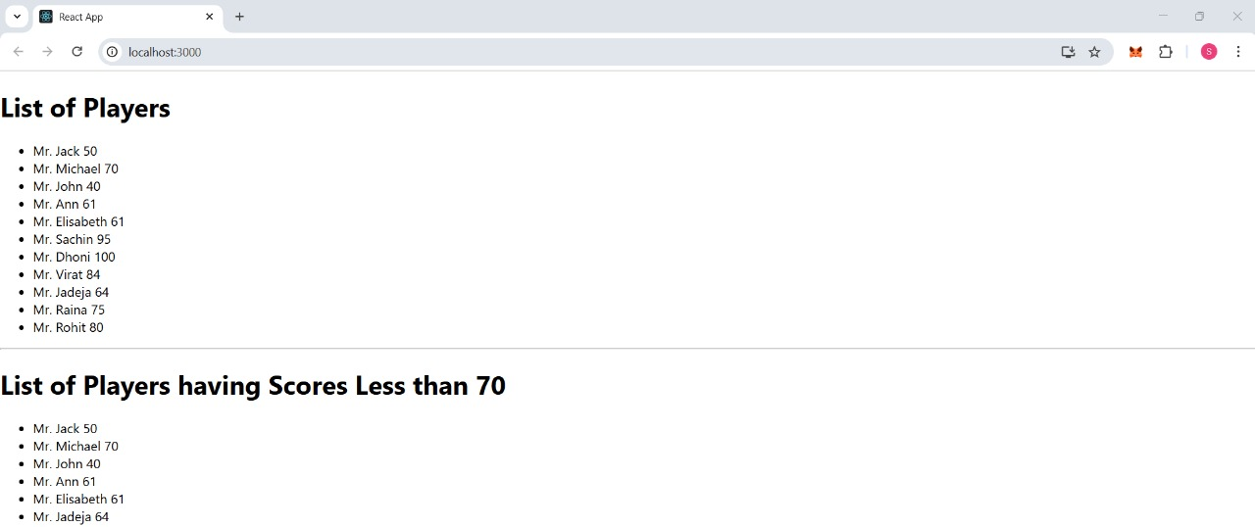

When flag = false

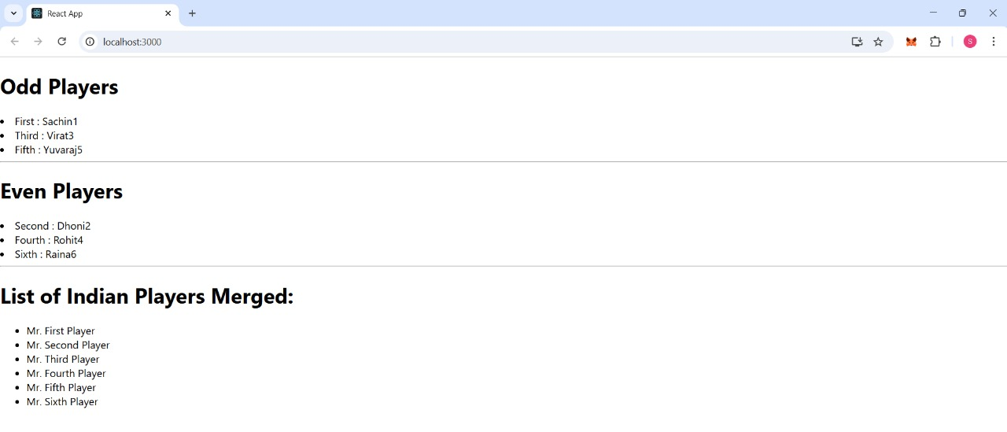

**10. REACTJS-HOL**

**Creating “officespacerentalapp”:**

1.Create a React Application with the name of “officespacerentalapp”.

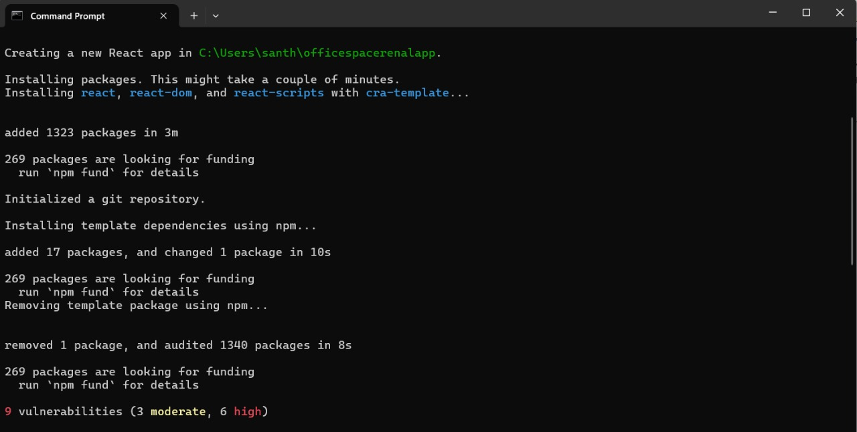

2. Once the App is created, navigate into the folder of officespacerentalapp.

3. Open the folder of officespacerentalapp in Visual Studio Code.

**App.js**

import React from "react";

import "./App.css";

function App() {

  const element = "Office Space";

  const jsxatt = <img src="office.jpg" width="25%" height="25%" alt="Office Space" />;

  const officeList = [

  { Name: "DBS", Rent: 50000, Address: "Chennai" },

  { Name: "UrbanDesk", Rent: 68000, Address: "Delhi" },

  { Name: "HiveWork", Rent: 55000, Address: "Kolkata" },

  { Name: "CoWorkHub", Rent: 73000, Address: "Ahmedabad" }

  ];

  return (

    <div style={{ padding: "20px", fontFamily: "Arial" }}>

      <h1>

        {element}, at Affordable Range

      </h1>

      {jsxatt}

      {officeList.map((ItemName, index) => {

        let colors = [];

        if (ItemName.Rent <= 60000) {

          colors.push("textRed");

        } else {

          colors.push("textGreen");

        }

        return (

          <div key={index} style={{ marginTop: "20px" }}>

            <h2>Name: {ItemName.Name}</h2>

            <h3 className={colors.join(" ")}>Rent: Rs. {ItemName.Rent}</h3>

            <h3>Address: {ItemName.Address}</h3>

          </div>

        );

      })}

    </div>

  );}

export default App;

**App.css**

.textRed {

  color: red;

}

.textGreen {

  color: green;

}

5. Run the following command to execute the React application.

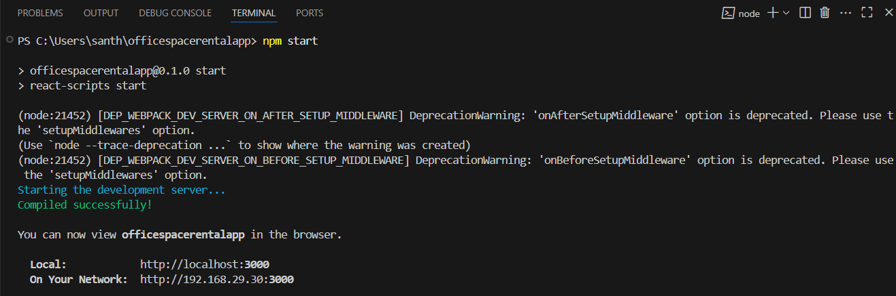

**OUTPUT:**

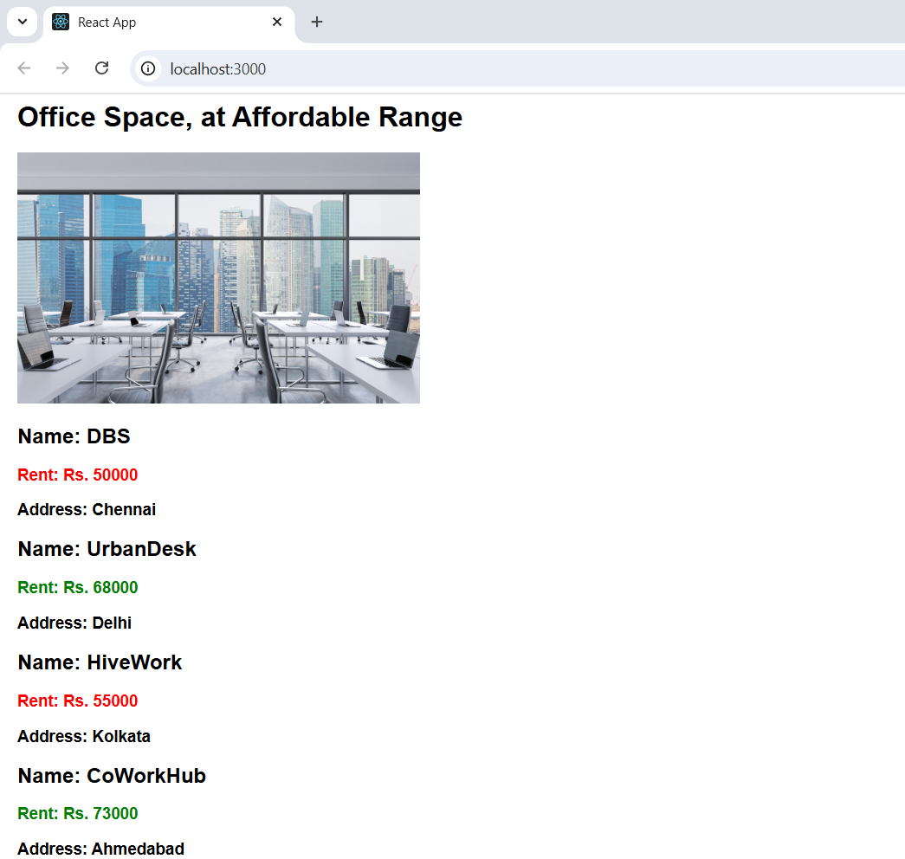

**11. REACTJS-HOL**

**Creating “eventexamplesapp”:**

1.Create a React Application with the name of “eventexamplesapp”.

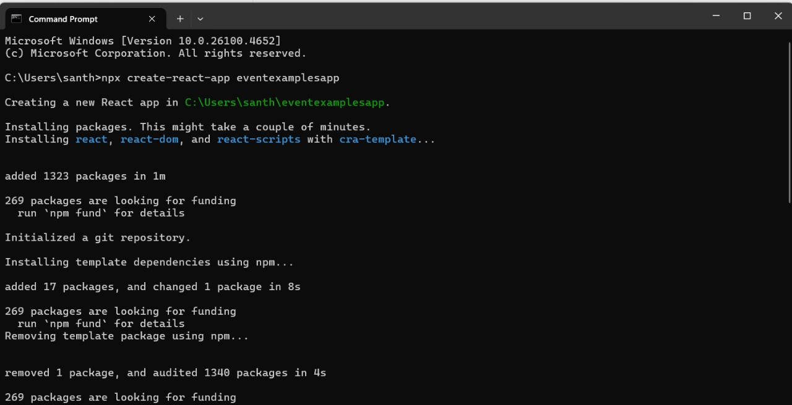

2. Once the App is created, navigate into the folder of eventexamplesapp.

3. Open the folder of eventexamplesapp in Visual Studio Code.

**App.js**

import React, { useState } from "react";

import "./App.css";

function App() {

  const [count, setCount] = useState(0);

  const [amount, setAmount] = useState("");

  const [currency, setCurrency] = useState("");

  const handleIncrement = () => {

    setCount(count + 1);

    sayHello("Member!");

  };

  const sayHello = (msg) => {

    alert(`Hello ${msg}`);

  };

  const handleDecrement = () =>{

    setCount(count - 1);

  }

  const sayWelcome = (msg) => {

    alert(msg);

  };

  const handleOnPress = (e) => {

    alert("I was clicked");

  };

  const handleSubmit = (e) => {

  e.preventDefault();

  let result = 0;

  if (currency.toLowerCase() === "euro") {

    result = amount * 0.01;

    alert(`Converting to Euro: Amount is ${result.toFixed(2)}`);

  } else if (currency.toLowerCase() === "inr") {

    result = amount * 100;

    alert(`Converting to INR: Amount is ${result}`);

  }

};

  return (

    <div className="App">

      <h3>Count: {count}</h3>

      <button className="incDec" onClick={handleIncrement}>Increment</button>

      <button onClick={handleDecrement}>Decrement</button>

      <br />

      <br />

      <button onClick={() => sayWelcome("welcome")}>Say Welcome</button>

      <br />

      <br />

      <button onClick={handleOnPress}>Click on me</button>

      <br />

      <br />

      <h2 style={{ color: "green" }}>Currency Convertor!!!</h2>

     <div className="currency" >

      <form onSubmit={handleSubmit} >

        <label>Amount:  </label>

          <input

            type="text"

            value={amount}

            onChange={(e) => setAmount(e.target.value)}

          />

        <br />

        <label>Currency: </label>

          <input

            type="text"

            value={currency}

            onChange={(e) => setCurrency(e.target.value)}

          />

        <br />

        <div className="form-button">

        <button type="submit">Submit</button>

        </div>

      </form>

      </div>

    </div>

  );

}

export default App;

4. Run the following command to execute the React application.

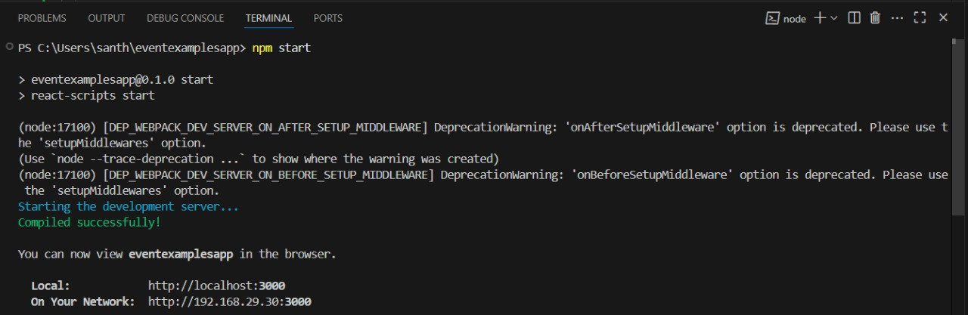

**OUTPUT:**

1.Incrementing and decrementing value

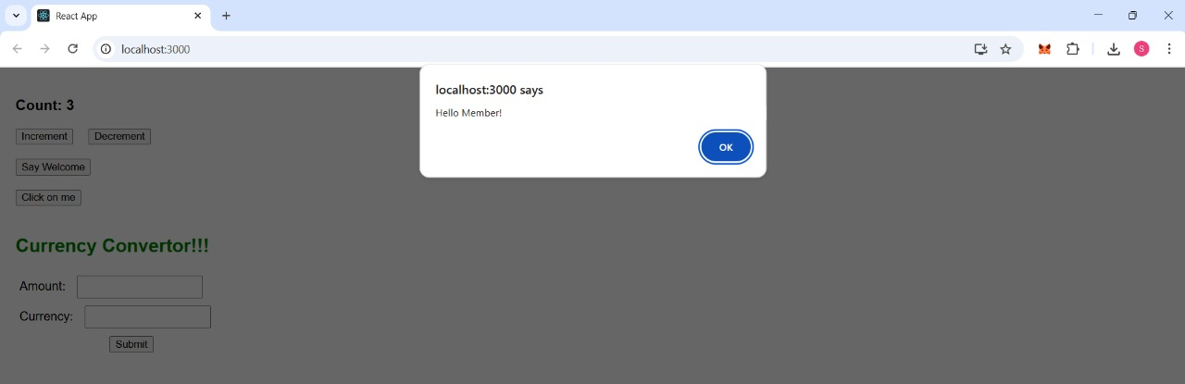

2. Clicking on “Say Welcome” button.

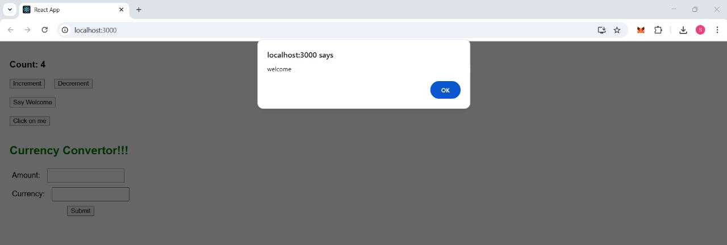

3. Clicking on “OnPress” button.

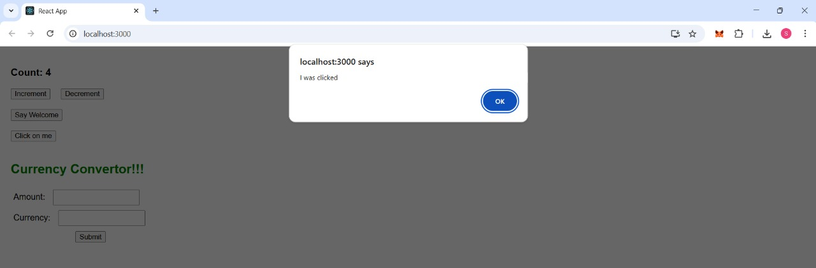

4. Converting from inr to euros in “CurrencyCoverter”

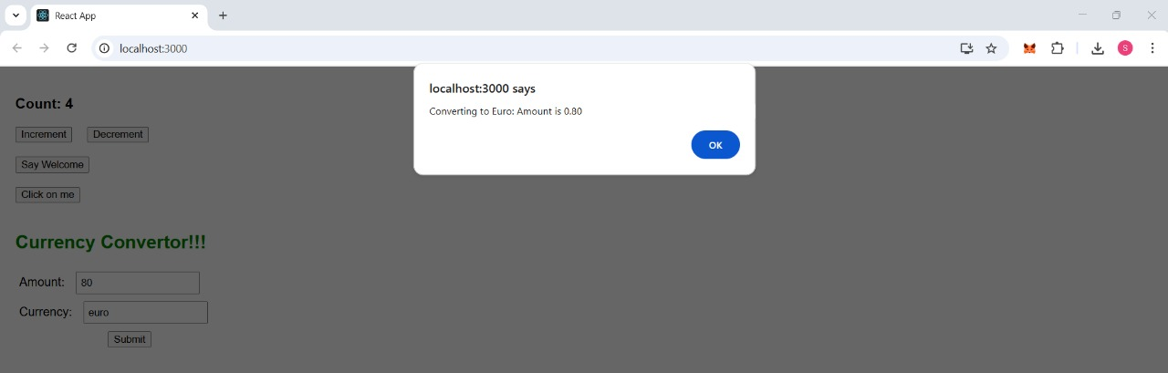

5. Converting from euros to inr in “CurrencyCoverter”

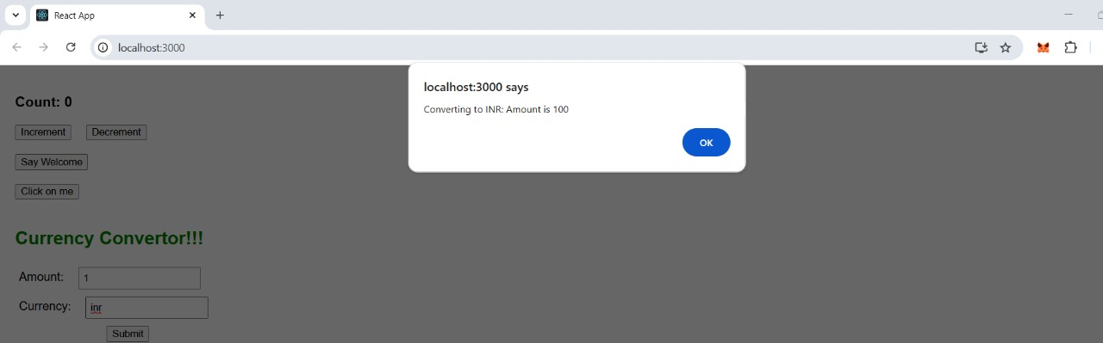

**12. REACTJS-HOL**

**Creating “ticketbookingapp”**

1.Create a React Application with the name of “ticketbookingapp”.

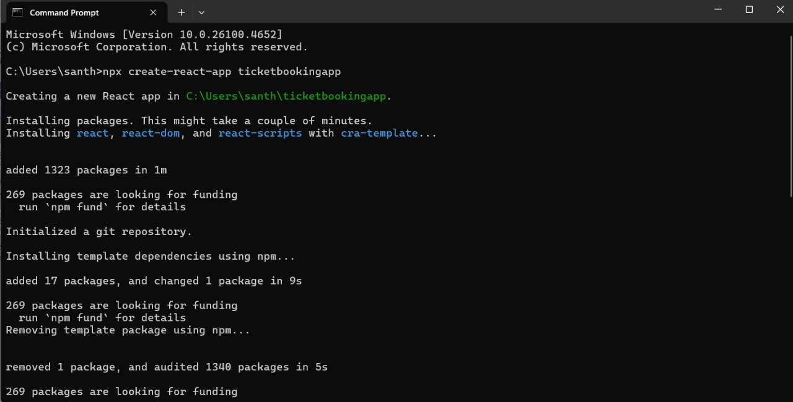

2. Once the App is created, navigate into the folder of ticketbookingapp.

3. Open the folder of ticketbookingapp in Visual Studio Code.

**App.js**

import React, { useState } from 'react';

import './App.css';

function LoginButton(props) {

  return (

    <div style={{ display: 'flex', marginLeft: '140px', marginTop: '10px' }}>

    <button onClick={props.onClick}>

      Login

    </button>

    </div>

  );

}

function LogoutButton(props) {

  return (

    <div style={{ display: 'flex', marginLeft: '140px', marginTop: '10px' }}>

    <button onClick={props.onClick}>

      Logout

    </button>

    </div>

  );

}

function Greeting(props) {

  const isLoggedIn = props.isLoggedIn;

  if (isLoggedIn) {

    return <UserGreeting />;

  }

  return <GuestGreeting />;

}

function UserGreeting() {

  return (

    <div style={{marginLeft: '30px'}}>

      <h2>Welcome back</h2>

      <TicketBooking />

    </div>

  );

}

function GuestGreeting() {

  return (

    <div style={{marginLeft: '30px'}}>

      <h2>Please sign up.</h2>

      <FlightDetails />

    </div>

  );

}

function FlightDetails() {

  return (

    <div>

      <h3>Available Flights</h3>

      <ul>

        <li>Flight 101 - Mumbai to Delhi - 10:00 PM</li>

        <li>Flight 202 - Bangalore to Gujarat - 10:00 AM</li>

        <li>Flight 303 - Hyderabad to Chennai - 6:00 PM</li>

      </ul>

    </div>

  );

}

function TicketBooking() {

  return (

    <div>

      <h4>Book Your Ticket</h4>

      <form>

        <label>Name: </label><input type="text" /><br />

        <label>Flight ID: </label><input type="text" /><br />

        <div style={{ display: 'flex', marginLeft: '100px', marginTop: '10px' }}>

    <button type="submit">Book Now</button>

  </div>

      </form>

    </div>

  );

}

function App() {

  const [isLoggedIn, setIsLoggedIn] = useState(false);

  const handleLoginClick = () => setIsLoggedIn(true);

  const handleLogoutClick = () => setIsLoggedIn(false);

  return (

    <div className="App">

      <Greeting isLoggedIn={isLoggedIn} />

      {isLoggedIn ? (

        <LogoutButton onClick={handleLogoutClick} />

      ) : (

        <LoginButton onClick={handleLoginClick} />

      )}

    </div>

  );

}

export default App;

4. Run the following command to execute the React application.

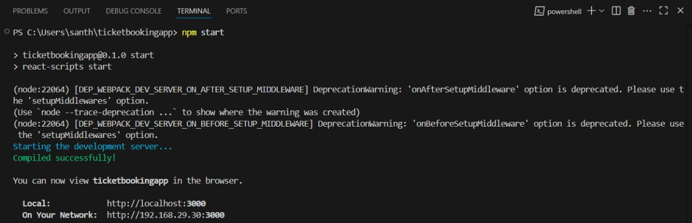

**OUTPUT:**

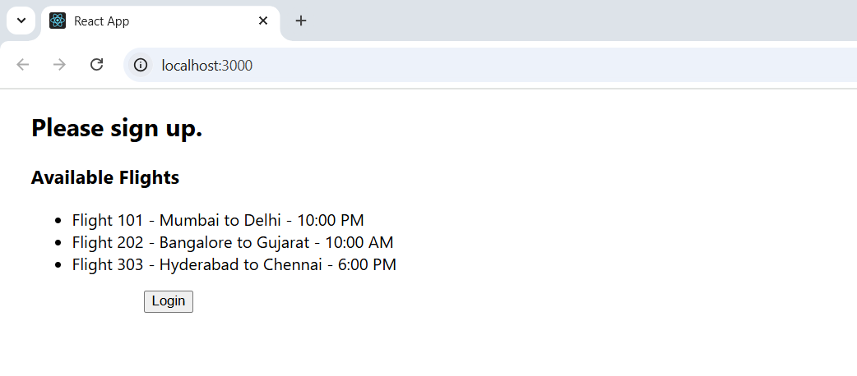

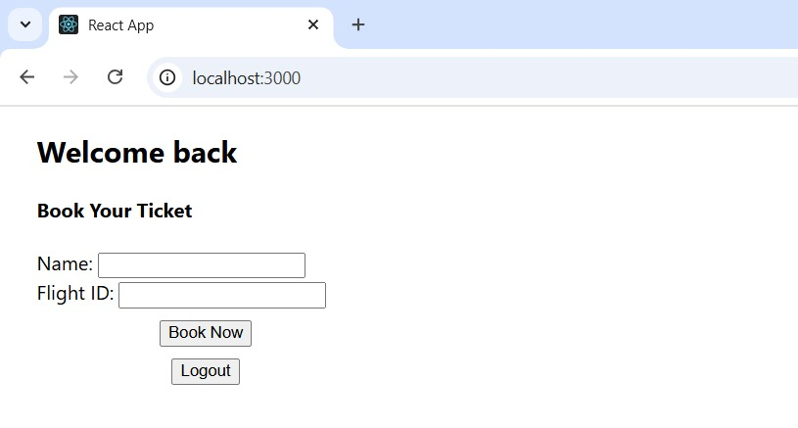

**13. REACTJS-HOL**

**Creating “bloggerapp”**

1. Create a React Application with the name of “bloggerapp”.

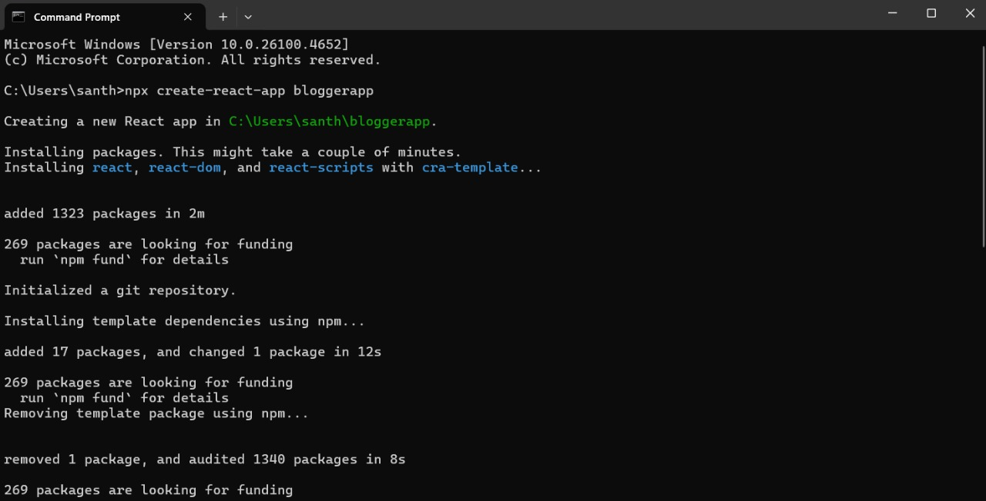

2. Once the App is created, navigate into the folder of bloggerapp.

3. Open the folder of bloggerapp in Visual Studio Code.

4. Create a folder named ‘components’ in src folder and create the components named BlogDetails.js, BookDetails.js, CourseDetails.js.

**BlogDetails.js**

const BlogDetails = ({ blogs }) => (

  <div>

    {blogs.map((blog, index) => (

      <div key={index}>

        <h3>{blog.title}</h3>

        <p>{blog.author}</p>

        <p>{blog.desc}</p>

      </div>

    ))}

  </div>

);

export default BlogDetails;

**BookDetails.js**

const BookDetails = ({ books }) => (

  <div>

    {books.map((book) => (

      <div key={book.id}>

        <h3>{book.bname}</h3>

        <h4>{book.price}</h4>

      </div>

    ))}

  </div>

);

export default BookDetails;

**CourseDetails.js**

const CourseDetails = ({ courses }) => (

  <div>

    {courses.map((course, index) => (

      <div key={index}>

        <h3>{course.name}</h3>

        <h4>{course.date}</h4>

      </div>

    ))}

  </div>

);

export default CourseDetails;

**App.js**

import React from 'react';

import './App.css';

import BookDetails from './components/BookDetails';

import BlogDetails from './components/BlogDetails';

import CourseDetails from './components/CourseDetails';

const books = [

  { id: 101, bname: 'Master React', price: 670 },

  { id: 102, bname: 'Deep Dive into Angular 11', price: 800 },

  { id: 103, bname: 'Mongo Essentials', price: 450 }

];

const courses = [

  { name: 'Angular', date: '4/5/2021' },

  { name: 'React', date: '6/13/2021' }

];

const blogs = [

  { title: 'React Learning', author: 'Stephen Biz', desc: 'Welcome to learning React!' },

  { title: 'Installation', author: 'Schwazenbier', desc: 'You can install React from npm.' }

];

function App() {

  return (

    <div style={{ display: 'flex', justifyContent: 'space-around' }}>

      <div className="mystyle1">

        <h1>Course Details</h1>

        {courses.length > 0 ? (

          <CourseDetails courses={courses} />

        ) : (

          <p>No courses are available.</p>

        )}

      </div>

      <div className="st2">

        <h1>Book Details</h1>

        {books.length > 0 ? (

          <BookDetails books={books} />

        ) : (

          <p>No books are available.</p>

        )}

      </div>

      <div className="v1">

        <h1>Blog Details</h1>

        {blogs.length > 0 ? (

          <BlogDetails blogs={blogs} />

        ) : (

          <p>No blogs are available.</p>

        )}

      </div>

    </div>

  );

}

export default App;

5. Run the following command to execute the React application.

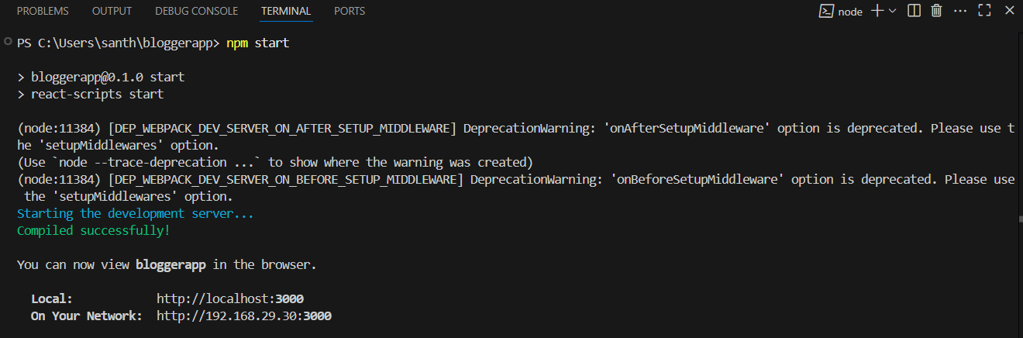

**OUTPUT:**

