Synopsis

Project Title
Air Quality Level Classification System

Problem Id: 19

Student Name - Kunal Joshi
University Roll number - 2028751
Section - Q

Student Name - Divyanshu Panwar
University Roll Number - 2020715
Section - Q

Student Name - Nikunj Singhal
University Roll number - 2028783
Section - Q

- Problem Description:
Air pollution has become a major environmental and public health concern worldwide. Increasing levels of pollutants such as carbon monoxide (CO), nitrogen dioxide (NO₂), and variations in temperature and humidity significantly impact air quality. Poor air quality can lead to serious health issues including respiratory diseases, cardiovascular problems, and reduced life expectancy. Therefore, there is a need for an intelligent system that can accurately classify air quality levels based on sensor data.
This project aims to design and develop a machine learning-based Air Quality Level Classification System that predicts air quality categories (e.g., Good, Moderate, Poor) using environmental and pollutant data. The system will utilize features such as CO, NO₂, temperature, and humidity collected from sensors. Data preprocessing techniques like handling missing values, noise removal, and feature scaling will be applied to improve data quality. Feature selection methods will help in identifying the most relevant parameters affecting air quality.
Classification algorithms such as K-Nearest Neighbors (KNN) and Logistic Regression will be used to build predictive models. The performance of these models will be evaluated using metrics like accuracy and precision. This system will help in monitoring air pollution levels and assist authorities and individuals in making informed decisions.
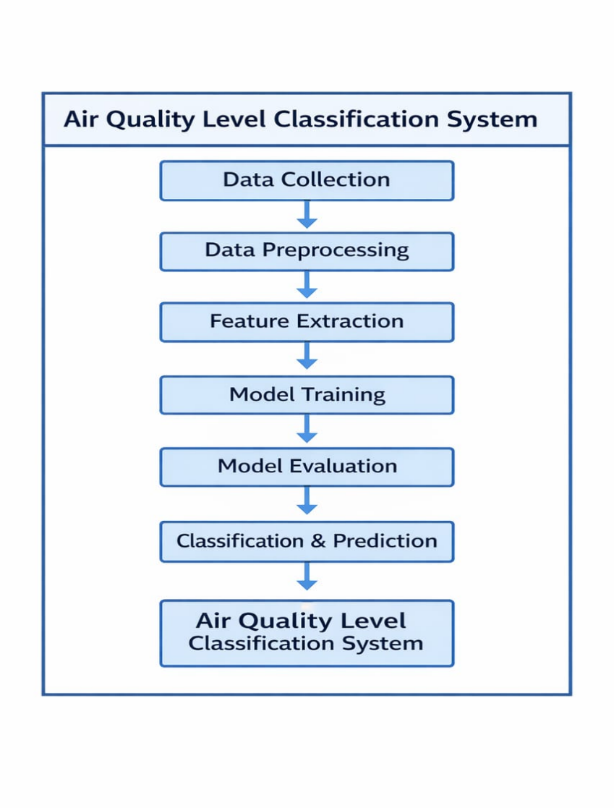

- Steps of Implementation:
- Data Collection
Collect an air quality dataset containing features like CO, NO₂, temperature, and humidity from sources such as Kaggle or UCI repository.
- Data Preprocessing
Clean the dataset to improve quality:
- Handle missing values (mean/median or removal)
- Remove noise and outliers (e.g., using Z-score method)
- Convert data into proper format if required
- Feature Scaling
Apply normalization or standardization so that all features are on the same scale. This improves the performance of models like KNN.
- Feature Selection
Select important features that contribute most to air quality prediction and remove irrelevant or redundant data to improve efficiency.
- Train-Test Split
Divide the dataset into training (80%) and testing (20%) sets to evaluate model performance on unseen data.
- Model Training
Train machine learning models:
- KNN: Classifies data based on nearest neighbors
- Logistic Regression: Predicts probability of class labels
- Model Evaluation
Evaluate model performance using metrics like accuracy, precision, recall, and confusion matrix.
- Result Analysis & Comparison
Compare both models to determine which gives better performance and reliability.
- Visualization
Use graphs like histograms, heatmaps, and confusion matrix plots to better understand data and model performance.

- Expected Modules/ Libraries to be used :
- Python
Used as the main programming language for building the project.
- NumPy
Helps in numerical operations and handling arrays efficiently.
- Pandas
Used for data loading, cleaning, and manipulation in tabular form.
- Matplotlib
Used to create basic graphs like histograms and plots.
- Seaborn
Used for advanced visualizations like heatmaps.
- Scikit-learn (sklearn)
Used for machine learning tasks such as preprocessing, model training (KNN, Logistic Regression), and evaluation.

- Expected Evaluation metrics and Plots to be used:
- Accuracy
Measures the overall correctness of the model (how many predictions are correct out of total predictions).
- Precision
Indicates how many of the predicted positive values are actually correct. Useful when false positives need to be minimized.
- Recall
Measures how many actual positive cases are correctly identified by the model.
- F1-Score
Harmonic mean of precision and recall, providing a balance between them.
- Confusion Matrix
A table used to visualize model performance by showing correct and incorrect predictions (True Positive, False Positive, etc.).

- Required topics from the subject:
- Supervised Learning: Understanding how models are trained using labeled data to classify air quality levels (Good, Moderate, Poor).
2. Data Preprocessing & Feature Scaling: Knowledge of cleaning data, handling missing values, and applying normalization/standardization to improve model performance.
3. Classification Algorithms & Evaluation: Understanding KNN and Logistic Regression along with evaluation metrics like accuracy and precision to assess model performance.

- Platform Required:
- Jupyter Notebook / Google Colab
- Python (Anaconda recommended)
- VS Code (optional)

- Books and Link Sources:
- Hands-On Machine Learning with Scikit-Learn & TensorFlow – Aurélien Géron
- Pattern Recognition and Machine Learning – Christopher Bishop
- Kaggle Datase
- UCI Machine Learning Repository

