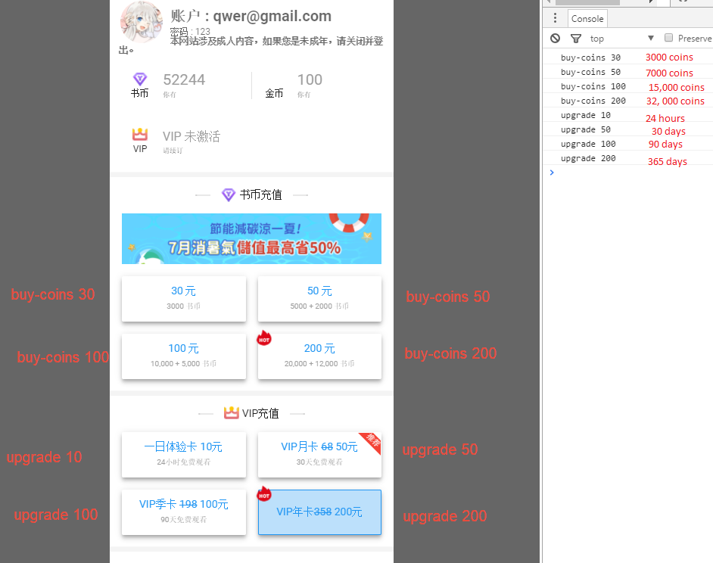
Above when user select an option we save the value as string in variable product
For example ➔ if user select the “buy-coins 30” it will save the value in product variable as “buy-coin 30”
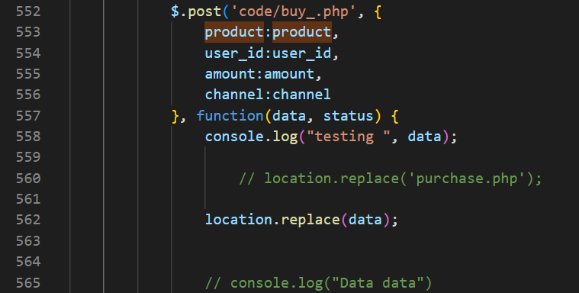
➔
Then we send a post request to ➔ buy.php [it’s in “code” folder] ➔
➔

The buy.php page will return a link for payments……
ALL we need to do is to take user to the new url that been given buy the buy.php page

In buy,php page here we store data, you can suggest some security concern in here…..
other codes are given by the payment provider

