Cloude.ai/new : Analysis
SQLBolt.com
Sqlfiddle.com: Optimization
Leetcode.com: percentage % people read

Copilot.microsoft.com
Cursor- Create Application example nodejs/reactjs
Perplexity: Preparation-interview
Grok.com- Report Research Preparation
Gamma.app: preparationof PPT
Napkin.ai: Convert Text description into image or visualization
Install merlin: chrome extension] Article: 3 bullet point.

Perplexity:
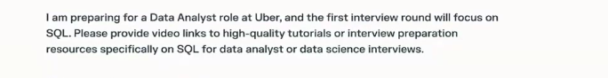

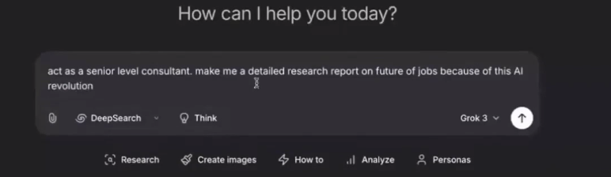DeepSearch

