This document shows how we can author the components created in AEM:

1. Title (OOTB) component: Allows to add following content
   1. Title : Header Title,
   2. Link : Path to Link (Optional)
   3. Size of Title : Drop Down <h1 to h6>

<http://localhost:4502/editor.html/content/nab/home.html>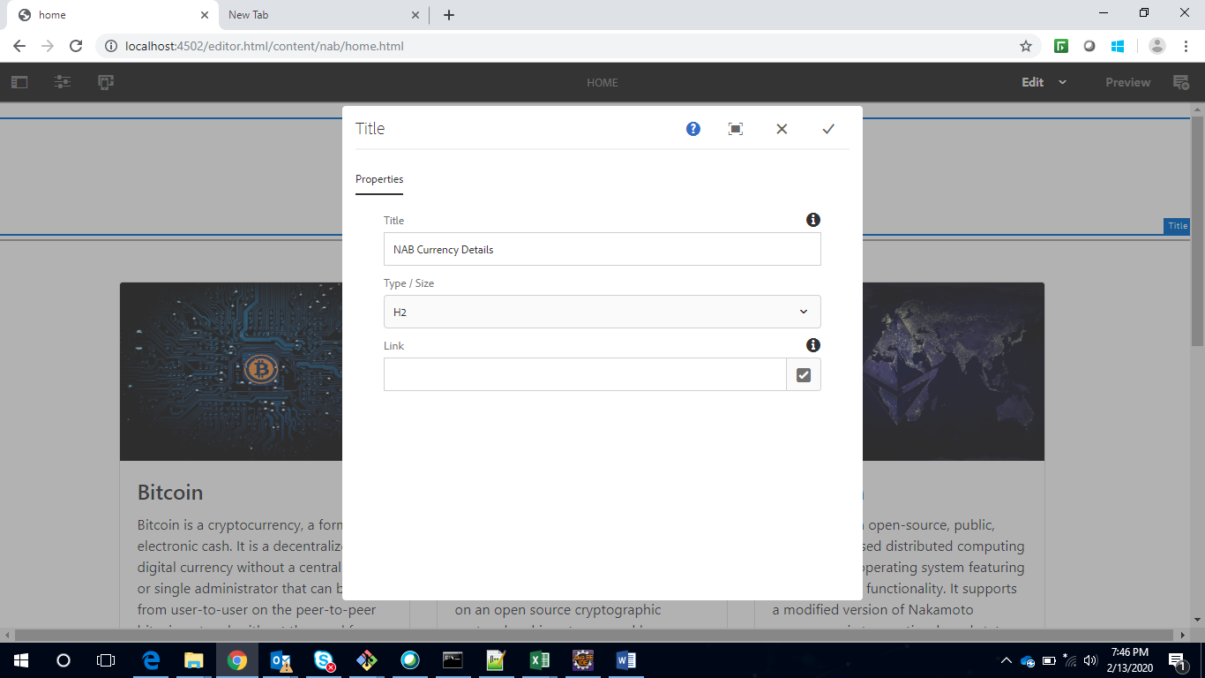

1. Currency List Component: This is a Multi-field component where multiple tiles for each currency can be added.
   1. Allows to add Currency Tile with respective fields:
      1. Title : Title of currency
      2. URL Title: Button Label
      3. URL : Link to the page
      4. Image link : Link to Image DAM Path
      5. Description: Description of currency.

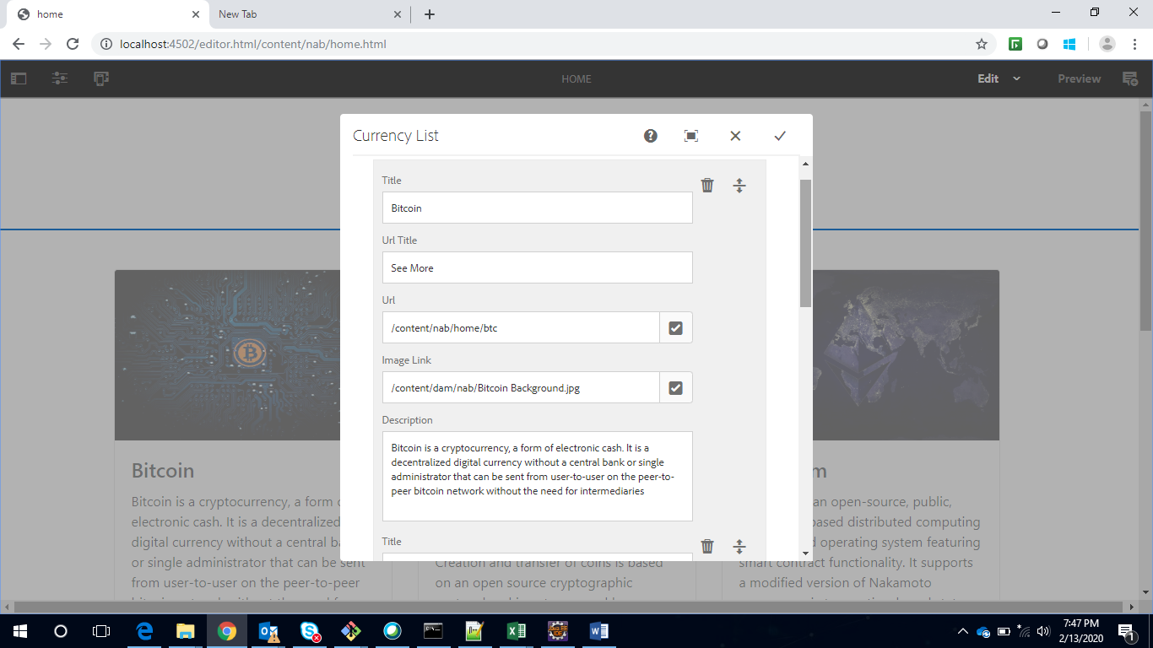

1. Profit table component : allows to following content
   1. Sell title : add title for Sell
   2. Buy Title : add But title for Buy
   3. Profit title : Header title for component

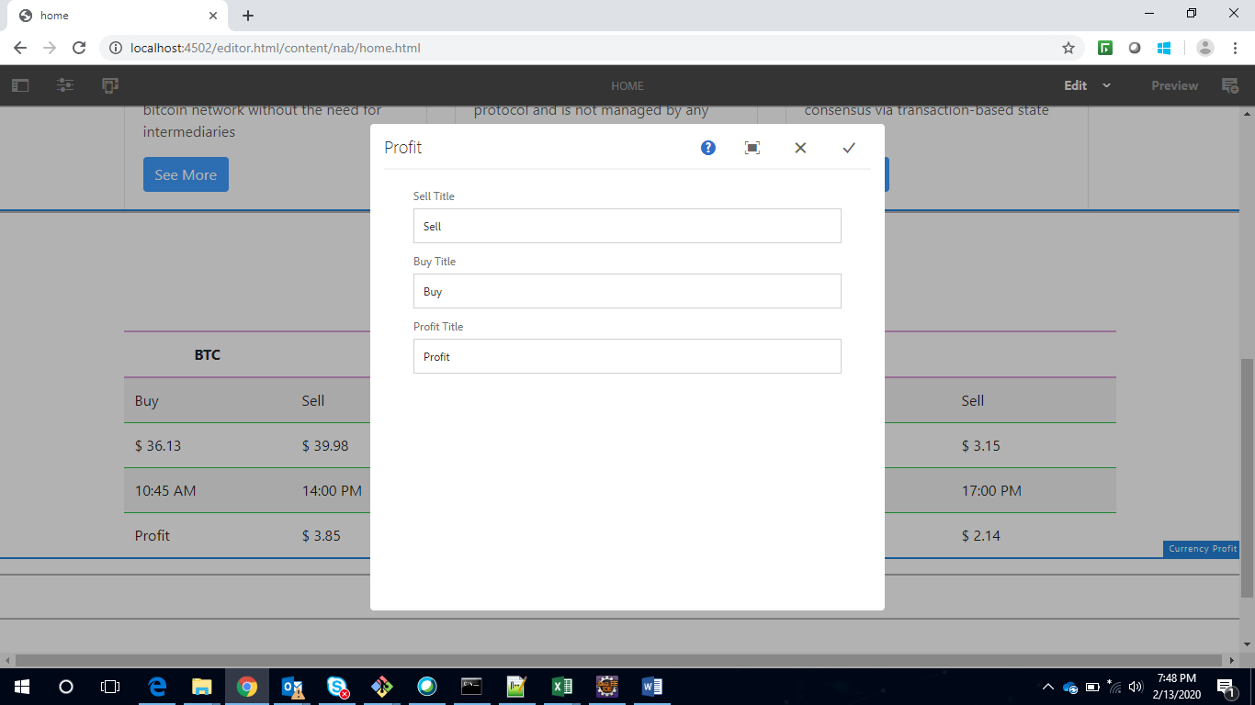

1. Image text (OOTB) component : allows to add content using following fields –
   1. under Image Property tab :
      1. Image asset : allows to add image
      2. Title : tallows to add Title
      3. Alignment : allows to set alignment of image
      4. Link : Link to Page Path
      5. Size : Set Image Width and Height
   2. Under Accessibility :
      1. Image Alt text : alt text for image

<http://localhost:4502/editor.html/content/nab/home/btc.html>

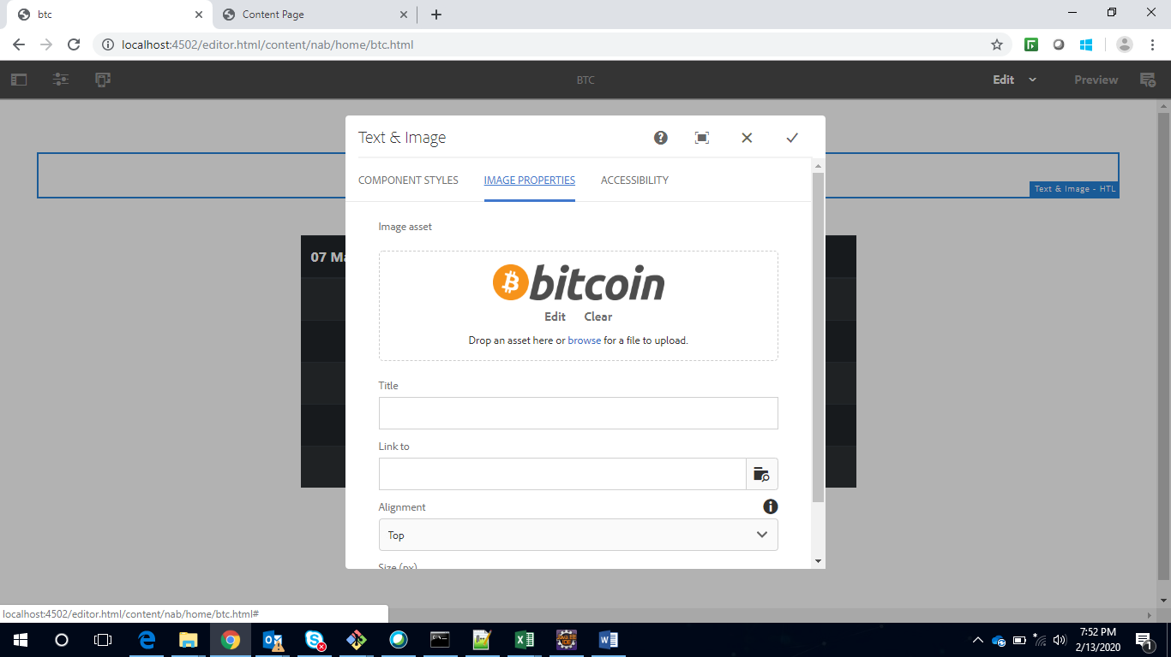

1. Currency Detail component :
   1. Select Currency: Allows to select different currency from drop down available to display respective currency data.

