Deployment Instructions:

1. Go to path /nab
2. Run the command:

mvn clean install -PautoInstallPackage

(make sure you have AEM, Maven and Java 8 installed)

You should see the success build as per below screenshot:

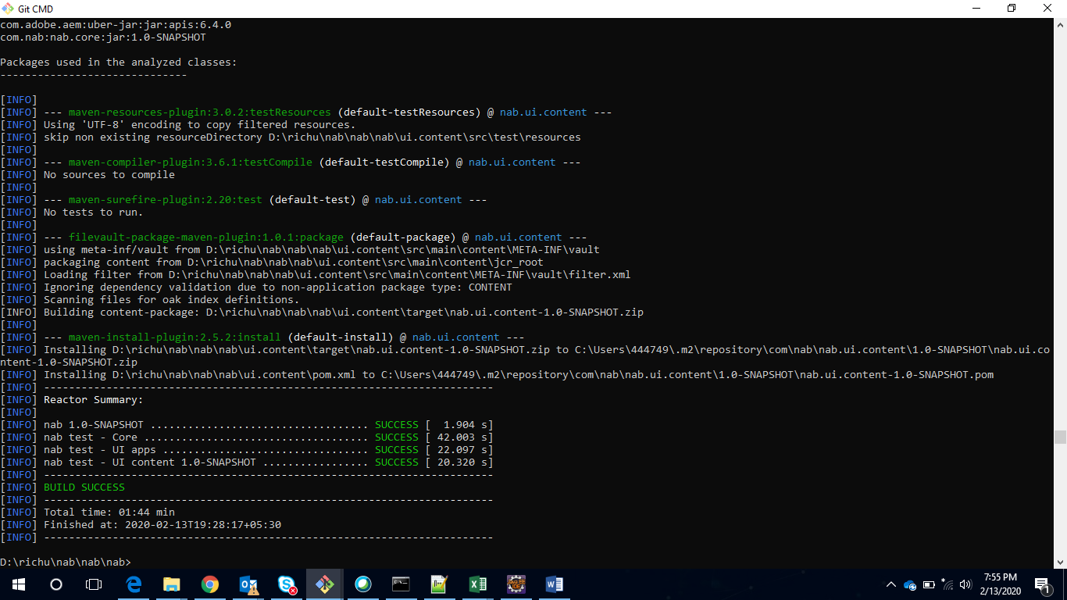

1. Create service User
   1. Go to <http://localhost:4502/crx/explorer/index.jsp> -> click on user administrator
   2. Click on system user button
   3. Enter “datawriteuser” , click on green button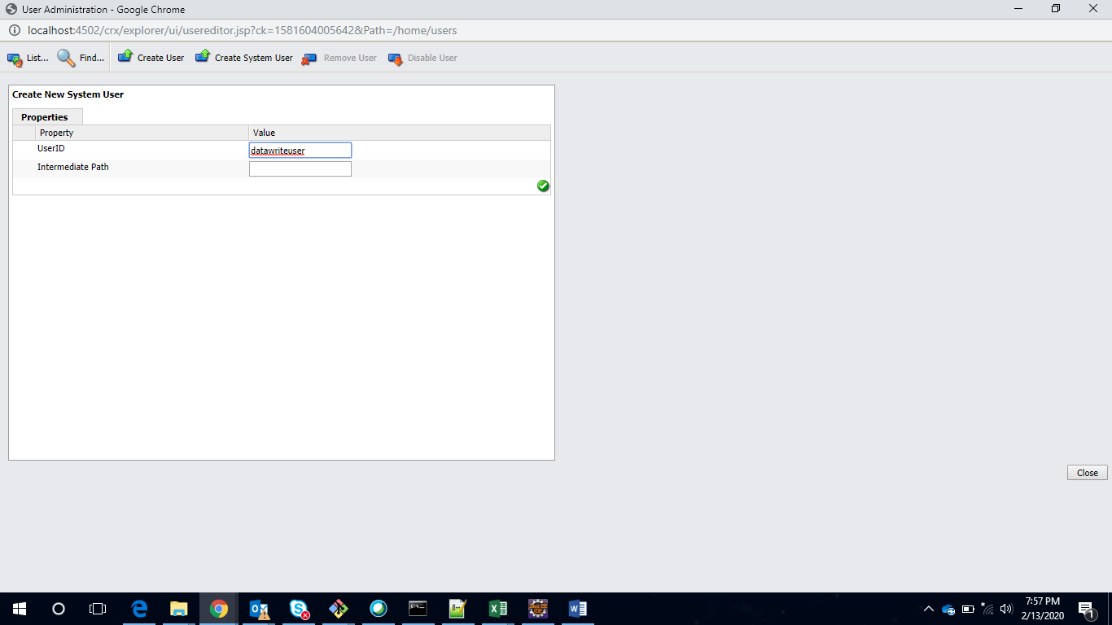
   4. Go to <http://localhost:4502/useradmin> , provide permissions.

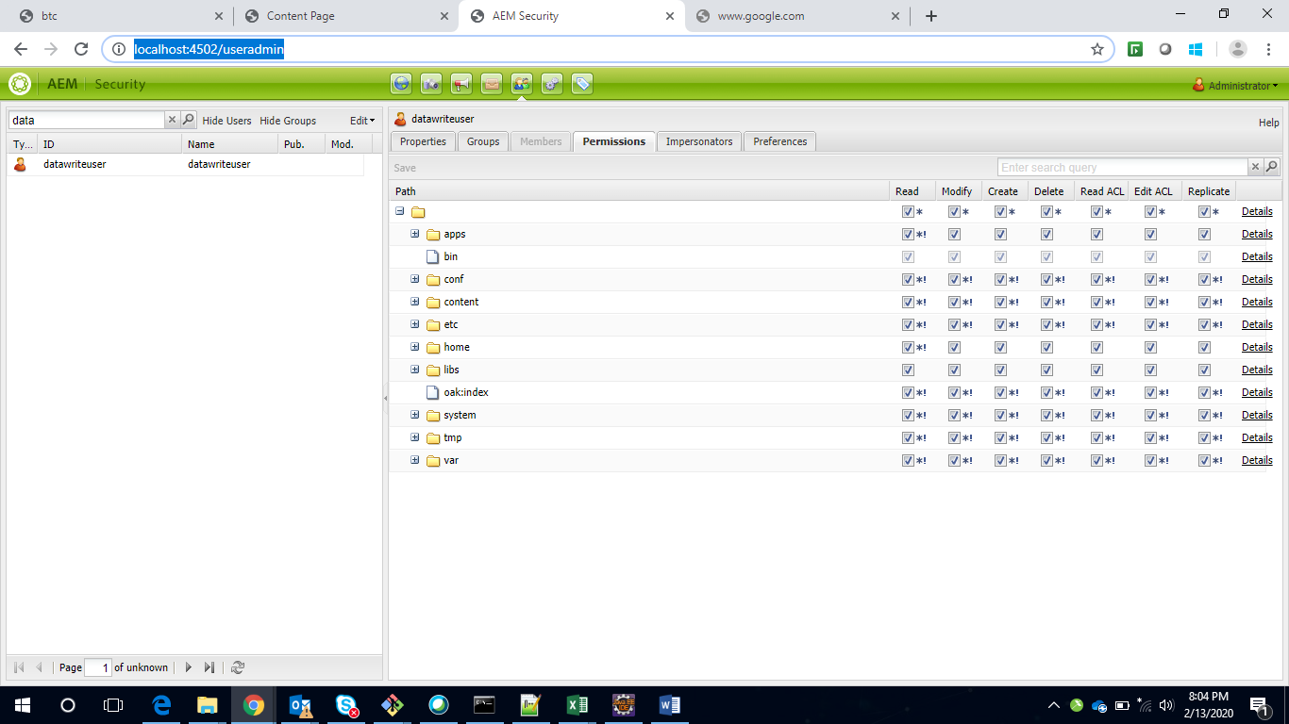

* 1. Upload csv files : 1. Go to <http://localhost:4502/assets.html/content/dam/nab/documents/csv>
     1. Go to nab/core/src/test/resources/ , upload 20.csv
  2. Go to home Page : <http://localhost:4502/editor.html/content/nab/home.html>