**Screens**

<http://localhost:4502/content/nab/home.html>

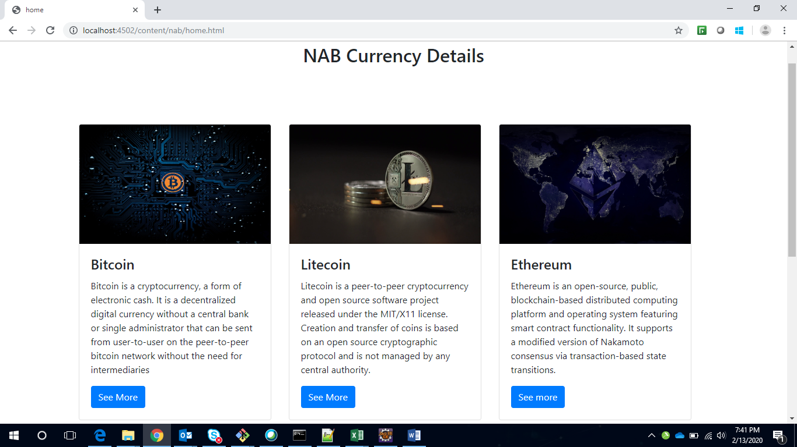

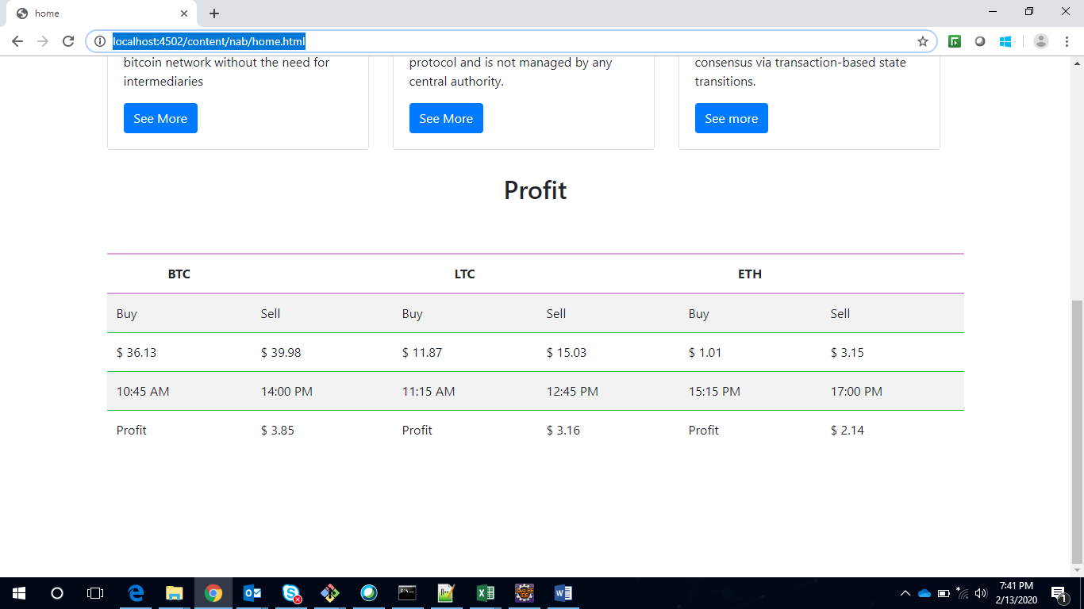

<http://localhost:4502/content/nab/home/btc.html>

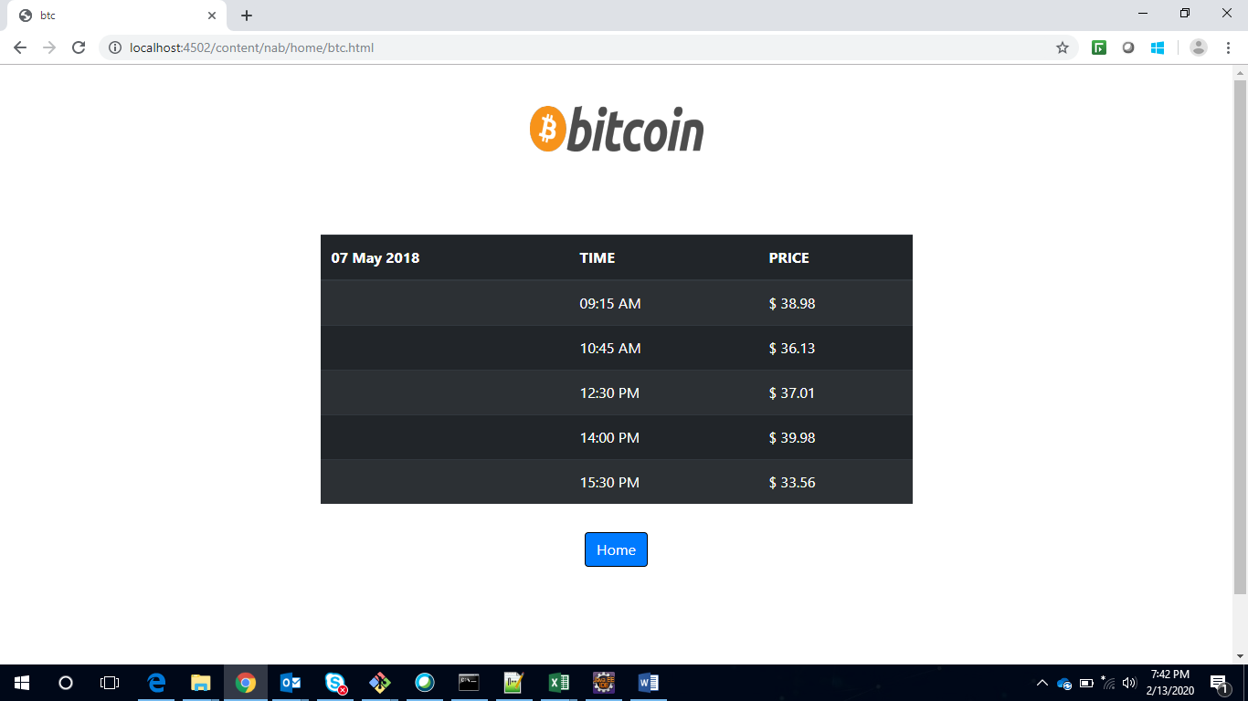

<http://localhost:4502/content/nab/home/ltc.html>

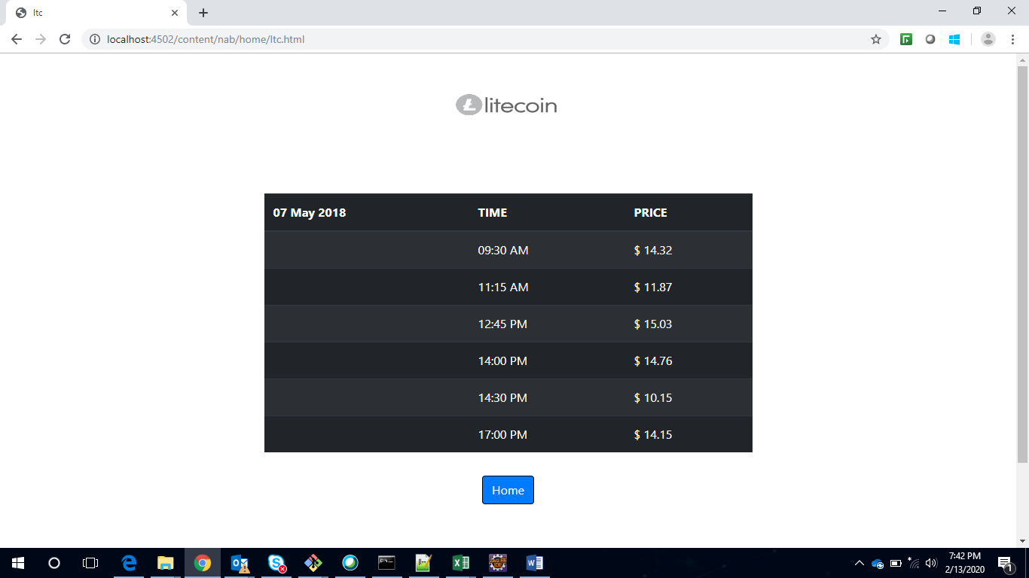

<http://localhost:4502/content/nab/home/eth.html>

