**Numerical methods for PDE**

Homework 4

Done by Denis Kalmykov

Test 1a:

Upwind: [0.19191447030275344, 0.019691921114570854, 0.0019735413133380453]

LW: [0.08130709385334028, 0.0007915373144041019, 7.86118460506871e-06]

As we can see an upwind scheme is the first order consistent with the problem and a Lax-Wendroff scheme has the second order of accuracy.

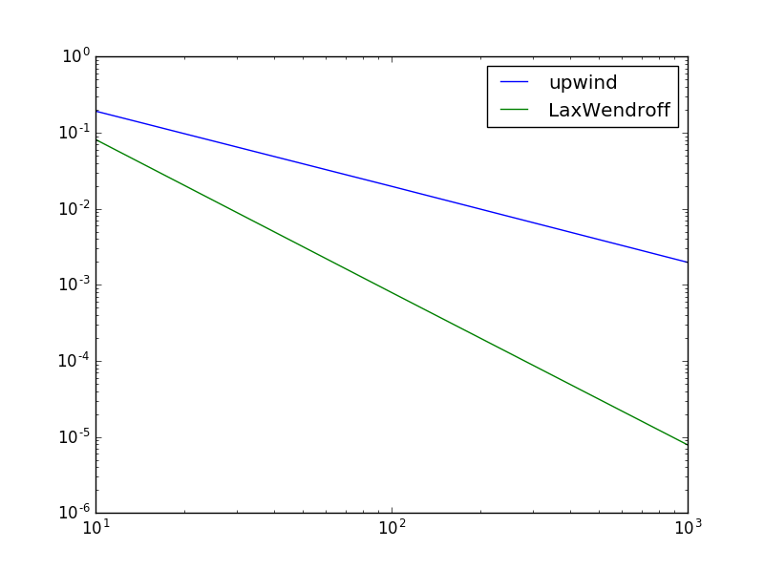

Test 1b:

Upwind: [0.028490420934608324, 0.00032675566095040007, 3.303443813059727e-06]

LW: [0.16693690326874555, 0.019681505742383476, 0.0019735312123059234]

The equation has been changed. That is way the upwind scheme now is the second order consistent and the other scheme has lost accuracy.

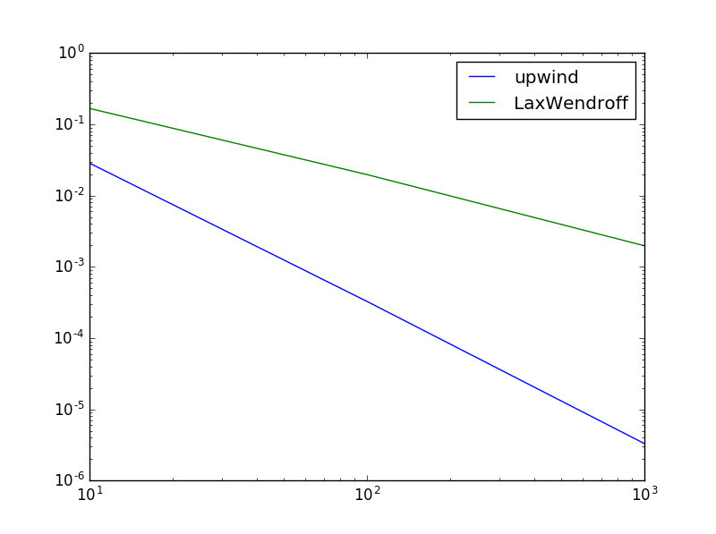

Test 2:

