KalaCare ERP
Automated Build & Deployment Process
git push → GitHub Actions → Self-hosted runner → Company server (IIS + Backend service)
Prepared: August 2026 | Kala Group IT

1. Overview
Today, deployment of the KalaCare ERP is manual: the frontend is built on the developer PC, the dist folders are copied to the company server by hand, files are replaced, and the backend is restarted manually in a PowerShell window. This document describes the automated process that replaces all of those manual steps with a single action: git push.
After the one-time setup described in Section 4, every push to the main branch will automatically build the frontend and backend on the company server, replace the hosted files, and restart the backend service. Total manual effort per deployment: only the git push.

Current system
- Frontend: React application, built with Vite into the client\dist folder, hosted as static files in IIS.
- Backend: Python FastAPI application, packaged with PyInstaller into a single backend.exe (server\dist), currently started manually in a PowerShell window.
- Source code: pushed to a private company GitHub repository (including the .env configuration file).

2. Components and Their Roles
Component | Role in the process
Developer PC | Where code is written. Only needs git. No building or copying required anymore.
GitHub (private repo) | Stores the source code and the deploy.yml workflow. Detects every push to main and starts the deployment job.
Self-hosted runner | A small GitHub agent installed on the company server as a Windows service. It connects OUTBOUND to GitHub (no firewall ports need to be opened) and executes the deployment steps locally on the server.
IIS | Hosts the frontend static files. Because they are static, IIS serves the new files immediately after copy — no restart needed.
KalaCareBackend service | The backend.exe wrapped as a Windows service using NSSM. Can be stopped/started by script and auto-starts after a server reboot.
Backup folder | Every deployment saves a dated copy of the previous frontend folder and backend.exe, so rollback is always possible.

3. Process Flowchart
The complete flow, from code change to live deployment:
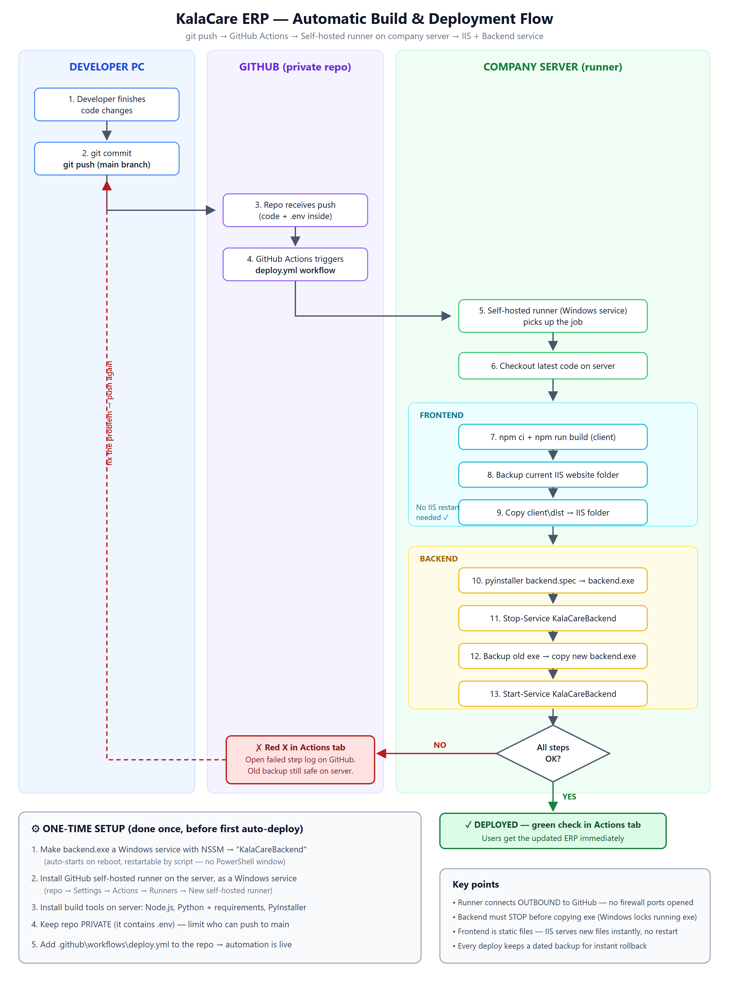

4. One-Time Setup (done once on the company server)

Step 1 — Run the backend as a Windows service (NSSM)
The backend must stop running in a manually-opened PowerShell window. A PowerShell window dies when the user logs off and cannot be restarted by automation. NSSM (from nssm.cc, free) wraps backend.exe as a proper Windows service:
nssm install KalaCareBackend "C:\apps\kalacare\backend\backend.exe"
nssm set KalaCareBackend AppDirectory "C:\apps\kalacare\backend"
Start-Service KalaCareBackend
Benefits: restart by one command (Restart-Service KalaCareBackend), and the backend auto-starts after every server reboot.

Step 2 — Install the GitHub self-hosted runner
- Open the company GitHub repository → Settings → Actions → Runners → New self-hosted runner → Windows.
- GitHub shows a short list of PowerShell commands (download, configure with a one-time token). Run them on the company server.
- When asked, install the runner as a Windows service so it survives reboots.
- Make sure the runner account has write access to the IIS website folder and permission to stop/start the KalaCareBackend service.

Step 3 — Install build tools on the server
- Node.js (LTS) — to build the frontend (npm ci, npm run build).
- Python 3.13 with all packages from server\requirements.txt.
- PyInstaller — to build backend.exe from backend.spec.

Step 4 — Repository settings
- Keep the repository PRIVATE. It contains the .env file with database and email credentials.
- Limit who can push to the main branch — every push to main deploys to production.

Step 5 — Add the workflow file
Add one file to the repository: .github\workflows\deploy.yml (full example in the Appendix). From this moment the automation is live.

5. What Happens on Every Push (automatic)
- Developer finishes code changes on the PC.
- git commit and git push to the main branch.
- GitHub receives the push and triggers the deploy.yml workflow.
- The self-hosted runner on the company server picks up the job and checks out the latest code.
- FRONTEND: npm ci + npm run build produces a fresh client\dist.
- The current IIS website folder is backed up (dated copy), then the new dist files replace it. No IIS restart is needed — users immediately receive the new frontend.
- BACKEND: PyInstaller builds a fresh backend.exe from backend.spec. The .env inside the repository is bundled into the exe automatically.
- The KalaCareBackend service is STOPPED (Windows locks a running exe — it cannot be replaced while running).
- The old backend.exe is backed up, the new one is copied in place.
- The KalaCareBackend service is STARTED again. Backend downtime is only a few seconds.
- The Actions tab on GitHub shows a green check (success) or a red X (failure with the exact failed step and its log).

6. Monitoring a Deployment
- Open the repository on GitHub → Actions tab. Every push appears as a run with live logs.
- Green check = deployed successfully; the updated ERP is live.
- Red X = the run failed. Click the run → click the failed step → read the log. The previous version's backup is still on the server.

7. Rollback (if a deployment breaks something)
Every deployment keeps dated backups on the server. To roll back:
- Frontend: delete the contents of the IIS folder and copy the backup folder contents back. Users get the old version instantly.
- Backend: Stop-Service KalaCareBackend → copy the backed-up backend.exe over the new one → Start-Service KalaCareBackend.
Alternatively, revert the bad commit in git and push — the pipeline will automatically redeploy the previous code.

8. Security Notes
- .env is stored in the repository and bundled into backend.exe at build time. This is acceptable only because the repository is PRIVATE. Everyone who is given repository access can read the production database password.
- The .env values also live permanently in git history. If the repository is ever exposed or access is widened, rotate (change) the database and SMTP passwords.
- The self-hosted runner executes whatever the workflow file says. Only trusted people should be able to push to main or edit .github\workflows.
- A future improvement: remove .env from the repository and keep it only on the server; the workflow then copies it into the checkout before the PyInstaller step (one extra line).

9. Quick Reference Commands (on the company server)
Task | Command
Restart backend manually | Restart-Service KalaCareBackend
Check backend service status | Get-Service KalaCareBackend
Stop / start backend | Stop-Service KalaCareBackend / Start-Service KalaCareBackend
Check runner service | Get-Service actions.runner.*
Edit backend service settings | nssm edit KalaCareBackend

Appendix — Example deploy.yml
File location in the repository: .github\workflows\deploy.yml
name: Deploy to company server
on:
push:
branches: [main]

jobs:
deploy:
runs-on: self-hosted # runs on the company server
steps:
- uses: actions/checkout@v4

# ---- Frontend ----
- name: Build frontend
run: |
cd client
npm ci
npm run build

- name: Deploy frontend to IIS folder
run: |
Copy-Item "C:\inetpub\kalacare" "C:\deploy-backup\frontend-$(Get-Date -Format yyyyMMdd-HHmm)" -Recurse
Remove-Item "C:\inetpub\kalacare\*" -Recurse -Force
Copy-Item "client\dist\*" "C:\inetpub\kalacare\" -Recurse

# ---- Backend ----
- name: Build backend exe
run: |
cd server
pyinstaller backend.spec

- name: Replace and restart backend
run: |
Stop-Service KalaCareBackend
Copy-Item "C:\apps\kalacare\backend\backend.exe" "C:\deploy-backup\backend-$(Get-Date -Format yyyyMMdd-HHmm).exe"
Copy-Item "server\dist\backend.exe" "C:\apps\kalacare\backend\backend.exe" -Force
Start-Service KalaCareBackend
Note: adjust the IIS folder path (C:\inetpub\kalacare) and backend folder path (C:\apps\kalacare\backend) to the real paths used on the company server.

