**Name: Kalabe Kebede**

**ID: 112134**

**Lab4a_Solution:**

**Problem Description:**

**Online market System**

I need to specify a new system called Online Market; it is going to be an eCommerce site. This is a system where sellers can upload their products on this website to sell and buyers can buy products from these sellers.

|  |  |
| --- | --- |
| Seller | * Seller can add products once he/she is approved by Admin (as a registered Seller). * Seller cannot buy products from this website. * Seller can cancel an order placed by a buyer. * Seller can delete a product but if there is an order with that product, the product cannot be deleted. * Seller gets email notifications of placed orders. |
| Buyer | * Buyer cannot sell items on this website. * Buyer can add/edit/delete products to the shopping cart. * Buyer can have a log of his/her past orders. * Order payment is handled by a third party. * Buyer can cancel an order before it gets shipped. * Buyer can download a pdf receipt of the order. * Buyer can write a product review. * Buyers will get email notifications of their purchased product. |
| Admin | * Admin can approve sellers’ registration. * Admin approves product reviews made by buyers. |

**Context diagram:** A context diagram **outlines how external entities interact with an internal software system**. This context diagram is primarily used to help businesses wrap their heads around the scope of a system. As a result, they can figure out how best to design a new system and its requirements or how to improve an existing system.

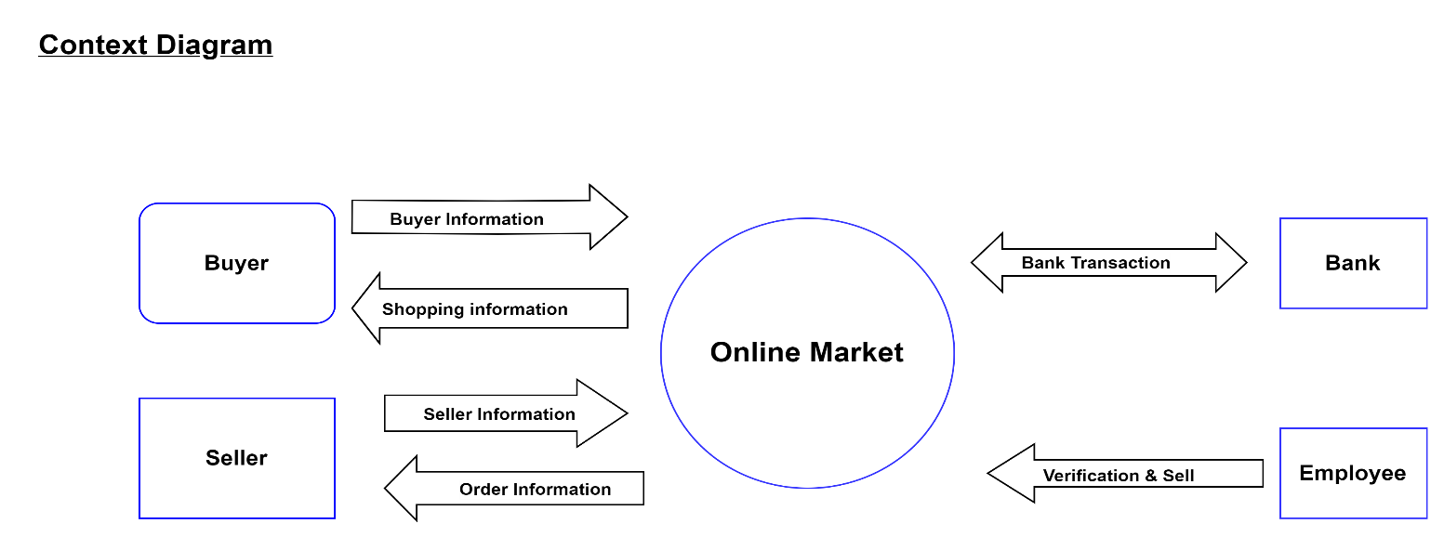

**Use-case diagrams:** Use-case diagrams **describe the high-level functions and scope of a system**. These diagrams also identify the interactions between the system and its actors. The use cases and actors in use-case diagrams describe what the system does and how the actors use it, but not how the system operates internally.

**This is my project URL: https://github.com/Kalab21/cs425_swe_online_market_project.git**