Tabellen und Graphiken für Simulation mit 5000 runs

Daniel Gotthardt

## Graphics

used (Mb) gc trigger (Mb) max used (Mb)

Ncells 626588 33.5 1433480 76.6 821837 43.9 Vcells 1216897 9.3 8388608 64.0 2375832 18.2

## Lade nötiges Paket: viridisLite

## ── Attaching core tidyverse packages ──────────────────────── tidyverse 2.0.0 ──  
## ✔ dplyr 1.1.4 ✔ readr 2.1.5  
## ✔ forcats 1.0.0 ✔ stringr 1.5.1  
## ✔ lubridate 1.9.3 ✔ tibble 3.2.1  
## ✔ purrr 1.0.2 ✔ tidyr 1.3.1  
## ── Conflicts ────────────────────────────────────────── tidyverse_conflicts() ──  
## ✖ dplyr::filter() masks stats::filter()  
## ✖ dplyr::lag() masks stats::lag()  
## ℹ Use the conflicted package (<http://conflicted.r-lib.org/>) to force all conflicts to become errors

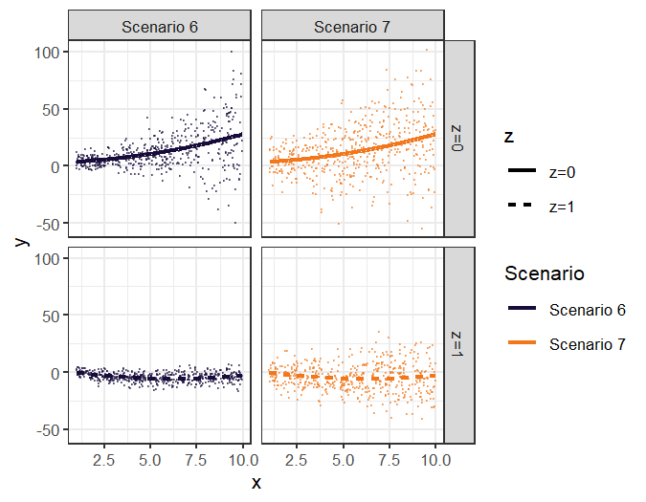

## I Scenario 3 Null with Non-linear mean model

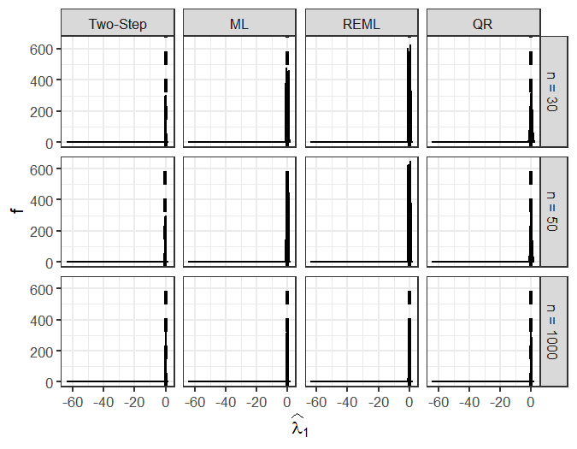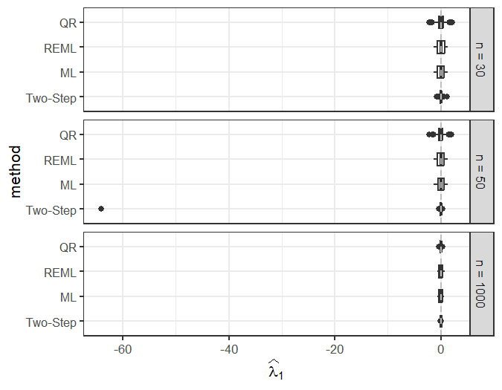 n_obs coef.type model repetition 1006.Two-Step.lambda_0.30 n = 30 widehat(lambda)[0] Two-Step 1006 1006.Two-Step.lambda_1.30 n = 30 widehat(lambda)[1] Two-Step 1006 1079.Two-Step.lambda_0.30 n = 30 widehat(lambda)[0] Two-Step 1079 1079.Two-Step.lambda_1.30 n = 30 widehat(lambda)[1] Two-Step 1079 1285.Two-Step.lambda_1.30 n = 30 widehat(lambda)[1] Two-Step 1285 1371.Two-Step.lambda_1.30 n = 30 widehat(lambda)[1] Two-Step 1371 1772.Two-Step.beta_1.30 n = 30 widehat(beta)[1] Two-Step 1772 1772.Two-Step.lambda_0.30 n = 30 widehat(lambda)[0] Two-Step 1772 1989.Two-Step.lambda_1.30 n = 30 widehat(lambda)[1] Two-Step 1989 2282.Two-Step.lambda_1.30 n = 30 widehat(lambda)[1] Two-Step 2282 2677.Two-Step.lambda_0.30 n = 30 widehat(lambda)[0] Two-Step 2677 2677.Two-Step.lambda_1.30 n = 30 widehat(lambda)[1] Two-Step 2677 2727.Two-Step.lambda_1.30 n = 30 widehat(lambda)[1] Two-Step 2727 3121.Two-Step.lambda_0.30 n = 30 widehat(lambda)[0] Two-Step 3121 3121.Two-Step.lambda_1.30 n = 30 widehat(lambda)[1] Two-Step 3121 3233.Two-Step.lambda_1.30 n = 30 widehat(lambda)[1] Two-Step 3233 3289.Two-Step.lambda_0.30 n = 30 widehat(lambda)[0] Two-Step 3289 3289.Two-Step.lambda_1.30 n = 30 widehat(lambda)[1] Two-Step 3289 3365.Two-Step.lambda_0.30 n = 30 widehat(lambda)[0] Two-Step 3365 3365.Two-Step.lambda_1.30 n = 30 widehat(lambda)[1] Two-Step 3365 3548.Two-Step.lambda_0.30 n = 30 widehat(lambda)[0] Two-Step 3548 3548.Two-Step.lambda_1.30 n = 30 widehat(lambda)[1] Two-Step 3548 3678.Two-Step.lambda_0.30 n = 30 widehat(lambda)[0] Two-Step 3678 3678.Two-Step.lambda_1.30 n = 30 widehat(lambda)[1] Two-Step 3678 400.Two-Step.lambda_1.30 n = 30 widehat(lambda)[1] Two-Step 400 4517.Two-Step.lambda_0.30 n = 30 widehat(lambda)[0] Two-Step 4517 4517.Two-Step.lambda_1.30 n = 30 widehat(lambda)[1] Two-Step 4517 580.Two-Step.lambda_0.30 n = 30 widehat(lambda)[0] Two-Step 580 580.Two-Step.lambda_1.30 n = 30 widehat(lambda)[1] Two-Step 580 695.Two-Step.lambda_1.30 n = 30 widehat(lambda)[1] Two-Step 695 760.Two-Step.lambda_1.30 n = 30 widehat(lambda)[1] Two-Step 760 1063.Two-Step.lambda_0.50 n = 50 widehat(lambda)[0] Two-Step 1063 1063.Two-Step.lambda_1.50 n = 50 widehat(lambda)[1] Two-Step 1063 2167.Two-Step.lambda_1.50 n = 50 widehat(lambda)[1] Two-Step 2167 242.Two-Step.lambda_0.50 n = 50 widehat(lambda)[0] Two-Step 242 242.Two-Step.lambda_1.50 n = 50 widehat(lambda)[1] Two-Step 242 2477.Two-Step.lambda_0.50 n = 50 widehat(lambda)[0] Two-Step 2477 2689.Two-Step.lambda_0.50 n = 50 widehat(lambda)[0] Two-Step 2689 2689.Two-Step.lambda_1.50 n = 50 widehat(lambda)[1] Two-Step 2689 2791.Two-Step.lambda_0.50 n = 50 widehat(lambda)[0] Two-Step 2791 2791.Two-Step.lambda_1.50 n = 50 widehat(lambda)[1] Two-Step 2791 3187.Two-Step.lambda_1.50 n = 50 widehat(lambda)[1] Two-Step 3187 3489.Two-Step.lambda_1.50 n = 50 widehat(lambda)[1] Two-Step 3489 3825.Two-Step.lambda_1.50 n = 50 widehat(lambda)[1] Two-Step 3825 4444.Two-Step.lambda_1.50 n = 50 widehat(lambda)[1] Two-Step 4444 4597.Two-Step.lambda_0.50 n = 50 widehat(lambda)[0] Two-Step 4597 4597.Two-Step.lambda_1.50 n = 50 widehat(lambda)[1] Two-Step 4597 4636.Two-Step.lambda_0.50 n = 50 widehat(lambda)[0] Two-Step 4636 4636.Two-Step.lambda_1.50 n = 50 widehat(lambda)[1] Two-Step 4636 4646.Two-Step.lambda_0.50 n = 50 widehat(lambda)[0] Two-Step 4646 4646.Two-Step.lambda_1.50 n = 50 widehat(lambda)[1] Two-Step 4646 4820.QR.lambda_0.50 n = 50 widehat(lambda)[0] QR 4820 4870.Two-Step.lambda_0.50 n = 50 widehat(lambda)[0] Two-Step 4870 4870.Two-Step.lambda_1.50 n = 50 widehat(lambda)[1] Two-Step 4870 494.Two-Step.lambda_1.50 n = 50 widehat(lambda)[1] Two-Step 494 4951.Two-Step.lambda_1.50 n = 50 widehat(lambda)[1] Two-Step 4951 532.Two-Step.lambda_0.50 n = 50 widehat(lambda)[0] Two-Step 532 532.Two-Step.lambda_1.50 n = 50 widehat(lambda)[1] Two-Step 532 683.Two-Step.lambda_1.50 n = 50 widehat(lambda)[1] Two-Step 683 coef 1006.Two-Step.lambda_0.30 10.5193410 1006.Two-Step.lambda_1.30 -0.6840193 1079.Two-Step.lambda_0.30 1.1703562 1079.Two-Step.lambda_1.30 0.4548547 1285.Two-Step.lambda_1.30 -0.3177923 1371.Two-Step.lambda_1.30 -0.2984935 1772.Two-Step.beta_1.30 8.5504371 1772.Two-Step.lambda_0.30 1.4711299 1989.Two-Step.lambda_1.30 0.3675272 2282.Two-Step.lambda_1.30 0.3193268 2677.Two-Step.lambda_0.30 5.9331952 2677.Two-Step.lambda_1.30 -0.3155790 2727.Two-Step.lambda_1.30 0.2988998 3121.Two-Step.lambda_0.30 9.4013916 3121.Two-Step.lambda_1.30 -0.7160693 3233.Two-Step.lambda_1.30 1.1758599 3289.Two-Step.lambda_0.30 5.5422948 3289.Two-Step.lambda_1.30 -0.3602124 3365.Two-Step.lambda_0.30 6.0772766 3365.Two-Step.lambda_1.30 -0.3964633 3548.Two-Step.lambda_0.30 5.6296455 3548.Two-Step.lambda_1.30 -0.3331243 3678.Two-Step.lambda_0.30 6.7890062 3678.Two-Step.lambda_1.30 -0.4255516 400.Two-Step.lambda_1.30 0.3679220 4517.Two-Step.lambda_0.30 5.6516440 4517.Two-Step.lambda_1.30 -0.3121981 580.Two-Step.lambda_0.30 1.1608335 580.Two-Step.lambda_1.30 0.5573587 695.Two-Step.lambda_1.30 -0.3232714 760.Two-Step.lambda_1.30 0.5054624 1063.Two-Step.lambda_0.50 1.8663493 1063.Two-Step.lambda_1.50 0.3220201 2167.Two-Step.lambda_1.50 -0.2525993 242.Two-Step.lambda_0.50 1.8770353 242.Two-Step.lambda_1.50 0.2880088 2477.Two-Step.lambda_0.50 5.2741536 2689.Two-Step.lambda_0.50 1.9785378 2689.Two-Step.lambda_1.50 0.2455334 2791.Two-Step.lambda_0.50 5.4594764 2791.Two-Step.lambda_1.50 -0.2714216 3187.Two-Step.lambda_1.50 -0.2253539 3489.Two-Step.lambda_1.50 0.2289078 3825.Two-Step.lambda_1.50 -0.2358362 4444.Two-Step.lambda_1.50 -0.2987616 4597.Two-Step.lambda_0.50 1.8669250 4597.Two-Step.lambda_1.50 0.2551325 4636.Two-Step.lambda_0.50 5.2458021 4636.Two-Step.lambda_1.50 -0.2475937 4646.Two-Step.lambda_0.50 425.9891331 4646.Two-Step.lambda_1.50 -64.0633199 4820.QR.lambda_0.50 23.4811878 4870.Two-Step.lambda_0.50 1.9642795 4870.Two-Step.lambda_1.50 0.2784372 494.Two-Step.lambda_1.50 -0.2666554 4951.Two-Step.lambda_1.50 0.2748958 532.Two-Step.lambda_0.50 5.7080787 532.Two-Step.lambda_1.50 -0.3564784 683.Two-Step.lambda_1.50 -0.2326146 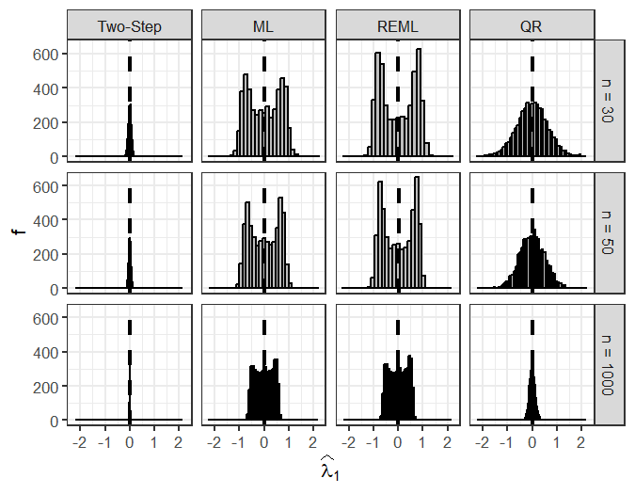

## II Scenario 4 Null with vertical Outlier

n_obs coef.type model repetition

1452.Two-Step.lambda_1.30 n = 30 widehat(lambda)[1] Two-Step 1452 2081.Two-Step.lambda_1.30 n = 30 widehat(lambda)[1] Two-Step 2081 214.ML.beta_1.30 n = 30 widehat(beta)[1] ML 214 214.REML.beta_1.30 n = 30 widehat(beta)[1] REML 214 2432.Two-Step.lambda_1.30 n = 30 widehat(lambda)[1] Two-Step 2432 2598.Two-Step.lambda_1.30 n = 30 widehat(lambda)[1] Two-Step 2598 306.ML.lambda_0.30 n = 30 widehat(lambda)[0] ML 306 306.REML.lambda_0.30 n = 30 widehat(lambda)[0] REML 306 326.ML.beta_0.30 n = 30 widehat(beta)[0] ML 326 3616.Two-Step.lambda_0.30 n = 30 widehat(lambda)[0] Two-Step 3616 3616.Two-Step.lambda_1.30 n = 30 widehat(lambda)[1] Two-Step 3616 384.Two-Step.lambda_0.30 n = 30 widehat(lambda)[0] Two-Step 384 384.Two-Step.lambda_1.30 n = 30 widehat(lambda)[1] Two-Step 384 4147.ML.beta_0.30 n = 30 widehat(beta)[0] ML 4147 4147.ML.beta_1.30 n = 30 widehat(beta)[1] ML 4147 4147.REML.beta_0.30 n = 30 widehat(beta)[0] REML 4147 4147.REML.beta_1.30 n = 30 widehat(beta)[1] REML 4147 4292.ML.lambda_0.30 n = 30 widehat(lambda)[0] ML 4292 4292.REML.lambda_0.30 n = 30 widehat(lambda)[0] REML 4292 4574.Two-Step.beta_0.30 n = 30 widehat(beta)[0] Two-Step 4574 4755.QR.lambda_0.30 n = 30 widehat(lambda)[0] QR 4755 858.Two-Step.lambda_1.30 n = 30 widehat(lambda)[1] Two-Step 858 2404.ML.beta_1.50 n = 50 widehat(beta)[1] ML 2404 2404.ML.lambda_0.50 n = 50 widehat(lambda)[0] ML 2404 2404.ML.lambda_1.50 n = 50 widehat(lambda)[1] ML 2404 3378.ML.beta_0.50 n = 50 widehat(beta)[0] ML 3378 3378.REML.beta_0.50 n = 50 widehat(beta)[0] REML 3378 79.Two-Step.lambda_0.50 n = 50 widehat(lambda)[0] Two-Step 79 79.Two-Step.lambda_1.50 n = 50 widehat(lambda)[1] Two-Step 79 coef se 1452.Two-Step.lambda_1.30 9.257921e-01 0.10270041 2081.Two-Step.lambda_1.30 1.979233e+00 0.09291861 214.ML.beta_1.30 6.869498e-01 0.21516233 214.REML.beta_1.30 6.890193e-01 0.21211188 2432.Two-Step.lambda_1.30 1.263455e+00 0.09654630 2598.Two-Step.lambda_1.30 1.137364e+00 0.10455596 306.ML.lambda_0.30 -4.915215e+00 0.82062666 306.REML.lambda_0.30 -4.557929e+00 0.99683997 326.ML.beta_0.30 -2.946886e+00 1.43723703 3616.Two-Step.lambda_0.30 1.859975e+01 0.53771473 3616.Two-Step.lambda_1.30 -2.169982e+00 0.10776128 384.Two-Step.lambda_0.30 2.493909e+01 0.59299206 384.Two-Step.lambda_1.30 -2.714568e+00 0.09424695 4147.ML.beta_0.30 -3.489864e+00 1.47529134 4147.ML.beta_1.30 5.762458e-01 0.19764478 4147.REML.beta_0.30 -3.519285e+00 1.46784057 4147.REML.beta_1.30 5.802807e-01 0.19599286 4292.ML.lambda_0.30 -5.187582e+00 0.86039138 4292.REML.lambda_0.30 -4.277098e+00 1.01881440 4574.Two-Step.beta_0.30 3.976331e+00 1.38953784 4755.QR.lambda_0.30 4.859484e+00 NA 858.Two-Step.lambda_1.30 1.608285e+00 0.10701870 2404.ML.beta_1.50 7.898855e-01 0.26847467 2404.ML.lambda_0.50 -7.198891e+14 0.07762161 2404.ML.lambda_1.50 2.347162e+14 0.01101443 3378.ML.beta_0.50 3.239012e+00 0.87614038 3378.REML.beta_0.50 3.227308e+00 0.87269699 79.Two-Step.lambda_0.50 2.400326e+01 0.44337150 79.Two-Step.lambda_1.50 -2.546097e+00 0.07786494 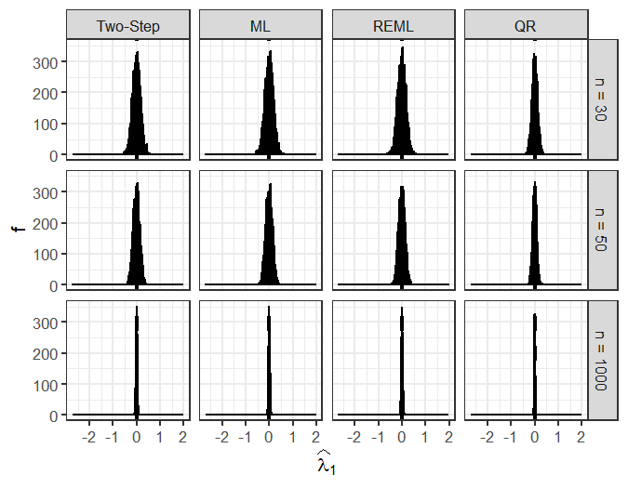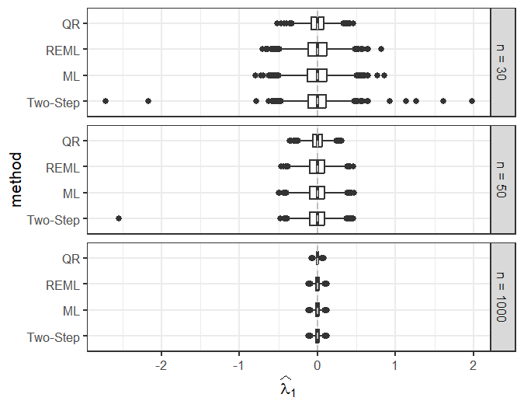

## II Scenario 7 Lin

n_obs coef.type tau repetition coef

1021.Tau75.(Intercept).30 n = 30 (Intercept) Tau75 1021 117.954432 1021.Tau75.z.30 n = 30 z Tau75 1021 -101.410751 1027.Tau75.z.30 n = 30 z Tau75 1027 -94.137480 1140.Tau75.(Intercept).30 n = 30 (Intercept) Tau75 1140 92.167699 1173.Tau75.(Intercept).30 n = 30 (Intercept) Tau75 1173 -75.284525 1190.Tau25.(Intercept).30 n = 30 (Intercept) Tau25 1190 -177.466242 1190.Tau25.x.30 n = 30 x Tau25 1190 33.552856 1190.Tau25.xz.30 n = 30 xz Tau25 1190 -28.806716 1190.Tau25.z.30 n = 30 z Tau25 1190 168.747825 1190.Tau50.(Intercept).30 n = 30 (Intercept) Tau50 1190 -80.986985 1190.Tau50.z.30 n = 30 z Tau50 1190 77.104860 1193.Tau50.(Intercept).30 n = 30 (Intercept) Tau50 1193 76.901852 1193.Tau50.z.30 n = 30 z Tau50 1193 -80.619898 1193.Tau75.(Intercept).30 n = 30 (Intercept) Tau75 1193 126.318542 1193.Tau75.xz.30 n = 30 xz Tau75 1193 15.489121 1193.Tau75.z.30 n = 30 z Tau75 1193 -124.979380 1212.Tau25.(Intercept).30 n = 30 (Intercept) Tau25 1212 -76.574331 1609.Tau75.(Intercept).30 n = 30 (Intercept) Tau75 1609 115.818821 1609.Tau75.z.30 n = 30 z Tau75 1609 -75.308301 1625.Tau25.(Intercept).30 n = 30 (Intercept) Tau25 1625 -84.729567 1639.Tau75.xx.30 n = 30 xx Tau75 1639 3.506216 1677.Tau25.(Intercept).30 n = 30 (Intercept) Tau25 1677 86.332131 1677.Tau25.z.30 n = 30 z Tau25 1677 -92.386229 1677.Tau50.z.30 n = 30 z Tau50 1677 -74.593349 1677.Tau75.(Intercept).30 n = 30 (Intercept) Tau75 1677 129.741559 1677.Tau75.z.30 n = 30 z Tau75 1677 -122.494717 1725.Tau25.z.30 n = 30 z Tau25 1725 -81.448592 1725.Tau75.z.30 n = 30 z Tau75 1725 -78.060203 1748.Tau75.x.30 n = 30 x Tau75 1748 -31.022818 1878.Tau75.(Intercept).30 n = 30 (Intercept) Tau75 1878 108.495657 1942.Tau50.(Intercept).30 n = 30 (Intercept) Tau50 1942 88.592403 1942.Tau75.(Intercept).30 n = 30 (Intercept) Tau75 1942 166.591129 1942.Tau75.x.30 n = 30 x Tau75 1942 -37.814615 1942.Tau75.z.30 n = 30 z Tau75 1942 -116.776575 2043.Tau75.(Intercept).30 n = 30 (Intercept) Tau75 2043 -87.237470 2043.Tau75.z.30 n = 30 z Tau75 2043 83.256052 210.Tau75.(Intercept).30 n = 30 (Intercept) Tau75 210 86.906295 210.Tau75.z.30 n = 30 z Tau75 210 -79.767670 2175.Tau50.xx.30 n = 30 xx Tau50 2175 -2.773610 2211.Tau75.z.30 n = 30 z Tau75 2211 78.337730 25.Tau25.(Intercept).30 n = 30 (Intercept) Tau25 25 103.011841 25.Tau50.(Intercept).30 n = 30 (Intercept) Tau50 25 73.057899 25.Tau75.(Intercept).30 n = 30 (Intercept) Tau75 25 163.310682 25.Tau75.x.30 n = 30 x Tau75 25 -51.248780 25.Tau75.xx.30 n = 30 xx Tau75 25 4.521195 25.Tau75.xz.30 n = 30 xz Tau75 25 12.960491 25.Tau75.z.30 n = 30 z Tau75 25 -86.617371 2718.Tau75.(Intercept).30 n = 30 (Intercept) Tau75 2718 110.755840 2718.Tau75.z.30 n = 30 z Tau75 2718 -94.511481 2728.Tau25.(Intercept).30 n = 30 (Intercept) Tau25 2728 -137.673084 2728.Tau25.x.30 n = 30 x Tau25 2728 50.009312 2728.Tau25.xx.30 n = 30 xx Tau25 2728 -3.787129 274.Tau75.xx.30 n = 30 xx Tau75 274 3.678505 2774.Tau50.(Intercept).30 n = 30 (Intercept) Tau50 2774 -68.875456 2774.Tau50.xz.30 n = 30 xz Tau50 2774 -20.051078 2774.Tau50.z.30 n = 30 z Tau50 2774 80.539148 2804.Tau25.xz.30 n = 30 xz Tau25 2804 16.325771 2804.Tau25.z.30 n = 30 z Tau25 2804 -128.326401 2851.Tau75.(Intercept).30 n = 30 (Intercept) Tau75 2851 83.540971 2929.Tau75.xz.30 n = 30 xz Tau75 2929 -21.356242 2929.Tau75.z.30 n = 30 z Tau75 2929 104.076776 3076.Tau25.z.30 n = 30 z Tau25 3076 -88.623381 3119.Tau75.xz.30 n = 30 xz Tau75 3119 -22.038407 3158.Tau50.z.30 n = 30 z Tau50 3158 -72.963501 3164.Tau25.(Intercept).30 n = 30 (Intercept) Tau25 3164 -77.059305 3203.Tau50.z.30 n = 30 z Tau50 3203 -70.679021 3383.Tau25.z.30 n = 30 z Tau25 3383 -77.551321 3423.Tau25.(Intercept).30 n = 30 (Intercept) Tau25 3423 -79.517865 3470.Tau75.(Intercept).30 n = 30 (Intercept) Tau75 3470 83.108906 3577.Tau25.(Intercept).30 n = 30 (Intercept) Tau25 3577 -85.287976 365.Tau25.z.30 n = 30 z Tau25 365 106.978200 3692.Tau50.z.30 n = 30 z Tau50 3692 -72.217262 3753.Tau50.(Intercept).30 n = 30 (Intercept) Tau50 3753 76.318669 377.Tau75.(Intercept).30 n = 30 (Intercept) Tau75 377 89.661910 3808.Tau25.(Intercept).30 n = 30 (Intercept) Tau25 3808 88.431053 3820.Tau75.x.30 n = 30 x Tau75 3820 38.835047 3827.Tau50.z.30 n = 30 z Tau50 3827 69.471107 3919.Tau25.(Intercept).30 n = 30 (Intercept) Tau25 3919 133.788913 3919.Tau25.xz.30 n = 30 xz Tau25 3919 17.381175 3919.Tau25.z.30 n = 30 z Tau25 3919 -130.743068 3919.Tau50.(Intercept).30 n = 30 (Intercept) Tau50 3919 85.282893 3919.Tau50.z.30 n = 30 z Tau50 3919 -70.769733 3963.Tau50.(Intercept).30 n = 30 (Intercept) Tau50 3963 -68.984559 3963.Tau75.(Intercept).30 n = 30 (Intercept) Tau75 3963 -73.024077 3997.Tau25.(Intercept).30 n = 30 (Intercept) Tau25 3997 -103.614810 3997.Tau25.z.30 n = 30 z Tau25 3997 80.310211 402.Tau25.z.30 n = 30 z Tau25 402 82.843013 402.Tau50.z.30 n = 30 z Tau50 402 71.887202 4307.Tau50.(Intercept).30 n = 30 (Intercept) Tau50 4307 -65.770983 4346.Tau75.(Intercept).30 n = 30 (Intercept) Tau75 4346 90.172275 4450.Tau25.z.30 n = 30 z Tau25 4450 89.517889 4450.Tau50.z.30 n = 30 z Tau50 4450 77.607618 4489.Tau50.(Intercept).30 n = 30 (Intercept) Tau50 4489 -82.317762 4527.Tau75.z.30 n = 30 z Tau75 4527 128.588519 4788.Tau75.x.30 n = 30 x Tau75 4788 37.320543 4788.Tau75.xx.30 n = 30 xx Tau75 4788 -3.138671 4887.Tau75.(Intercept).30 n = 30 (Intercept) Tau75 4887 109.018793 4887.Tau75.z.30 n = 30 z Tau75 4887 -75.553435 4906.Tau25.(Intercept).30 n = 30 (Intercept) Tau25 4906 -86.219752 4906.Tau50.(Intercept).30 n = 30 (Intercept) Tau50 4906 -71.995837 4948.Tau75.(Intercept).30 n = 30 (Intercept) Tau75 4948 90.983563 4962.Tau75.x.30 n = 30 x Tau75 4962 -31.039132 55.Tau75.z.30 n = 30 z Tau75 55 92.936223 599.Tau50.(Intercept).30 n = 30 (Intercept) Tau50 599 78.111757 67.Tau75.z.30 n = 30 z Tau75 67 -84.093170 690.Tau50.(Intercept).30 n = 30 (Intercept) Tau50 690 -74.452364 690.Tau50.z.30 n = 30 z Tau50 690 83.282931 690.Tau75.z.30 n = 30 z Tau75 690 86.885739 691.Tau75.(Intercept).30 n = 30 (Intercept) Tau75 691 87.617694 746.Tau25.z.30 n = 30 z Tau25 746 -96.402740 771.Tau75.(Intercept).30 n = 30 (Intercept) Tau75 771 83.087234 905.Tau25.(Intercept).30 n = 30 (Intercept) Tau25 905 -87.173789 984.Tau75.(Intercept).30 n = 30 (Intercept) Tau75 984 85.261667 984.Tau75.z.30 n = 30 z Tau75 984 -80.905391 1237.Tau75.z.50 n = 50 z Tau75 1237 -66.755432 1597.Tau50.(Intercept).50 n = 50 (Intercept) Tau50 1597 -48.957001 2093.Tau25.z.50 n = 50 z Tau25 2093 -61.549175 2093.Tau50.xz.50 n = 50 xz Tau50 2093 9.397671 2093.Tau50.z.50 n = 50 z Tau50 2093 -72.692006 225.Tau50.(Intercept).50 n = 50 (Intercept) Tau50 225 59.556043 2346.Tau75.x.50 n = 50 x Tau75 2346 27.149755 2623.Tau25.z.50 n = 50 z Tau25 2623 -62.255305 2664.Tau25.xx.50 n = 50 xx Tau25 2664 -2.297621 3586.Tau50.(Intercept).50 n = 50 (Intercept) Tau50 3586 -49.656978 3887.Tau25.z.50 n = 50 z Tau25 3887 -61.635671 3887.Tau50.xz.50 n = 50 xz Tau50 3887 8.110031 3887.Tau50.z.50 n = 50 z Tau50 3887 -67.839879 4017.Tau50.(Intercept).50 n = 50 (Intercept) Tau50 4017 53.255464 4040.Tau75.(Intercept).50 n = 50 (Intercept) Tau75 4040 60.188076 4225.Tau25.(Intercept).50 n = 50 (Intercept) Tau25 4225 -71.439742 427.Tau75.(Intercept).50 n = 50 (Intercept) Tau75 427 68.930825 4388.Tau25.xx.50 n = 50 xx Tau25 4388 -2.110089 4781.Tau50.(Intercept).50 n = 50 (Intercept) Tau50 4781 59.797069 4850.Tau25.(Intercept).50 n = 50 (Intercept) Tau25 4850 -60.412599 4903.Tau50.(Intercept).50 n = 50 (Intercept) Tau50 4903 53.886213 4915.Tau75.(Intercept).50 n = 50 (Intercept) Tau75 4915 64.906033 4999.Tau50.(Intercept).50 n = 50 (Intercept) Tau50 4999 51.168407 766.Tau25.(Intercept).50 n = 50 (Intercept) Tau25 766 -54.891915 956.Tau50.(Intercept).50 n = 50 (Intercept) Tau50 956 52.375776 se 1021.Tau75.(Intercept).30 103.3464702 1021.Tau75.z.30 101.7798063 1027.Tau75.z.30 16.5925063 1140.Tau75.(Intercept).30 50.3790635 1173.Tau75.(Intercept).30 46.4222611 1190.Tau25.(Intercept).30 53.6602920 1190.Tau25.x.30 8.4492130 1190.Tau25.xz.30 7.1102584 1190.Tau25.z.30 52.4257889 1190.Tau50.(Intercept).30 50.6954741 1190.Tau50.z.30 45.4086471 1193.Tau50.(Intercept).30 49.2650419 1193.Tau50.z.30 43.1935159 1193.Tau75.(Intercept).30 39.5930605 1193.Tau75.xz.30 6.1364636 1193.Tau75.z.30 37.1624426 1212.Tau25.(Intercept).30 45.1417216 1609.Tau75.(Intercept).30 31.9492172 1609.Tau75.z.30 22.8918606 1625.Tau25.(Intercept).30 84.8245354 1639.Tau75.xx.30 1.3772458 1677.Tau25.(Intercept).30 24.3547732 1677.Tau25.z.30 19.8279480 1677.Tau50.z.30 62.8164886 1677.Tau75.(Intercept).30 48.9868752 1677.Tau75.z.30 45.5477403 1725.Tau25.z.30 51.7616814 1725.Tau75.z.30 53.5840137 1748.Tau75.x.30 13.4250898 1878.Tau75.(Intercept).30 17.8322799 1942.Tau50.(Intercept).30 75.5418278 1942.Tau75.(Intercept).30 55.2256893 1942.Tau75.x.30 12.7584206 1942.Tau75.z.30 45.2934758 2043.Tau75.(Intercept).30 23.4261678 2043.Tau75.z.30 21.8646467 210.Tau75.(Intercept).30 53.3078883 210.Tau75.z.30 43.8438257 2175.Tau50.xx.30 0.6936462 2211.Tau75.z.30 35.0965020 25.Tau25.(Intercept).30 140.7369031 25.Tau50.(Intercept).30 78.9204874 25.Tau75.(Intercept).30 55.4292698 25.Tau75.x.30 17.7024166 25.Tau75.xx.30 1.3851800 25.Tau75.xz.30 6.5501649 25.Tau75.z.30 35.5445388 2718.Tau75.(Intercept).30 48.9381277 2718.Tau75.z.30 45.2581720 2728.Tau25.(Intercept).30 39.6644880 2728.Tau25.x.30 13.7697379 2728.Tau25.xx.30 1.1048775 274.Tau75.xx.30 2.3460739 2774.Tau50.(Intercept).30 38.1590401 2774.Tau50.xz.30 6.4805150 2774.Tau50.z.30 36.7426811 2804.Tau25.xz.30 8.1132969 2804.Tau25.z.30 59.7571039 2851.Tau75.(Intercept).30 32.0784695 2929.Tau75.xz.30 6.5456391 2929.Tau75.z.30 36.1644584 3076.Tau25.z.30 47.8782426 3119.Tau75.xz.30 6.4238664 3158.Tau50.z.30 18.2973180 3164.Tau25.(Intercept).30 32.4554157 3203.Tau50.z.30 31.8792166 3383.Tau25.z.30 18.8865786 3423.Tau25.(Intercept).30 113.8836886 3470.Tau75.(Intercept).30 56.8243567 3577.Tau25.(Intercept).30 26.8841274 365.Tau25.z.30 48.6148243 3692.Tau50.z.30 46.1881767 3753.Tau50.(Intercept).30 37.2376947 377.Tau75.(Intercept).30 28.5682797 3808.Tau25.(Intercept).30 17.3236481 3820.Tau75.x.30 30.9519414 3827.Tau50.z.30 27.8757558 3919.Tau25.(Intercept).30 37.7062164 3919.Tau25.xz.30 6.1661427 3919.Tau25.z.30 34.3610081 3919.Tau50.(Intercept).30 71.6597298 3919.Tau50.z.30 68.5809023 3963.Tau50.(Intercept).30 28.5268371 3963.Tau75.(Intercept).30 30.2635954 3997.Tau25.(Intercept).30 77.2179259 3997.Tau25.z.30 71.3266813 402.Tau25.z.30 49.6595324 402.Tau50.z.30 36.1756784 4307.Tau50.(Intercept).30 36.9772877 4346.Tau75.(Intercept).30 107.5259739 4450.Tau25.z.30 38.9577136 4450.Tau50.z.30 45.6442025 4489.Tau50.(Intercept).30 29.9884847 4527.Tau75.z.30 17.0492168 4788.Tau75.x.30 10.5734417 4788.Tau75.xx.30 1.2166094 4887.Tau75.(Intercept).30 40.3532856 4887.Tau75.z.30 35.5571549 4906.Tau25.(Intercept).30 84.4753742 4906.Tau50.(Intercept).30 24.3397975 4948.Tau75.(Intercept).30 33.2721613 4962.Tau75.x.30 7.1169595 55.Tau75.z.30 40.2142354 599.Tau50.(Intercept).30 20.9989335 67.Tau75.z.30 95.7736186 690.Tau50.(Intercept).30 41.2996147 690.Tau50.z.30 33.1018334 690.Tau75.z.30 101.4413346 691.Tau75.(Intercept).30 511.6930899 746.Tau25.z.30 38.6970077 771.Tau75.(Intercept).30 60.1205760 905.Tau25.(Intercept).30 25.7574864 984.Tau75.(Intercept).30 45.8728708 984.Tau75.z.30 39.6069058 1237.Tau75.z.50 22.5271660 1597.Tau50.(Intercept).50 14.4720095 2093.Tau25.z.50 15.4986771 2093.Tau50.xz.50 4.1585135 2093.Tau50.z.50 23.1746618 225.Tau50.(Intercept).50 22.4929932 2346.Tau75.x.50 9.0935519 2623.Tau25.z.50 20.2625761 2664.Tau25.xx.50 0.7062431 3586.Tau50.(Intercept).50 24.0206518 3887.Tau25.z.50 11.7018333 3887.Tau50.xz.50 2.5033953 3887.Tau50.z.50 14.8544872 4017.Tau50.(Intercept).50 18.3456368 4040.Tau75.(Intercept).50 30.0447672 4225.Tau25.(Intercept).50 33.1950791 427.Tau75.(Intercept).50 31.9097691 4388.Tau25.xx.50 0.6915068 4781.Tau50.(Intercept).50 23.2484384 4850.Tau25.(Intercept).50 25.9148505 4903.Tau50.(Intercept).50 15.7303930 4915.Tau75.(Intercept).50 42.2479056 4999.Tau50.(Intercept).50 21.3611494 766.Tau25.(Intercept).50 45.6191029 956.Tau50.(Intercept).50 21.5603232 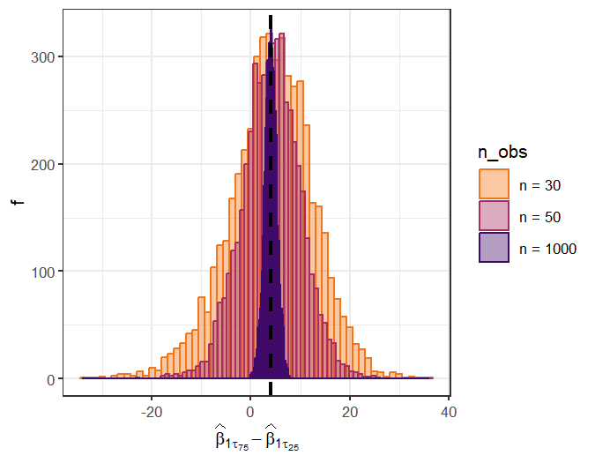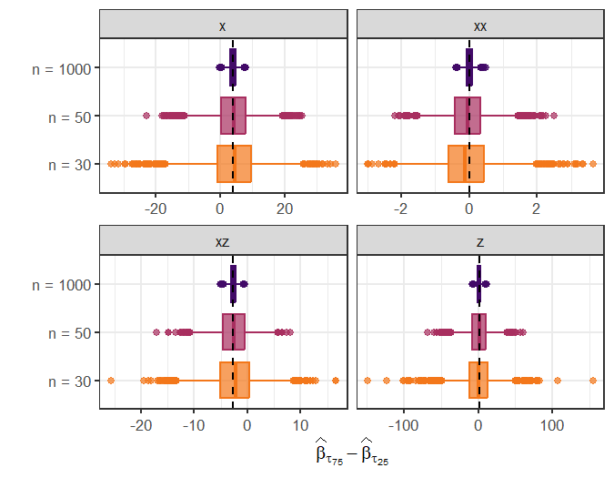

## Tables

### Rejection for Null (lambda and beta)

|  |  | beta_1 | lambda_1 |
| --- | --- | --- | --- |
| H_0 rejection rate , n = 30 |  |  |  |
|  | Two-Step | 0.053 (0.003) | 0.079 (0.004) |
|  | ML | 0.091 (0.004) | 0.103 (0.004) |
|  | REML | 0.080 (0.004) | 0.060 (0.003) |
|  | QR | 0.037 (0.003) | 0.014 (0.002) |
| H_0 rejection rate , n = 50 |  |  |  |
|  | Two-Step | 0.055 (0.003) | 0.059 (0.003) |
|  | ML | 0.072 (0.004) | 0.070 (0.004) |
|  | REML | 0.066 (0.004) | 0.051 (0.003) |
|  | QR | 0.042 (0.003) | 0.022 (0.002) |
| H_0 rejection rate , n = 1000 |  |  |  |
|  | Two-Step | 0.045 (0.003) | 0.048 (0.003) |
|  | ML | 0.047 (0.003) | 0.049 (0.003) |
|  | REML | 0.047 (0.003) | 0.048 (0.003) |
|  | QR | 0.052 (0.003) | 0.046 (0.003) |

### Rejection for Null (lambda only)

## Warning in rbind(deparse.level, ...): number of columns of result, 4, is not a  
## multiple of vector length 6 of arg 1  
## Warning in rbind(deparse.level, ...): number of columns of result, 4, is not a  
## multiple of vector length 6 of arg 1  
## Warning in rbind(deparse.level, ...): number of columns of result, 4, is not a  
## multiple of vector length 6 of arg 1

|  |  | beta_1 | lambda_1 |
| --- | --- | --- | --- |
| H_0 rejection rate , n = 30 |  |  |  |
|  | Two-Step | 0.999 (0.000) | 0.077 (0.004) |
|  | ML | 0.999 (0.000) | 0.098 (0.004) |
|  | REML | 0.998 (0.001) | 0.058 (0.003) |
|  | QR | 0.960 (0.003) | 0.014 (0.002) |
| H_0 rejection rate , n = 50 |  |  |  |
|  | Two-Step | 1.000 (0.000) | 0.068 (0.004) |
|  | ML | 1.000 (0.000) | 0.079 (0.004) |
|  | REML | 1.000 (0.000) | 0.053 (0.003) |
|  | QR | 0.999 (0.000) | 0.026 (0.002) |
| H_0 rejection rate , n = 1000 |  |  |  |
|  | Two-Step | 1.000 (0.000) | 0.051 (0.003) |
|  | ML | 1.000 (0.000) | 0.052 (0.003) |
|  | REML | 1.000 (0.000) | 0.051 (0.003) |
|  | QR | 1.000 (0.000) | 0.049 (0.003) |

### Rejection for Null (lambda only) und mispecified linear mean model for nonlinear datageneration

## Warning in rbind(deparse.level, ...): number of columns of result, 4, is not a  
## multiple of vector length 6 of arg 1  
## Warning in rbind(deparse.level, ...): number of columns of result, 4, is not a  
## multiple of vector length 6 of arg 1  
## Warning in rbind(deparse.level, ...): number of columns of result, 4, is not a  
## multiple of vector length 6 of arg 1

|  |  | beta_1 | lambda_1 |
| --- | --- | --- | --- |
| H_0 rejection rate , n = 30 |  |  |  |
|  | Two-Step | 1.000 (0.000) | 0.008 (0.001) |
|  | ML | 1.000 (0.000) | 0.850 (0.005) |
|  | REML | 1.000 (0.000) | 0.879 (0.005) |
|  | QR | 1.000 (0.000) | 0.050 (0.003) |
| H_0 rejection rate , n = 50 |  |  |  |
|  | Two-Step | 1.000 (0.000) | 0.008 (0.001) |
|  | ML | 1.000 (0.000) | 0.868 (0.005) |
|  | REML | 1.000 (0.000) | 0.888 (0.004) |
|  | QR | 1.000 (0.000) | 0.058 (0.003) |
| H_0 rejection rate , n = 1000 |  |  |  |
|  | Two-Step | 1.000 (0.000) | 0.001 (0.000) |
|  | ML | 1.000 (0.000) | 0.935 (0.003) |
|  | REML | 1.000 (0.000) | 0.935 (0.003) |
|  | QR | 1.000 (0.000) | 0.061 (0.003) |

### Rejection for Dopplnull (lambda and beta) with vertical outliers / influential outliers

## Warning in rbind(deparse.level, ...): number of columns of result, 4, is not a  
## multiple of vector length 6 of arg 1  
## Warning in rbind(deparse.level, ...): number of columns of result, 4, is not a  
## multiple of vector length 6 of arg 1  
## Warning in rbind(deparse.level, ...): number of columns of result, 4, is not a  
## multiple of vector length 6 of arg 1  
## Warning in rbind(deparse.level, ...): number of columns of result, 4, is not a  
## multiple of vector length 6 of arg 1  
## Warning in rbind(deparse.level, ...): number of columns of result, 4, is not a  
## multiple of vector length 6 of arg 1  
## Warning in rbind(deparse.level, ...): number of columns of result, 4, is not a  
## multiple of vector length 6 of arg 1

|  |  | 10 % Vertical Outlier |  | 10 % Influential Outlier |  |
| --- | --- | --- | --- | --- | --- |
|  |  | beta_1 | lambda_1 | beta_1 | lambda_1 |
| H_0 rejection rate , n = 30 |  |  |  |  |  |
|  | Two-Step | 0.052 (0.003) | 0.241 (0.006) | 0.134 (0.005) | 0.286 (0.006) |
|  | ML | 0.083 (0.004) | 0.272 (0.006) | 0.208 (0.006) | 0.328 (0.007) |
|  | REML | 0.072 (0.004) | 0.206 (0.006) | 0.187 (0.006) | 0.233 (0.006) |
|  | QR | 0.028 (0.002) | 0.006 (0.001) | 0.037 (0.003) | 0.047 (0.003) |
| H_0 rejection rate , n = 50 |  |  |  |  |  |
|  | Two-Step | 0.048 (0.003) | 0.271 (0.006) | 0.232 (0.006) | 0.405 (0.007) |
|  | ML | 0.068 (0.004) | 0.290 (0.006) | 0.291 (0.006) | 0.430 (0.007) |
|  | REML | 0.063 (0.003) | 0.247 (0.006) | 0.278 (0.006) | 0.367 (0.007) |
|  | QR | 0.037 (0.003) | 0.015 (0.002) | 0.065 (0.003) | 0.093 (0.004) |
| H_0 rejection rate , n = 1000 |  |  |  |  |  |
|  | Two-Step | 0.054 (0.003) | 0.313 (0.007) | 1.000 (0.000) | 1.000 (0.000) |
|  | ML | 0.054 (0.003) | 0.314 (0.007) | 1.000 (0.000) | 1.000 (0.000) |
|  | REML | 0.054 (0.003) | 0.312 (0.007) | 1.000 (0.000) | 1.000 (0.000) |
|  | QR | 0.055 (0.003) | 0.050 (0.003) | 0.860 (0.005) | 0.970 (0.002) |

### Scenario 6 - Varianzmodelle bei exponentieller Streuung

#### N = 30 und N = 50

|  |  | lambda_0 | lambda_1 | lambda_2 | lambda_3 |
| --- | --- | --- | --- | --- | --- |
| Bias of point estimates, n = 30 |  |  |  |  |  |
|  | Two-Step | -0.036 (0.020) | -0.045 (0.004) | 0.146 (0.028) | 0.012 (0.005) |
|  | ML | -0.666 (0.030) | 0.053 (0.005) | 0.129 (0.045) | -0.043 (0.007) |
|  | REML | -0.115 (0.021) | -0.011 (0.003) | -0.064 (0.030) | 0.009 (0.005) |
| Empirical SE of point estimates, n = 30 |  |  |  |  |  |
|  | Two-Step | 1.426 (0.014) | 0.286 (0.003) | 1.948 (0.020) | 0.352 (0.004) |
|  | ML | 2.135 (0.022) | 0.328 (0.003) | 3.189 (0.032) | 0.511 (0.005) |
|  | REML | 1.486 (0.015) | 0.231 (0.002) | 2.093 (0.021) | 0.362 (0.004) |
| Coverage rate of 95%-interval, n = 30 |  |  |  |  |  |
|  | Two-Step | 0.906 (0.004) | 0.878 (0.005) | 0.903 (0.004) | 0.896 (0.004) |
|  | ML | 0.786 (0.006) | 0.803 (0.006) | 0.777 (0.006) | 0.766 (0.006) |
|  | REML | 0.939 (0.003) | 0.937 (0.003) | 0.938 (0.003) | 0.933 (0.004) |
| Bias of point estimates, n = 50 |  |  |  |  |  |
|  | Two-Step | -0.034 (0.013) | -0.023 (0.003) | 0.135 (0.019) | 0.000 (0.003) |
|  | ML | -0.322 (0.013) | 0.024 (0.002) | 0.043 (0.019) | -0.017 (0.003) |
|  | REML | -0.073 (0.012) | -0.004 (0.002) | -0.039 (0.017) | 0.004 (0.003) |
| Empirical SE of point estimates, n = 50 |  |  |  |  |  |
|  | Two-Step | 0.906 (0.009) | 0.190 (0.002) | 1.344 (0.014) | 0.236 (0.002) |
|  | ML | 0.902 (0.009) | 0.147 (0.001) | 1.304 (0.013) | 0.216 (0.002) |
|  | REML | 0.854 (0.009) | 0.138 (0.001) | 1.230 (0.012) | 0.202 (0.002) |
| Coverage rate of 95%-interval, n = 50 |  |  |  |  |  |
|  | Two-Step | 0.917 (0.004) | 0.913 (0.004) | 0.919 (0.004) | 0.922 (0.004) |
|  | ML | 0.865 (0.005) | 0.884 (0.005) | 0.871 (0.005) | 0.867 (0.005) |
|  | REML | 0.940 (0.003) | 0.937 (0.003) | 0.939 (0.003) | 0.938 (0.003) |

#### S6 für n = 1000

|  |  | lambda_0 | lambda_1 | lambda_2 | lambda_3 |
| --- | --- | --- | --- | --- | --- |
| Bias of point estimates, n = 1000 |  |  |  |  |  |
|  | Two-Step | -0.001 (0.002) | -0.001 (0.000) | 0.013 (0.003) | -0.001 (0.000) |
|  | ML | -0.011 (0.002) | 0.000 (0.000) | 0.002 (0.003) | -0.000 (0.000) |
|  | REML | -0.002 (0.002) | -0.000 (0.000) | -0.000 (0.003) | 0.000 (0.000) |
| Empirical SE of point estimates, n = 1000 |  |  |  |  |  |
|  | Two-Step | 0.149 (0.001) | 0.025 (0.000) | 0.212 (0.002) | 0.035 (0.000) |
|  | ML | 0.150 (0.001) | 0.025 (0.000) | 0.212 (0.002) | 0.035 (0.000) |
|  | REML | 0.150 (0.001) | 0.025 (0.000) | 0.212 (0.002) | 0.035 (0.000) |
| Coverage rate of 95%-interval, n = 1000 |  |  |  |  |  |
|  | Two-Step | 0.950 (0.003) | 0.949 (0.003) | 0.949 (0.003) | 0.951 (0.003) |
|  | ML | 0.948 (0.003) | 0.949 (0.003) | 0.948 (0.003) | 0.949 (0.003) |
|  | REML | 0.950 (0.003) | 0.951 (0.003) | 0.950 (0.003) | 0.951 (0.003) |

### Scenario 7 - Quantreg bei linearer Streuung

#### N = 30 und N = 50

## Warning in rbind(deparse.level, ...): number of columns of result, 7, is not a  
## multiple of vector length 8 of arg 1  
## Warning in rbind(deparse.level, ...): number of columns of result, 7, is not a  
## multiple of vector length 8 of arg 1  
## Warning in rbind(deparse.level, ...): number of columns of result, 7, is not a  
## multiple of vector length 8 of arg 1

|  |  | beta_0 | beta_1 | beta_2 | beta_3 | beta_4 |
| --- | --- | --- | --- | --- | --- | --- |
| Bias of point estimates, n = 30 |  |  |  |  |  |  |
|  | Tau25 | 0.141 (0.262) | -0.093 (0.108) | 0.027 (0.010) | -0.143 (0.054) | 0.268 (0.257) |
|  | Tau50 | 0.231 (0.236) | -0.063 (0.097) | -0.002 (0.009) | 0.039 (0.048) | -0.121 (0.229) |
|  | Tau75 | 0.221 (0.272) | 0.034 (0.109) | -0.032 (0.010) | 0.185 (0.054) | -0.648 (0.261) |
| Empirical SE of point estimates, n = 30 |  |  |  |  |  |  |
|  | Tau25 | 18.551 (0.186) | 7.644 (0.076) | 0.734 (0.007) | 3.789 (0.038) | 18.143 (0.181) |
|  | Tau50 | 16.653 (0.167) | 6.865 (0.069) | 0.661 (0.007) | 3.425 (0.034) | 16.189 (0.162) |
|  | Tau75 | 19.241 (0.192) | 7.739 (0.077) | 0.741 (0.007) | 3.803 (0.038) | 18.429 (0.184) |
| Coverage rate of 95%-interval, n = 30 |  |  |  |  |  |  |
|  | Tau25 | 0.903 (0.004) | 0.915 (0.004) | 0.903 (0.004) | 0.903 (0.004) | 0.909 (0.004) |
|  | Tau50 | 0.936 (0.003) | 0.950 (0.003) | 0.942 (0.003) | 0.948 (0.003) | 0.948 (0.003) |
|  | Tau75 | 0.895 (0.004) | 0.910 (0.004) | 0.893 (0.004) | 0.906 (0.004) | 0.909 (0.004) |
| Bias of point estimates, n = 50 |  |  |  |  |  |  |
|  | Tau25 | 0.132 (0.174) | -0.095 (0.073) | 0.021 (0.007) | -0.073 (0.038) | 0.205 (0.176) |
|  | Tau50 | -0.108 (0.161) | 0.060 (0.067) | -0.005 (0.006) | -0.004 (0.034) | 0.025 (0.158) |
|  | Tau75 | -0.125 (0.177) | 0.035 (0.074) | -0.013 (0.007) | 0.071 (0.038) | -0.118 (0.175) |
| Empirical SE of point estimates, n = 50 |  |  |  |  |  |  |
|  | Tau25 | 12.326 (0.123) | 5.129 (0.051) | 0.497 (0.005) | 2.666 (0.027) | 12.420 (0.124) |
|  | Tau50 | 11.363 (0.114) | 4.725 (0.047) | 0.459 (0.005) | 2.435 (0.024) | 11.197 (0.112) |
|  | Tau75 | 12.547 (0.125) | 5.204 (0.052) | 0.504 (0.005) | 2.660 (0.027) | 12.376 (0.124) |
| Coverage rate of 95%-interval, n = 50 |  |  |  |  |  |  |
|  | Tau25 | 0.926 (0.004) | 0.949 (0.003) | 0.940 (0.003) | 0.942 (0.003) | 0.939 (0.003) |
|  | Tau50 | 0.923 (0.004) | 0.944 (0.003) | 0.943 (0.003) | 0.946 (0.003) | 0.937 (0.003) |
|  | Tau75 | 0.921 (0.004) | 0.946 (0.003) | 0.937 (0.003) | 0.945 (0.003) | 0.937 (0.003) |

#### S7 für n = 1000

|  |  | beta_0 | beta_1 | beta_2 | beta_3 | beta_4 |
| --- | --- | --- | --- | --- | --- | --- |
| Bias of point estimates, n = 1000 |  |  |  |  |  |  |
|  | Tau25 | -0.017 (0.035) | 0.007 (0.015) | -0.001 (0.001) | 0.005 (0.008) | -0.008 (0.035) |
|  | Tau50 | 0.004 (0.032) | -0.006 (0.014) | 0.001 (0.001) | -0.002 (0.007) | 0.017 (0.032) |
|  | Tau75 | -0.002 (0.035) | -0.006 (0.015) | 0.001 (0.002) | -0.004 (0.008) | 0.024 (0.035) |
| Empirical SE of point estimates, n = 1000 |  |  |  |  |  |  |
|  | Tau25 | 2.483 (0.025) | 1.066 (0.011) | 0.105 (0.001) | 0.558 (0.006) | 2.444 (0.024) |
|  | Tau50 | 2.264 (0.023) | 0.974 (0.010) | 0.096 (0.001) | 0.515 (0.005) | 2.258 (0.023) |
|  | Tau75 | 2.454 (0.025) | 1.076 (0.011) | 0.106 (0.001) | 0.553 (0.006) | 2.440 (0.024) |
| Coverage rate of 95%-interval, n = 1000 |  |  |  |  |  |  |
|  | Tau25 | 0.936 (0.003) | 0.943 (0.003) | 0.943 (0.003) | 0.953 (0.003) | 0.949 (0.003) |
|  | Tau50 | 0.939 (0.003) | 0.947 (0.003) | 0.945 (0.003) | 0.943 (0.003) | 0.944 (0.003) |
|  | Tau75 | 0.937 (0.003) | 0.937 (0.003) | 0.943 (0.003) | 0.949 (0.003) | 0.947 (0.003) |

#### S7 Tabelle für die Differenz

## Warning in rbind(deparse.level, ...): number of columns of result, 6, is not a  
## multiple of vector length 8 of arg 1  
## Warning in rbind(deparse.level, ...): number of columns of result, 6, is not a  
## multiple of vector length 8 of arg 1  
## Warning in rbind(deparse.level, ...): number of columns of result, 6, is not a  
## multiple of vector length 8 of arg 1  
## Warning in rbind(deparse.level, ...): number of columns of result, 6, is not a  
## multiple of vector length 8 of arg 1  
## Warning in rbind(deparse.level, ...): number of columns of result, 6, is not a  
## multiple of vector length 8 of arg 1  
## Warning in rbind(deparse.level, ...): number of columns of result, 6, is not a  
## multiple of vector length 8 of arg 1

|  |  | beta_1 | beta_2 | beta_3 | beta_4 |
| --- | --- | --- | --- | --- | --- |
| Bias of point estimates, n = 30 |  |  |  |  |  |
|  | QR | 0.128 (0.120) | -0.060 (0.012) | -0.916 (0.293) | 0.329 (0.060) |
| Empirical SE of point estimates, n = 30 |  |  |  |  |  |
|  | QR | 8.501 (0.085) | 0.815 (0.008) | 20.706 (0.207) | 4.250 (0.043) |
| H_0 rejection rate , n = 30 |  |  |  |  |  |
|  | QR | 0.056 (0.003) | 0.044 (0.003) | 0.034 (0.003) | 0.063 (0.003) |
| Bias of point estimates, n = 50 |  |  |  |  |  |
|  | QR | 0.130 (0.083) | -0.034 (0.008) | -0.323 (0.201) | 0.143 (0.043) |
| Empirical SE of point estimates, n = 50 |  |  |  |  |  |
|  | QR | 5.888 (0.059) | 0.567 (0.006) | 14.218 (0.142) | 3.060 (0.031) |
| H_0 rejection rate , n = 50 |  |  |  |  |  |
|  | QR | 0.070 (0.011) | 0.032 (0.011) | 0.026 (0.011) | 0.074 (0.011) |
| Bias of point estimates, n = 1000 |  |  |  |  |  |
|  | QR | -0.013 (0.017) | 0.002 (0.002) | 0.032 (0.040) | -0.009 (0.009) |
| Empirical SE of point estimates, n = 1000 |  |  |  |  |  |
|  | QR | 1.230 (0.012) | 0.120 (0.001) | 2.795 (0.028) | 0.641 (0.006) |
| H_0 rejection rate , n = 1000 |  |  |  |  |  |
|  | QR | 0.902 (0.003) | 0.050 (0.011) | 0.071 (0.011) | 0.988 (0.001) |