

**KGiSL INSTITUTE OF TECHNOLOGY**

(Approved By AICTE, New Delhi, Affiliate to Anna University

Recognized by UGC, Accredited by NBA(IT)

265, KGISL Campus, Thudiyalur Road, Saravanampatti, Coimbatore-641035**.)**

**DEPARTMENT OF**

**ARTIFICIAL INTELLIGENCE AND DATA SCIENCE**

**NAAN MUDHALVAN - INTERNET OF THINGS**

**PUBLIC TRANSPORT OPTIMIZATION**

**NAME:** KALAI KATHIR S J

**REG NO:** 711721243041

**NM ID:** au711721243041

**TEAM MENTOR:** Mr**.** Mohankumar M

**TEAM EVALUATOR:** Ms. Akilandeeshwari M

**Phase 5: Project Documentation & Submission**

**Problem Statement:**

Our challenge is to develop a smart parking solution using IoT technology. We aim to monitor real-time parking space occupancy, offer dynamic parking guidance to users, and seamlessly integrate these features into a mobile app. The ultimate goal is to enhance the efficiency and convenience of public parking services, alleviating the common difficulties of finding available parking spaces in urban areas.

**Project Overview**

1. **Objectives**

* **Define the purpose of the project:** Creating a real-time parking availability system using IoT sensors, Raspberry Pi, and a mobile app.
* **Describe the primary goals:** Enhancing parking management, providing real-time information to users, and improving the parking experience.

1. **IoT Sensor Setup**

|  |  |  |  |  |
| --- | --- | --- | --- | --- |
| **Sensor** | **Model** | **Purpose** | **Installation** | **Specifications** |
| Ultrasonic sensor | HC-SR04 | To detect vehicle presence within parking spaces. | Mounted above each parking spot for accurate detection. | Operating voltage 5V, operating current 15mA |
| PIR motion sensor | HC-SR501 | To detect general movement in the parking area. | Positioned at key locations to monitor general occupancy. | Operating voltage 5V, standby current <50µA, detection range up to 7 meters |
| GPS sensor | NEO-6M | To track the location of buses and trains in real time. | Mounted on the roof of each bus. | Operating voltage 3.3V or 5V, accuracy up to 2.5 meters |
| Passenger counter sensor | IR-PASS | To count the number of passengers entering and exiting buses and trains. | Mounted at the entrance and exit of each bus. | Operating voltage 5V, detection range up to 1 meter |
| Temperature sensor | DHT11 | To monitor the temperature inside buses and trains. | Mounted inside buses. | Operating voltage 3.3V or 5V, accuracy up to ±1°C |
| Air quality sensor | MQ135 | To monitor the air quality inside buses and trains. | Mounted inside buses. | Operating voltage 5V, detection range 100 to 1000 ppm |

**3.Raspberry Pi Integration**

**Configuration and Setup:**

The Raspberry Pi serves as the central processing unit for public transport optimization system. The following steps outline the configuration and setup process:

**Hardware Configuration**

Raspberry Pi Model: Raspberry Pi 4 Model B

Operating System: Raspbian Buster

Connectivity: Connected to local Wi-Fi network

Power Supply: 5V, 3A power adapter

**Software Installation**

The necessary software libraries can be installed on the Raspberry Pi to communicate with the sensors. A Python script can be written to collect and process the sensor data and send it to the central server using a wireless protocol such as Wi-Fi or cellular.

**Integration with IoT Sensors**

Each IoT sensor is integrated with the Raspberry Pi by connecting it to the GPIO pins and installing the necessary software libraries. The GPIO pins are the general-purpose input/output pins on the Raspberry Pi, which can be used to connect to a variety of devices, including sensors. The software libraries provide a way for the Raspberry Pi to communicate with the sensors.

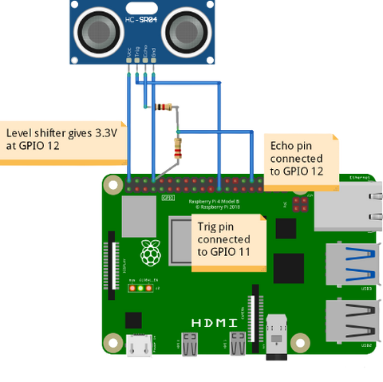

Once the sensors are connected and the software is installed, you can write a Python script to collect and process the sensor data. The Python script will read the data from the sensors and then perform any necessary processing, such as converting the data to a different format or calculating a derived value. The script can then send the data to the central server using a wireless protocol such as Wi-Fi or cellular.

1. **Code Implementation**

**Raspberry Pi Code:**

Python scripts to process sensor data and update status.

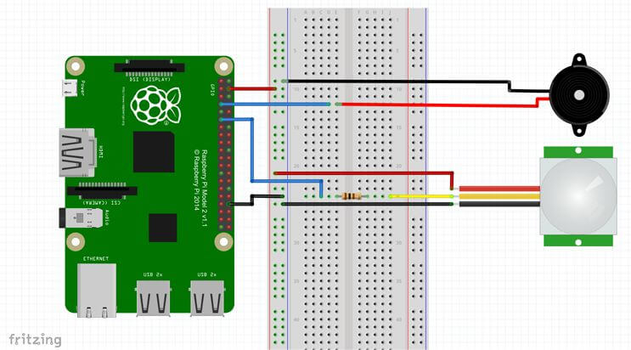

**Python Scripts on IoT**

import requests

import time

from gps_module import get_current_location # Implement GPS module functions

from passenger_counter import count_passengers # Implement passenger counter module

platform_url = "https://your-transit-platform.com/api/data"

while True:

try:

# Get GPS location

current_location = get_current_location() # Implement this function

# Count passengers

passenger_count = count_passengers() # Implement this function

# Create a data payload

payload = {

"vehicle_id": "12345", # Replace with the actual vehicle ID

"timestamp": time.time(),

"location": current_location,

"passenger_count": passenger_count

}

# Send data to the platform

response = requests.post(platform_url, json=payload)

if response.status_code == 200:

print("Data sent successfully")

else:

print("Failed to send data")

# Wait for a predefined interval before sending the next update

time.sleep(60)

# Send data every minute, adjust as needed

except Exception as e:

print("An error occurred:", e)

**Iot Sensor Code:**

function install_app() {

var baseURL = location.href.substring(0, location.href.lastIndexOf("/"));

var canInstall = !!(navigator.mozApps && navigator.mozApps.install);

if (canInstall) {

var req = navigator.mozApps.install(baseURL + '/manifest.webapp');

req.onsuccess = function() {

$("#toastModal .modal-body").text("Installation complete.");

$("#toastModal").modal('show');

};

req.onerror = function() {

$("#toastModal .modal-body").text("Installation failed: "+this.error.name);

$("#toastModal").modal('show');

};

} else {

$("#toastModal .modal-body").text("Open web apps are not supported on this platform. Try FirefoxOS devices from Mozilla.");

$("#toastModal").modal('show');

}

return false;

}

add_onclick("install_app", install_app);

function maybe_show_install_app() {

var baseURL = location.href.substring(0, location.href.lastIndexOf("/"));

var canCheckInstall = !!(navigator.mozApps && navigator.mozApps.checkInstalled);

var installCheck, appSelf;

if (canCheckInstall) {

installCheck = navigator.mozApps.checkInstalled(baseURL + '/manifest.webapp');

installCheck.onsuccess = function() {

if (installCheck.result == null) {

appSelf = navigator.mozApps.getSelf();

appSelf.onsuccess = function() {

if (appSelf.result == null) {

$(".install-btn").removeClass("hidden", installCheck.result);

}

};

};

};

}

}

function set_line_station(obj, station, route) {

set_line(obj, route);

set_station(obj, station, route);

}

function load_times(data) {

var index = 0;

var station_template, line_template;

line_template = prepare_template(

$(".table-times thead"),

$(".table-times thead .template"));

add_new_row(line_template, set_line_station, data.stops[0], data.route);

station_template = prepare_template(

$(".table-times tbody"),

$(".table-times tbody .template"));

for (index = 1; index < data.stops.length; index++) {

add_new_row(station_template, set_station, data.stops[index], data.route);

}

$(".loading-spinner").addClass("hidden");

$(".table-times").removeClass("hidden");

$(".actions-times").removeClass("hidden");

update_station_times();

}

function line_row_onclick(route_id) {

start_loading();

$(".actions-times").removeClass("hidden");

get_route_times(route_id, load_times);

}

add_onclick("line_row_onclick", line_row_onclick);

function setup_control() {

load_favorites();

setup_onclick();

maybe_show_install_app();

}

$(setup_control);

<!DOCTYPE html>

<html lang="en">

<head>

<meta charset="utf-8">

<meta http-equiv="X-UA-Compatible" content="IE=edge">

<meta name="viewport" content="width=device-width, initial-scale=1, user-scalable=no">

<title>Timisoara public transport</title>

<!-- Bootstrap -->

<link href="css/bootstrap.min.css" rel="stylesheet">

<link href="css/bs-theme.css" rel="stylesheet">

<script src="https://oss.maxcdn.com/libs/html5shiv/3.7.0/html5shiv.js"></script>

<script src="https://oss.maxcdn.com/libs/respond.js/1.4.2/respond.min.js"></script>

<![endif]-->

</head>

<body>

<div class="container theme-page" role="main">

<!-- Fixed navbar -->

<div class="navbar navbar-inverse navbar-fixed-top" role="navigation">

<div class="container">

<div class="navbar-header">

<button type="button" class="navbar-toggle" data-toggle="collapse" data-target=".navbar-collapse">

<span class="sr-only">Toggle navigation</span>

<span class="icon-bar"></span>

<span class="icon-bar"></span>

<span class="icon-bar"></span>

</button>

<a class="navbar-back-icon navbar-action-icon hidden" data-onclick="load_favorites" href="#"></a>

<a class="navbar-brand-icon navbar-action-icon" data-onclick="load_favorites" href="#"></a>

<a class="navbar-brand" data-onclick="load_favorites">Public transport<br>Timisoara</a>

</div>

<div class="navbar-collapse collapse">

<ul class="nav navbar-nav">

<li><a class="view-app-btn" href="index.html">View App</a></li>

<li><a href="#about" data-toggle="modal" data-target="#aboutModal">About</a></li>

<li><a href="https://github.com/MihaiBalint/TimisoaraPublicTransport" target="_blank">Developer</a></li>

</ul>

</div><!--/.nav-collapse -->

</div>

</div>

<!-- Fixed navbar -->

<div class="navbar navbar-inverse navbar-fixed-bottom" role="navigation">

<div class="container">

<div class="navbar-header">

<div class="actions-container actions-lines">

<a class="navbar-action-icon tram-kinds" data-onclick="load_trams" href="#"></a>

<a class="navbar-action-icon trolleybus-kinds" data-onclick="load_trolleybuses" href="#"></a>

<a class="navbar-action-icon bus-kinds" data-onclick="load_busses" href="#"></a>

</div>

<div class="actions-container actions-times hidden">

<a class="navbar-action-icon update-times" data-onclick="update_station_times" href="#"></a>

</div>

</div>

</div>

</div>

</div>

<div class="loading-spinner">

Loading...

</div>

<table class="table table-striped table-lines hidden">

<tbody>

<tr class="template" data-onclick="line_row_onclick">

<td class="vehicle-col">

<div><a href="#" class="vehicle-name">E33</a></div>

<div class="vehicle-type">autobuz</div>

</td>

<td class="departure-col">

<span class="departure-label">Catedrala</span>

</td>

<td class="dir-arrow-col">

<div class="icon-arrow-to"></div>

</td>

<td class="destination-col">

<span class="destination-label">Sagului</span>

</td>

</tr>

</tbody>

</table>

<table class="table table-striped table-times hidden">

<thead>

<tr class="template">

<th class="vehicle-col">

<div class="vehicle-name">E33</div>

<div class="vehicle-type">autobuz</div>

</th>

<th class="route-col">

<todo />

</th>

<th class="departure-col">

<div class="departure-label">Catedrala</div>

<div class="station-time">7 min</div>

</th>

<th class="dir-arrow-col">

<div class="icon-arrow-to"></div>

</th>

<th class="destination-col">

<span class="destination-label">Sagului</span>

</th>

</tr>

</thead>

<tbody>

<tr class="template">

<td class="vehicle-col"></td>

<td class="route-col">

<todo />

</td>

<td class="station-col" colspan="3">

<div class="station-label">Catedrala</div>

<div class="station-time">7 min</div>

</td>

</tr>

</tbody>

</table>

<!-- About Modal -->

<div class="modal fade" id="aboutModal" tabindex="-1" role="dialog" aria-labelledby="aboutModalLabel" aria-hidden="true">

<div class="modal-dialog">

<div class="modal-content">

<div class="modal-header">

<button type="button" class="close" data-dismiss="modal" aria-hidden="true">&times;</button>

<h4 class="modal-title" id="aboutModalLabel">About app</h4>

</div>

<div class="modal-body">

</div>

<div class="modal-footer">

<button type="button" class="btn btn-default btn-primary" data-dismiss="modal">Ok</button>

</div>

</div>

</div>

</div>

<!-- Toaster Modal -->

<div class="modal fade" id="toastModal" tabindex="-1" role="dialog" aria-labelledby="toastModalLabel" aria-hidden="true">

<div class="modal-dialog">

<div class="modal-content">

<div class="modal-header">

<button type="button" class="close" data-dismiss="modal" aria-hidden="true">&times;</button>

<h4 class="modal-title" id="toastModalLabel">Message</h4>

</div>

<div class="modal-body">

Everything ok!

</div>

<div class="modal-footer">

<button type="button" class="btn btn-default btn-primary" data-dismiss="modal">Ok</button>

</div>

</div>

</div>

</div>

<!-- jQuery (necessary for Bootstrap's JavaScript plugins) -->

<script src="https://code.jquery.com/jquery.js"></script>

<script src="js/bootstrap.min.js"></script>

<script src="js/live_data.js"></script>

<script src="js/common.js"></script>

<script src="js/editor.js"></script>

</body>

</html>

**CONCLUSION:**

The IoT-based public transport optimization project is a promising initiative to enhance the efficiency, reliability, and accessibility of public transportation systems in rapidly growing urban environments. By leveraging IoT sensors and data analytics, the project aims to optimize routes and schedules, reduce wait times, and improve service reliability, culminating in a number of benefits for passengers, public transportation operators, and the environment.