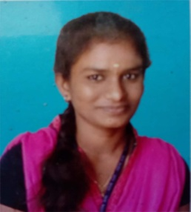KALAIARASI S

## Mobile number: 7339285422

E-mail ID: [kalaiarasi9298@gmail.com](mailto:kalaiarasi9298@gmail.com)

**CAREER OBJECTIVE:**

To become a software engineer, I will get a chance to use my talents, creativity and ability to the maximum, and contribute to the growth of organization as well as myself.

# ACADEMIC DETAILS:

|  |  |  |  |
| --- | --- | --- | --- |
| **COURSE** | **INSTITUTE** | **PERIOD** | **PERCENTAGE OF MARK (%)** |
| SSLC | Infant Jesus High  School, Trichy. | 2013 | 95.8% |
| HSC | St.Annes Girls’  Higher Secondary School, Trichy. | 2013-2015 | 86% |
| B.E(ECE) | Government College Of Engineering,  Bodinayakanur. | 2015-2019 | 72.9% |

**TECHNICAL SKILLS:**

Programming languages:

* HTML
* CSS
* JAVASCRIPT
* JAVA AND FULLSTACK DEVELOPMENT
* MYSQL

# WORKSHOP ATTENDED:

* **Basics of Electronics,** Live Wire, Theni July 2016.
* **IOT using Raspberry pi using python,** Pantech, Madurai 25, 26 September 2017.
* **Automotive Electronics, GCE,** Bodi 26 July 2018.
* **Science and Technology Capacity Building for Industrial Needs,** Chennai 6 Feb 2019.

# PROJECT:

Rust Detection Using Image Processing by using MATLAB software.

# PERSONAL SKILLS:

* Adaptability,
* Leadership skills,
* Comprehensive problem solving abilities,
* Good communication skills,
* Quick learner,
* Good Time management and hard worker.

# PERSONAL PROFILE:

* Father’s Name: M.SHANMUGAM
* Date of Birth: 09-02-1998
* Gender: Female
* Nationality: Indian
* Languages Known: Tamil, English
* Address for communication: 231, DOBI COLONY, RAMACHANDRA NAGAR, E.PUDUR, TRICHY-12.

# DECLARATION:

I hereby declare that all the above information given by me is true to the best of my knowledge and belief.

Date: (S.KALAIARASI)

Place: