Sure, Good Evening everybody, professors, students, Ladies and Gentlemen! I’m Kalaipriya Kannan, I’m a senior business analyst working for Legato Health Technologies, Bangalore. And its my great pleasure to welcome all of you to the Blockchain session. The topic for today’s session Is Blockchain overview and usecases. I’m gonna take you through the agenda in a few mins, and before that I’d like to walk you… through my career journey a bit more

Self introduction – career journey &

I spend my leisure time by exploring new technologies, love work outs, travelling, exploring places and enjoy food. The open opportunities in the current industry is my biggest motivation to continue learning.

I’m very much excited to be a part of the session, delivering the concepts of the blockchain to the young minds this evening, as you’ve all got a forum to learn the lucrative technology at such an early stage.
I hope y’all are as excited as me! I tailored the agenda keeping in mind, it should reach the audience of ALL types. There may be a few participants who might already have explored or learning blockchain concepts, and for them, this training might sound like a LEVEL 1.5 (which covers the fundamentals or foundation concepts and a little bit on the architecture side). For the rest, do not worry, as I’m gonna explain the concepts in the layman terms, for easy understanding.
I‘ll try to make this session an interactive one and also I promise you this is gonna be an informative one as well, provided, if I have all of your attention for the next 1.5 hours. At the end of the session, you should be familiar with the foundation concepts of blockchain, and will be able to relate the case studies that you may be exploring in future.

Alright, let’s get started with the Agenda -

01 What is Blockchain?

Just an alternative to the traditional database system. Because of several technical and security constraints, people prefer to use Blockchain for their industry needs.
Continuously growing list of records called BLOCKS, and that are CHAINED (linked) and secured using Cryptography techniques (be it with SHA 1, MD5 or SHA256. The chained blocks are referred to the term Blockchain.
Helps providing distributed immutable ledger (UNCHANGEABLE) , eliminates the need of central authority and also provides security and privacy

Refer to notebook –
DigiCash Inc. was a company that deals with finance through electronic money funding system. It was founded in 1989 by David, an American computer scientist and Also cryptographer.
● David made it possible by introducing a new mechanism called Blind Signature which plays a vital role in assuring the transactions made anonymously.
Hashcash: Founded by Adam Back. Its an email filter based on a proof-of-work system to identify & filter out spam mails and DoS attacks.
B-Money: B-Money is an early age distributed cash system proposed by Wei Dai, a computer engineer He’s known for his contributions to cryptography and cryptocurrencies.
It was assumed that the "digital aliases" will be able to send and receive money through a decentralized network and even ensure the implementation of contracts among themselves without the involvement of a third party. Unfortunately, the B-Money project did not move from the dead end after the implementation of the white paper.

E-Gold
E-gold Ltd was a digital gold currency company founded by Douglas Jackson and Barry Downey in 1996. This org has faced many hurdles like security issues, digital scams, cyber attacks as the technology available during the time was primitive
Bit Gold
Bit gold is one of the most known decentralized virtual currency projects taken before blockchain. It was proposed by Nicholas (Nick) Szabo in 1998. It operates on a decentralized and distributed system instead of a centralized authority controlling the entire system
BitCoin
Satoshi Nakamoto. He launched the network by creating the first block of the Bitcoin Blockchain by mining 50 bitcoins on January 3, 2009.
What is Consensus?
Consensus is a mechanism to ensure all nodes are in sync and agree on which transactions are legitimate and are added to the blockchain. Consensus assure that the protocol rules are being followed and guarantee that all transactions occur in a trustless way.

What is mining:
the process of adding a new transactions to the existing transactions, Miners help adding the transaction by taking the mining fees.

Proof-of-Work (PoW)
In Proof-of-Work, miners compete to solve a difficult mathematical problem based on a cryptographic hash algorithm. Miner did spend a lot of time and resources to solve the problem. When a block is 'solved’, the transactions contained are considered Confirmed. Miners receive a reward when they solve the complex mathematical
problem.
Proof-of-Stake (PoS)
Proof-of-Stake is a different way to validate transactions and achieve consensus. Proof-of-Stake chooses the creator of a block based on their wealth, also known as stake. Here, there is no block reward. Miners take the transaction fees.

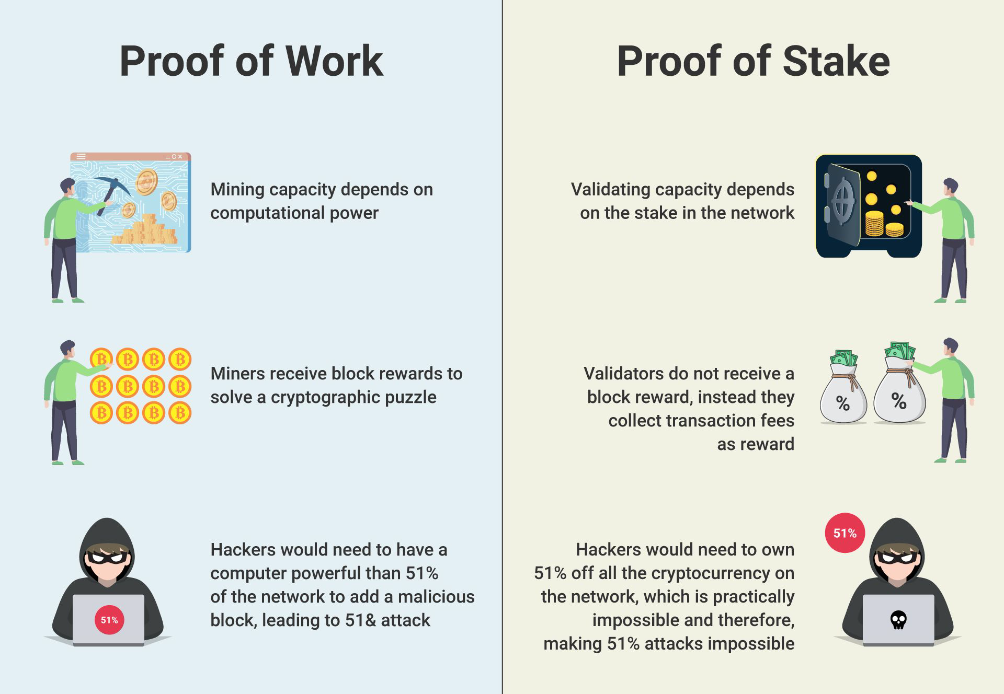

What are Smart Contracts?

A smart contract is a set of rules written in Programming language

Before blockchain this type of smart contract was impossible because parties to an agreement of this sort would maintain separate databases. With a shared database running a blockchain protocol, the smart contracts auto-execute, and all parties validate the outcome and without need for a third-party.

02 Types of Blockchain
Public Blockchain
2
A public blockchain is permissionless. so anybody can access the network and read, write or participate without authorization and permission.
It is decentralized and has no network-controlled entity.
Data added to a public blockchain is protected because data cannot be changed or manipulated until it has been checked on the blockchain. Public blockchain has more complex rules and consensus algorithm for better security. It is very expensive to mine and to add a Block.

Examples of a public blockchain are Bitcoin and Ethereum.

Federated/Consortium Blockchain
A Consortium or Federated Blockchain is a private, permissioned blockchain – here the entities can only become members of the network by prior approval or voting. Here, more than one central node is in-charge, that provide access to pre-selected nodes to read, write, and audit the blockchain. Only consortium members can make, validate, and review transactions. This sort of blockchain is suitable for use between companies that often have dealings with each other. While these are more secure, they come at the cost of decentralization. However, this suits enterprise use cases and business processes.

Example: R3’s Corda Blockchain

03 Ethereum
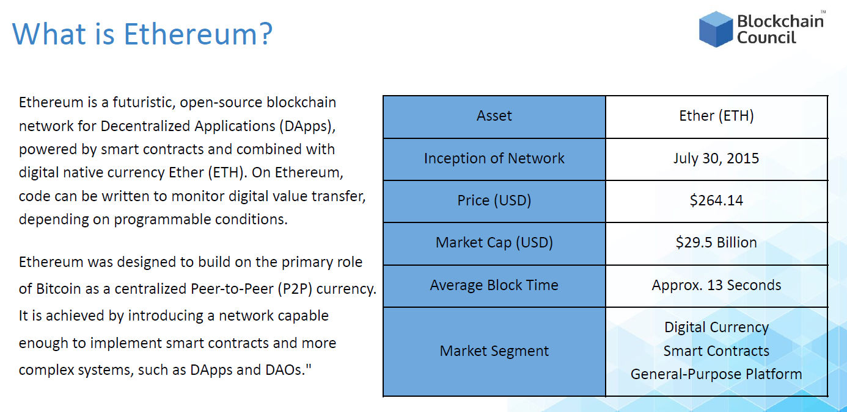
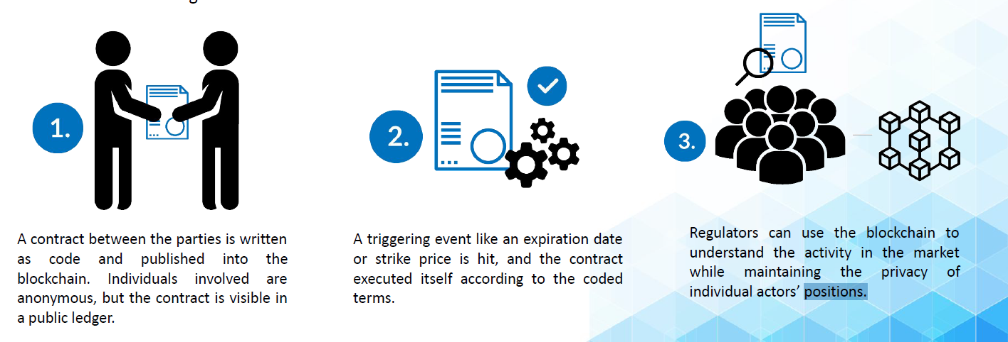
ERC Token Standards:
An Ethereum Improvement Proposal (EIP) is a design document that describes a new function for Ethereum, its systems, or its ecosystem.

04 Hyperledger Fabric
Hyperledger Fabric is one of the major and oldest Blockchain projects within Hyperledger Umbrella. Similar to other Blockchain technologies, it has a ledger, uses smart contracts, and provides a system by which participants manage their transactions.

The important features are -

Hyperledger is Private and Permissioned. And The members of a Hyperledger Fabric network enroll through a trusted Membership Service Provider aka MSP. Hyperledger Fabric offers a pluggable mechanism for multiple formats, consensus algorithms and MSP services. Hyperledger offers a functionality of creating channels, allowing a group of participants to create a separate ledger of transactions.

Architecture:

Point 2
During simulation of a transaction at an endorser, a read-write set is prepared for the transaction. The read set contains a list of unique keys and their committed version numbers (but not values) that the transaction reads during simulation. The write set contains a list of unique keys (though there can be overlap with the keys present in the read set) and their new values that the transaction writes.

MSP:
Because Fabric is a permissioned network, blockchain participants need a way to prove their identity to the rest of the network in order to transact on the network.
Certificate Authorities issue identities by generating a public and private key which forms a key-pair that can be used to prove identity. This identity needs a way to be recognized by the network, that’s when the MSP comes in. The Main job of MSP is to assign roles to the nodes in the network. Example what are the nodes that can acts as Peer and what are the nodes that can act as Order or admin for that matter!

5 Industry Use cases
Supply chain:
Food: When a customer shops in stores, they know we expect great prices, and great quality and great service. On the flip side, an unspoken expectation is that the product to be safe! If you think about the food system, its pretty complex. It involves farmers, processors, distributors. The way the industry works today is that each segment of the food system operate in their own way. The business proposals or agreements generally documented on papers, bonds or the systems which they don’t interact with each other. Even if you want to trace out, you will never know or have a full view of whats happening in the backend.
However, with blockchain we can make this expectation into reality, & possibility of bringing all the segment owners into one distributed ledger and define them a standard protocols to follow and have them update of the process going on in the backend. If there’s some mishappening occur in future, we know who is liable for that matter. This helps foster transparency on whats happening to that particular product we are buying.
Fun fact: China and UAE are the early adopters of Blockchain Food industry
Healthcare:
The main challenge with the Healthcare system in todays world is they cannot share or exchange info to other participants due to non disclosure agreements as involves PII and PHI data. In the current scenario all the participants works separately and a lot of times, you have to share the same documents several times to multiple parties involved for verification or for claim processing. Blockchain eliminates this as it brings all the involved parties together and thus the exchange of paper based information is no longer needed. And even if you want to use your medical history or claim in future, you know where to reach out!
Government Agencies:
Estonia built one of the most advanced digital government! Banking, prescriptions, and even voting are managed through digital mode called e-Estonia. During Covid-19 when the people around the world struggle to make transactions, Estonia didn’t struggle BUT was topping them in handling things successfully. There were countries who postponed their election due to lockdown & a lot of system break down, but for Estonia there was no break in anything. It proves that the digital governance works pretty well!
Internet of things:
Blockchain can also be used in the IoTs. IoT devices uses blockchain technology as a backend networking system to store the information. As you may know, IoT is a system of interconnected computing object and devices via the Internet. This enables the devices to send and receive the data and communicate with one another.
Blockchain on IoT provides several benefits such as high data security, better quality control in IoT manufacturing, Real time tracking, Encryption for multi factor authorization, Data anonymity and a lot more.
You can also link any IoT devices to supply chain process to track the product and offer the correct location of any goods without any interference. If needed, more access control mechanism can be set to restrict unwanted participants entry.
Here’s a quick 1 min video shows how blockchain plays a role with SCM & IoT combined
https://www.youtube.com/watch?v=HJ1W4vHPDFY
06 How to determine the need of Blockchain?
Read the questions on the slide
1. Do you want the data be consistent across the organizations?
2. Will the data remain unchanged once it is written?
3. How many org do you have to participate? Is it just one organization (OR) do you have many contributing entities?
If your answer to the very first question is no, you can skip the remaining 2 questions; your business do not really need a blockchain. For instance, if the data is not necessarily consistent across the entities, an enterprise can consider the spreadsheets or the documents.
Suppose, if you answer Yes to the first question, But to No to the second one.
i.e., If the administrators and participating authorities, have to modify the written data at some point, blockchain is not an appropriate choice because it does not allow any modification once the data enters the chain, Right?! In this case, the business should consider a database rather than……….. ledger technology.
So, lets look at the third question,
if there is only one enterprise or organization that is contributing, or if you think there is no trust issue among contributing organization, the data does not need to be distributed — and in this case, blockchain is not needed.
Got it?! Ok, let’s move on…
Next is to Choose The Right Distributed Ledger Technology For Your Enterprise
When the need for a blockchain is determined, we’ll have another question in mind "permissioned blockchain" and "public blockchain." Again, You should ask the right questions, to determine which type of blockchain will be suitable for your enterprise:
1. Determine whether you need an enhanced security and consensus of multiple participants? - If you think the answer is no, your business should consider a different solution, such as workflow management or the sign-off process.
2. What type of entities you have in your transaction? i.e, a group of selective and trusted entities/organization, or whether it’s a group of public anonymous entities?
For the second question, if your business needs a group of selective and trusted entities, you might want to consider a permissioned blockchain. On the other hand, if your business needs a group of public anonymous entities, you should have a public blockchain.
Okay, that’s all I have for today, to summarize, we have covered
- What is blockchain & its architecture
- History of blockchain
- Types of Blockchain
- Blockchain technologies & use cases
- And How to determine the need of a blockchain
I hope this gives you an idea of the technology and I’m sure you’ll be very familiar with the foundation and the fundamental concepts of the blockchain.
I do have a few reference links for you to explore. This will give you a detailed understanding of the concepts that you’re interested in.

