Java Roadmap
- Java – Intro
- Java – Statements, commands
- Java – identifier and rules, keywords
- Java – Data types
- Java – operators
- Java – Control flow statement {control & iterative}
- Java – Access modifier
- Java – OOPs
- Java – Exception Handling
- Java – package, lang package
- Java – collection framework
- Java – 8 features => Functional interface, lambda expression/ single arrow, predefined FI=> function, predicate, consumer, supplier, Bi function, Bi predicate, double colon operator
- Interface & enhancement => static, default method
- Date & time API
- Stream API
- Optional Class
- Spring Boot

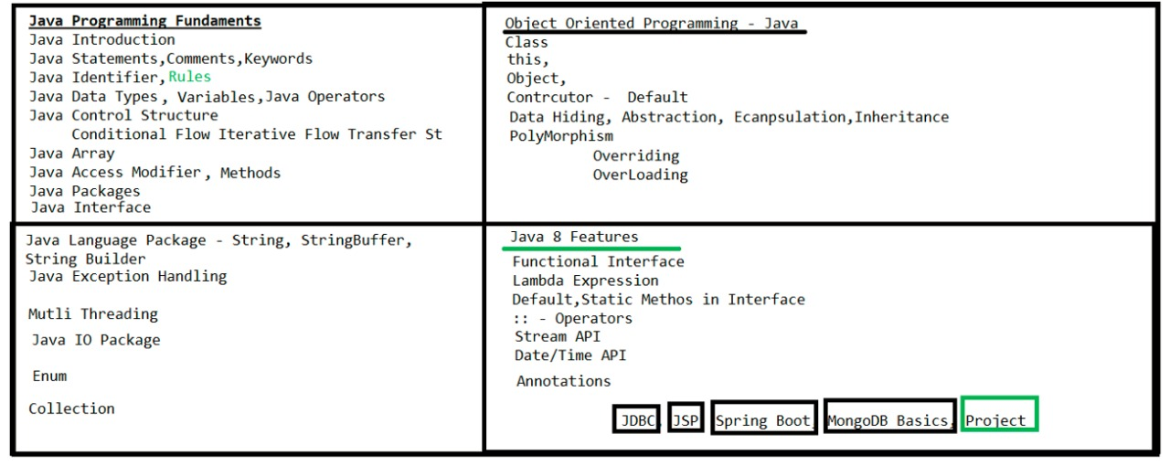
Java
- Java is a high-level language and object-oriented programming language.
- Java is Strictly Typed Programming language.
- It is designed to be simple, secure, portable, and platform-independent, meaning you can write code once and run it anywhere

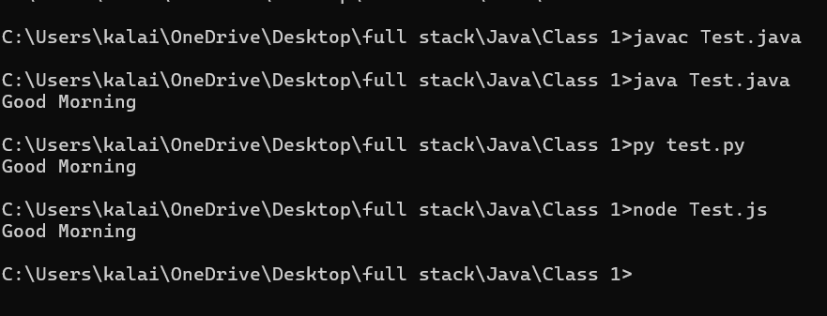

What is different between Compiler and Interpreter?
- A compiler translates the entire source code of a program into machine code (or bytecode) before execution. (Java, C++, .Net)
- An interpreter translates and executes the code line by line, at runtime (while the program is running).(Python, JavaScript)

Java file contain
- Classes variable + methods
- Interface variable + methods
- Enum
Identifier:
- A name in java program is called identifier. It can be either class name, variable name, method, label name
- If we are using any other characters we will get compile time error.
Identifier Rules:
- Identifier should contain a-z, A-Z, 0 to 9, _, $.
- Identifier should not start with digits 0 to 9
- Identifier should not contain any special symbol/character.
- Identifier should not use keyword/Reserved words
- Identifier are case Sensitive.

Keywords: In Java there are 50+ keywords are there.
- Data Types true, false, byte, short, int, long, float, double, char
- Operators instance of, new
- Control flow if, else, switch, case, break, default, for, while, do
- Access Modifier public, static, native, specifier, private, final, protected, synchronized
- OOP class, extends, import, new, super, implements, export
- Error handling try, catch, finally, throw,

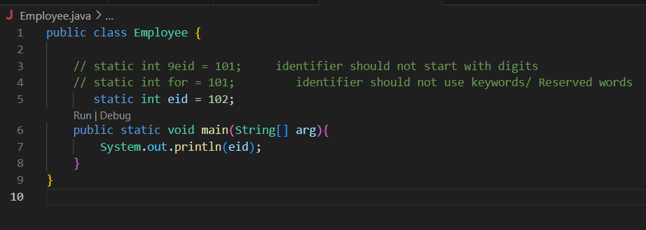

Java Comments:
Comments in java are non-executable code. It is meant only for humans to read.
- Single line Comments //
- Multi line comments /* ……. */
Java Data Type:
Java is Strictly Typed Programming Language. There are 3 Data Types
- Pre-defined / primitive Data Types
- Derived Data Types
- User Defined Data Types
Primitive Data Types:
It can hold single values.
    - Numeric Data Types * Integral – bytes(range: -128 to 127), short(range: -32768 to 32767), int(range: 2 power 31), long
* Floating – float, double.
- Char Data Types Char
- Boolean Data Types Boolean
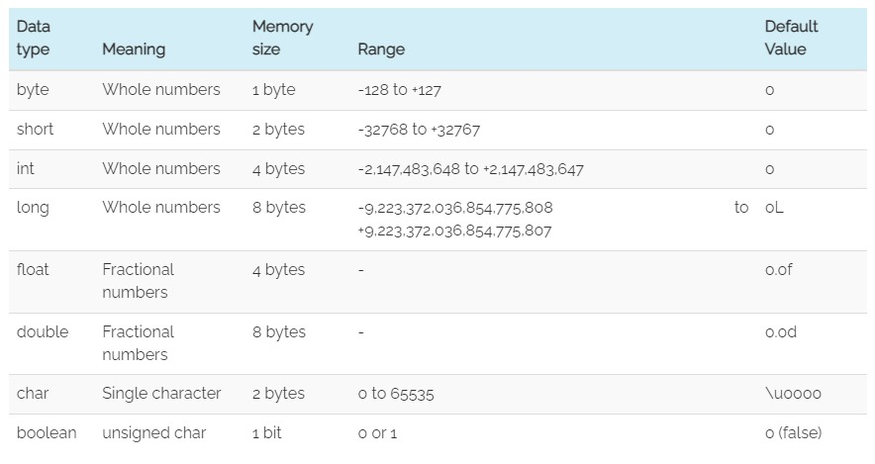
Example:
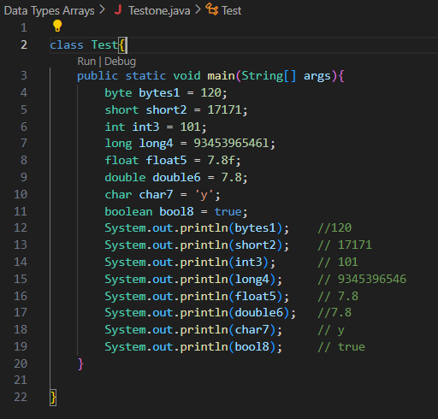

Derived/ Reference Data Type:
Reference/Derived data type are holds multiple values.
- String
- Array

Java Array:
- Array is group of elements as one entity
- It allowed duplicates.
- Array don’t allow heterogeneous elements
- Array element are storing based on indexing.
Example:
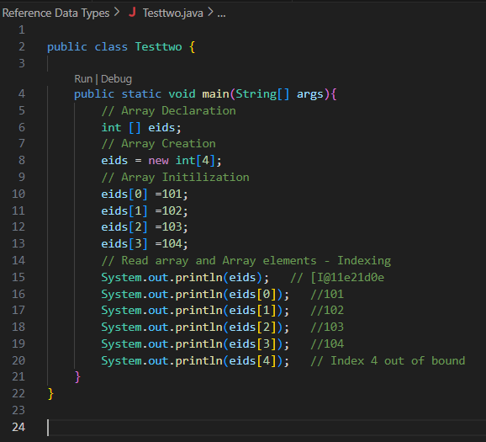

Java Variable:
A variable in Java is like a container that holds data. You give it a name, and you can store different values in it while the program runs.

Types of Variable;
- Instance Variable default values are stored based on type, in case only declaration.
- Static Variable default values are stored based on type, in case only declaration.
- Local Variable
Instance Variable:
- if variable value is varied from object to object.
- Separate copy will create for object to object.
- Where to use inside a class, out the method()
- How to access using object/ instance only

Example:
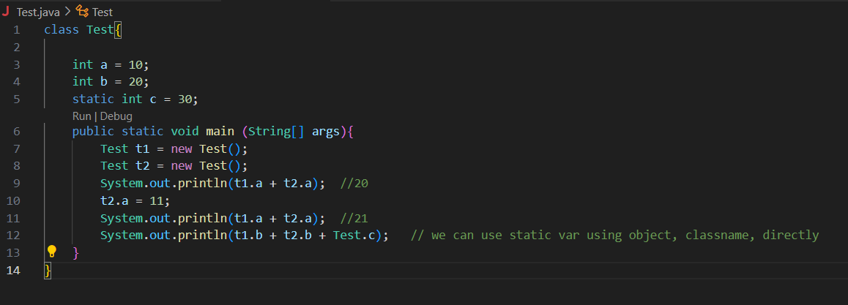
Static Variable:
- If variable value is not varied from object to object
- Only one copy will create at class level & shared every object, using Instance/ object & using className.
- Where to use inside a class, outside methods using static keywords
- How to access using object and using ClassName or using directly in static context methods.
Example:
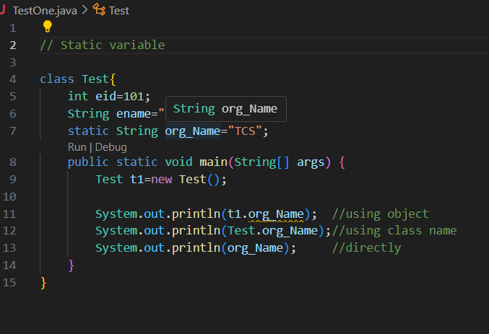

Local Variable:
- Local variable scope is with in the method only
- Local variables disappear once the method or block ends.
- There is no default values for local variable, we must initialize the value to the variable.

Example:
