––
Java Roadmap
- Java – Intro
- Java – Statements, commands
- Java – identifier and rules, keywords
- Java – Data types
- Java – operators
- Java – Control flow statement {control & iterative}
- Java – Access modifier
- Java – OOPs
- Java – Exception Handling
- Java – package, lang package
- Java – collection framework
- Java – 8 features => Functional interface, lambda expression/ single arrow, predefined FI=> function, predicate, consumer, supplier, Bi function, Bi predicate, double colon operator
- Interface & enhancement => static, default method
- Date & time API
- Stream API
- Optional Class
- Spring Boot

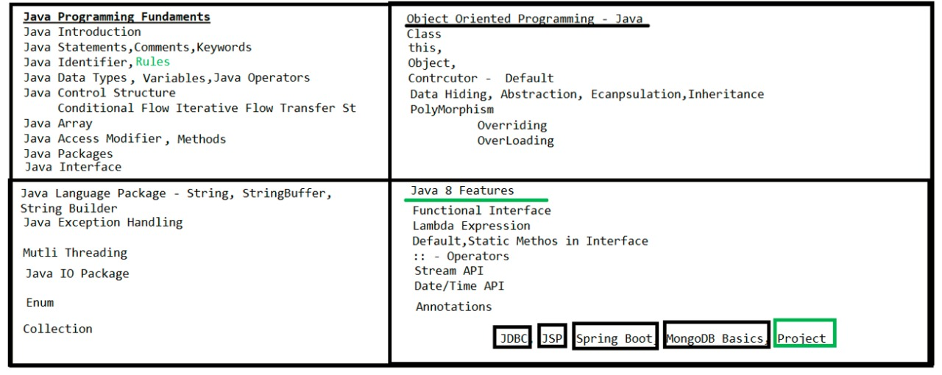
Java
- Java is a high-level language and object-oriented programming language, platform independent.
- Java is Strictly Typed Programming language.
- It is designed to be simple, secure, portable, and platform-independent, meaning you can write code once and run it anywhere

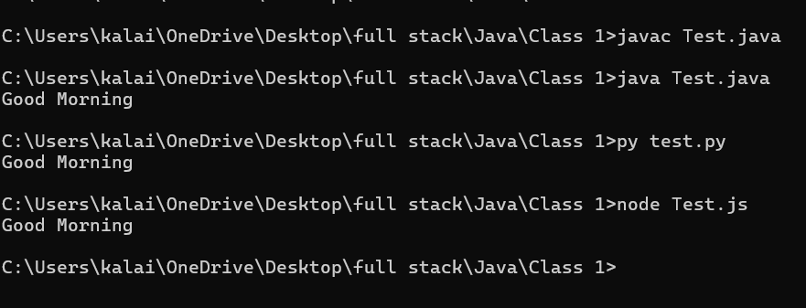

What is different between Compiler and Interpreter?
- A compiler translates the entire source code of a program into machine code (or bytecode) before execution. (Java, C++, .Net)
- An interpreter translates and executes the code line by line, at runtime (while the program is running). (Python, JavaScript)
We can compile without main method while executing it will show error.
Source code
Byte code
Machine code
Java interpreter
Javac compiler

Java file contain
- Classes à variable + methods
- Interface à variable + methods
- Enum

First program in java:
It is a key word. New class has been created.
class first_Program{
Java identifier
public static void main(String[] args){
System.out.println("even");
}
}
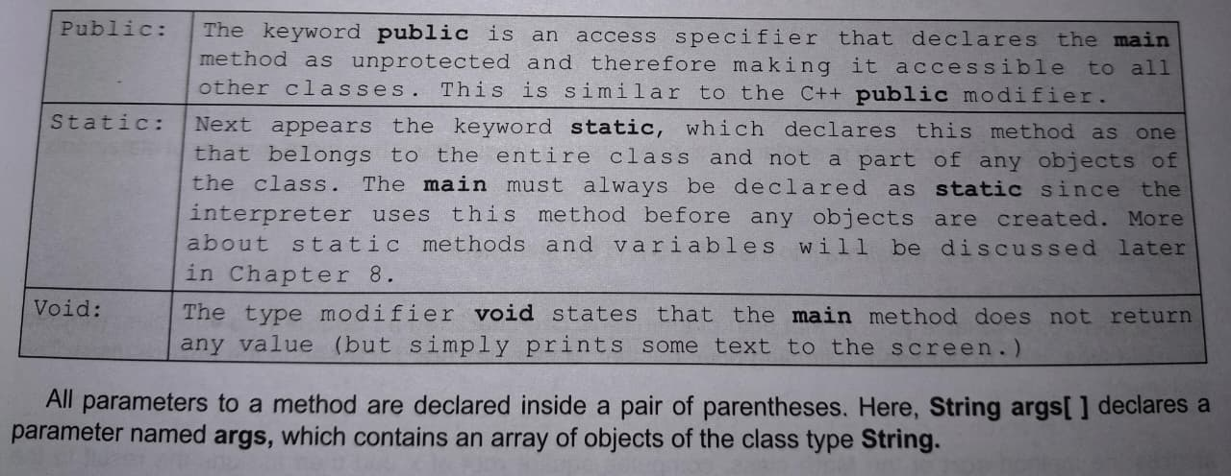
Identifier:
- A name in java program is called identifier. It can be either class name, variable name, method, label name
- If we are using any other characters we will get compile time error.
Identifier Rules:
- Identifier should contain a-z, A-Z, 0 to 9, _, $.
- Identifier should not start with digits 0 to 9
- Identifier should not contain any special symbol/character.
- Identifier should not use keyword/Reserved words
- Identifier is case Sensitive.

Keywords: In Java there are 50+ keywords are there.
- Data Types à true, false, byte, short, int, long, float, double, char
- Operators à instance of, new
- Control flow à if, else, switch, case, break, default, for, while, do
- Access Modifier à public, static, native, specifier, private, final, protected, synchronized
- OOP à class, extends, import, new, super, implements, export
- Error handling à try, catch, finally, throw,

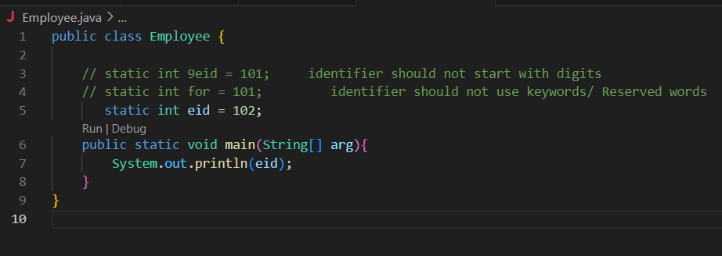

Java Comments:
Comments in java are non-executable code. It is meant only for humans to read.
- Single line Comments à //
- Multi line comments à /* ……. */
Java Data Type:
Java is Strictly Typed Programming Language. There are 3 Data Types
- Pre-defined / primitive Data Types
- Derived Data Types
- User Defined Data Types
Primitive Data Types:
It can hold single values.
    - Numeric Data Types à * Integral – bytes(range: -128 to 127), short(range: -32768 to 32767), int(range: 2 power 31), long
* Floating – float, double.
- Char Data Types à Char
- Boolean Data Types à Boolean
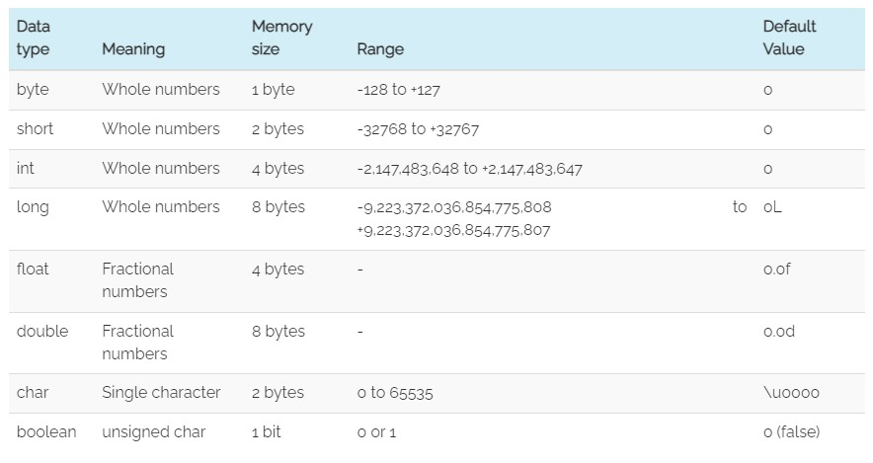
Example:
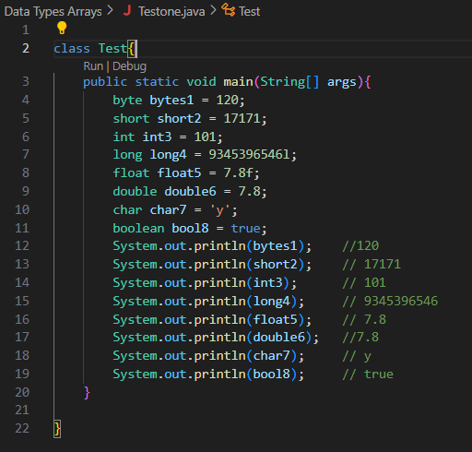

Derived/ Reference Data Type:
Reference/Derived data type are holding multiple values.
- String
- Array
- Class objects
- Interface
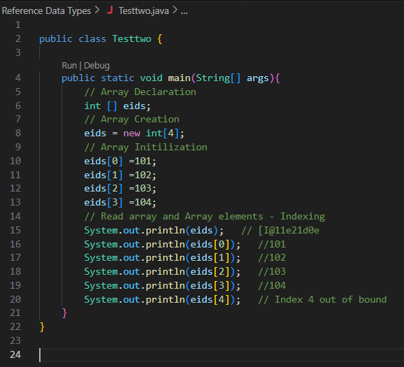
Java Array:
Example
- Array is group of elements as one entity
- It allowed duplicates.
- Array don’t allow heterogeneous elements
- Array element is storing based on indexing.

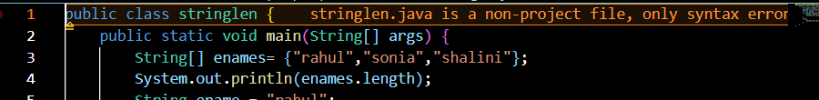
We can declare an array at a time simply by creating, declaring and inserting the values.
Java Variable:
A variable in Java is like a container that holds data. You give it a name, and you can store different values in it while the program runs.
Types of Variables:
- Instance Variable à default values are stored based on type, in case only declaration.
- Static Variableà default values are stored based on type, in case only declaration.
- Local Variable separate copy is created for all the objects.
Instance Variable:
- if variable value is varied from object to object.
- Separate copy will create for object to object.
- Where to use à inside a class, out the method ()
- How to accessà using object/ instance only

Example:
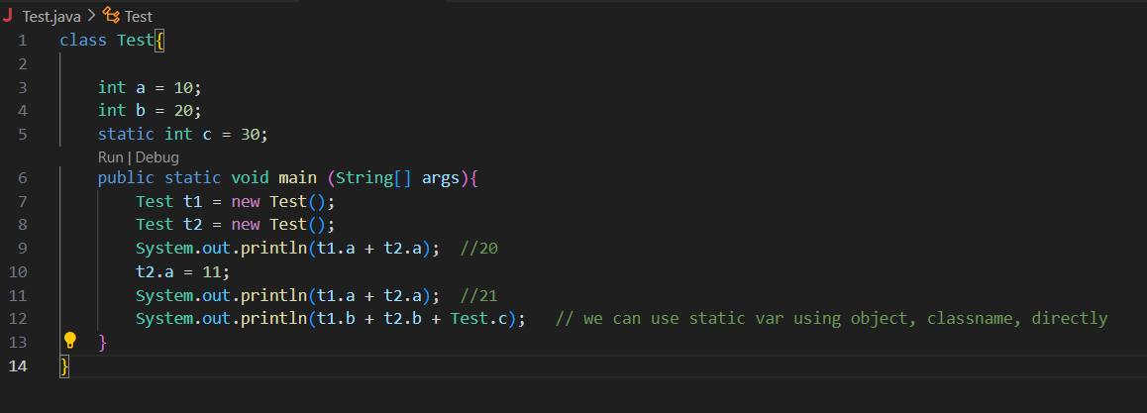
Static Variable:
- If variable value is not varied from object to object
- Only one copy will create at class level & shared every object, using Instance/ object & using className.
- Where to useà inside a class, outside methods using static keywords
- How to accessà using object and using ClassName or using directly in static context methods.
Example:
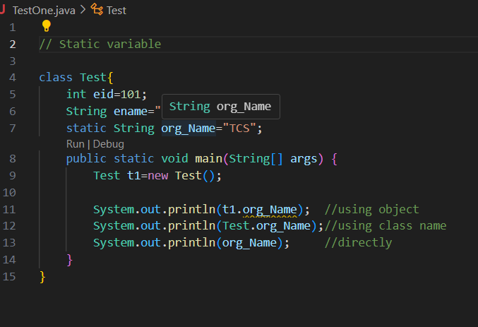

Local Variable:
- Local variable scope is within the method only
- Local variables disappear once the method or block ends.
- There are no default values for local variable, we must initialize the value to the variable.

Example:
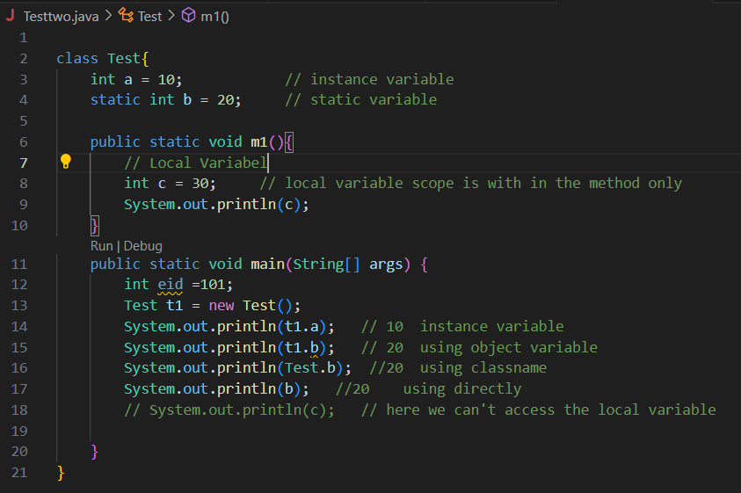
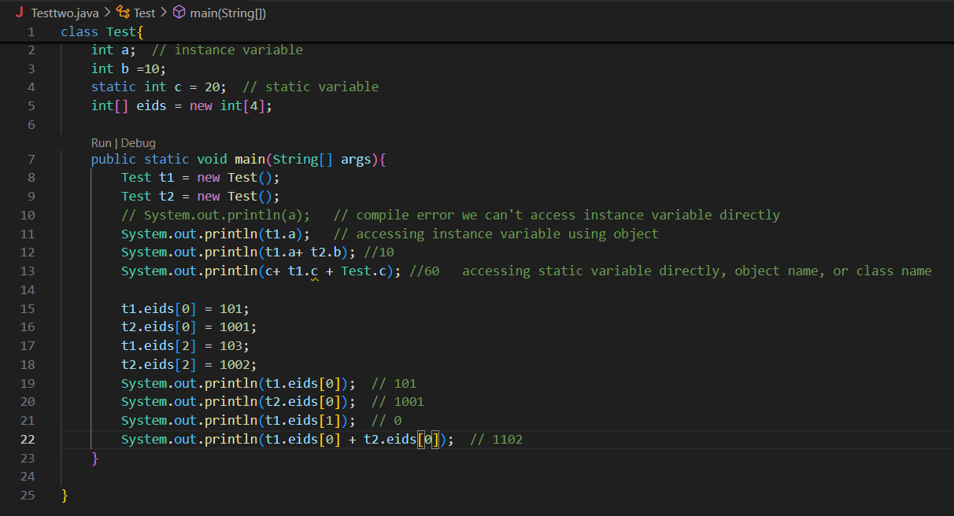
Operator:
- Operator in Java is a symbol that performs an operation on variable and values.
- In java there are lot of operators are there they are.

  - Arithmetic operator. ( +, -, *, /, %)
  - Logical operator. (&&, !)
  - Relational operator. (==, !=, >, <, >=, <=)
  - Equality operator.
  - Assignment operator. (=, +=, -=)
  - Increment / Decrement (a++, ++a)
  - Ternary operator. (Condition? True: false;)
  - Bitwise operator.

Increment / Decrement.
- Increment → increase a variable’s value by 1
- Decrement → decreases a variable’s value by 1
Java Provides two types of each;
- Prefix. à first increases the values by 1, then uses it.
- Postfix. à first uses the current value, then increases it by 1.

Example:

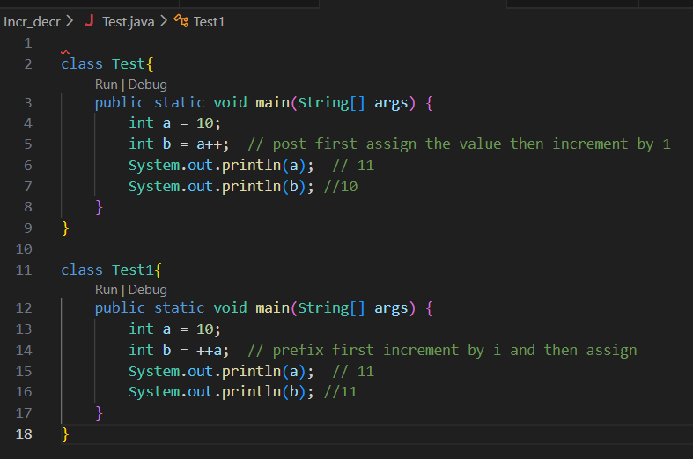
Logical, Relational and Equality operator:
These 3 operators are return only true/false.
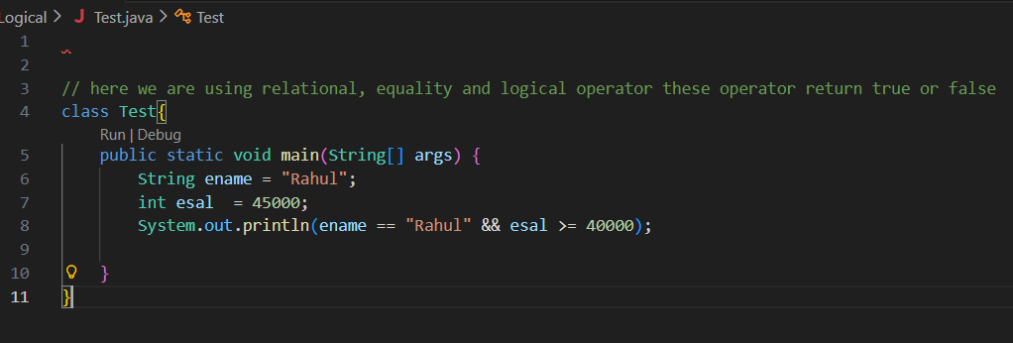
Ternary operator;
The Ternary operator is a shortcut for if-else statements.
Syntax:
condition? value_if_true: value_if_false;
Example:
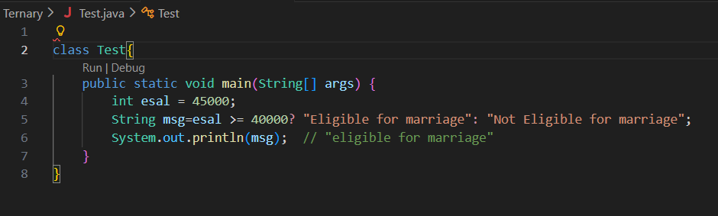
Conditional Statement:
- A conditional statement in Java is used to make decisions in your program.
- It allows your code to execute certain blocks only when a condition is true.
* If
* if else
* if-else-if ladder.
* switch.
If:
Executes a block only if the condition is true.
Example:
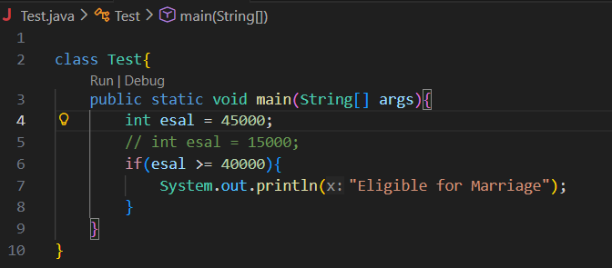
If else:
If condition is true → run if block
Else → run else block
Example:
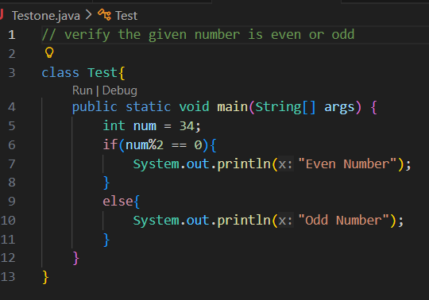
What is different between array length and string length ()?
Array length | String length ()
It is a property | It is a method
It returns array size | It returns number of characters
Applicable for only arrays | Applicable for only string object

Example:
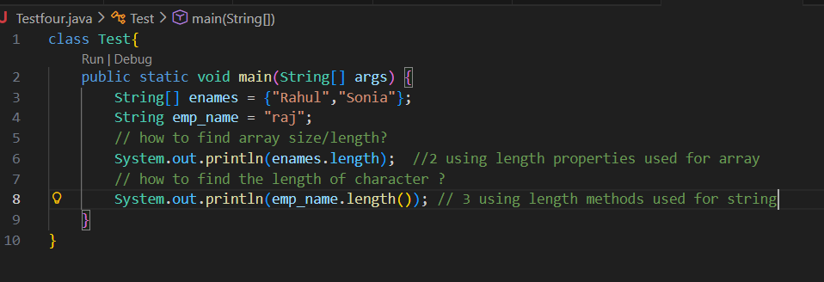

Iterative:
An iterative statement in Java is used to repeat a block of code multiple times.
  - For loop
  - While loop
  - Do while loop

For loop:
Used when you know how many times you want to repeat.
Syntax:
For (initialization st; condition st; incr/decr) {
// statement1;
// statement 2; }
Example;
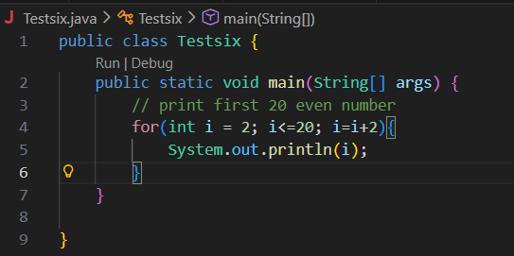

For Each loop:
for-each loop is used to access every element in an array or list without using index.
Syntax:
for(datatype variable : arrayOrCollection){
// use variable
}
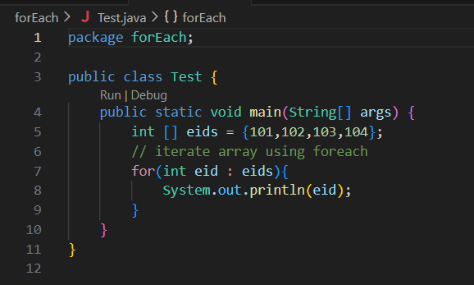
Example:
Int [] eids = {101,102,103}
For (eid:eids){
Sop(eid)
Access Modifier:
In Java, access modifiers are keywords used to control who can access classes, methods, variables, and constructors. It tells our JVM whether we can access or not.
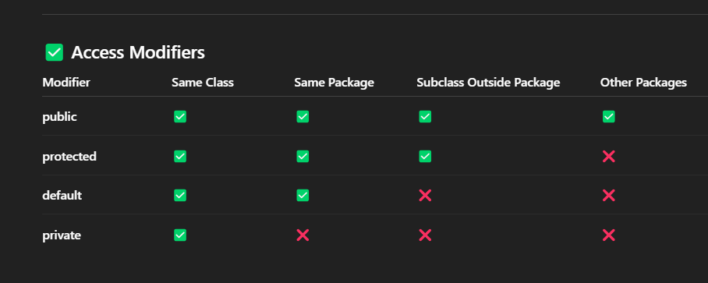
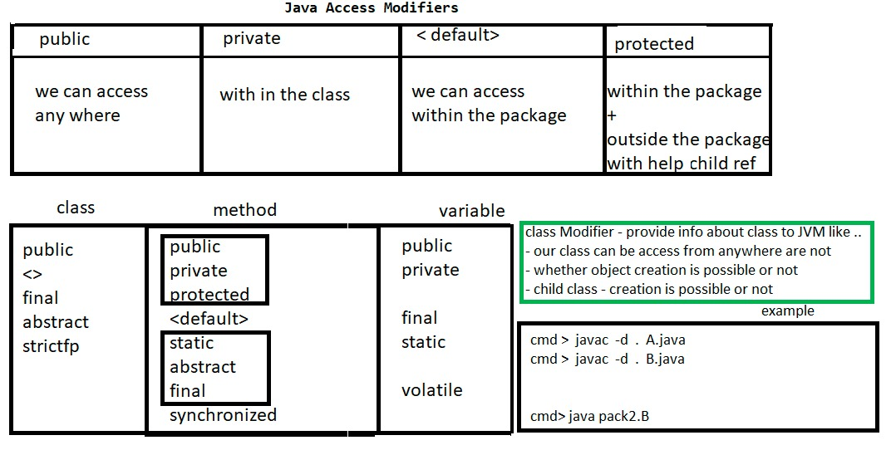
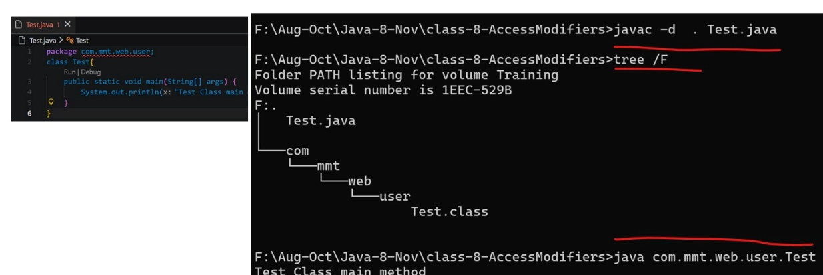
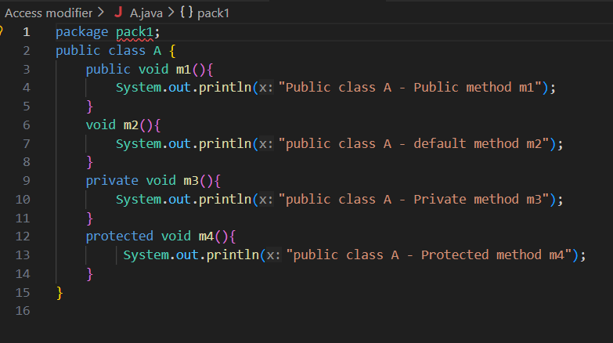
Public à We can access anywhere.
Private can be accessed only inside the class.
Protected àwe can access within package, outside package with help of child / reference.
Private protected can’t be accessed outside of the package
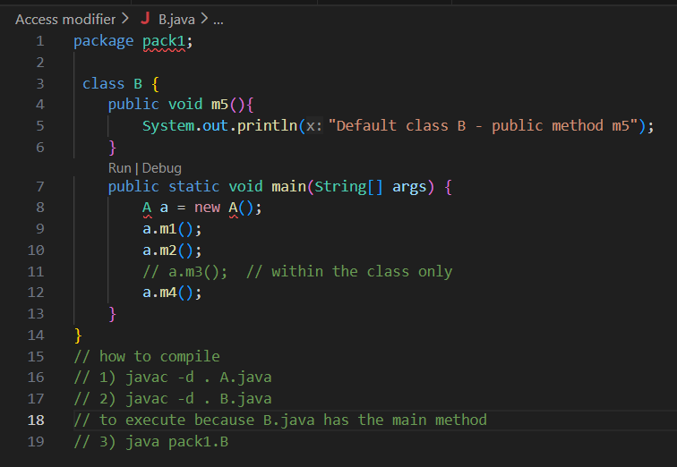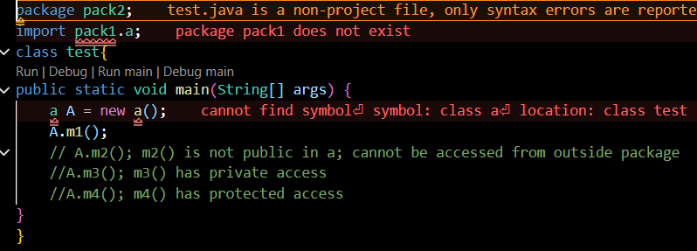

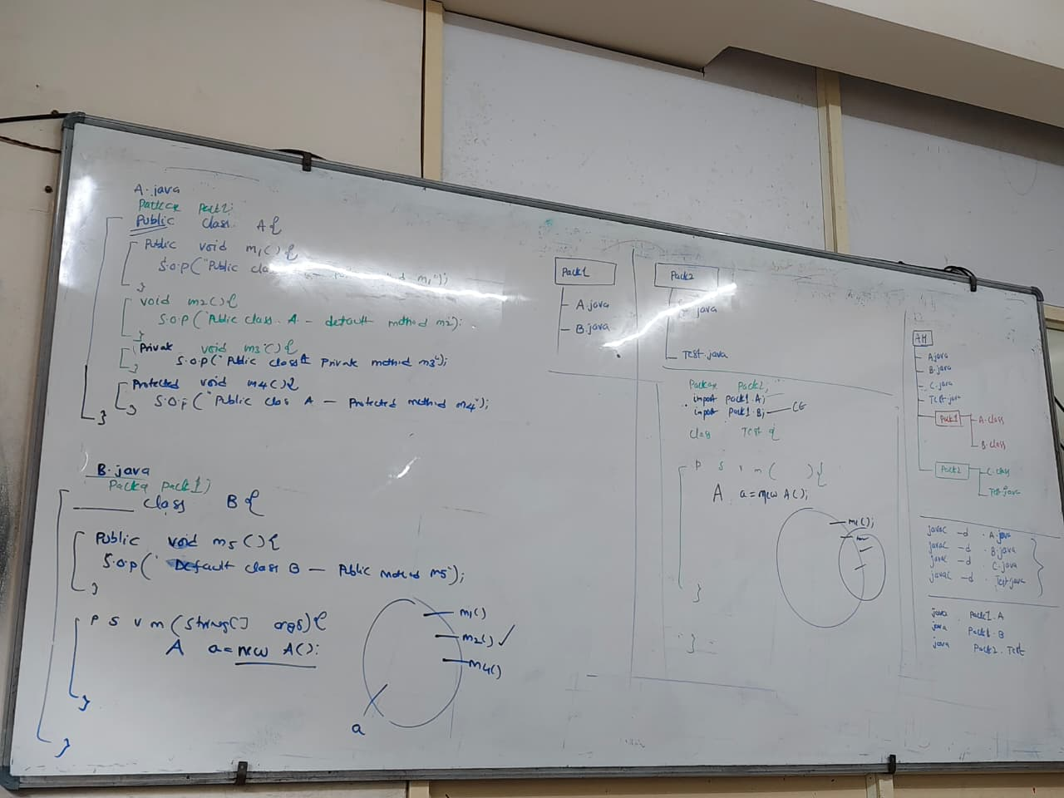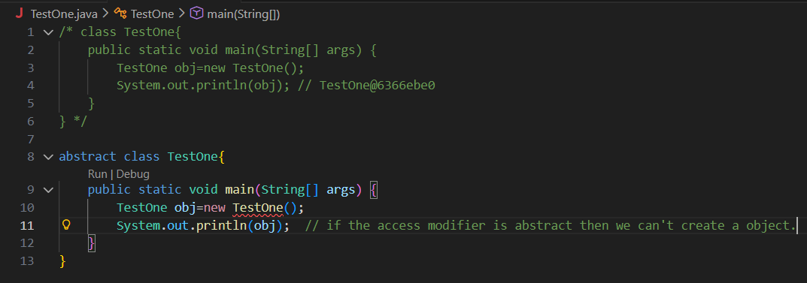
We can’t create object for abstract classes or instantiate classes
class | method | variable
public | Public | Public
<default> | Private | Private
Final | Protected | Default
Abstract | Default | final
Strictfp | Final, abstract, static, synchronized | Static, volatile

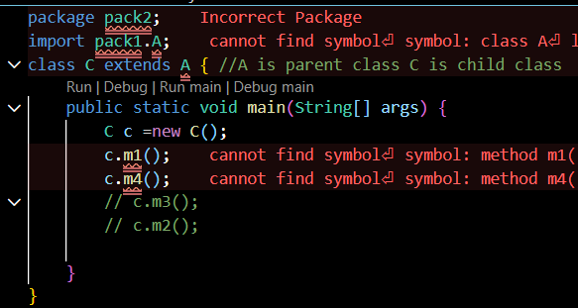
If you declare the class name as final you can’t create child class.
If we use class C extends A the methods which are present A are copied to C.
Now we can use the methods from C. Class A is parent class, Class C is child reference.
Even though we can’t access private and default only public and protected methods can be accessed.
Specifier | Meaning
%d | integer
%f | float / double
%.2f | double with 2 decimal places
%s | string
%c | character
%b | boolean
%n | new line

What is Inheritance?
- If we want to access/reuse parent class functionality in child class. We can access using keyword extends.
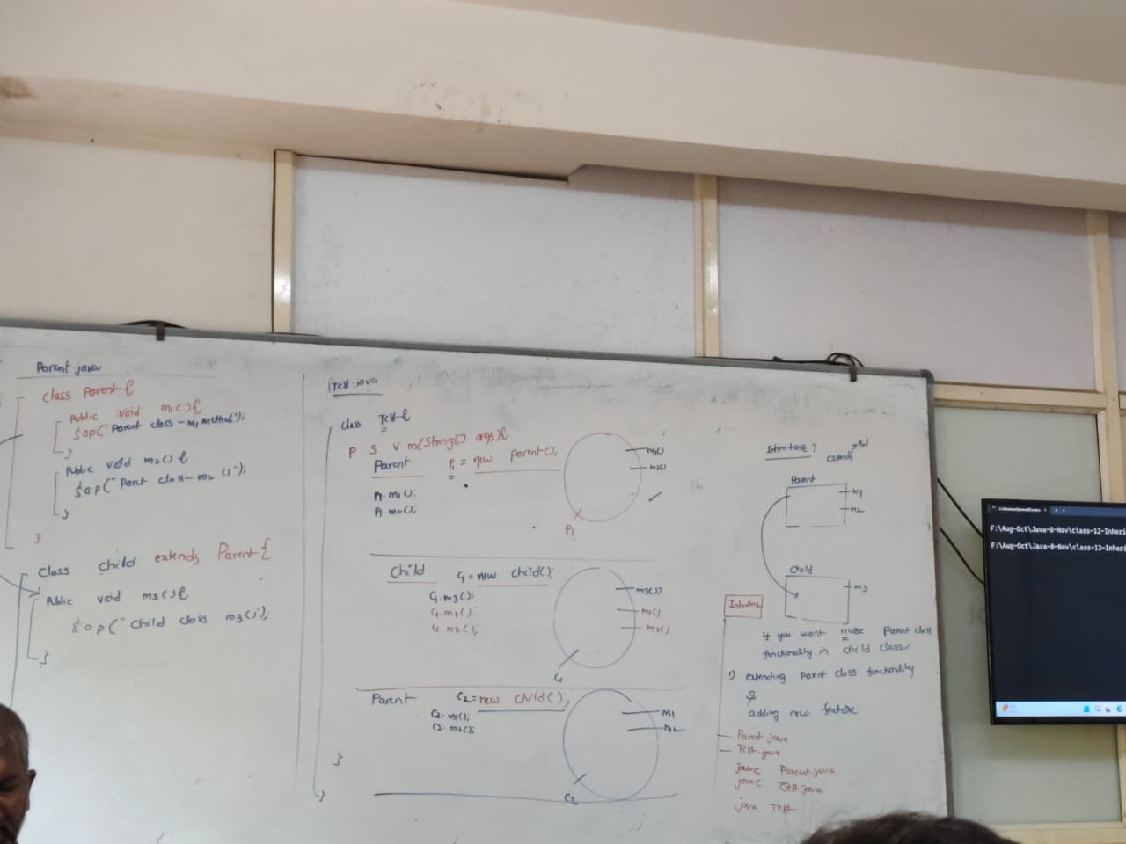
- child p2 = new parent(); is not possible.
- Child type cant refer parent class.

Final Keyword:
- If the variable is declared as final, we can’t change the value of variable.
- If the class is declared as final, we can’t declare child class, inheritance is not possible.
- Final is applicable for variable, class and methods.
- If we give final keyword for methods overriding is not possible.
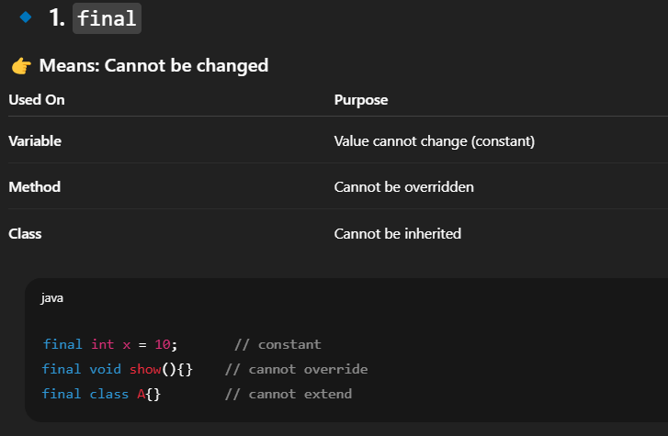
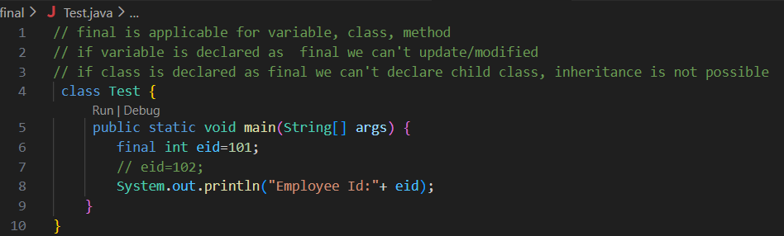
Abstract Keyword:
- Abstract modifier is applicable for class and method but not for variable.
- Abstract method has only declaration and not an implementation.
- If the class name is Abstract, we can’t create object.
- If class contains one abstract method class name must be abstract.
Example:
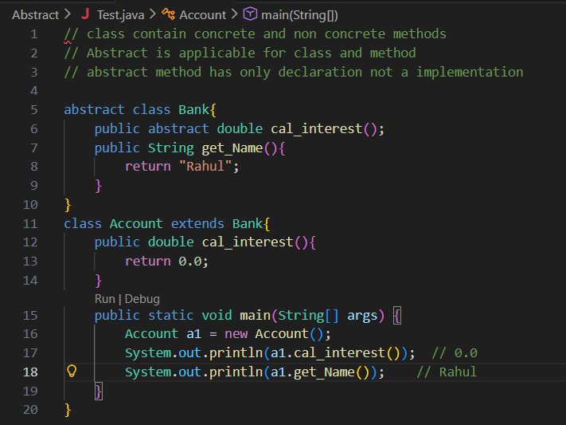
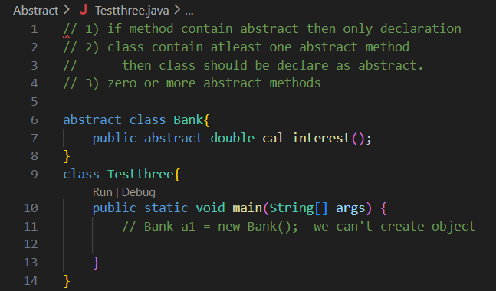
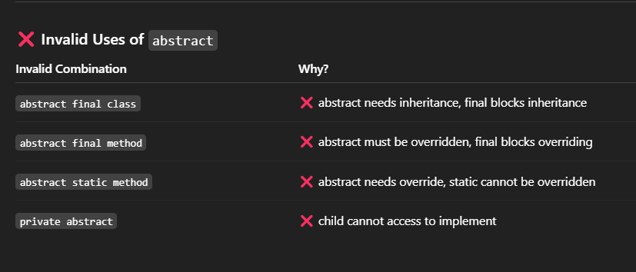
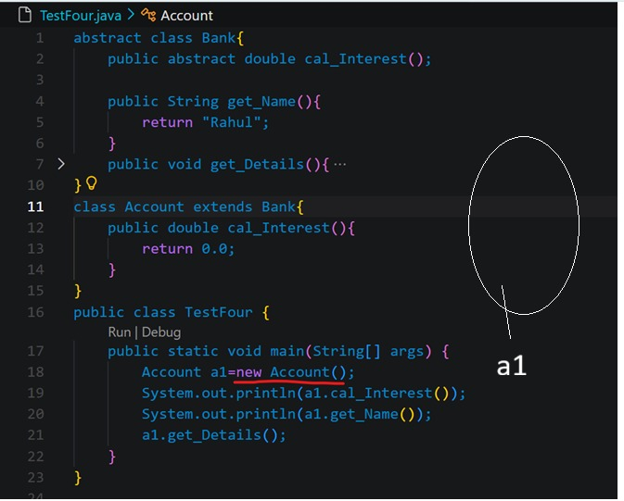

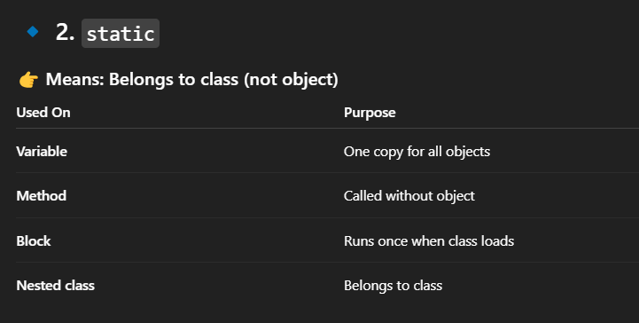

Interface:
- An interface is a blueprint of a class. It contains abstract methods.
- Whether you declare or not by default interface methods are public and abstract.
- Interfaces cannot be instantiated.
- You can only create objects of classes that implement the interface.

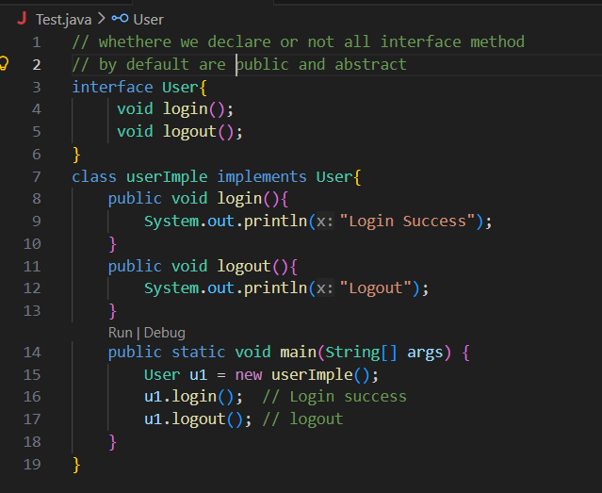
implementation
declaration

Abstract Class | Interface
Zero or more abstract methods and concrete methods | 100 % abstract methods
Variables - Can have normal variables | Variables - Only public static final constants.
Multiple Inheritance – Not supported | Multiple Inheritance – Supported (class can implement multiple interfaces)
Access Modifiers – Methods can have any modifier (public, protected, private) | Access Modifiers – All methods are public by default
Implements/Extends – class uses extends | Class uses implements

OOPS:
Class:
- Class is a blueprint, template, or design for creating objects
- It contains variables and methods
- Class does not occupy memory until an object is created
Object:
- An object is a real-world instance of a class
- It has an actual value.
- It occupies memory; to create an object, we use the new keyword.
The four principles of OOPS are
- Abstraction
- Encapsulation
- Inheritance
- Polymorphism
Oops main objective is readability, Reusability, Security.
Encapsulation:
- Binding private variable and methods(function) into a single unit class
- To access private variable in other class we can use setter and getter
- Main use of encapsulation is security.
Example:
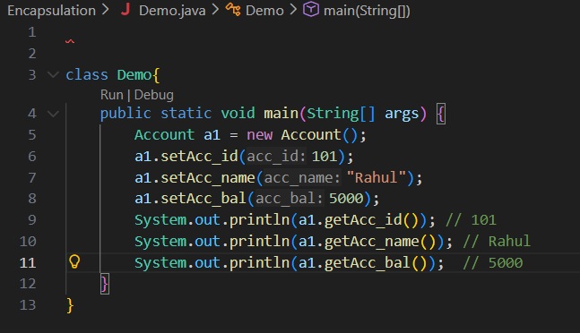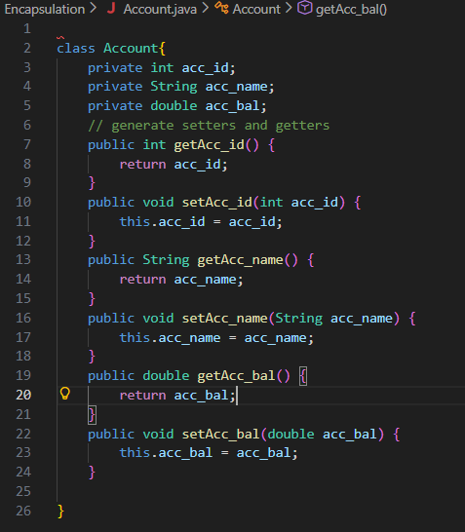
This pointerpointing current object, to refer class member inside a class.
Inheritance:
- Inheriting properties from one class to another class
- Reusing existing class functionality and adding new features
- By default, every java parent class is object, it will get invocation ambiguity.
- We can achieve inheritance by using extents keyword.
Types of Inheritance:
- Single Inheritance
- Multilevel Inheritance
- Hierarchical Inheritance
- Multiple Inheritance (not supported in class but supported in interface)
Multi-level inheritance

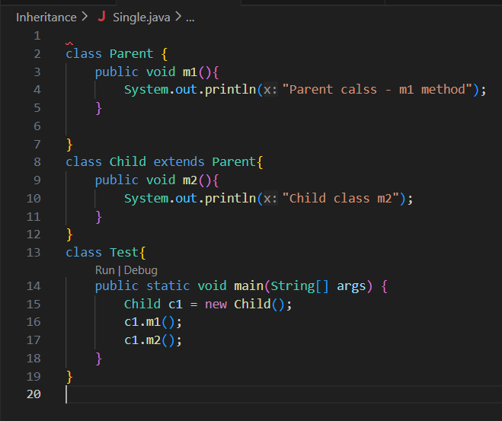
Single Inheritance:
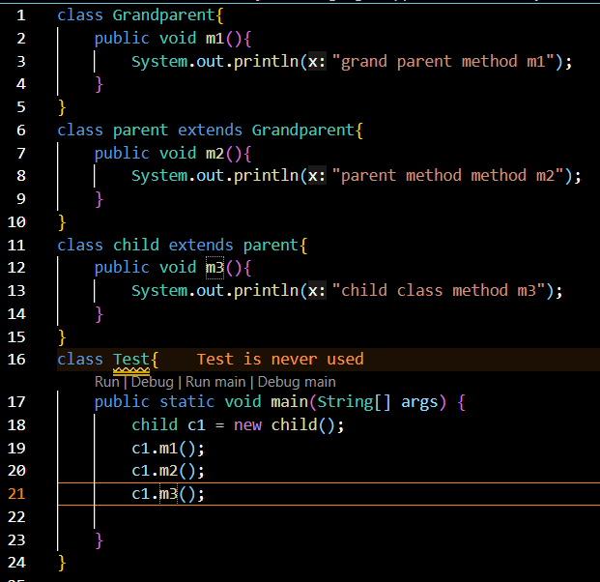
Constructor:
- Constructor is a special method in java used to initialize an object value, when it is created.
- Constructor method is executed only once automatically at the time of object creation.
- Class name and constructor name should be same.

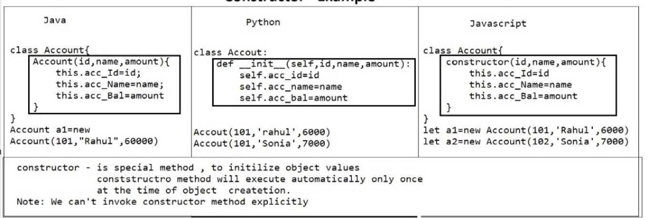
This pointerpointing current object, to refer class member inside a class.
THIS

Acc_Id:102
Acc_Name:sonia
Acc_Bal:6000

Acc_Id:101
Acc_Name:Rahul
Acc_Bal:0.0

Acc_Id:103
Acc_Name:priya
Acc_Bal:7000

Acc_Id:101
Acc_Name:Rahul
Acc_Bal:0.0

Acc_Id:101
Acc_Name:Rahul
Acc_Bal:5000

Acc_Id:101
Acc_Name:Rahul
Acc_Bal:0.0

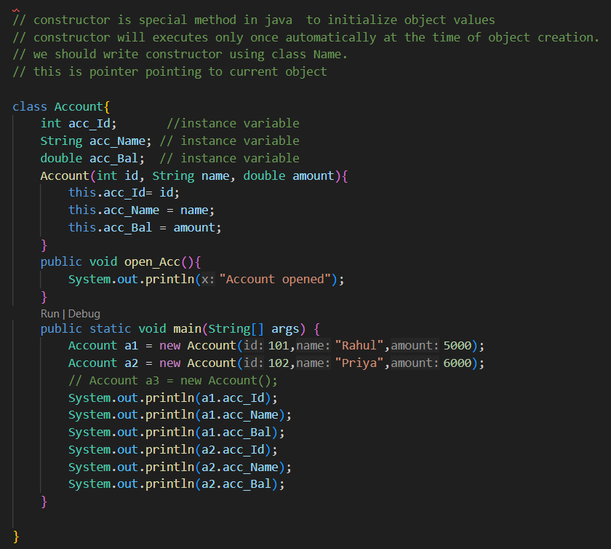
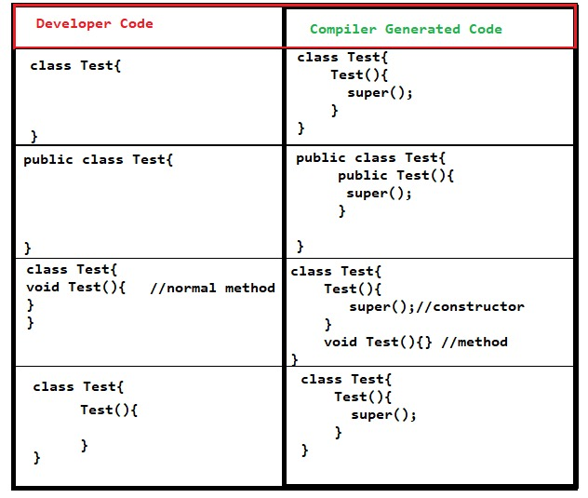
Super invoking the super class methods.

Polymorphism:
- Polymorphism in Java means one name, many forms.
- Same method name but different behaviours
- Poly – many, morphism – form.
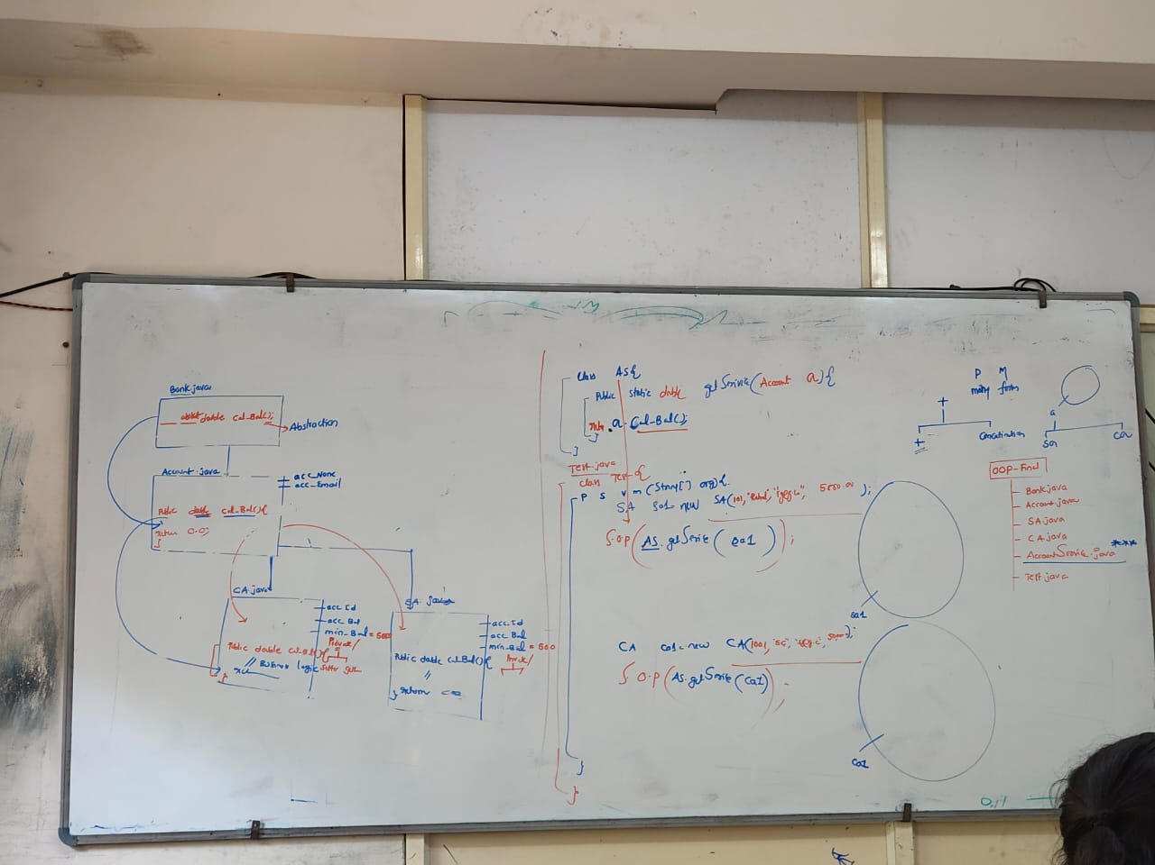
- We can achieve Polymorphism by using method overloading & method overriding.
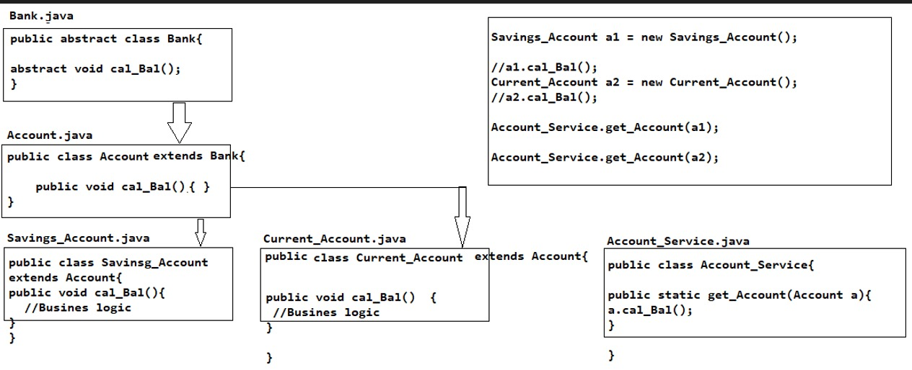
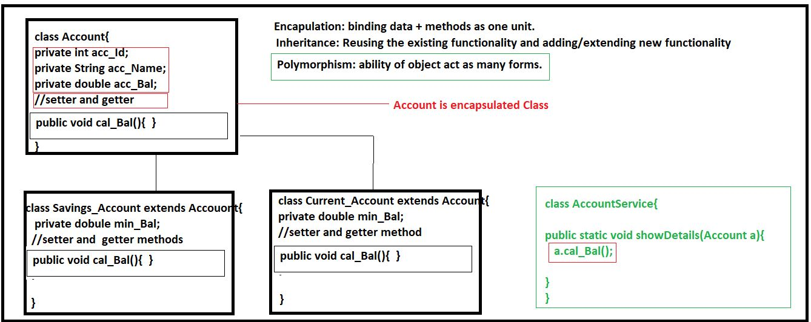
java. lang Package:
- java.lang is a built-in java package that contains classes and interface.
- java.lang package by default available to every java program
- Lang package contain object class, string class, string buffer, wrapper class.
Wrapper Class:
- Wrapper class is class converts a primitive datatype into an object.
Primitive Type | Wrapper Class
byte | Byte
short | Short
int | Integer
long | Long
float | Float
double | Double
char | Character
boolean | Boolean

toString():
- toString() is a method used to convert an object into a string representation.
- Print our object in a meaningful way.
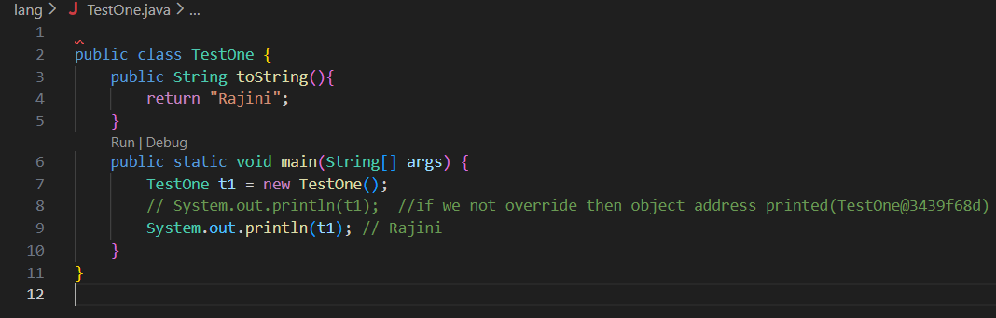

Java object class:
By default, every parent class is object
- toString()
- clone()
- hashcode()
- equals() – object class equal method for reference comparation
- wait()
- finalize()
- getClass()
- notify()
- notifyAll()

.equal() | == (operator)
Applicable only object | Applicable for object & primitive Datatype
Object class equals() method reference comparsion | If we want compare object using equality operator(==) then relation is required
String, String Buffer, String builder classes equal() method content comparision | Equality operator – primitive DT content comparision.

+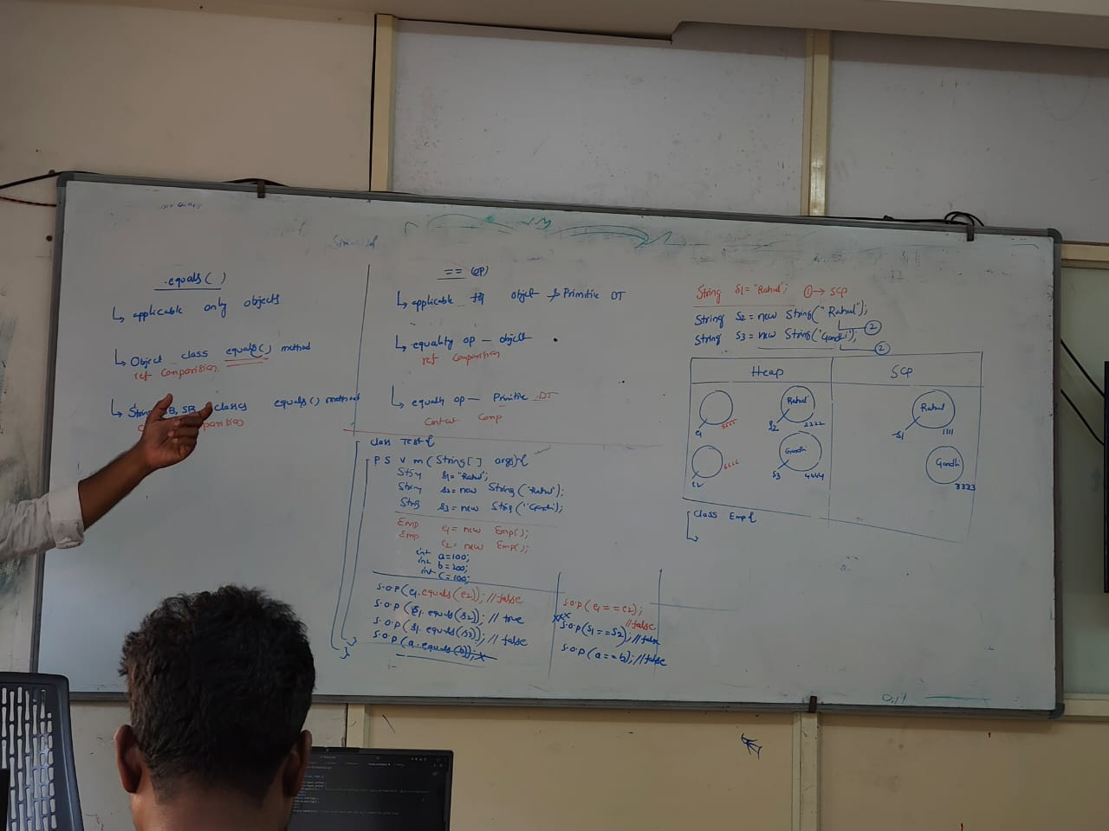
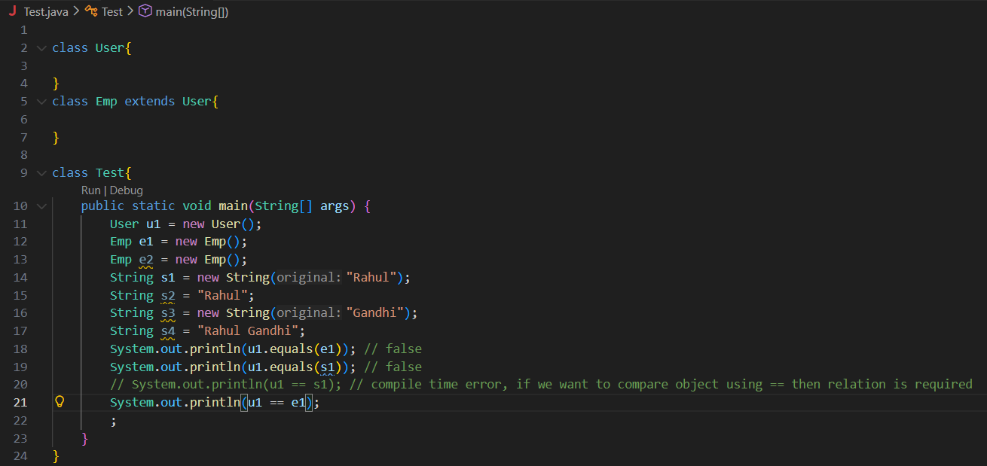
String:
- String is a group of character enclosed within double quotes.
- Strings are immutable.
- String, String Buffer, String Builder -> equal method override for content comparation.
- To make to String mutable we use String Buffer & String Builder.
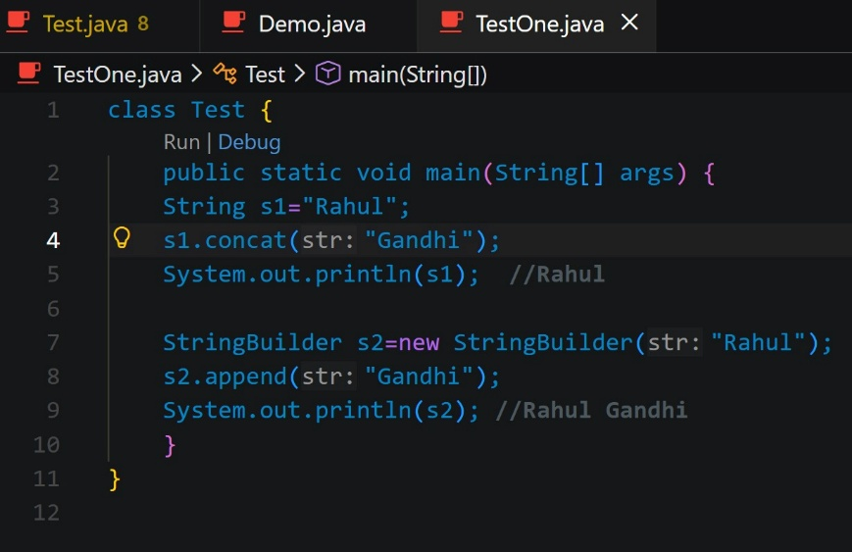

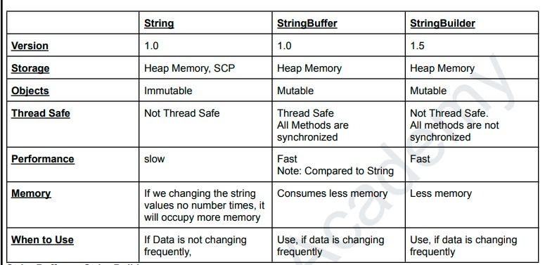

Wrapper Class:
- Wrapper class is class converts a primitive datatype into an object.
- Wrapper class main objective is gaining autoboxing and unboxing.
- Wrapper class is mainly used for collections framework.
- Autoboxing = automatically convert primitive datatype into object.
Primitive to object(valueOf),
Object to primitive(intvalue())
Object to string(toString())
String to object (valueOf())
String to primitive(parseInt())
Primitive to string (String.valueOf())
- Unboxing = automatically convert object into primitive datatype
- How to convert string to primitive? by using parseInt()
- How to read data from command line?
By using args, command line by default type is string
int a = Integer.parseInt(args[0]); // here we will get data in string and we converting into integer by using parseInt

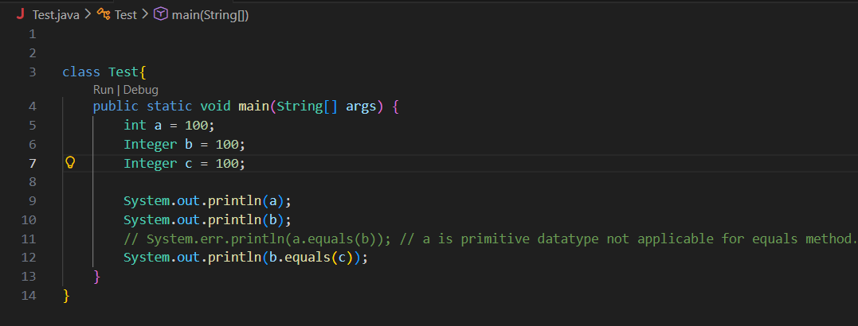

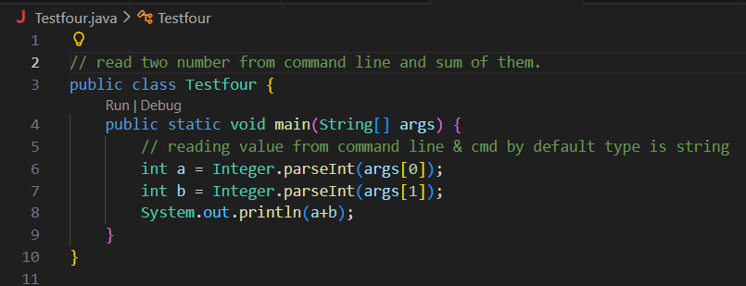
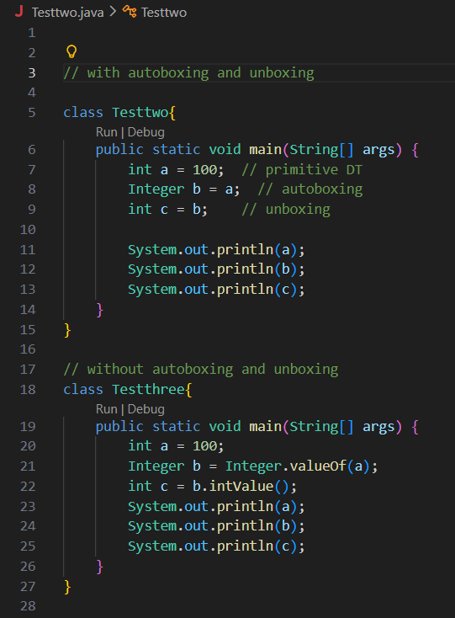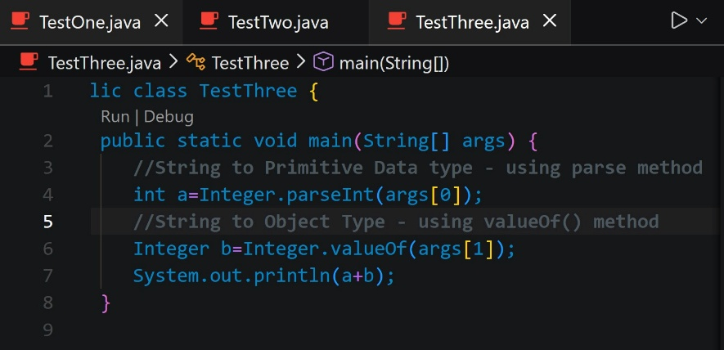

Exception Handling:
- Exception Handling is a mechanism to handle runtime errors so that the normal flow of the program is not interrupted.
- An exception is unexpected events occurs program terminate abnormally. ( NullPointerException, ArithmeticException)
- An Error is out of program, that cannot be handled (OutOfMemoryError, StackOverflowError)
- We can handle exception Handling by try, catch, finally, throws, throw.
Types of Exception Handling:
- Checked Exception – compile time error, handle by try, catch & throws
- UnChecked Exception – runtime error

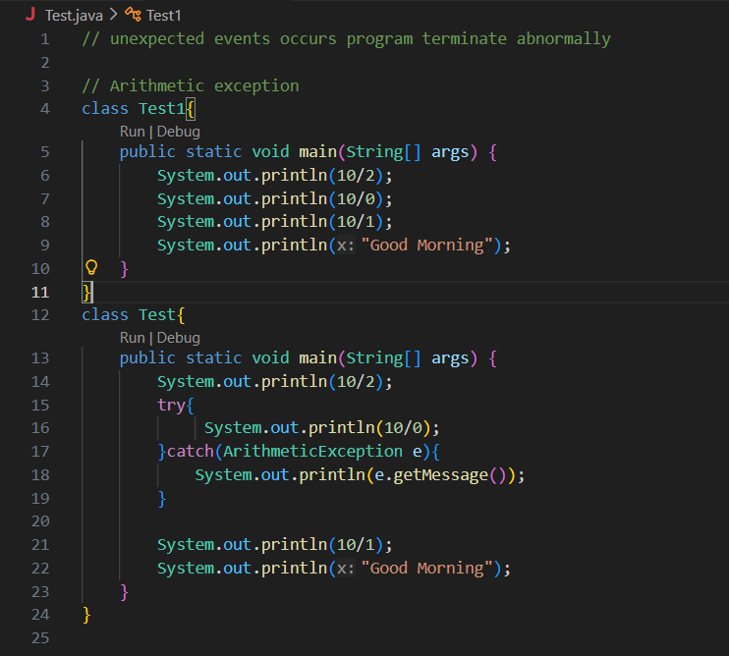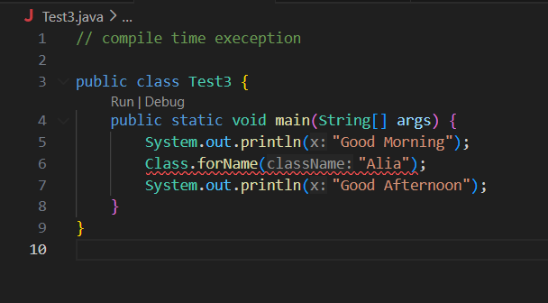
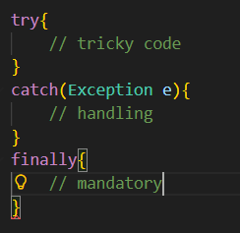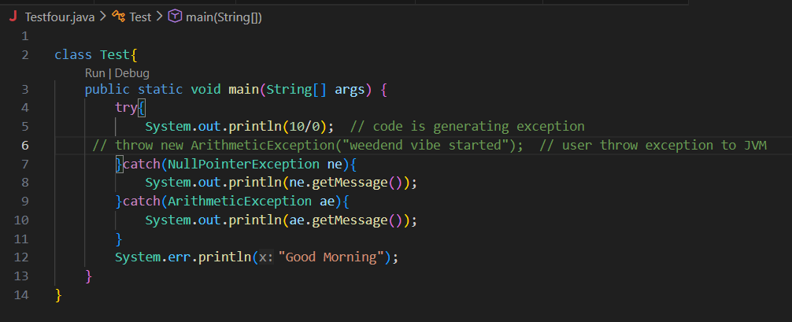

Throw = user throw the exception to JVM, it’s compile time exception.
Throws = ignore the exception,

Collections Frame work
Collections frame work
collection
Arrays
hashtable
Tree map

Linked hashmap
hashmap
Priority queue©
Dqueue(i)
Queue(i)
Map(interface)
Linked hashset©
Linkedlist(c)
ArrayList(c)
Treeset©
Hashset©
Set(i)
List(i)
Utility classes
Collection(interface)

Collections is a framework of collection, utility classes, map interface and their implemented classes
Collection is a root element of list, set and map.
Inserting & Iterating elements present in array list using loops:
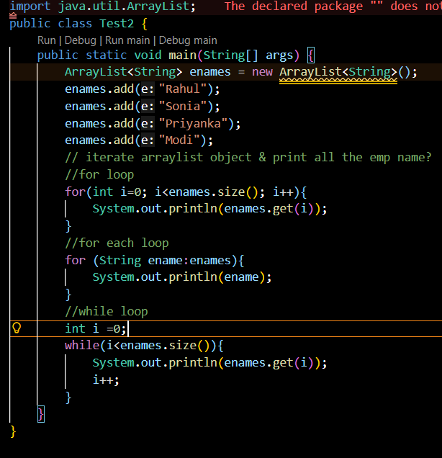
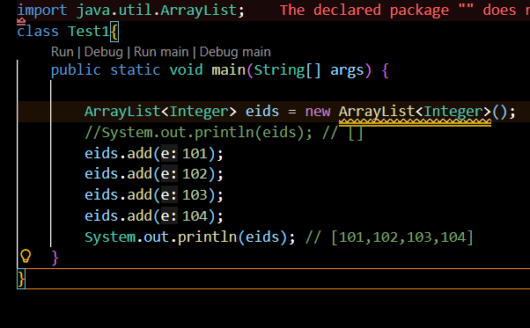

ARRAY LIST | LINKED LIST
Contiguous memory location | stored in the form of nodes
if you’re frequent operation is retrieve data | if you’re frequent operation is inserting/ deleting data
Searching is fast | Searching is difficult
Manipulation is difficult | Manipulation is fast

Collection(i) - 16+ abstract Methods

List (i)- set().get() 16 abstract methods

class Arraylist implements List{

18+ -already implemented }

class LinkedList implements List, Deque{

22+ methods implemented already }

Collections Framework:
A group of class and interfaces used to store and manipulate multiple data efficiently.

Real-Time Example
In E-commerce Application:
Cart Items → List
Unique Coupons → Set
User Details → Map
Order Queue → Queue

Why Collections Came?
Problem with Arrays:
- Fixed size
- Difficult insert/delete
- No built-in methods
Collections solve:
- Dynamic size
- Easy operations
- Faster data handling
List Interface:
List is interface it maintains insertion order, allow duplicates, it can access index based manner.
Real-Time Example
Food delivery cart:
Pizza
Burger
Pizza
Duplicates allowed.
Implementations
- ArrayList
- LinkedList
ArrayList:
ArrayList is dynamic array, it stores element in index based mannes, it’s contiguous memory, so searching easy and inserting and deleting is difficult.

