Node JS:
* Node JS is a open source, cross platform JavaScript run-time environment that executes JavaScript code outside of a browser
Synchronous:
* Code runs line by line, one after another.
* Main disadvantages of synchronous is blocking the other requests.
Example:
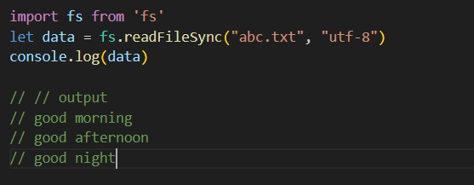
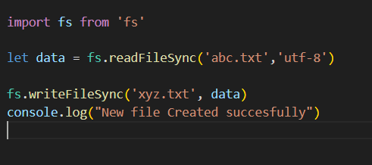
Asynchronous:
* It will run at a time.
* It won't block others request.
Example:
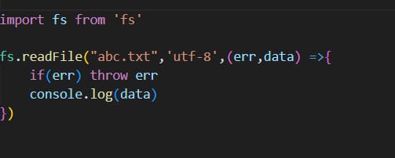

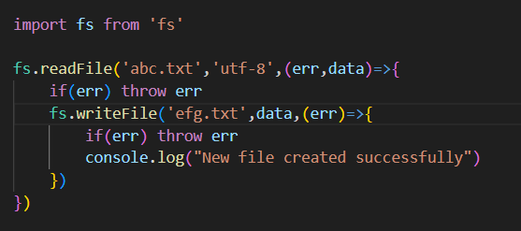

What is Module in Node js?
* A Module is a reusable block of code(a file or set of functions) that you can import and use in other file.

Types of Modules in Nodesjs:
* Built-in Modules --> provided by node.js itself
example:
* fs --> for working with files.
* http --> for creating web server.
* path --> for handling file paths.
* os --> for system information.
* Local Module --> your own custom file
* math.js or user.js
* Third-party Modules --> installed using npm

What is require in Node js?
* The require is a function used to import modules into our file

